1. URL: <https://test-zcon.herokuapp.com>

It will show the registration page.

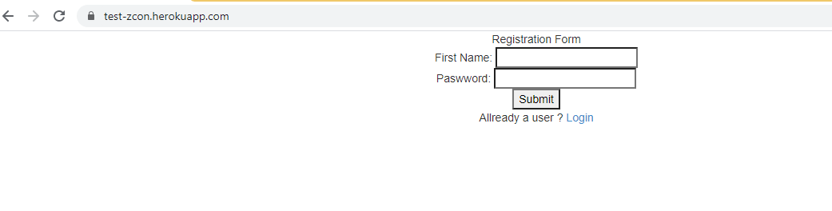

1. Create a new user

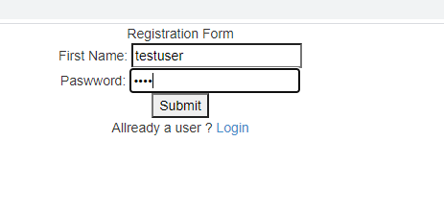

User created

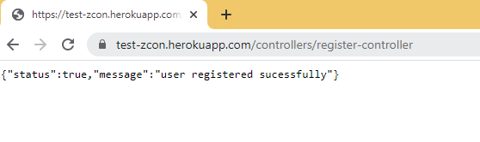

1. To login, click on Login link on the index page

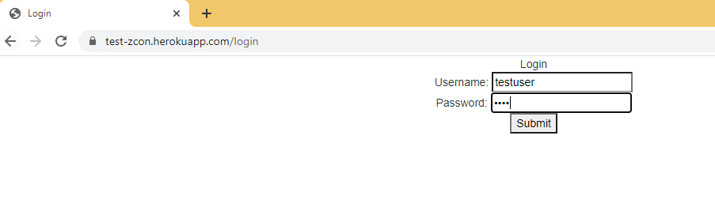

1. Gift purchase page

