Case Study Analysis Report

**Case Study Title**: Uncovering Patterns in Hotel Booking Data for Operational Efficiency and Revenue Growth

**Prepared by:** MUSKAN CHAUHAN

**Roll no:** 250240325040

**Date:** 8/06/2025

# Executive Summary

This report is all about analysing hotel booking data. Imagine you're a hotel manager trying to understand who books, when they book, and how much they pay.

We looked at:

* When people book (early or late)
* Where they’re from (countries)
* If they get room upgrades
* How many nights they stay
* What affects the price they pay per night (called ADR - *Average Daily Rate*)

We used some basic statistics and graphs to make sense of this. In the end, we gave suggestions to improve bookings and make more money.

# Table of Contents

1. Introduction

2. Background / Context

3. Analysis

4. Conclusion

# Introduction

We took a big table (dataset) full of hotel booking details like:

* Guest nationality
* Type of room they booked
* How long they stayed
* How much they paid

We cleaned up the data and used it to find useful patterns and trends.

# 2. Background / Context

This data was from two types of hotels — a **city hotel** and a **resort hotel**. We had over 100,000 bookings But, some parts of the data were messy:

1. Some columns had lots of missing values (so we removed or fixed them).
2. Date information was split into day, month, and year I combined it into one single date.

# 3. Analysis

We used different tools to understand the data:

* **Univariate Analysis**:

We looked at each column separately to understand basic patterns.  
For example:

* How many bookings came from each country?
* Which room types were booked most often?
* What’s the most common number of guests?

This helped us get a feel for the data before comparing anything.

Bar chart for categorical values for univariate analysis:

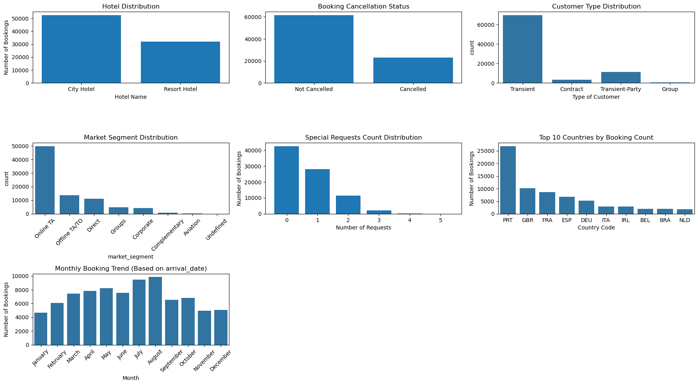

Created histogram for continuous and discrete column for univariate analysis:

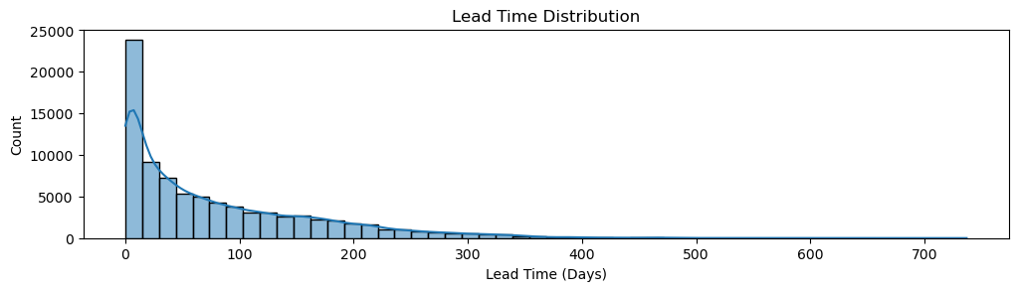

This chart shows how many days in advance people book their hotel stays:

* Most people book very close to their stay date, especially within the first 0–20 days.
* As the number of days increases, the number of bookings drops sharply.
* Very few guests book more than 100 days in advance.

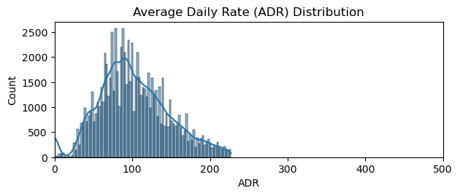

This chart shows how hotel room prices per night (ADR) are spread out:

* Most bookings are priced between 50 and 150 units.
* The peak is around 100, meaning that's the most common nightly rate.
* Prices above 200 are rare.
* **Bivariate/Multivariate Analysis**:

Next, we looked at how two or more things are related.  
For example:

* Is there a connection between room type and price?
* Do guests from different countries pay more or less?
* Does lead time (how early someone books) affect cancellations?

This helped us find relationships between columns.

Boxplot for bivariate analysis:

This chart shows how the average price per night (ADR) varies based on guest or booking characteristics.

* Corporate and Offline TA/TO guests tend to pay more.
* Guests who are repeated usually pay higher rates.
* Assigned and reserved room types affect ADR — some types are priced much higher.
* Bookings via agents or with deposits tend to have lower ADR.
* Cancellations lead to lower ADR, while booking changes don’t affect ADR much.

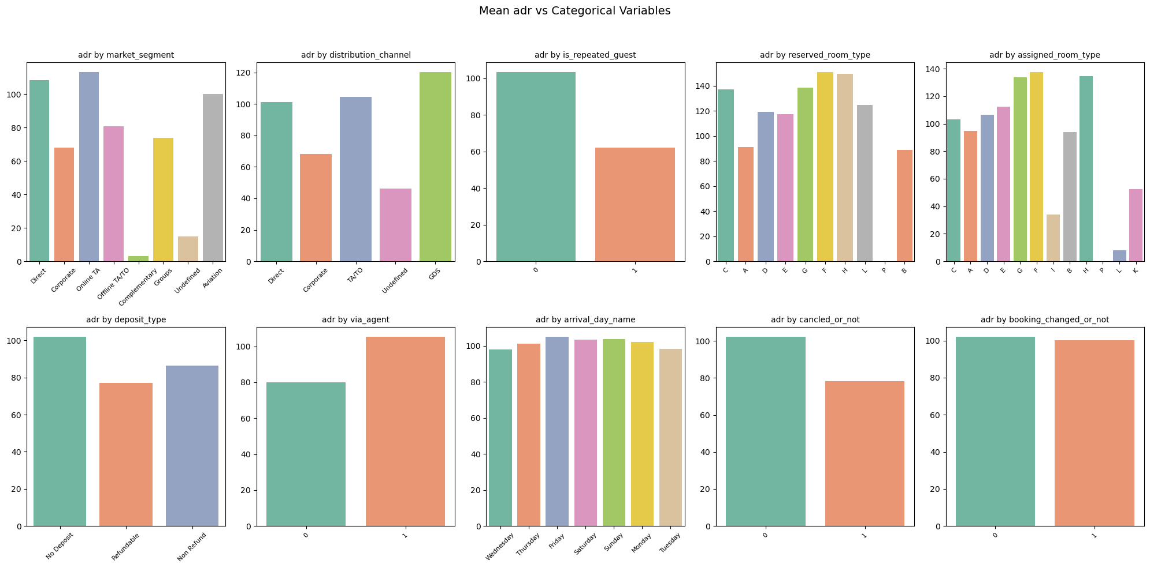

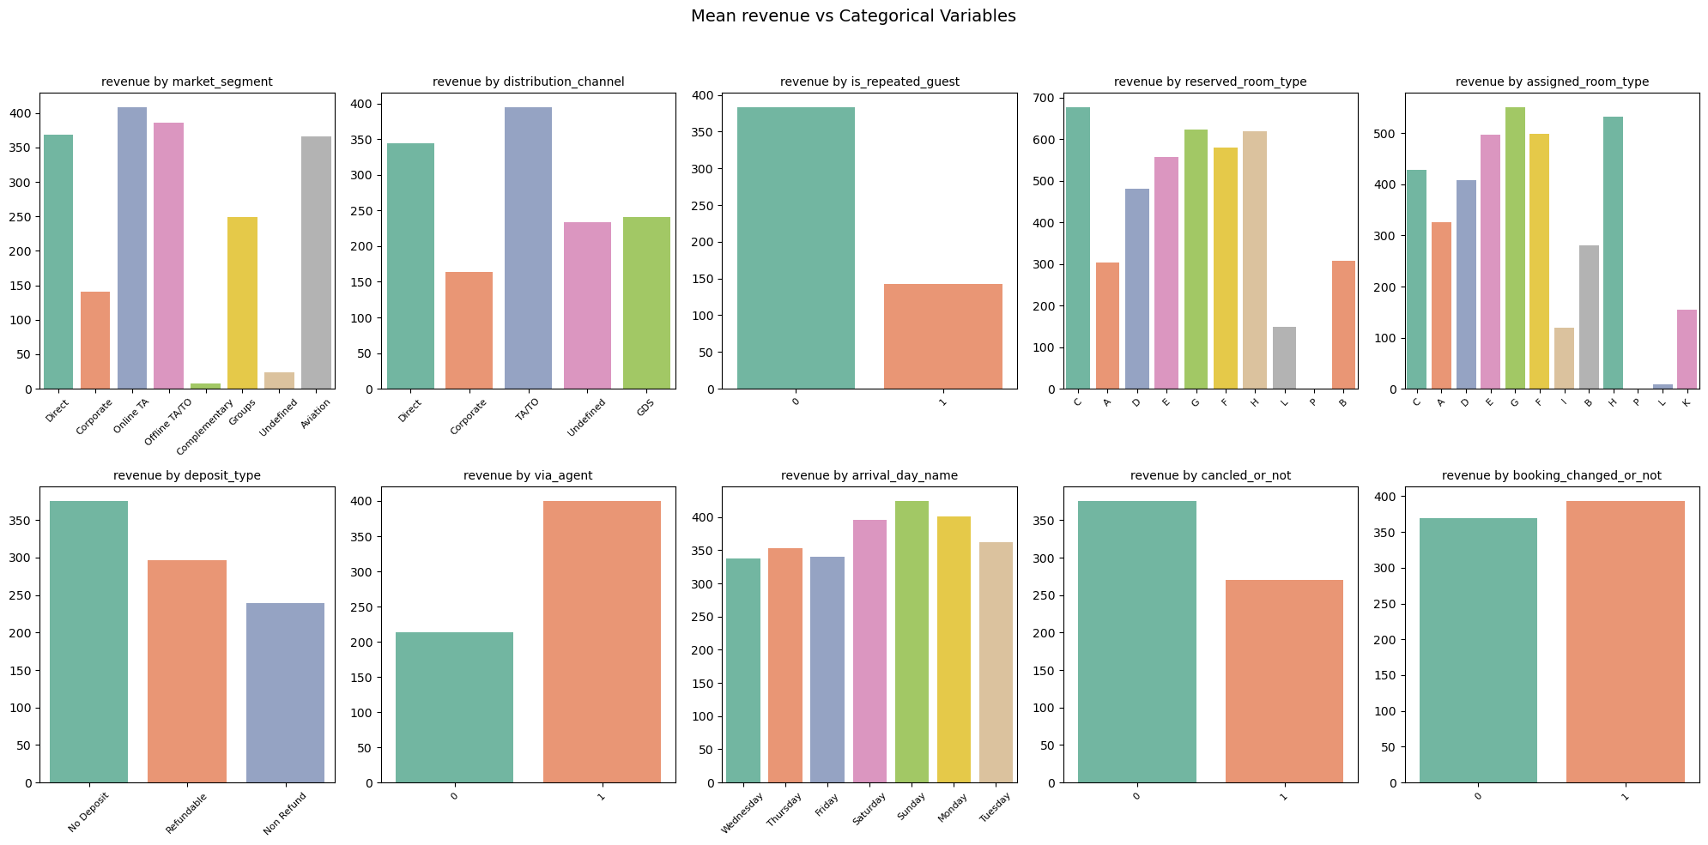

**Time Series Analysis – Looking at Trends Over Time**

We studied how bookings change across months and years.  
For example:

* Are there more bookings in summer?
* Did prices increase or drop in certain months?

This helped us understand seasonal patterns in the data.

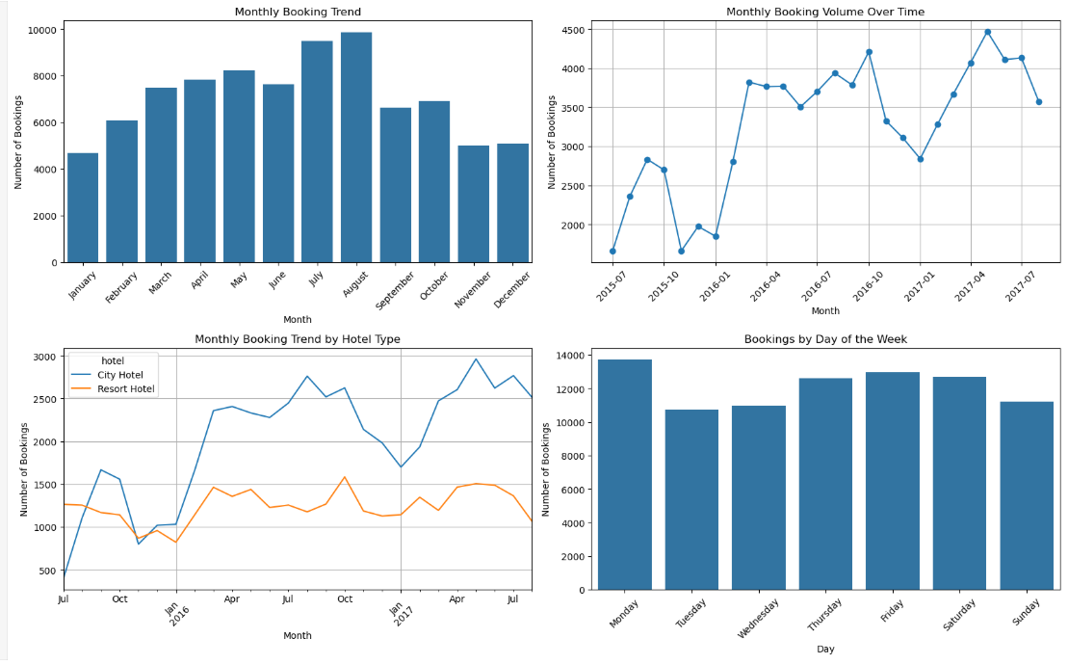

* Bookings peak in July and August, showing summer is the busiest time.
* City hotels consistently get more bookings than resort hotels throughout the year.
* Over time, total booking volume increased, showing growing business.
* Monday has the highest bookings, suggesting many people book after weekends.

These insights help hotels plan staffing, marketing, and pricing.

**Correlation – Are Things Related?**

We used correlation to check how strongly different factors move together.  
For example:

* If a guest books earlier, do they usually pay more?
* Do longer stays mean higher total prices?

Correlation helps us find what affects what, even if it's not obvious.

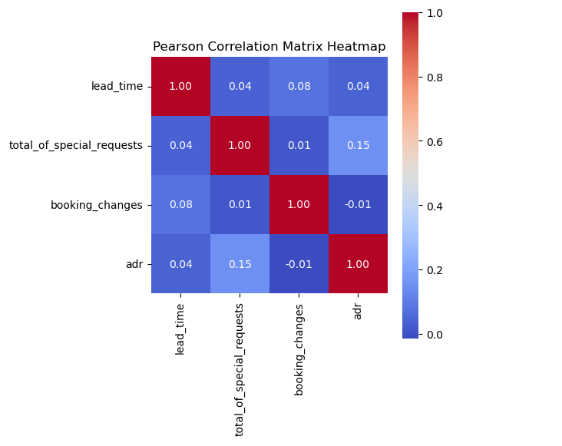

* total_of_special_requests and adr (average price per night) have a slight positive correlation (0.15) — guests who pay more tend to make more requests.
* Other features like lead_time, booking_changes, and adr show very weak or no strong relationship.
* Nothing here is highly correlated, meaning no variable strongly predicts another in this small selection.

**Hypothesis Testing – Are Our Guesses Statistically True?**

Sometimes we have a gut feeling (like “guests who book early cancel less”).  
We used hypothesis testing to check if these guesses are true using math.

It’s like A/B testing — we compare groups and check if the difference is real or just by chance.

**Cleaning the Data – Fixing the Mess**

Before analyzing, we had to clean up the messy parts of the data:

Removed the "company" column

* The “company” column had too many missing values, so we deleted it.
* It didn’t give us useful information, so we dropped it to avoid confusion.

**Filled Missing Values**

For some important columns, we filled in the blanks:

* "Agent": Filled with the most common agent ID.
* "Country": Filled missing countries with the one that appeared the most.
* "Children": If the number of children was missing, we assumed it was zero or the most common number.

This way, we avoided errors or gaps in our analysis.

# 7. Conclusion

Through our detailed analysis of the hotel booking dataset, we gained valuable insights into customer behavior, booking patterns, and factors that influence revenue. Here's what we concluded:

* Pricing (ADR) is most influenced by the hotel type, customer type, and lead time. Guests who book earlier or belong to certain customer groups tend to pay more.
* Transient guests and international travelers usually book earlier and stay for shorter durations, but contribute significantly to revenue.
* There are noticeable differences in booking habits by country—for example, UK and France guests book earlier, while Portuguese guests stay for shorter durations.
* Special requests and booking modifications are more common among high-paying guests.
* Guests who have their room upgraded or reassigned are less likely to cancel, and about 1 in 4 bookings involve such changes.
* Certain market segments, like corporate or direct bookings, are more reliable—they cancel less and pay more.
* Data cleaning was crucial. We filled missing values smartly and removed irrelevant columns to keep the analysis accurate.