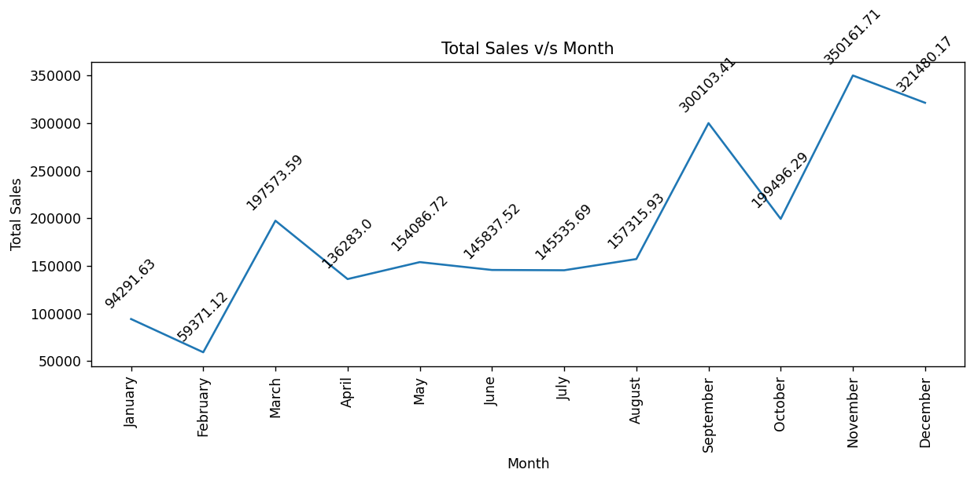
1st Insight:

- Sales remain relatively stable from April to August, indicating consistent customer demand during these months. The company can use this period to introduce promotional campaigns or special offers to further increase sales.
- November and December record the highest sales of the year, suggesting a peak demand period. The company should ensure sufficient inventory and efficient supply chain management to meet customer demand during these months.
- Sales are drastically low in the month of February suggesting a slowdown in customer purchase. The company should investigate the factors contributing to lower sales during this month and consider promotional campaigns to improve performance.
- After reaching a high point in September, sales decreased by approximately one-third in October. The company should analyze factors such as promotions, inventory availability, or customer demand during October to understand the decline and reduce similar fluctuations in the future.

