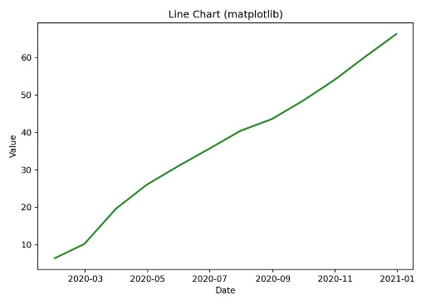
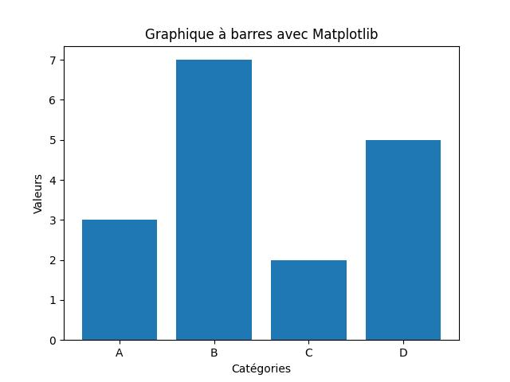
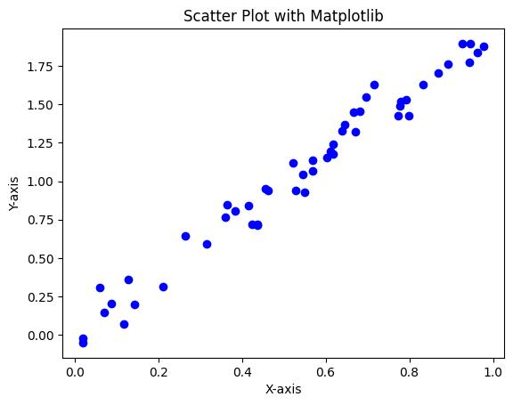
Matplotlib: It is a python library used for creating graphs, charts and visualizations. It helps us to display the data visually, amking it easier to analyse trends, patterns and relationships.
Matplotlib can create:
- Line charts
- Bar charts
- Scatter plots
- Histograms
- Pie charts
- Box plots
- Heatmaps (with extensions)
- 3D plots

Why Use Matplotlib?
- Easy to learn and widely used.
- Works well with libraries such as NumPy and Pandas.
- Useful for data analysis, machine learning, scientific computing, and reporting.
- Produces publication-quality figures.

Most of the plotting is done through: import matplotlib.pyplot as plt
The pyplot module provides functions similar to drawing on a canvas, such as:
- plt.plot() – line plots
plt.plot(x_values, y_values, marker = 0)
where:
- x_values → values on the x-axis
- y_values → values on the y-axis
- marker = 0 → adds a circular marker at each point

- plt.bar() – bar charts. Best for comparing categories.
Examples:
  - Sales by product
  - Students by department
  - Revenue by region

- plt.scatter() – scatter plots. Best for:
  - Finding relationships between variables
  - Detecting patterns
  - Detecting outliers
Example:
- Hours studied vs exam score
- Advertising spend vs sales

- plt.hist() – histograms. A histogram shows how values are distributed. Best for answering:
  - Are most values high or low?
  - Is data spread out?
  - Is the distribution normal?

- plt.show() – display the figure

Commonly Used Functions
When creating plots with Matplotlib, the below functions are used to add labels and formatting to make the chart easier to understand.

Function | Purpose
plt.title("Title") | Adds a title to the graph.
plt.xlabel("Label") | Labels the x-axis.
plt.ylabel("Label") | Labels the y-axis.

1. plt.legend()
Purpose: Shows what each line, bar, or set of points represents. In the same chart if we have two graphs, two different curves.
Without a legend, viewers may not know which line corresponds to which dataset.
2. plt.grid()
Purpose: Adds horizontal and vertical guide lines to the graph.
These lines make it easier to estimate values.
3. plt.xlim()
Purpose: Controls which part of the x-axis is visible.
Suppose your data goes from 0 to 100 but you're only interested in 20–50. Think of it as zooming in horizontally.
4. plt.ylim()
Purpose: Controls which part of the y-axis is visible. Think of it as zooming in vertically.
Useful when:
- Comparing small changes
- Removing unnecessary empty space
- Focusing on a specific range
5. plt.figure()
Purpose: Creates a new graph and controls its size.
plt.figure(figsize=(8, 4))
- First number = width
- Second number = height
This is often the first line before plotting.
6. plt.subplot()
Purpose: Places multiple graphs inside one figure. Useful when comparing multiple visualizations.
plt.subplot(1, 2, 1)
plt.plot([1,2,3], [2,4,6])
plt.subplot(1, 2, 2)
plt.bar([1,2,3], [2,4,6])
plt.show()
+---------+---------+
| Line | Bar |
| Graph | Graph |

Meaning of (1, 2, 1):
- 1 row
- 2 columns
- This is graph #1
Meaning of (1, 2, 2):
- 1 row
- 2 columns
- This is graph #2

7. plt.savefig()
Purpose: Saves the graph to a file. Use this when creating reports or presentations.
plt.plot([1,2,3], [2,4,6])
plt.savefig("sales.png")

8. plt.tight_layout()
Purpose: Automatically fixes spacing problems. Sometimes titles and labels overlap. Matplotlib adjusts spacing automatically. This is commonly placed right before: plt.show().
9. plt.xticks()
Purpose: rotates the labels on the x-axis. Written after plt.plot()
Plt.xticks(rotation = 45)

Where rotation tells how many degrees to rotate.
This improves readability, especially when:
- Labels are long (e.g., "January", "February").
- There are many categories.
- The figure is not very wide.

10. plt.yticks()
Purpose: It works the same as plt.xticks() but for y-axis.

Here each function has a specific role:
Function | What it does
figure() | Creates the canvas
plot() | Draws the line
title() | Adds heading
xlabel() | Labels x-axis
ylabel() | Labels y-axis
grid() | Adds guide lines
legend() | Explains plotted data
tight_layout() | Fixes spacing
savefig() | Saves graph
show() | Displays graph

Flowchart:
Create → Plot → Label → Beautify → Save/Show
Steps:
plt.figure()
plt.plot(...)
plt.title(...)
plt.xlabel(...)
plt.ylabel(...)
plt.grid()
plt.legend()
plt.tight_layout()
plt.savefig(...)
plt.show()

Other Improvements:
Step after plt.plot()
for x, y in zip(monthly_sales['Month'], monthly_sales['Sales']):
Where:
- zip() combines the two columns together. Creates pairs.
('Jan', 1200)
('Feb', 1500)
('Mar', 1700)
- Now x and y is used to loop through every value pair, where x: month, y: sales.
What will happen in every loop?
plt.annotate(text, (x, y)) {This is compulsory format, rest all are optional}
text: the text to be displayed on the graph
(x,y): location where the text should be displayed
Where:
- annotate() writes text on the graph at a specified location.
- Here text will be: f'{y:.2f}'
  - Where: ‘f’ is f-string, to format the sales value to nearest 2 decimal places using 2f.
  - If already formatted value we will write:
plt.annotate(str(y), (x, y))

- (x,y): This specifies the point where the label belongs.

Use an offset for the text: textcoords="offset points"
- Instead of placing the text directly on the marker, Matplotlib uses an offset.
- We're telling Matplotlib: The text position will be specified as an offset in points by us.
- Without the offset the number overlaps the point.

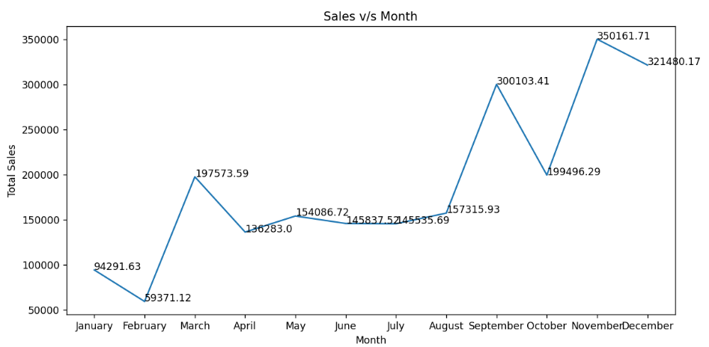
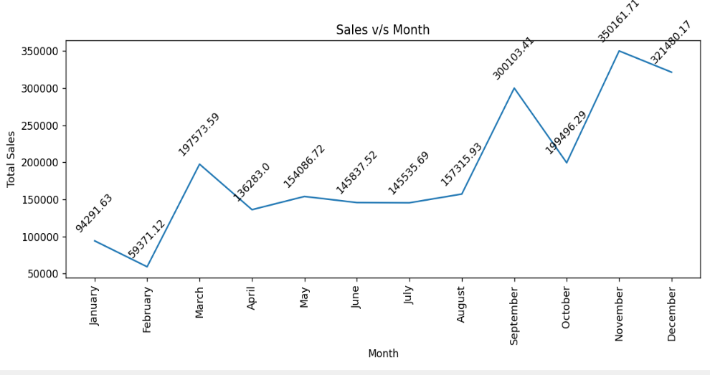
- With an offset, the text is moved away from the point.

- We have to mention the xytext=(0, 8) means:
  - 0 → don't move left or right.
  - 8 → move 8 points upward.
Additionally we have other options to do horizontal alignment.
‘ha’ stands for horizontal alignment.
Possible values:
- 'left'
- 'center'
- 'right'
Also, we can rotate the text using rotation = degrees, where degrees can be any value to which you want to rotate the text.
Overall, we can write the code as:
for x, y in zip(monthly_sales[‘Month’], monthly_sales[‘Sales’]):
plt.annotate(str(y), (x, y), textcoords = “offset points”, xytext = (0,8), ha = “center”, rotation = 45)

