GYM MEMBERSHIP
MANAGEMENT SYSTEM
DBMS MINI PROJECT REPORT

Submitted by | Muskan Gupta
UID | 25BCD10069
Department | BCA Data Science
Submitted to | Ms. Harkamal Kaur
Academic Session: 2026–2027

1. Introduction
The Gym Membership Management System is a database-based application designed to store and manage the daily records of a gym. It keeps information about members, membership plans, trainers, payments, and attendance in an organized manner. Instead of maintaining separate paper registers, the gym can use a relational database to retrieve accurate information quickly.
This mini project is implemented using MySQL. It demonstrates core DBMS concepts such as tables, primary keys, foreign keys, data insertion, filtering, joins, aggregate functions, views, and updates.

2. Objectives / Problem Statement

Problem Statement
Manual gym record keeping can cause duplicate entries, difficulty in checking fee status, and delays in finding a member's plan or trainer. The system aims to solve these problems by maintaining connected records in a structured database.

Objectives
- Store member details such as name, age, phone number, and joining date.
- Maintain membership plans and their duration and fees.
- Store trainer details and assign trainers to members.
- Record payments and identify pending fees.
- Maintain member attendance records.
- Use SQL queries to generate useful summaries such as plan-wise member counts and total paid revenue.
- Demonstrate primary keys, foreign keys, joins, aggregate functions, views, and update operations.

3. Modules, Tools and Technologies Used

Modules
Module | Description
Member Management | Add and view member details and connect each member to a plan and trainer.
Membership Plan Management | Store plan names, duration in months, and membership fees.
Trainer Management | Maintain trainer names, specializations, and contact numbers.
Payment Management | Record fees and payment status such as Paid or Pending.
Attendance Management | Store the attendance date and check-in time for each member.
Reports | Display member-plan-trainer details, pending payments, plan-wise counts, and revenue.

Tools and Technologies
- Database: MySQL 8.x
- Interface/IDE: MySQL Workbench or MySQL command-line client
- Language: SQL (Structured Query Language)
- Operating System: Windows / Linux / macOS
- Concepts: Relational tables, primary and foreign keys, INSERT, SELECT, JOIN, WHERE, GROUP BY, SUM, VIEW, UPDATE

Database Design
The project contains five related tables:
- membership_plans(plan_id, plan_name, duration_months, fee)
- trainers(trainer_id, trainer_name, specialization, phone)
- members(member_id, member_name, age, phone, join_date, plan_id, trainer_id)
- payments(payment_id, member_id, amount, payment_date, payment_status)
- attendance(attendance_id, member_id, attendance_date, check_in)
Relationship summary: One membership plan can be linked to many members; one trainer can train many members; one member can have multiple payment records and attendance records. Foreign keys maintain referential integrity.

4. Code with Expected Outputs
The following SQL script is designed for MySQL. Run it from top to bottom in MySQL Workbench. The screenshots below are prepared expected-output illustrations based on the sample records in the script; they are not captured from a live MySQL session. Your exact display may vary slightly by MySQL version.

4.1 Create database and tables
CREATE DATABASE gym_management;
USE gym_management;
CREATE TABLE membership_plans (
plan_id INT PRIMARY KEY AUTO_INCREMENT,
plan_name VARCHAR(30) NOT NULL,
duration_months INT NOT NULL,
fee DECIMAL(8,2) NOT NULL
);
CREATE TABLE trainers (
trainer_id INT PRIMARY KEY AUTO_INCREMENT,
trainer_name VARCHAR(50) NOT NULL,
specialization VARCHAR(40),
phone VARCHAR(15)
);
CREATE TABLE members (
member_id INT PRIMARY KEY AUTO_INCREMENT,
member_name VARCHAR(50) NOT NULL,
age INT,
phone VARCHAR(15),
join_date DATE,
plan_id INT,
trainer_id INT,
FOREIGN KEY (plan_id) REFERENCES membership_plans(plan_id),
FOREIGN KEY (trainer_id) REFERENCES trainers(trainer_id)
);
CREATE TABLE payments (
payment_id INT PRIMARY KEY AUTO_INCREMENT,
member_id INT NOT NULL,
amount DECIMAL(8,2) NOT NULL,
payment_date DATE,
payment_status VARCHAR(20) DEFAULT 'Paid',
FOREIGN KEY (member_id) REFERENCES members(member_id)
);
CREATE TABLE attendance (
attendance_id INT PRIMARY KEY AUTO_INCREMENT,
member_id INT NOT NULL,
attendance_date DATE NOT NULL,
check_in TIME,
FOREIGN KEY (member_id) REFERENCES members(member_id)
);

4.2 Insert sample records
INSERT INTO membership_plans (plan_name, duration_months, fee) VALUES
('Monthly', 1, 1200.00),
('Quarterly', 3, 3200.00),
('Yearly', 12, 10000.00);
INSERT INTO trainers (trainer_name, specialization, phone) VALUES
('Aman Sharma', 'Strength Training', '9876501234'),
('Neha Verma', 'Yoga and Fitness', '9876505678');
INSERT INTO members (member_name, age, phone, join_date, plan_id, trainer_id) VALUES
('Muskan Gupta', 21, '9876511111', '2026-10-01', 2, 1),
('Riya Singh', 22, '9876522222', '2026-10-05', 1, 2),
('Aarav Mehta', 23, '9876533333', '2026-10-10', 3, 1);
INSERT INTO payments (member_id, amount, payment_date, payment_status) VALUES
(1, 3200.00, '2026-10-01', 'Paid'),
(2, 1200.00, '2026-10-05', 'Paid'),
(3, 10000.00, '2026-10-10', 'Pending');
INSERT INTO attendance (member_id, attendance_date, check_in) VALUES
(1, '2026-10-20', '07:15:00'),
(2, '2026-10-20', '08:00:00'),
(1, '2026-10-21', '07:20:00');

4.3 Query 1: Display members with plan and trainer (JOIN)
SELECT m.member_id, m.member_name, p.plan_name, t.trainer_name
FROM members m
JOIN membership_plans p ON m.plan_id = p.plan_id
JOIN trainers t ON m.trainer_id = t.trainer_id;
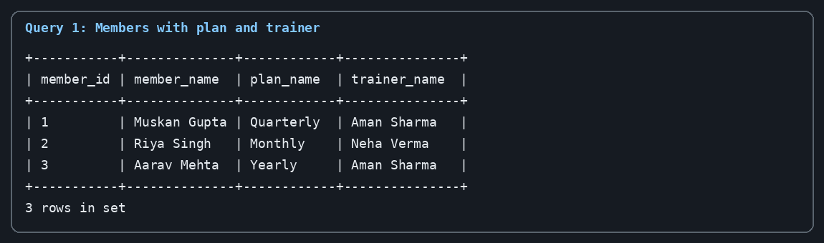

4.4 Query 2: Show pending payments (WHERE)
SELECT payment_id, member_id, amount, payment_status
FROM payments
WHERE payment_status = 'Pending';
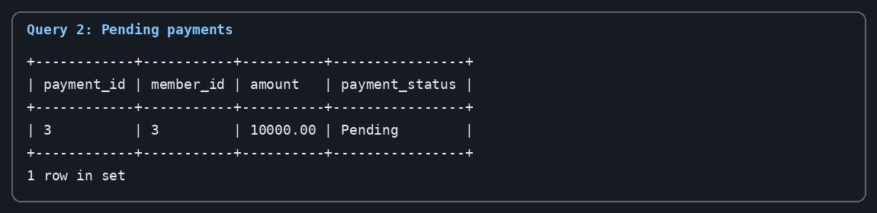

4.5 Query 3: Count members in each plan (GROUP BY)
SELECT p.plan_name, COUNT(m.member_id) AS total_members
FROM membership_plans p
LEFT JOIN members m ON p.plan_id = m.plan_id
GROUP BY p.plan_id, p.plan_name;
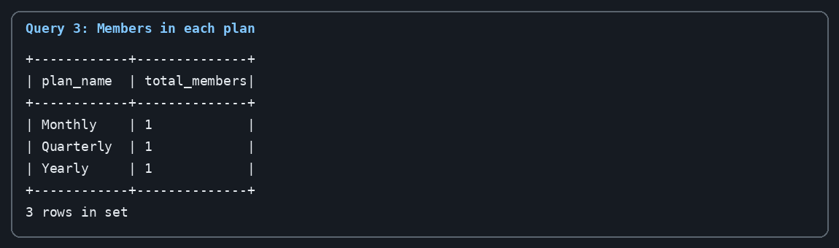

4.6 Query 4: Calculate total paid revenue (SUM)
SELECT SUM(amount) AS total_revenue
FROM payments
WHERE payment_status = 'Paid';
Expected result: ₹4,400.00 (₹3,200 + ₹1,200; pending payment is not counted).
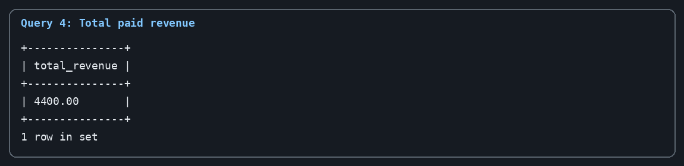

4.7 Create and use a VIEW
CREATE VIEW member_summary AS
SELECT m.member_id, m.member_name, p.plan_name, p.fee, t.trainer_name
FROM members m
JOIN membership_plans p ON m.plan_id = p.plan_id
JOIN trainers t ON m.trainer_id = t.trainer_id;
SELECT * FROM member_summary;
Expected result: a summary containing each member's name, plan, plan fee, and assigned trainer.

4.8 Update a payment record
UPDATE payments
SET payment_status = 'Paid'
WHERE payment_id = 3;
SELECT payment_id, amount, payment_status FROM payments;
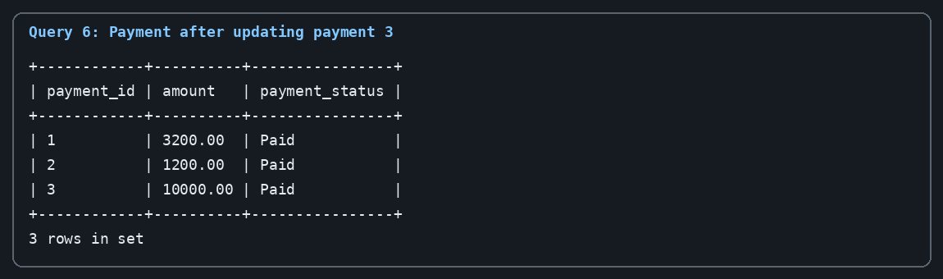

4.9 Optional DELETE query
-- This removes attendance record 3 if you choose to test DELETE.
DELETE FROM attendance
WHERE attendance_id = 3;
Note: Run this optional query only after reviewing the record. DELETE permanently removes the selected row unless a transaction is rolled back.

5. Conclusion
The Gym Membership Management System demonstrates how a relational database can organize a gym's member information, plans, trainers, payments, and attendance. SQL queries help retrieve connected records, identify pending payments, count members by plan, and calculate received revenue. The project covers essential DBMS concepts including primary keys, foreign keys, joins, aggregate functions, views, and data modification. It can be extended in the future with login roles, membership expiry alerts, monthly reports, and a graphical user interface.

How to run and prepare actual screenshots
- Install MySQL Server and MySQL Workbench if they are not already installed.
- Open the supplied gym_membership_management.sql file in Workbench.
- Execute the script from the first line. If rerunning, drop the database first or remove existing objects to avoid 'already exists' errors.
- Run each SELECT query separately and take screenshots of the actual result grid for final submission if your teacher requires live screenshots.
- Save the SQL file, report, and README together in one project folder.

GitHub upload
The project files are included in the accompanying ZIP package. To upload them, sign in to GitHub, create a new repository named gym-membership-management-system, choose Public or Private as instructed by your teacher, and upload the report, SQL file, and README.md. Add a short repository description such as 'DBMS mini project using MySQL'. This document/package has been prepared locally; it has not been uploaded to GitHub because no GitHub account authorization or repository link was provided.

