To Do:

Youtube computer science

Daily coding

Library book coding interview book

Apply

Tips: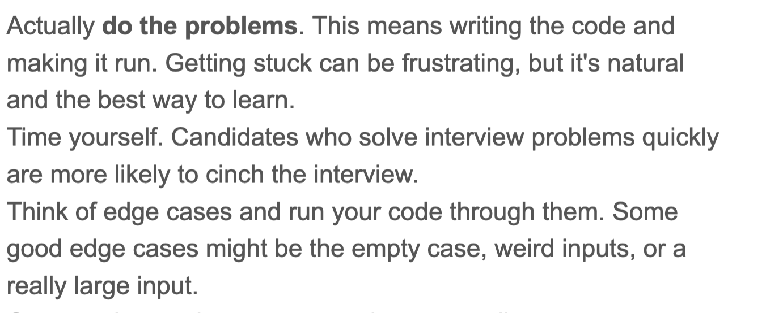

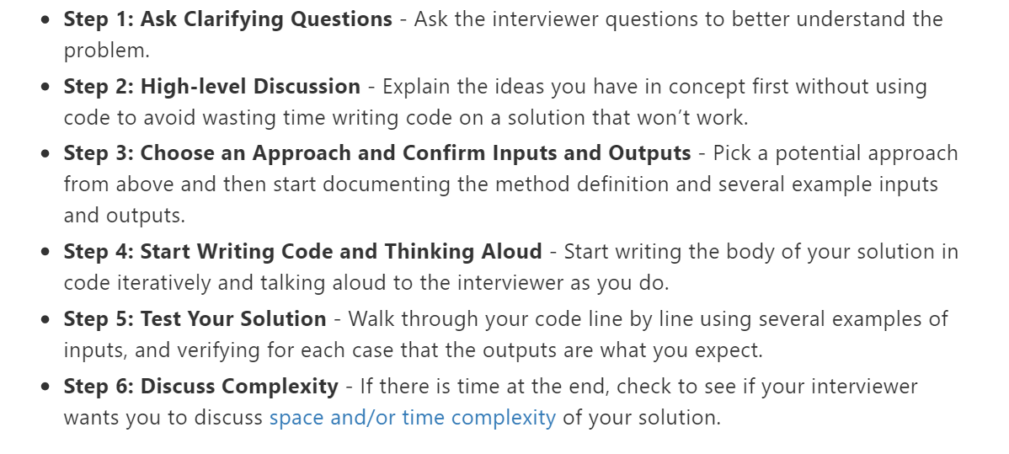

Check Glassdoor: Many companies have interview questions on Glassdoor.

Check out Mock Interviews or Pramp.

**Data Structures + CS Concepts to review:**

**Recourses:**

1. finish 2 sudo placement -
   1. <https://practice.geeksforgeeks.org/batch/Must%20Do-Interview%20Preparation>
   2. [**https://practice.geeksforgeeks.org/batch/Sudo%20Placement%202019/**](https://practice.geeksforgeeks.org/batch/Sudo%20Placement%202019/)

4. [**https://hackmd.io/@nesquena/HJ9YQDE2b?type=view**](https://hackmd.io/@nesquena/HJ9YQDE2b?type=view)

1. **Strings manipulation important,** KMP, Z-Algorithm, etc)
2. **Arrays + Vectors**
3. **Linked Listss**
4. **Double linked list**
5. HashMaps, HashSets,
6. Stac**ks + Queues (seem to be less frequently asked)**
7. Trees (specifically binary search trees and binary trees MST) but also probably rare
8. Graphs (Dijsktra and flows are rarely asked) topolgicla
9. **(sets, maps, unordered set/map, vector, sort) stl**
10. Sorting and searching **( mergesort or quicksort)** insertion-sort or radix-sort heapsort Bucket Sort, Selection sort
11. Binary Search BFS, DFS
12. Recursion backtracking
13. Dynamic Programming on trees as well medium level problems
14. Greedy Algorithms
15. Divide and Conquer
16. Priority Queues/Heaps (also seems rarer but I got asked a question about it)Problems with matricies/2d arrays or vectors (the question I got related to the priority queue also required that you were comfortable with doing something within in a 2d vector)
17. Bit Manipulation
18. Segment Tree
19. Tries,
20. 10. Math Concepts like Prime Seive - Not that much important
21. Bitmask DP - sometimes asked in interviews\
22. Binomial heap, finonacci heap, skip list, red-lack tree, tries, ternaray search, segment tree, splay tree

Reachit jain Data structures path:

<https://mail.google.com/mail/u/0/?tab=rm&ogbl#starred/FMfcgxwChmMxJlRBwjdftnZvnNJmHbbb>

1. Famous Interview Questions You Must Know ► [https://www.youtube.com/watch?v=u5-ss...](https://www.youtube.com/watch?v=u5-ss5kKy7g&list=PLfBJlB6T2eOshO8-LYaMt-Pes1IFojJ_l)
2. Coding Interview Prep Guide ► [https://www.youtube.com/playlist?list..](https://www.youtube.com/playlist?list=PLfBJlB6T2eOv8klCHHNVLOmTOIxKu-xzn)
3. Competitive Programming Talks with ICPC World finalists ► [https://www.youtube.com/playlist?list...](https://www.youtube.com/playlist?list=PLfBJlB6T2eOup9gVZLAMjEV50YPKcPXuO)
4. OOPS Interview Questions ► [https://www.youtube.com/watch?v=qsMah...](https://www.youtube.com/watch?v=qsMahidcehY&list=PLfBJlB6T2eOv0s4dZXm_uhOt5GmmfDs8-)
5. Gaurav Challenges Rachit ► [https://www.youtube.com/playlist?list...](https://www.youtube.com/playlist?list=PLfBJlB6T2eOvIEiSo43vr4vk7ASI4GkVS)
6. How to use Codeforces for Improving ► [https://www.youtube.com/watch?v=X-2OU...](https://www.youtube.com/watch?v=X-2OUqnUH6U&list=PLfBJlB6T2eOuDDm9xscqMZR3nnLP5FiyN)
7. Math Problems with Interesting Analysis ► [https://www.youtube.com/playlist?list...](https://www.youtube.com/playlist?list=PLfBJlB6T2eOthkt1Lkt839s8lcfcbQzJr)
8. Dynamic Programming: Zero to Hero ► [https://www.youtube.com/playlist?list...](https://www.youtube.com/playlist?list=PLfBJlB6T2eOtMXgK3FLUTawHjzpIEySHF)
9. Dynamic Programming on Trees ► [https://www.youtube.com/playlist?list...](https://www.youtube.com/playlist?list=PLfBJlB6T2eOsET4tlfcLs7oXR7kCyt1xc)
10. Graph Theory for Beginners ► [https://www.youtube.com/playlist?list...](https://www.youtube.com/playlist?list=PLfBJlB6T2eOu3dTPKzvAf2axlmQUXGY91)
11. SquareRoot Decomposition for Beginners ► [https://www.youtube.com/watch?v=bvZ0T...](https://www.youtube.com/watch?v=bvZ0TxZSGmk&list=PLfBJlB6T2eOvR8yXHkdju-jDpW2bD8Rlj)
12. Segment Trees ► [https://youtu.be/gNf5ZQsqr0w](https://www.youtube.com/watch?v=gNf5ZQsqr0w)
13. [https://www.youtube.com/watch?v=LK02Z...](https://www.youtube.com/watch?v=LK02ZPv9vdk)

After completing ds and algo:

1. Daily Coding Problem
2. <https://docs.google.com/spreadsheets/d/1x0RErIFtrZbZriM5AJ3ySkSp_sVK_2fnSSexFSXXFA4/edit#gid=0> tech road map another daily question
3. <https://techdevguide.withgoogle.com/> grow technical skills with google
4. <https://codeforces.com/problemset?order=BY_SOLVED_DESC> spreadsheet
5. <http://www.ardendertat.com/2012/01/09/programming-interview-questions/> questions
6. <https://www.geeksforgeeks.org/>
7. <https://mail.google.com/mail/u/0/#starred/FMfcgxwChcqWNLGldNpVwCkdWrWSSJvV> livestream data science linear algebra
8. <https://code.google.com/codejam/past-contests>
9. [**https://hackmd.io/s/HJN9k17sm**](https://hackmd.io/s/HJN9k17sm) <https://hackmd.io/s/rkg8GyDiQ> codepath interview preparation <https://hackmd.io/@nesquena/rkg8GyDiQ?type=view>
10. <https://www.codenewbie.org/basecs> practice questions
11. <https://codezen.codingninjas.in/practice/123652/4611/interview-shuriken-19:-maximum-subarray-sum> coding practice questions
12. <https://www.interviewcake.com/question/java/linked-list-cycles> intervia ccake all company questions

**Project:**

1. whatsapp clone -<https://www.freecodecamp.org/news/native-android-app-tutorial-whatsapp-clone/>
2. Website creation -<https://www.freecodecamp.org/news/html-and-css-course/>
3. <https://www.freecodecamp.org/news/python-connect-four-artificial-intelligence/> create connect 4
4. <https://www.codecademy.com/paths/web-development/tracks/learn-html-web-dev-path/modules/introduction-to-web-development/videos/introduction-to-web-development> website
5. Django -<https://www.youtube.com/watch?v=UyQn0BhVqNU&list=PLVAVnrCH1BlFuxZARkBbN8KXSjxPgl7Ml>
6. Data science -<https://handbook-for-cuny-hunter-cs-students.webnode.com/database-tutorial/>

2. Resume

Main page

Medium.com hacernoon.com dev.to airhub uber and facebook engineering blogs