Vision Transformers for Satellite Image Classification
Zero-shot, linear probe and fine-tuning, with a robustness study
[Your name] · [Course / programme] · October 2026
Abstract. I compare three ways of using pre-trained vision transformers on a four-class satellite land-cover dataset: zero-shot CLIP, linear probes on frozen CLIP and DINOv2 features, and a fine-tuned supervised ViT. All trained methods exceed 99.6% test accuracy, against 74.6% for zero-shot CLIP. Because accuracy is saturated, the informative results come from stress tests. The dataset confounds image resolution with class, and the CLIP probe’s accuracy falls by 12 points when that cue is removed; DINOv2 and the fine-tuned ViT are far less affected by resolution but remain sensitive to brightness and colour changes.

1. Introduction
Pre-trained vision transformers (ViTs) are now the default starting point for image classification (Dosovitskiy et al., 2021). They can be used without training (zero-shot, via language prompts in CLIP; Radford et al., 2021), through frozen features with a simple classifier (linear probe), or by updating all weights (fine-tuning). My research question is: how well do these three strategies classify satellite images, and do the predictions rely on scene content or on dataset shortcuts such as resolution and colour? Shortcut learning, where a model exploits a spurious cue that happens to predict the label, is a recognised source of misleading benchmark scores (Geirhos et al., 2020). The study covers classification, retrieval and embedding analysis, with every choice made on validation data and the test set used once per model.

2. Dataset and justification
The dataset contains 5,631 RGB images in four classes: cloudy (1,500), desert (1,131), green_area (1,500) and water (1,500). [Source and licence: add dataset link here.] I chose it because its labels are coarse and visually grounded, it is small enough for a single T4 GPU (which allowed three fine-tuning seeds and many perturbation experiments), and land-cover monitoring is a real application with societal stakes.
An audit before modelling revealed an artefact: cloudy and desert images are 256×256 pixels, whereas green_area and water images are 64×64. A rule that only looks at image size scores 53.3% (chance is 25%), and a logistic regression on three numbers (mean R, G, B) scores 82.4% on a separate random 70/30 split, so these serve as reference baselines. I also searched for leakage: 78 images belong to exact-duplicate sets (none with conflicting labels), and a 256-bit difference hash with Hamming distance ≤ 2 found 77 near-duplicate pairs (56 within a class, 21 across classes). Duplicates were linked into 5,574 groups, and groups were split 70/15/15, stratified by class (seed 42), giving 3,942 training, 846 validation and 843 test images (test: 225 cloudy, 170 desert, 225 green_area, 223 water).
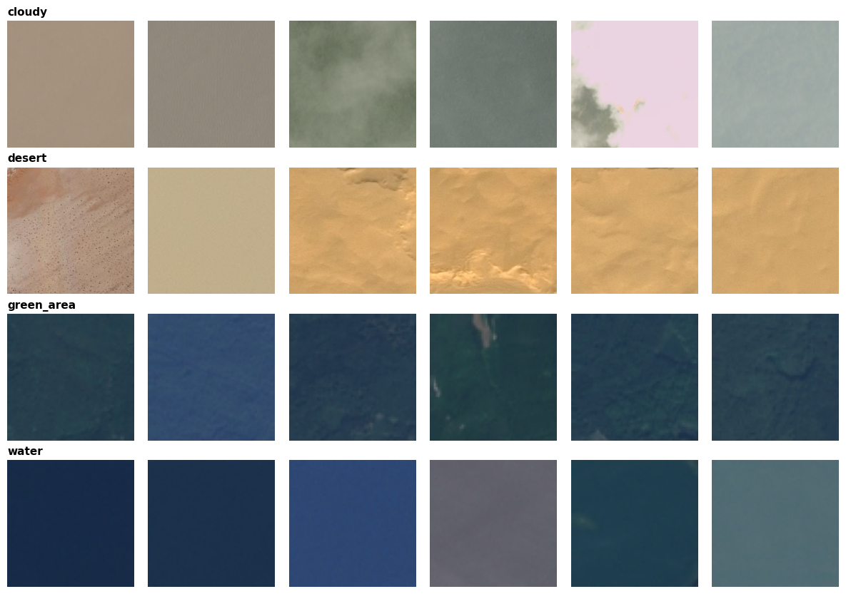
Figure 1. Random samples per class. Water and green_area images (64×64) are visibly blurrier and darker than cloudy and desert images (256×256).

3. Pre-processing
Each model uses its official processor. CLIP resizes to 224×224 and applies CLIP normalisation; DINOv2 resizes the short side to 256, centre-crops 224×224 and normalises; the ViT uses bicubic 224×224 resizing with its own mean and standard deviation. Consequently the 64×64 images are enlarged about 3.5× and look blurry, which is itself a cue that distinguishes them from the 256×256 classes. For fine-tuning, training images receive random horizontal and vertical flips and random 90° rotations (overhead imagery has no canonical orientation). I deliberately avoided colour jitter because colour is genuinely informative here. Validation and test images are only resized and normalised.

4. Models and configuration
Table 1. The four methods compared.
Method | Model | Configuration
Zero-shot | CLIP ViT-B/32 (openai/clip-vit-base-patch32) | No training. Image–text cosine similarity; prompt chosen on validation.
Linear probe | CLIP ViT-B/32 (512-d) and DINOv2-base (1,536-d: CLS + mean patch token) | Frozen encoders; standardisation + logistic regression; C ∈ {0.001,…,100} chosen on validation macro-F1 (C = 0.01 for both).
Fine-tuning | Supervised ViT-B/16 (google/vit-base-patch16-224, ≈86M parameters) | New 4-class head; all weights updated (Section 5).

For zero-shot classification I treated prompt wording as an experiment: five templates (e.g. “a satellite image taken from space showing {}”) crossed with plain class names or richer descriptions (e.g. “water such as sea, lake or river”), plus prompt ensembles. Validation macro-F1 ranged from 0.45 to 0.73, so wording alone moves macro-F1 by almost 30 points. The best combination (rich descriptions, “from space” template) was frozen before touching the test set. Models were loaded with Hugging Face Transformers (Wolf et al., 2020) and probes trained with scikit-learn (Pedregosa et al., 2011).

5. Fine-tuning process
All weights were updated with AdamW (Loshchilov and Hutter, 2019; weight decay 0.01), a 10% linear warm-up followed by linear decay, batch size 32, four epochs, fp16 mixed precision and gradient clipping at 1.0. I searched learning rates {1e-5, 2e-5, 5e-5} on validation with seed 42. All three reached the same best validation macro-F1 (0.9989), so the search could not discriminate and 1e-5 was kept; this is a limitation. The final model was then trained with three seeds (42–44), keeping in each run the epoch with the best validation macro-F1 (epochs 1, 2 and 2). Training loss fell from about 0.4 to 0.001 and validation accuracy exceeded 99.5% after the first epoch in every run, with no sign of overfitting. All five runs took 0.27 GPU-hours on a Tesla T4 (an energy upper bound of 0.019 kWh, GPU only).

6. Evaluation protocol
I report accuracy and macro-F1 (the classes are mildly imbalanced) with 95% bootstrap confidence intervals over the test set (1,000 resamples; 2,000 for paired comparisons). Models are compared on identical images with a paired bootstrap of the accuracy difference and McNemar’s exact test, Bonferroni-corrected for six comparisons. For robustness, the test images (never the training images) were altered and the trained models were not retrained: same_res shrinks 256×256 images to 64×64 (removing the resolution cue), plus greyscale, a +15% hue rotation, and brightness ×0.5 and ×1.5. Errors were split into cross-group (a 256×256 class predicted as a 64×64 class or vice versa, the pattern a resolution shortcut would cause) and within-group errors. Retrieval is scored with precision@K.

7. Results
Table 2. Test results (843 images). The two reference baselines come from Notebook 1 on different data and are shown for context only.
Method | Test accuracy (95% CI) | Macro-F1
Chance | 25.0% | –
Image-size-only rule (reference) | 53.3% | –
Mean-RGB logistic regression (reference) | 82.4% | –
Zero-shot CLIP ViT-B/32 | 74.6% (71.5–77.6) | 74.8%
Linear probe, CLIP ViT-B/32 | 99.88% (99.53–100.0) | 99.89%
Linear probe, DINOv2-base | 99.64% (99.17–100.0) | 99.67%
Fine-tuned ViT, mean ± SD of 3 seeds | 99.96% ± 0.07 | 99.96% ± 0.06
Fine-tuned ViT, seed 42 (best validation) | 99.88% (99.64–100.0) | 99.89%
Fine-tuned ViT, 3-seed ensemble | 100.0% | 100.0%

Zero-shot CLIP scores 74.6%, below the colour-only baseline. Its errors are systematic: desert recall is 99.4% but precision only 69.5%, while green_area has 96.5% precision but 60.9% recall, so CLIP over-predicts “desert” and under-predicts “green area”. Every method with supervision is far above the colour-only baseline, so these models use more than average colour. Among the three trained approaches I found no clear difference: the CLIP and DINOv2 probes differ by +0.24 points (95% CI −0.24 to +0.71; McNemar p = 1.0 after correction), and the fine-tuned ViT differs from either by at most two images. Only the comparisons with zero-shot CLIP are significant (about 25 points, p < 10⁻⁶⁰). With 0–3 errors in 843 images the test set is saturated and cannot rank the trained models, and fine-tuning brought no measurable benefit over linear probes. Label efficiency is high: with only 78 training images (2%), validation accuracy is already 95.2% (CLIP) and 97.7% (DINOv2), and with 197 images 99.3% and 99.0%.
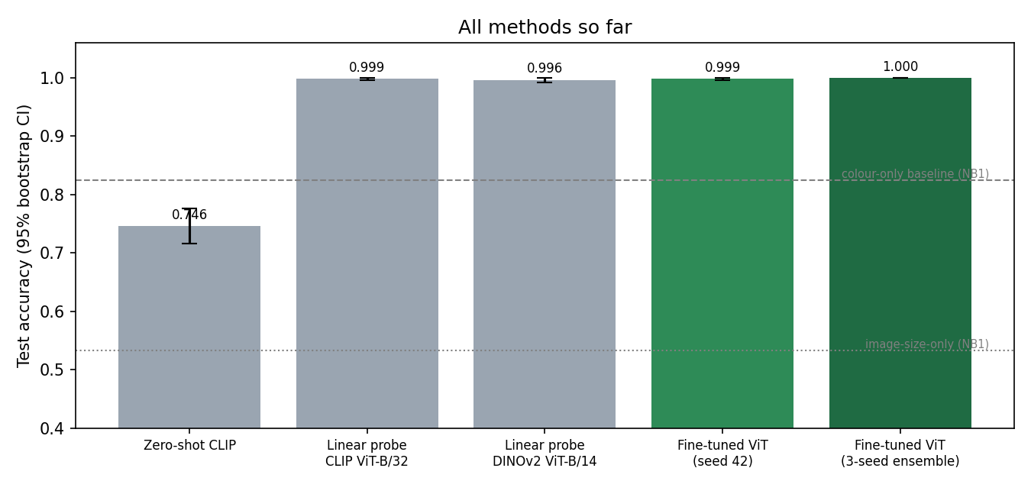
Figure 2. Test accuracy of all methods with 95% bootstrap confidence intervals.

8. Robustness and analysis of performance
Table 3. Test accuracy under perturbations. Every change is significant (paired 95% CI excludes zero) except zero-shot with same resolution and the DINOv2 probe when darkened.
Accuracy (%) | Original | Same res. | Greyscale | Hue shift | Darker | Brighter
Zero-shot CLIP | 74.6 | 73.5 | 55.5 | 40.5 | 65.2 | 61.8
CLIP probe | 99.9 | 87.8 | 77.0 | 88.6 | 90.6 | 89.3
DINOv2 probe | 99.6 | 98.5 | 88.5 | 98.3 | 99.4 | 99.1
Fine-tuned ViT (seed 42) | 99.9 | 98.2 | 89.9 | 98.2 | 75.8 | 87.9

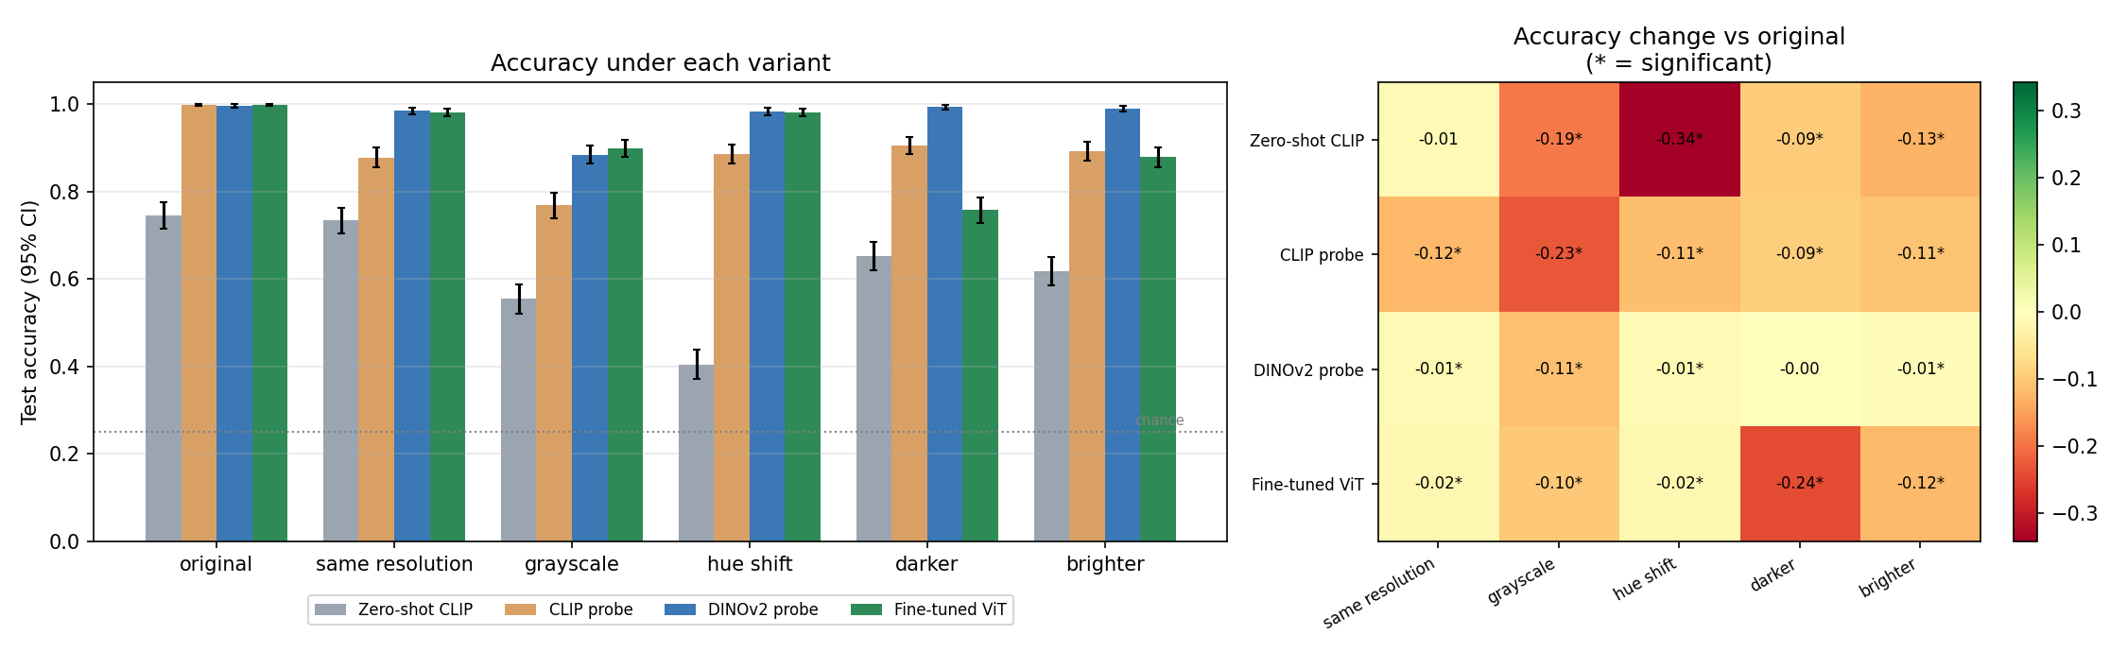
Figure 3. Accuracy under each perturbation (left) and change relative to the original images (right; * = significant).
Resolution. The CLIP probe loses 12.1 points under same_res (99.9% to 87.8%; CI of the change −14.5 to −9.8) and its cross-group error rises from 0% to 12.0% of all test images. Desert recall falls to 52% (89 of 170), with 44 desert images labelled green_area and 36 water (Figure 4). DINOv2 (−1.2) and the fine-tuned ViT (−1.7) barely change, and zero-shot CLIP is unaffected (−1.1, not significant). This is consistent with the CLIP probe partly using resolution or sharpness, while the other models rely mostly on content. It is evidence, not proof: shrinking is itself a perturbation, and the resulting blur differs from native 64×64 imagery.
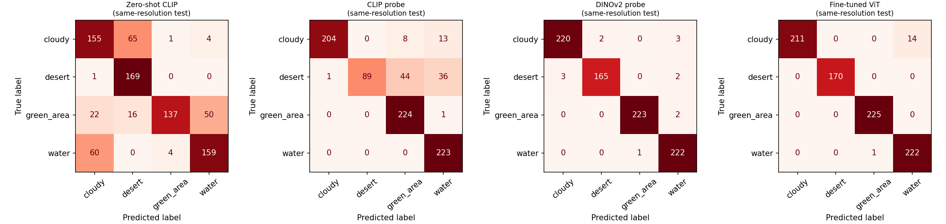
Figure 4. Confusion matrices when all images are 64×64. Only the CLIP probe collapses (desert predicted as green_area or water).
Colour. Greyscale reduces accuracy for every model: −19.1 (zero-shot), −22.9 (CLIP probe), −11.2 (DINOv2 probe) and −10.0 points (ViT). A hue shift hurts zero-shot CLIP most (−34.2 points; cross-group error 53.5%) and the CLIP probe moderately (−11.3), but barely affects DINOv2 (−1.3) and the ViT (−1.7). Illumination. Darkening costs the fine-tuned ViT 24.1 points (75.8%), with a cross-group error of 19.3%, the largest drop of any trained model, whereas the DINOv2 probe loses only 0.2 points (not significant). A plausible but untested explanation is that fine-tuning without brightness augmentation specialised the network to the training intensity range. Ranking by worst case reverses the ranking by headline accuracy: the worst-variant accuracy is 88.5% for the DINOv2 probe, 77.0% for the CLIP probe, 75.8% for the ViT and 40.5% for zero-shot CLIP.

9. Retrieval and embedding structure
In image-to-image retrieval (test queries, training gallery, cosine similarity) CLIP reaches precision@1 of 99.2% and precision@10 of 98.4%, and DINOv2 99.5% and 98.3% (chance ≈ 25%); water is the hardest class (precision@10 94.8% and 95.5%). In CLIP text-to-image retrieval, queries for clouds, desert and forest or farmland return only correct images in the top ten, but water queries fail: precision@10 is 0.0 for the class prompt and for “a satellite image of a lake”, and 0.1 for “the sea”. The top results for “lake” are dark green_area images (Figure 5), mirroring zero-shot CLIP’s weakness on blurry 64×64 scenes. A UMAP projection (Figure 6) shows four clean clusters for DINOv2, whereas in CLIP water and green_area overlap; in both models clusters align with native image size, which is the confound.
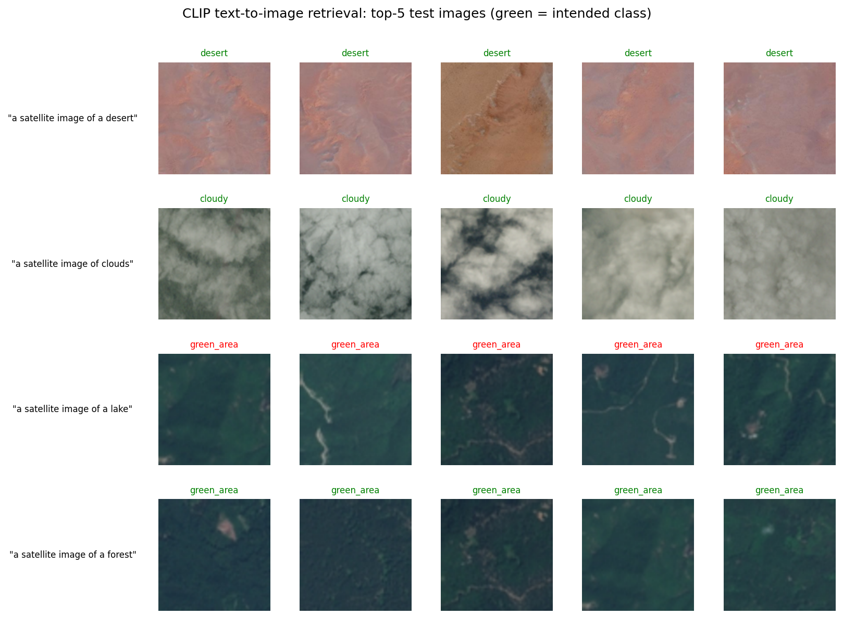
Figure 5. CLIP text-to-image retrieval: top-5 test images per query (green title = intended class). The “lake” query retrieves forest.
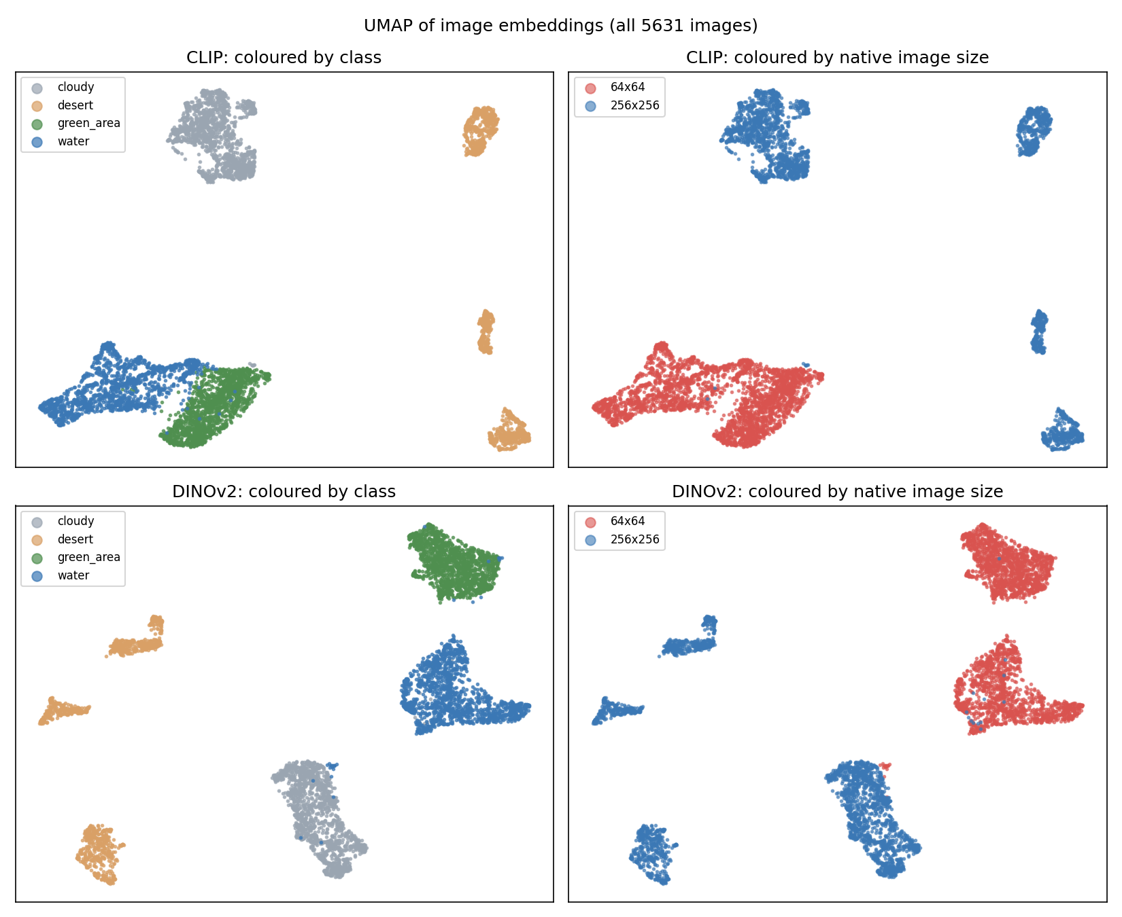
Figure 6. UMAP of CLIP and DINOv2 embeddings coloured by class (left) and native image size (right).

10. Potential biases and dataset artefacts
- Resolution–class confound. Size separates the two pairs of classes perfectly, so a model can halve the problem without looking at land. I can test for this (Section 8) but cannot remove it without new data with matched resolution.
- Colour dependence. Colour is a legitimate cue for these classes, but the 10–34 point drops under greyscale and hue shift mean accuracy will not transfer automatically to other sensors, seasons or atmospheric conditions.
- Coarse, heterogeneous labels. “green_area” merges forest and farmland and “water” merges sea, lake and river; prompts and embeddings treat these concepts differently, as the failed water queries show.
- Unknown coverage. The geographic, seasonal and sensor distribution is not documented, so I could not measure performance by region. The only subgroups available (class and native resolution) are confounded with each other.
- Saturated test set. With 843 images and almost no errors, small differences between trained models are undetectable.

11. Ethical and societal implications
Misplaced confidence. A headline accuracy above 99% is misleading. The same models lose 10–24 points under modest changes in brightness or colour. Land-cover classifiers inform decisions such as crop monitoring, flood response, aid allocation and verification of land-use claims; silent failure on a new sensor, season or region could misdirect resources or unfairly penalise communities. Results should therefore be reported with robustness tests, validated on local data before deployment, and combined with human review for consequential decisions.
Dual use and privacy. The same pipeline that maps vegetation can support surveillance of property, settlements or military sites. This four-class, low-resolution model carries little risk of identifying individuals, but the methods transfer directly to higher-resolution imagery, where privacy and misuse concerns grow.
Representation and inherited bias. Remote-sensing datasets often under-represent some regions, and an undocumented source means I cannot claim fair coverage. The pre-trained models also inherit the biases of their web-scale or ImageNet-style training data; I did not test their effect on satellite imagery.
Environmental cost and transparency. Fine-tuning used about 0.27 GPU-hours (≤ 0.019 kWh, GPU only; pre-training and embedding extraction excluded). Since linear probes matched fine-tuning and DINOv2 was the most robust, the cheaper option was also the better choice here. All code, splits and results are released for reproducibility. [AI-assistance statement: add according to your institution’s policy.]

12. Limitations and conclusion
Limitations: a single dataset and split; one seed for the probes; a small learning-rate grid with tied results; synthetic perturbations that show sensitivity but not its cause; and no manual error categorisation, since the trained models make at most three test errors. I also did not test whether brightness augmentation would repair the ViT’s fragility.
Conclusion. Zero-shot CLIP is far weaker than a colour-only baseline, whereas frozen CLIP or DINOv2 features and a fine-tuned ViT all exceed 99.6% and are statistically indistinguishable on this test set. Robustness, not accuracy, separates them: the DINOv2 probe gave the best combination of accuracy, stability and cost. Future work should use matched-resolution data from several regions and train with perturbations.

References
Dosovitskiy, A. et al. (2021) An image is worth 16×16 words: Transformers for image recognition at scale. ICLR.
Geirhos, R. et al. (2020) Shortcut learning in deep neural networks. Nature Machine Intelligence, 2, 665–673.
Loshchilov, I. and Hutter, F. (2019) Decoupled weight decay regularization. ICLR.
McInnes, L., Healy, J. and Melville, J. (2018) UMAP: Uniform manifold approximation and projection for dimension reduction. arXiv:1802.03426.
McNemar, Q. (1947) Note on the sampling error of the difference between correlated proportions or percentages. Psychometrika, 12, 153–157.
Oquab, M. et al. (2024) DINOv2: Learning robust visual features without supervision. Transactions on Machine Learning Research.
Pedregosa, F. et al. (2011) Scikit-learn: Machine learning in Python. JMLR, 12, 2825–2830.
Radford, A. et al. (2021) Learning transferable visual models from natural language supervision. ICML.
Wolf, T. et al. (2020) Transformers: State-of-the-art natural language processing. EMNLP: System Demonstrations.

