ONE PAGE WRITEUP
HOW MOBILE TRASMITS
Mobile phones work by converting your voice into digital bits, sending them as electromagnetic waves to nearby towers, routing them through wired optical-fiber networks and switching centers, then reversing the process at your friend’s phone. Different generations (1G–5G) mainly differ in how efficiently they use radio spectrum and how much data speed and services they support.
Inside your phone
- When you speak, the microphone uses a MEMS sensor and IC to convert sound into a digital signal (zeros and ones).
- The phone’s antenna sends these bits as electromagnetic waves by changing characteristics like amplitude, frequency, or phase (modulation).
- For example, in frequency-based modulation, 0 and 1 can be represented by low and high frequencies.
Role of cell towers and fibers
- Electromagnetic waves cannot travel very far because of obstacles, interference, and Earth’s curvature, so cell towers are used.
- The coverage area is divided into hexagonal cells, each with a tower and its own frequency slot.
- Towers are interconnected using underground or undersea optical fiber cables that carry signals as high-frequency light pulses to base transceiver stations for processing.
How calls are routed (MSC)
- When your phone sends a signal, the local tower forwards it through fibers to a mobile switching center (MSC), which is the central controller for a group of towers.
- When you buy a SIM, your details (plan, location, activity status) are stored in a “home MSC”; if you move, another “foreign MSC” serves you but keeps syncing with the home MSC.
- The MSC tracks your approximate location by periodic updates, when you cross a set number of towers, and when you power on the phone.
Example: Emma calls John
- Emma dials John → request goes to Emma’s home MSC → then to John’s home MSC.
- John’s home MSC checks his current MSC and cell.
  - If he is in his home MSC and available (not busy, not switched off), the request goes to his current cell tower and his phone rings.
  - If he is in a foreign MSC, John’s home MSC forwards the request there; that MSC locates his cell and sets up the call.
Frequency spectrum and sharing
- Each subscriber needs a frequency range to send digital bits, but cellular spectrum is limited while users are in the billions.
- This is handled using:
  - Frequency slot distribution: different frequency blocks are assigned to different cell towers.
  - Multiple access techniques: efficiently share a tower’s frequency slot among all active users (e.g., dividing by time, code, or subcarriers).

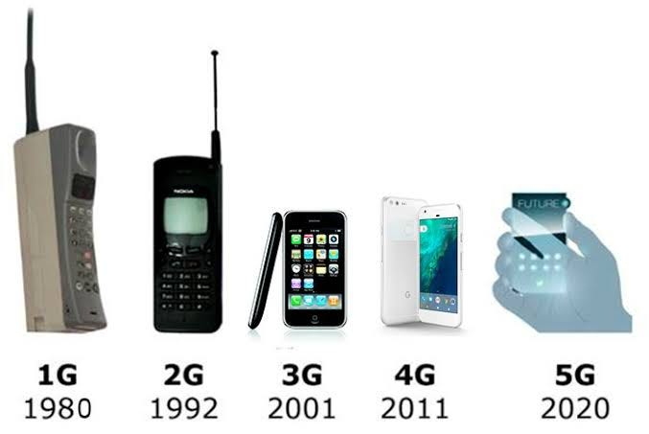
Generations of mobile networks (1G–5G)
- 1G:
  - First truly mobile, cable-free phones using analog wireless transmission.
  - Poor voice quality and security; used FDMA (frequency division multiple access) which wasted spectrum.
- 2G:
  - Switched to digital multiple access (TDMA or CDMA), improving quality and security.
  - Introduced SMS and basic internet browsing as new data services.
- 3G:
  - Focus on higher data speed using WCDMA with more bandwidth.
  - Typical speeds around 2 Mbps, enabling GPS, video, and richer smartphone features.
- 4G:
  - Speeds roughly 20–100 Mbps, good for HD movies and TV streaming.
  - Uses OFDM-based multiple access and MIMO (multiple transmit–receive antennas in phone and tower) to boost capacity and speed.
- 5G:
  - Uses enhanced MIMO and millimeter waves to provide very high data rates and low latency.
  - Targets seamless connectivity for Internet of Things applications like driverless cars and smart homes.

