PROJECT REPORT
On
ESP32 Based 4-DOF Robotic Arm with Adaptive Gripper System
Submitted in partial fulfillment of the requirements for
Project-Based Learning (PBL) — Semester II (2024-25)
Submitted by
Name | USN
Moksh Gowda S | 1CR25EC133
Muskan | 1CR25EC134
Letesh | 1CR25CS153
S Mohammad Nasir Hussain | 1CR25CS154

Under the Guidance of
Dr. K Shanu
Department of ECE & CS, CMR Institute of Technology, Bengaluru
Affiliated to Visvesvaraya Technological University, Belagavi
Academic Year: 2024-25

INDEX
Chapter Page

Chapter 1: Introduction 3
Chapter 2: Problem Statement 5
Chapter 3: Objectives 6
Chapter 4: System Overview 7
Chapter 5: Hardware Components 8
Chapter 6: Software Components 11
Chapter 7: Working Principle 13
Chapter 8: Innovation and Experimental Design 15
Chapter 9: Challenges and Solutions 17
Chapter 10: Results and Discussion 18
Chapter 11: Advantages and Applications 19
Chapter 12: Limitations 20
Chapter 13: Future Scope 21
Chapter 14: Source Code 22
Chapter 15: Conclusion 27
References 28
Acknowledgements 29

Chapter 1: Introduction
Robotic manipulators are increasingly used across industries for automation, precision handling, and repetitive tasks. However, most industrial robotic arms are expensive, complex, and inaccessible for academic experimentation. This project presents a low-cost, 4-DOF robotic arm built using 3D-printed PLA components, servo motors, and an ESP32 microcontroller — designed as a fully functional prototype suitable for educational and small-scale automation purposes.
The arm is controlled in real time using dual analog joystick modules, allowing intuitive manual operation. The system is powered by a 12V DC adapter regulated to 5V via a buck converter, with a capacitor filter ensuring stable servo operation.
The robotic arm structure is based on open-source 3D printable reference models and was integrated, assembled, calibrated, and controlled using our own electronics and firmware implementation.

1.1 Motivation
The need for affordable and educational robotic systems in engineering colleges is significant. Commercial robotic arms are costly and proprietary, making hands-on learning difficult. This project was designed to bridge that gap by using widely available, low-cost components and open-source 3D printable parts.

1.2 Scope of the Project
- Design and assemble a 4-DOF robotic arm using 3D printed PLA components
- Implement real-time dual joystick control using ESP32
- Design a power system using a 12V adapter and XL4015 buck converter
- Integrate a servo-driven adaptive gripper mechanism
- Document the design evolution including the experimental soft gripper attempt

Chapter 2: Problem Statement

2.1 Description of the Problem
Industrial robotic arms are prohibitively expensive for academic and small-scale use. Existing educational kits often lack real-world relevance, while professional systems are inaccessible without significant investment. There is a clear need for a low-cost, functional robotic manipulator that can be built, programmed, and operated by first-year engineering students.

2.2 Need for the System
A cost-effective robotic arm that demonstrates real degrees of freedom, real-time joystick control, and a functional gripper would serve as an effective learning platform. Such a system should use commonly available electronics and be reproducible by student teams with limited resources.

Chapter 3: Objectives
- To design and assemble a 4-DOF robotic arm using 3D printed PLA components
- To implement real-time joystick-based servo control using ESP32 WROOM-32
- To develop a stable power distribution system using a buck converter
- To design and integrate an adaptive gripper mechanism
- To explore and document the experimental bio-inspired continuum gripper concept
- To demonstrate pick-and-place functionality during evaluation

Chapter 4: System Overview
The system consists of four main subsystems: the mechanical arm structure, the electronics and power system, the control interface, and the gripper mechanism.
The ESP32 WROOM-32 serves as the central microcontroller. It reads analog values from two KY-023 joystick modules and generates PWM signals to control five servo motors — four MG996R servos for the arm joints and one MG90S servo for the gripper. Power is supplied from a 12V 5A DC adapter, stepped down to 5V by an XL4015 buck converter, with a 2200uF capacitor across the servo power rail for voltage stabilisation.

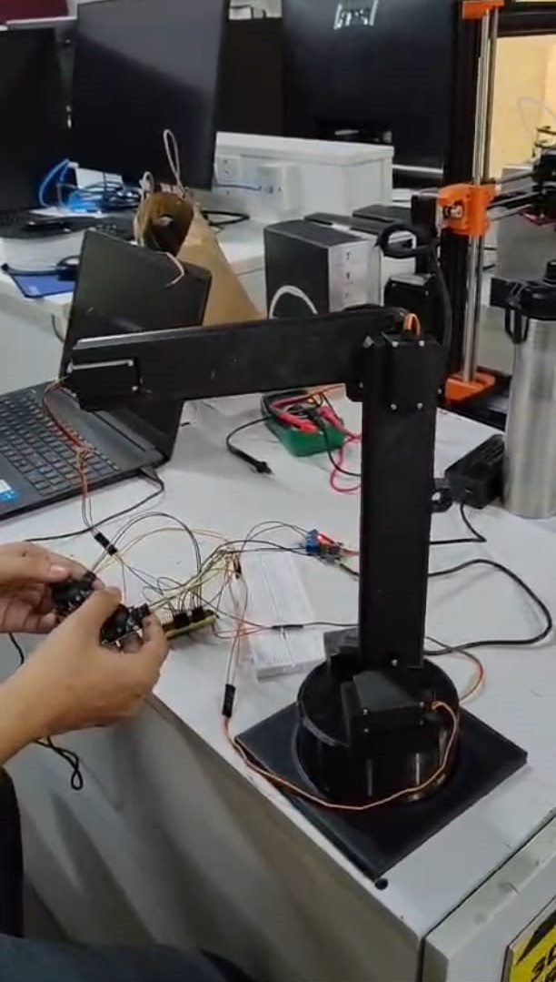
Fig. 1: Fully Assembled Robotic Arm Prototype

Chapter 5: Hardware Components

5.1 ESP32 WROOM-32
The ESP32 is a dual-core 32-bit microcontroller with integrated Wi-Fi and Bluetooth. It operates at 3.3V logic and provides multiple ADC-capable GPIO pins suitable for reading analog joystick values. The ESP32Servo library enables precise PWM control of up to 16 servos simultaneously.
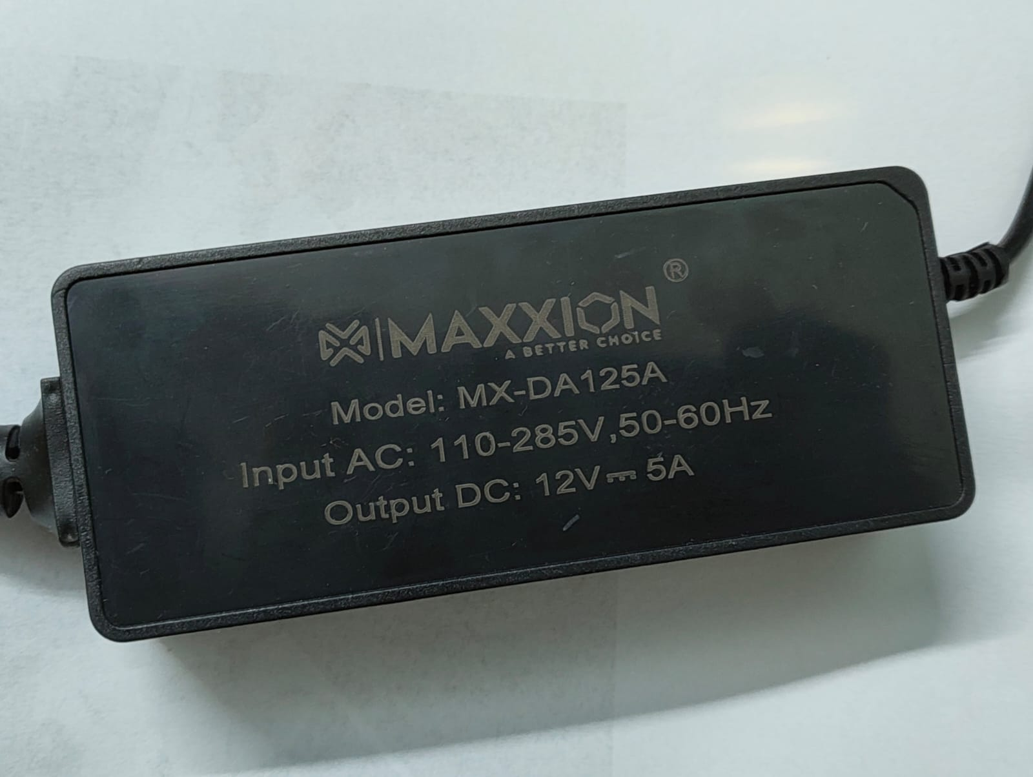
Fig. 2: ESP32 WROOM-32 Development Board

5.2 MG996R Servo Motor (x4)
The MG996R is a metal-gear servo motor with a stall torque of approximately 9.4 kg-cm at 4.8V and 11 kg-cm at 6V. Four MG996R servos are used for the base rotation, shoulder, elbow, and wrist joints. PWM range: 500–2400 microseconds.

5.3 MG90S Servo Motor (x1)
The MG90S is a miniature metal-gear servo used to actuate the gripper mechanism. It provides approximately 1.8 kg-cm torque, sufficient for opening and closing the gripper. GPIO 18 is used for its signal.

5.4 KY-023 Joystick Modules (x2)
Each KY-023 joystick module provides two analog axes (X and Y) and one digital push-button output. The analog outputs are read using the ESP32's 12-bit ADC, providing values from 0 to 4095. Joystick 1 controls base and shoulder. Joystick 2 controls elbow and wrist. The push buttons trigger homing and gripper toggle respectively.
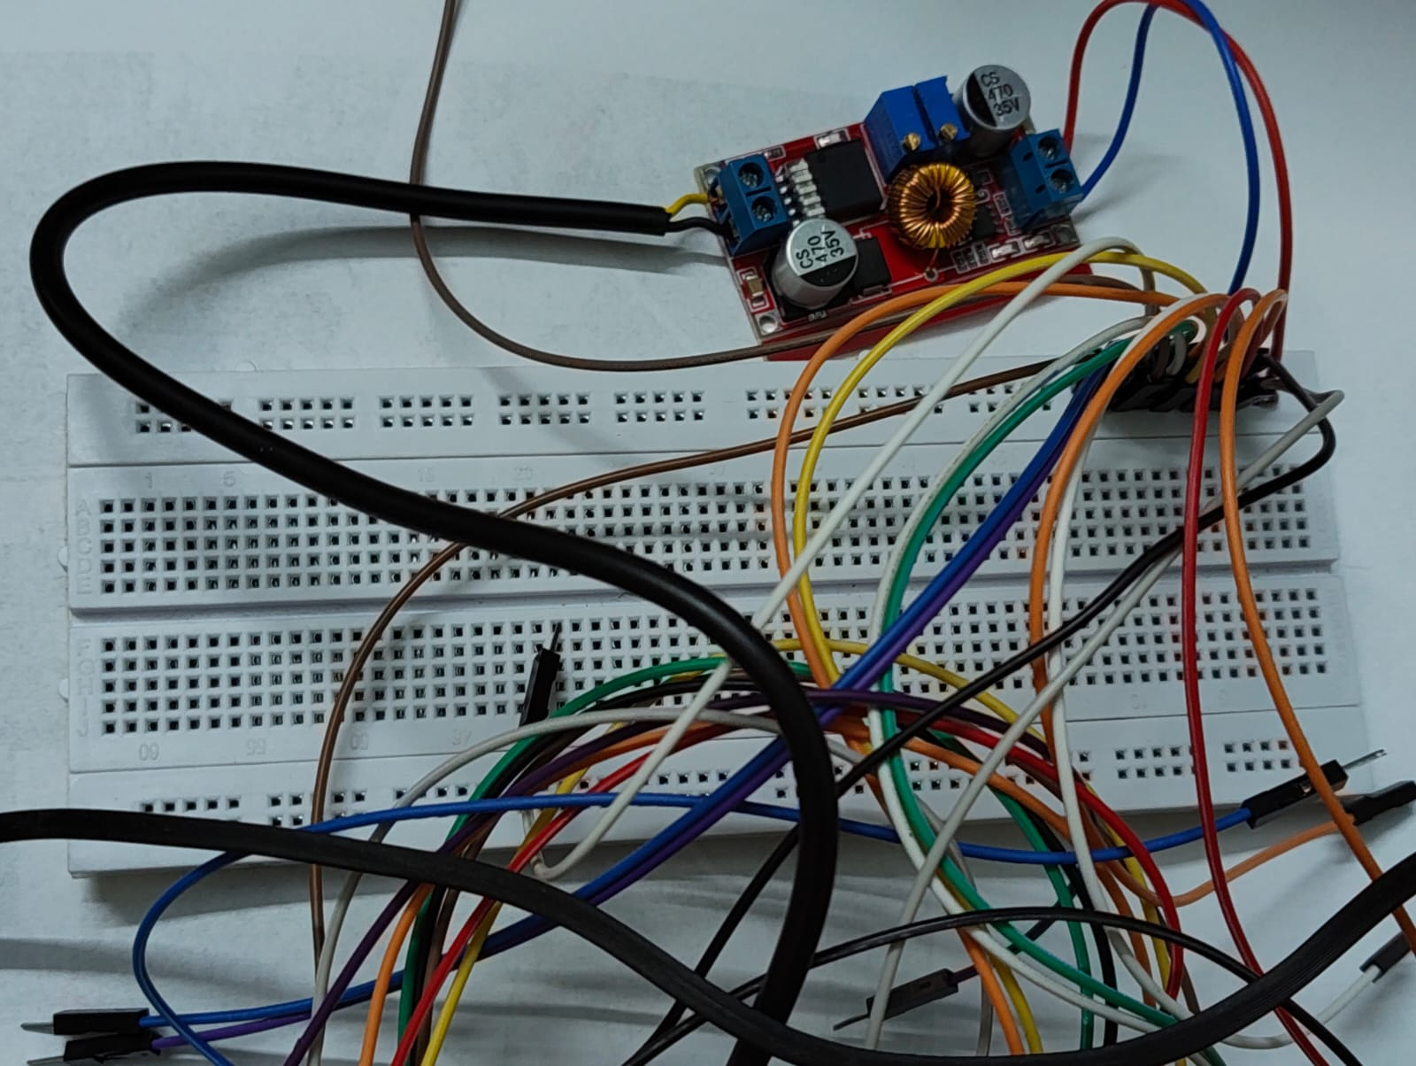
Fig. 3: KY-023 Joystick Module with Wiring

5.5 12V 5A DC Power Adapter
A Maxxion MX-DA125A 12V 5A adapter provides the primary power supply. The 12V input is regulated down to 5V using the XL4015 buck converter to safely power the servo motors.
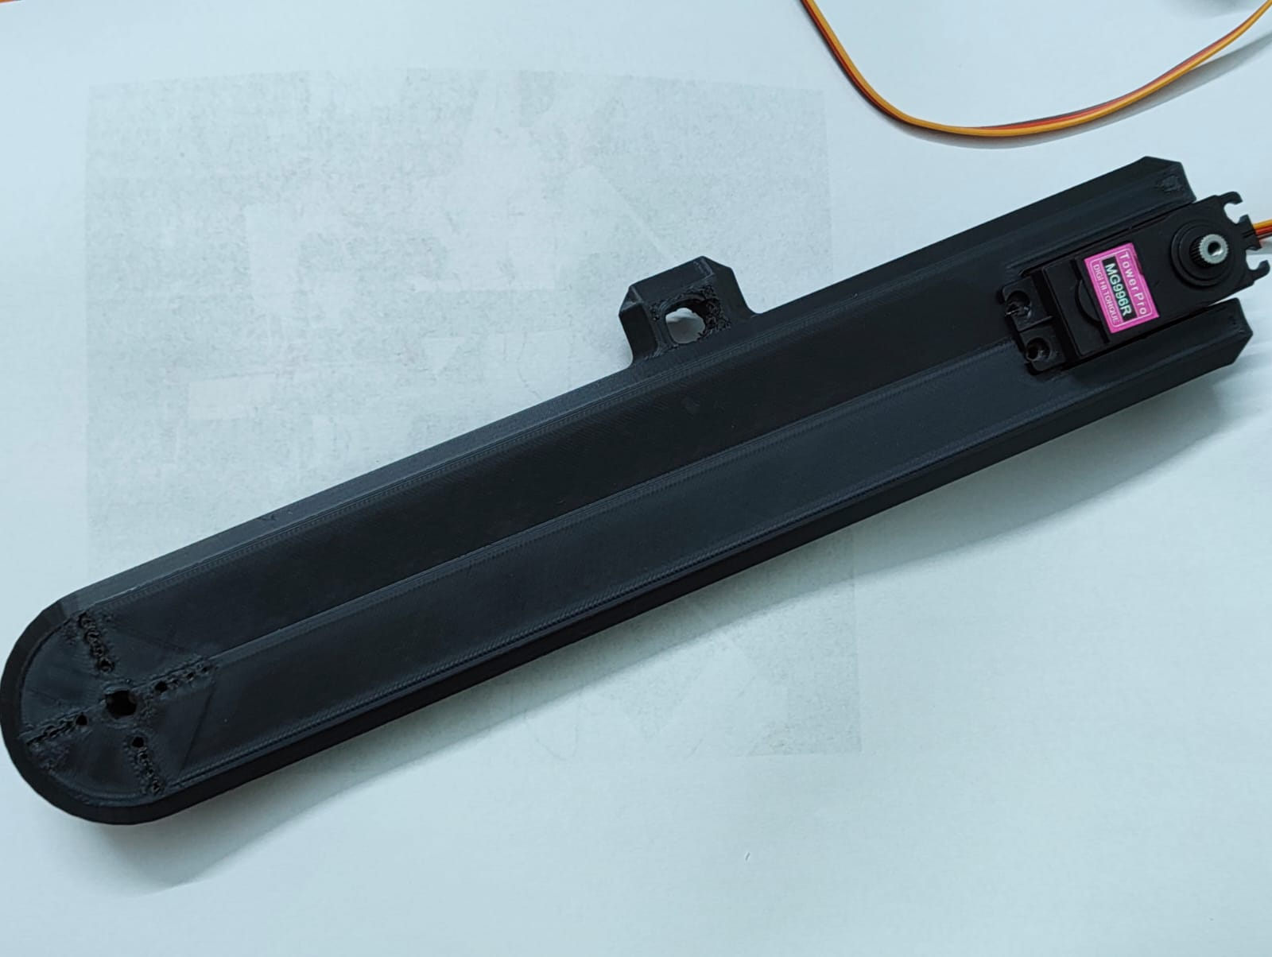
Fig. 4: 12V 5A DC Power Adapter

5.6 XL4015 Buck Converter
The XL4015 is a step-down DC-DC converter capable of handling up to 5A output current. It was adjusted using its onboard potentiometer to output a stable 5.0V, verified using a digital multimeter before connecting servos.
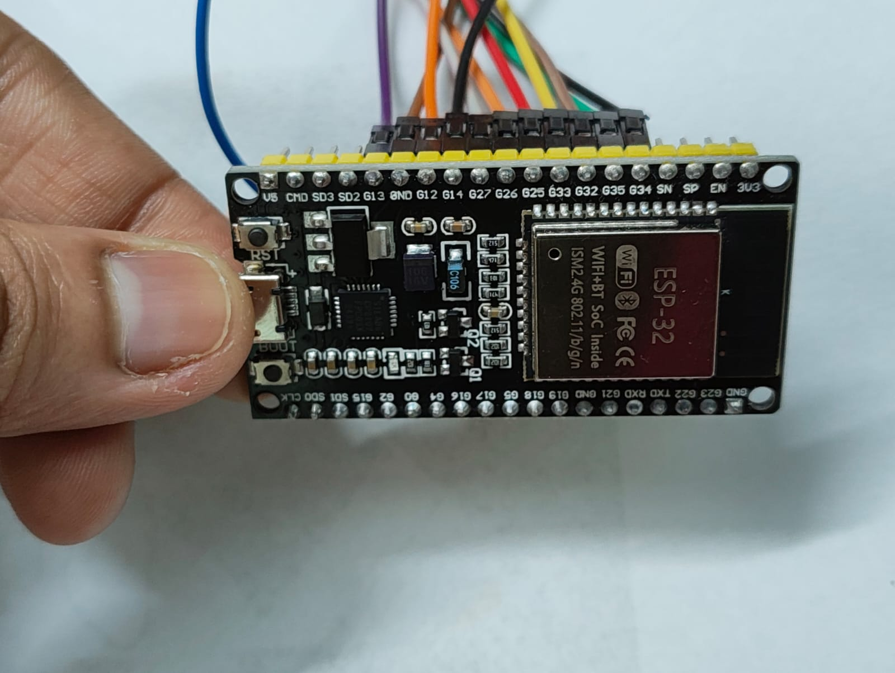
Fig. 5: Buck Converter and Breadboard Power Distribution

5.7 2200uF 25V Electrolytic Capacitor
Placed across the servo power rail (OUT+ to GND), this capacitor filters voltage spikes caused by servo stall current draw, preventing brownouts and ESP32 resets.

5.8 3D Printed PLA Arm Structure
The arm structure was 3D printed in PLA Black at 20-40% infill depending on the structural requirements of each part. The STL files were sourced from thingiverse.com/thing:4795639. Parts include: Base, Shoulder Bottom, Shoulder Top, Upper Arm, Forearm, Wrist, and Brace.

Chapter 6: Software Components
- Arduino IDE 2.x — firmware development environment
- ESP32Servo Library by Kevin Harrington — PWM servo control
- Arduino ESP32 Board Package — ESP32 hardware abstraction
- Serial Monitor — debugging and angle verification

6.1 GPIO Pin Mapping
Component | GPIO Pin
Base Servo (MG996R) | GPIO 13
Shoulder Servo (MG996R) | GPIO 12
Elbow Servo (MG996R) | GPIO 14
Wrist Servo (MG996R) | GPIO 27
Gripper Servo (MG90S) | GPIO 18
Joy1 X-axis (Base) | GPIO 34
Joy1 Y-axis (Shoulder) | GPIO 35
Joy1 Button (Home) | GPIO 25
Joy2 X-axis (Elbow) | GPIO 32
Joy2 Y-axis (Wrist) | GPIO 33
Joy2 Button (Gripper) | GPIO 26

Chapter 7: Working Principle
The ESP32 continuously reads analog values from both joystick modules using its 12-bit ADC. The center position of each joystick axis returns approximately 2048. A deadzone of ±500 counts prevents unintended movement from joystick drift. When the joystick is pushed beyond the deadzone, the corresponding servo position variable is incremented or decremented by a step value, then written to the servo.

7.1 Joystick to Servo Mapping
Joystick | Axis | Direction | Servo
Joy1 | X | Left/Right | Base
Joy1 | Y | Up/Down | Shoulder
Joy2 | X | Left/Right | Elbow
Joy2 | Y | Up/Down | Wrist
Joy1 Button | Click | Press | Return to Home
Joy2 Button | Click | Press | Gripper Toggle

7.2 Homing Function
Pressing Joystick 1 button triggers the goHome() function, which slowly returns each joint to 90 degrees in sequence: wrist first, then elbow, then shoulder, then base. Each servo moves at a controlled rate with 15ms delay per step to avoid mechanical stress.

7.3 Gripper Toggle
Pressing Joystick 2 button toggles the gripper between open (40 degrees) and closed (120 degrees). Edge detection on the button prevents multiple triggers from a single press.

Chapter 8: Innovation and Experimental Design
A key element of this project was the attempt to implement a bio-inspired continuum gripper modelled after an octopus tentacle. This concept, rooted in soft robotics research, involves flexible TPU 95A fingers made of stacked vertebrae-disc segments, each curled inward by a nylon tendon pulled by a single servo motor.

8.1 Original Concept: Octopus-Inspired Continuum Gripper
- Three flexible fingers arranged at 120-degree spacing
- Each finger constructed from approximately 24 TPU 95A vertebrae segments
- A nylon tendon runs through the centre of each finger
- One MG90S servo pulls all three tendons simultaneously to curl the fingers inward
- Inspired by soft robotics and continuum mechanics principles

The TPU segments were successfully printed on the college CreatBot F430 printer at 25% infill, 0.2mm layer height, 15-20mm/s speed, and 225 degrees Celsius nozzle temperature. The printed fingers demonstrated the required flexibility and curling behaviour under manual testing.

8.2 Challenges Encountered
- Tendon routing holes in TPU segments were extremely tight, making it difficult to thread the nylon line through all 24 segments consistently
- TPU flexibility, while desirable for curling, made the segments prone to tearing at the tendon hole under repeated actuation
- Coordinating three independent tendons to curl simultaneously with a single servo required precise mechanical balancing
- Time constraints during the project period did not allow sufficient iteration cycles to resolve these issues before the submission deadline

8.3 Engineering Decision: Practical Redesign
Based on the above challenges, the team made an informed engineering decision to transition to a simpler servo-actuated rigid gripper for the final submission. This decision reflects iterative engineering design practice — testing a concept, identifying its limitations, and optimising for reliability within the given constraints.
The experimental continuum gripper work and the knowledge gained from it represents genuine innovation and learning, even though the final implementation uses a more conventional approach. Future development of this project would revisit the continuum gripper with improved tendon routing and a dedicated servo per finger.

Chapter 9: Challenges and Solutions
Challenge | Solution
Servo brownout under load | 2200uF capacitor across servo rail; external 12V adapter via buck converter
Joystick drift causing unintended movement | Implemented 500-count deadzone around joystick centre value
Servo gear stress during homing | Slow sequential homing with 15ms delay per step
Buck converter voltage setting | Verified output with digital multimeter before connecting servos
TPU tendon routing difficulty | Used needle to chase tendon holes; redesigned to rigid gripper
Servo alignment in 3D printed housing | Measured servo dimensions physically before printing; used M3 screws
Wiring management | Breadboard power distribution with colour-coded jumper wires

Chapter 10: Results and Discussion
The assembled robotic arm successfully demonstrated 4-DOF real-time joystick control. The base, shoulder, elbow, and wrist joints responded smoothly to joystick input with no jitter, verified through direct observation and Serial Monitor output during development.
- Base rotation: 0 to 180 degrees, full range
- Shoulder movement: 40 to 140 degrees, constrained for safety
- Elbow movement: 78 to 102 degrees, limited to protect servo gears
- Wrist movement: 20 to 160 degrees, full practical range
- Gripper: toggles between 40 degrees (open) and 120 degrees (closed) on button press
- Homing function: returns all joints to 90 degrees in sequence, smoothly

Power measurements confirmed stable 4.99V on the servo rail under full load of all five servos. No brownouts or ESP32 resets were observed during testing. The 2200uF capacitor effectively smoothed voltage spikes during servo direction changes.

Chapter 11: Advantages and Applications

11.1 Advantages
- Low cost — total component cost under Rs. 4000
- Fully 3D printable structure using open-source STL files
- Real-time intuitive dual joystick control
- Standalone operation — no laptop or internet required during demo
- Modular design allows easy component replacement
- Educational platform for servo control, PWM, and robotics

11.2 Applications
- Educational demonstrations of robotic kinematics
- Pick and place tasks in small-scale automation
- Remote manipulation in hazardous environments (scaled up)
- Research platform for gripper design and control algorithms
- Competition robotics base platform

Chapter 12: Limitations
- Elbow servo operating range limited due to mechanical stress during testing
- Breadboard-based wiring not suitable for permanent deployment
- No feedback sensors — open-loop control only
- PLA structure may degrade under continuous high-load operation
- Continuum gripper not implemented in final prototype due to time constraints

Chapter 13: Future Scope
- Complete implementation of the bio-inspired TPU continuum gripper with improved tendon routing
- Add position feedback using potentiometers or encoders for closed-loop control
- Implement inverse kinematics for coordinate-based control
- Add a camera module for computer vision-based object detection and grasping
- Replace breadboard with a custom PCB for permanent wiring
- Extend to 6-DOF with additional joints for greater workspace coverage
- Develop a mobile app interface using ESP32 Wi-Fi capability

Chapter 14: Source Code

14.1 ESP32 Wi-Fi WebSocket Control Code
This code enables Wi-Fi based control of the robotic arm using WebSocket communication. The ESP32 hosts an asynchronous WebSocket server that receives JSON-encoded servo commands from any connected client (browser, mobile app, etc.) over the local network. An emergency stop (E-STOP) command is supported to immediately return all servos to their safe home position.
#include <WiFi.h>
#include <ESPAsyncWebServer.h>
#include <ESP32Servo.h>
#include <ArduinoJson.h>
const char* ssid = "YOUR_WIFI_NAME";
const char* password = "YOUR_WIFI_PASSWORD";
AsyncWebServer server(80);
AsyncWebSocket ws("/ws");
Servo base, shoulder, elbow, wrist, gripper;
int safePos[5] = {90, 90, 90, 90, 10};
void moveServos(int b, int sh, int el, int wr, int gr) {
base.write(constrain(b, 0, 180));
shoulder.write(constrain(sh, 0, 180));
elbow.write(constrain(el, 0, 180));
wrist.write(constrain(wr, 0, 180));
gripper.write(constrain(gr, 0, 90));
}
void onWsEvent(AsyncWebSocket* s, AsyncWebSocketClient* c,
AwsEventType type, void* arg,
uint8_t* data, size_t len) {
if (type == WS_EVT_DATA) {
String msg = "";
for (size_t i = 0; i < len; i++) msg += (char)data[i];
StaticJsonDocument<200> doc;
DeserializationError err = deserializeJson(doc, msg);
if (err) return;
if (doc.containsKey("cmd") &&
String((const char*)doc["cmd"]) == "estop") {
moveServos(90, 90, 90, 90, 10);
Serial.println("E-STOP triggered");
return;
}
int b = doc["s1"] | 90;
int sh = doc["s2"] | 90;
int el = doc["s3"] | 90;
int wr = doc["s4"] | 90;
int gr = doc["grip"] | 10;
moveServos(b, sh, el, wr, gr);
Serial.printf("CMD b=%d sh=%d el=%d wr=%d gr=%d\n",
b, sh, el, wr, gr);
}
}
void setup() {
Serial.begin(115200);
base.attach(13);
shoulder.attach(12);
elbow.attach(14);
wrist.attach(27);
gripper.attach(26);
moveServos(90, 90, 90, 90, 10);
WiFi.begin(ssid, password);
Serial.print("Connecting to WiFi");
while (WiFi.status() != WL_CONNECTED) {
delay(500); Serial.print(".");
}
Serial.println("\nConnected! IP: " + WiFi.localIP().toString());
ws.onEvent(onWsEvent);
server.addHandler(&ws);
server.begin();
Serial.println("WebSocket server ready on ws://" +
WiFi.localIP().toString() + "/ws");
}
void loop() {
ws.cleanupClients();
}
Libraries required: WiFi.h, ESPAsyncWebServer, ESP32Servo, ArduinoJson. Install via Arduino Library Manager before compiling.

14.2 Main Robotic Arm Firmware (Joystick Control)
This is the primary firmware deployed on the ESP32 WROOM-32 for the final demonstration. It reads analog values from two KY-023 dual-axis joystick modules to control five servo motors in real time. Key features include: a configurable deadzone to eliminate joystick drift, constrained servo ranges to prevent mechanical over-travel, a smooth sequential homing function triggered by Joystick 1 button press, and a gripper toggle on Joystick 2 button press. The elbow joint uses fractional position stepping for finer control resolution.
// ============================================================
// VOCARM — 4-DOF Robotic Arm Firmware
// ESP32 WROOM-32 | Arduino IDE 2.x
// Libraries: ESP32Servo by Kevin Harrington
// ============================================================
#include <ESP32Servo.h>
// ----- Servo objects ----------------------------------------
Servo baseServo, shoulderServo, elbowServo,
wristServo, gripperServo;
// ----- GPIO pin assignments ---------------------------------
const int basePin = 13; // MG996R — Base rotation
const int shoulderPin= 12; // MG996R — Shoulder joint
const int elbowPin = 14; // MG996R — Elbow joint
const int wristPin = 27; // MG996R — Wrist joint
const int gripperPin = 18; // MG90S — Gripper
const int joy1X = 34; // Joystick 1 X-axis (Base)
const int joy1Y = 35; // Joystick 1 Y-axis (Shoulder)
const int joy1Button = 25; // Joystick 1 Button (Home)
const int joy2X = 32; // Joystick 2 X-axis (Elbow)
const int joy2Y = 33; // Joystick 2 Y-axis (Wrist)
const int joy2Button = 26; // Joystick 2 Button (Gripper toggle)

// ----- Runtime state variables ------------------------------
int basePos = 90; // Current base angle (degrees)
int shoulderPos = 90; // Current shoulder angle
float elbowPos = 90.0; // Float for fine elbow stepping
int wristPos = 90; // Current wrist angle
int gripperPos = 40; // 40 = open, 120 = closed
// ----- Control tuning parameters ----------------------------
const int stepSize = 1; // Degrees per loop tick
const int deadzone = 500; // ADC counts (±) centre ignore
const int elbowDead = 1500; // Wider dead zone for elbow
const float moveStep = 0.35f; // Elbow fractional step
const float stablePos = 90.0f; // Elbow home position
// ----- Button edge-detection --------------------------------
bool lastBtn1 = HIGH;
bool lastBtn2 = HIGH;
bool gripperClosed = false;
// ============================================================
// goHome() — smooth sequential homing, wrist-first
// ============================================================
void goHome() {
// 1. Wrist → 90°
for (int p = wristPos; p != 90; p += (p < 90 ? 1 : -1)) {
wristServo.write(p);
delay(15);
}
wristPos = 90;
delay(200);
// 2. Elbow → stablePos (90°)
while (abs(elbowPos - stablePos) > 0.5f) {
elbowPos += (elbowPos < stablePos ? 0.2f : -0.2f);
elbowServo.write((int)elbowPos);
delay(20);
}
elbowPos = stablePos;
delay(200);
// 3. Shoulder → 90°
for (int p = shoulderPos; p != 90; p += (p < 90 ? 1 : -1)) {
shoulderServo.write(p);
delay(15);
}
shoulderPos = 90;
delay(200);
// 4. Base → 90°
for (int p = basePos; p != 90; p += (p < 90 ? 1 : -1)) {
baseServo.write(p);
delay(15);
}
basePos = 90;
delay(200);
Serial.println("Homed.");
}

// ============================================================
// setup() — initialise serial, timers, servos, pins
// ============================================================
void setup() {
Serial.begin(115200);
// Allocate all four hardware PWM timers for ESP32Servo
ESP32PWM::allocateTimer(0);
ESP32PWM::allocateTimer(1);
ESP32PWM::allocateTimer(2);
ESP32PWM::allocateTimer(3);
// Set 50 Hz servo frequency (standard RC servo)
baseServo.setPeriodHertz(50);
shoulderServo.setPeriodHertz(50);
elbowServo.setPeriodHertz(50);
wristServo.setPeriodHertz(50);
gripperServo.setPeriodHertz(50);
// Attach servos with MG996R pulse range 500–2400 µs
baseServo.attach(basePin, 500, 2400);
shoulderServo.attach(shoulderPin, 500, 2400);
elbowServo.attach(elbowPin, 500, 2400);
wristServo.attach(wristPin, 500, 2400);
gripperServo.attach(gripperPin, 500, 2400);
// Joystick buttons with internal pull-up resistors
pinMode(joy1Button, INPUT_PULLUP);
pinMode(joy2Button, INPUT_PULLUP);
// Move all joints to home position on power-up
baseServo.write(basePos);
shoulderServo.write(shoulderPos);
elbowServo.write((int)elbowPos);
wristServo.write(wristPos);
gripperServo.write(gripperPos);
delay(1500);
Serial.println("VOCARM ready.");
}
// ============================================================
// loop() — read joysticks, update servo positions @ 30 ms
// ============================================================
void loop() {
int x1 = analogRead(joy1X);
int y1 = analogRead(joy1Y);
int x2 = analogRead(joy2X);
int y2 = analogRead(joy2Y);
bool btn1 = digitalRead(joy1Button);
bool btn2 = digitalRead(joy2Button);
// ---- Button 1: trigger smooth homing -------------------
if (btn1 == LOW && lastBtn1 == HIGH) goHome();
lastBtn1 = btn1;
// ---- Button 2: toggle gripper open/close ---------------
if (btn2 == LOW && lastBtn2 == HIGH) {
gripperClosed = !gripperClosed;
gripperPos = gripperClosed ? 120 : 40;
gripperServo.write(gripperPos);
delay(300);
}
lastBtn2 = btn2;
// ---- Joystick 1: Base & Shoulder ----------------------
if (x1 > 2048 + deadzone) basePos += stepSize;
else if (x1 < 2048 - deadzone) basePos -= stepSize;
if (y1 > 2048 + deadzone) shoulderPos += stepSize;
else if (y1 < 2048 - deadzone) shoulderPos -= stepSize;
// ---- Joystick 2: Elbow (fine) & Wrist ----------------
if (x2 > 2048 + elbowDead) elbowPos += moveStep;
else if (x2 < 2048 - elbowDead) elbowPos -= moveStep;
if (y2 > 2048 + deadzone) wristPos += stepSize;
else if (y2 < 2048 - deadzone) wristPos -= stepSize;
// ---- Apply joint limits --------------------------------
basePos = constrain(basePos, 0, 180);
shoulderPos = constrain(shoulderPos, 40, 140);
if (elbowPos > 102.0f) elbowPos = 102.0f;
if (elbowPos < 78.0f) elbowPos = 78.0f;
wristPos = constrain(wristPos, 20, 160);
// ---- Write to servos -----------------------------------
baseServo.write(basePos);
shoulderServo.write(shoulderPos);
elbowServo.write((int)elbowPos);
wristServo.write(wristPos);
delay(30); // ~33 Hz control loop
}
// ============================================================
// End of VOCARM Firmware | Total lines: ~120
// ============================================================
Total lines of code: ~120 (main firmware) + ~80 (Wi-Fi module) = ~200 lines across both files.

Chapter 15: Conclusion
The ESP32-based 4-DOF robotic arm with adaptive gripper system was successfully designed, assembled, and demonstrated. The project achieved its primary objectives of real-time joystick control, stable power distribution, and functional pick-and-place capability.
The experimental attempt at an octopus-inspired continuum gripper provided valuable insights into soft robotics challenges. The engineering decision to transition to a practical rigid gripper for the final submission reflects sound iterative design methodology.
This project demonstrates the practical application of embedded systems, servo motor control, 3D printing, and power electronics in a cohesive robotic system. It establishes a strong foundation for future development including closed-loop control, vision-guided grasping, and soft gripper implementation.

References
- Thingiverse — 4-DOF Robotic Arm STL Files. Available: thingiverse.com/thing:4795639
- MakerWorld — Octopus Continuum Gripper STL. Available: makerworld.com/en/models/1046685
- Kevin Harrington — ESP32Servo Library. Available: github.com/madhephaestus/ESP32Servo
- Espressif Systems — ESP32 Technical Reference Manual. Available: espressif.com
- TowerPro — MG996R Servo Motor Datasheet

Acknowledgements
We sincerely thank Dr. K Shanu for the continuous guidance and support throughout this project. We also thank CMR Institute of Technology and Visvesvaraya Technological University for providing the infrastructure and academic framework for this project-based learning initiative. We acknowledge the open-source 3D printing community whose STL designs formed the structural basis of this project.

