Dr. Hari Singh Gour Vishwavidyalaya

Sagar,Madhya
Pradesh

INTERNSHIP PROJECT REPORT

BANKING INFORMATION SYSTEM

A Java
-
Based Console Application

Submitted by

Muskan Perveen

Roll Number: Y24601035

Branch: Computer Science Engineering

Organization: Upskill Campus

Internship Details

Internship Duration: 1 Month

Project Technology: Java

Submission Date: 30 September 2026

INTRODUCTION
The Banking Information System is a Java-based console application developed as an internship project. It is designed to perform basic banking operations such as viewing account details, checking account balance, depositing money, withdrawing money and viewing transaction history.
The project uses Java programming concepts such as classes, methods, conditional statements, loops and ArrayList. It provides a simple menu-driven interface that allows users to perform different banking operations

OBJECTIVES
The main objectives of the Banking Information System are:
- To develop a simple banking application using Java.
- To display account holder details and account balance.
- To provide deposit and withdrawal facilities.
- To maintain a transaction history during program execution.
- To understand the practical use of Java programming concepts.
- To develop problem-solving and programming skills.

TECHNOLOGIES USED
- Java: Java is the main programming language used to develop this project.
- JDK: The Java Development Kit is used to compile and run the Java program.
- VS Code: Visual Studio Code is used to write and edit the source code.
- ArrayList: It is used to store transaction history while the program is running.
- Scanner: It is used to accept input from the user through the console.

KEY FEATURES
- Account Details: Displays the account holder's name and account number.
- Balance Enquiry: Allows the user to check the current account balance.
- Deposit Money: Allows the user to deposit money into the account.
- Withdraw Money: Allows the user to withdraw money if sufficient balance is available.
- Transaction History: Displays the transactions performed during the current program session.
- Exit Option: Allows the user to exit the application.

WORKING OF THE PROJECT
The Banking Information System starts by displaying a menu of banking operations. The user selects an option by entering the corresponding number.
The application performs the selected operation. The user can view account details, check the balance, deposit money, withdraw money or view transaction history. The program checks the entered amount before performing deposit and withdrawal operations. After completing an operation, the menu is displayed again until the user selects the exit option.
The application uses a simple console-based interface and stores transaction history temporarily while it is running.
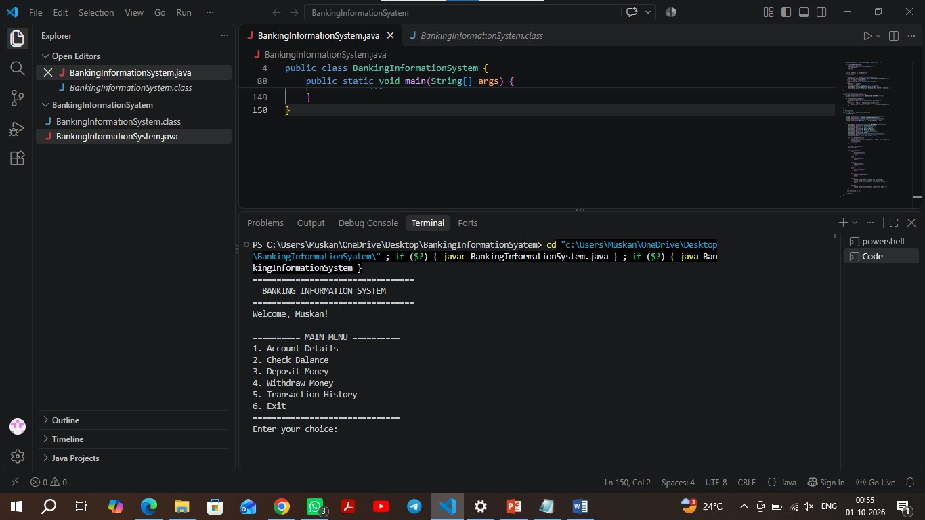

Main Menu

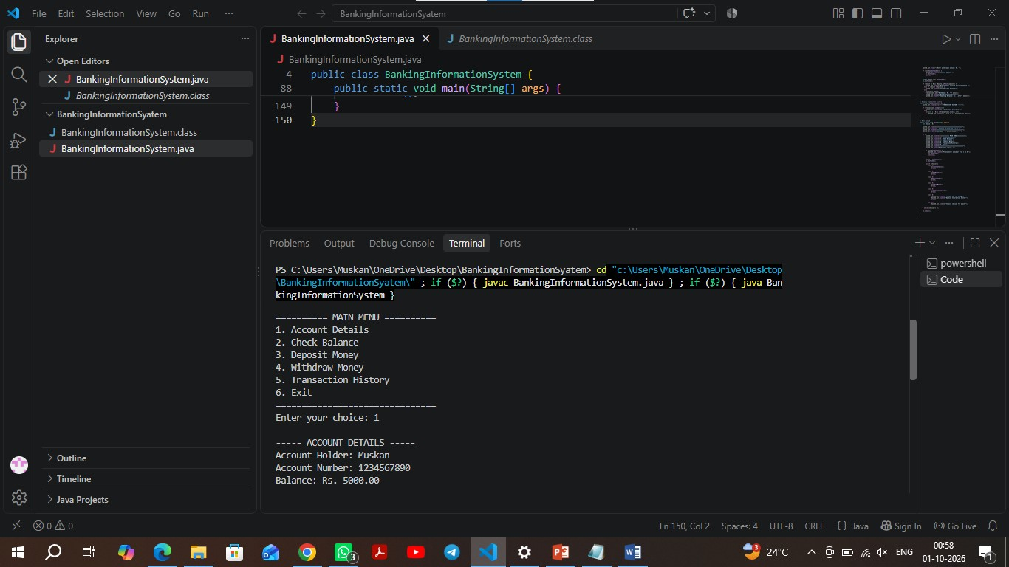

Account Details

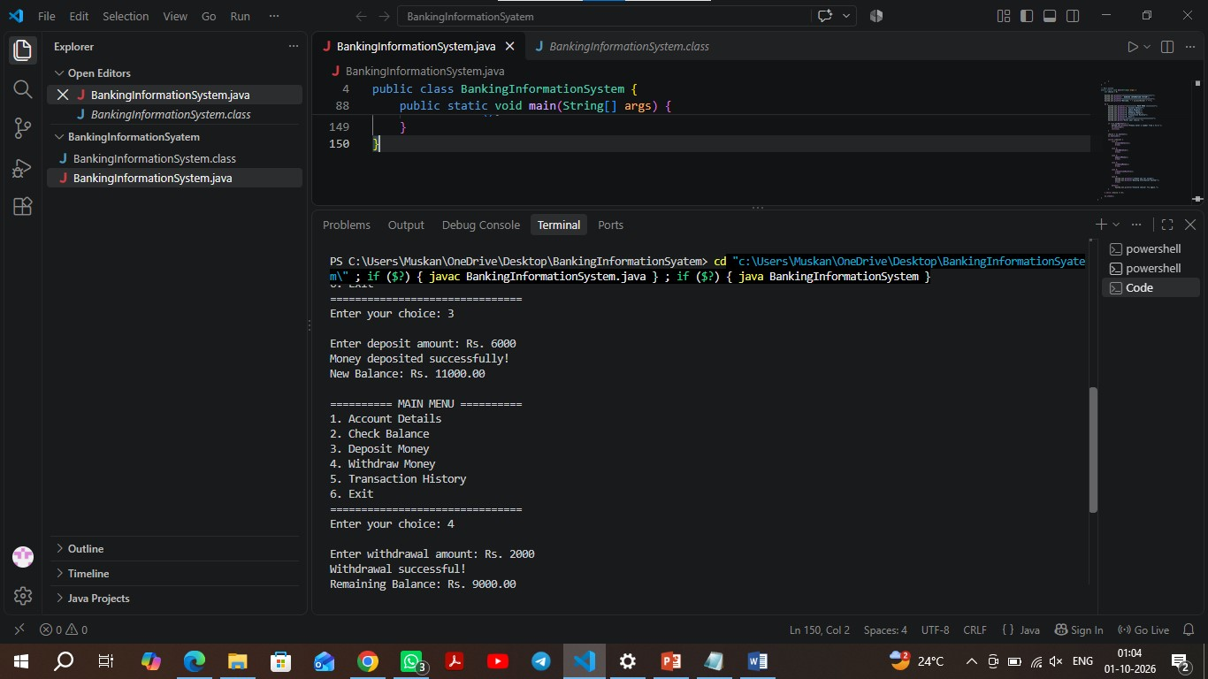

Deposit &Withdrawal Money

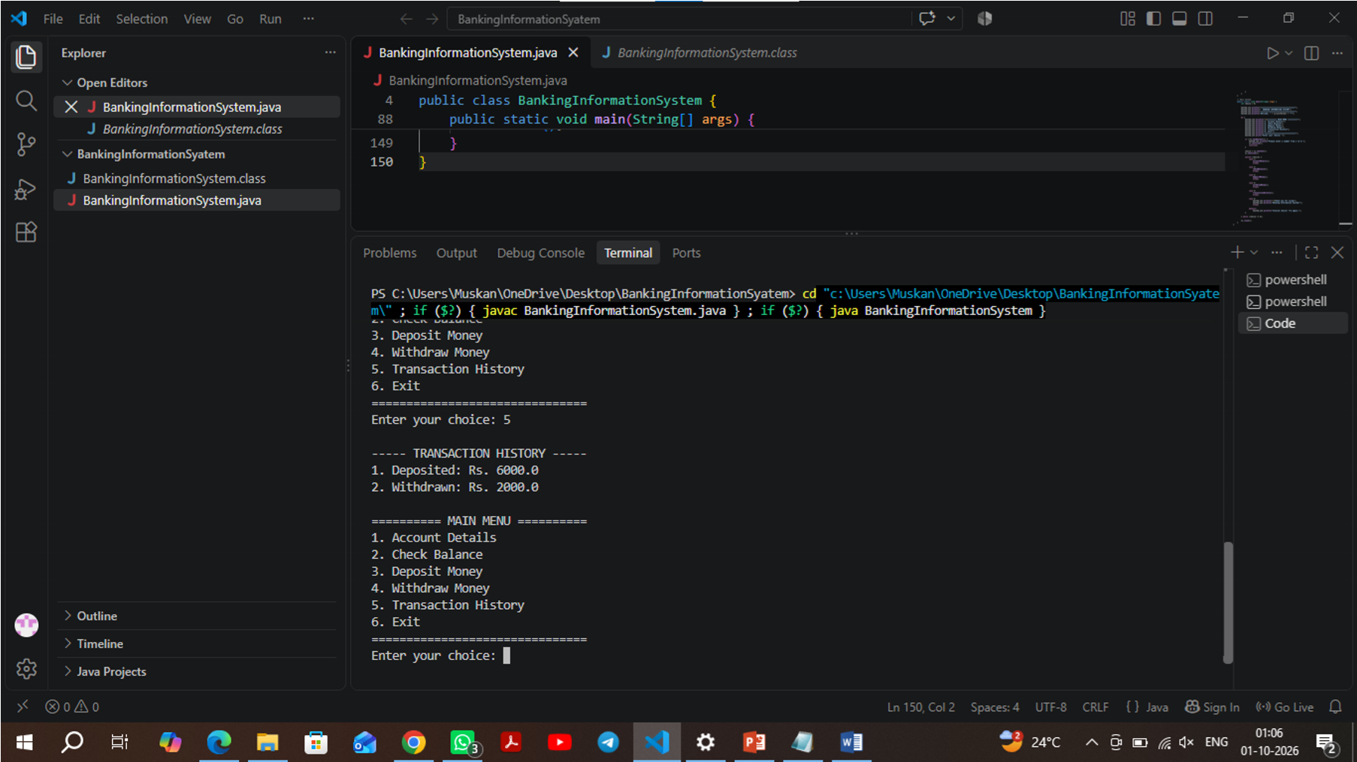

Transaction History

GITHUB REPOSITORY
The source code of the Banking Information System project is available on GitHub.
GitHub Repository: https://github.com/muskanleyakat25-svg/upskillcampus
SourceCode:https://github.com/muskanleyakat25svg/upskillcampus/blob/main/BankingInformationSystem.java

Report Link: https://github.com/muskanleyakat25-svg/upskillcampus/blob/main/Muskan_Banking_Information_System_Report.pdf

CONCLUSION
The Banking Information System project helped me understand the practical implementation of Java programming concepts. Through this project, I learned how to use classes, methods, loops, conditional statements, Scanner and ArrayList.
The project provides basic banking operations through a simple console interface. It also helped me improve my coding, logical thinking and problem-solving skills. This internship project provided valuable practical experience in Java application development.

