**THE RECORD LOW BERING SEA ICE EXTENT IN 2018: CONTEXT, IMPACTS AND AN ASSESSMENT OF THE ROLE OF ANTHROPOGENIC CLIMATE CHANGE**

Richard L. Thoman Jr. 1, Uma S. Bhatt2, Peter A. Bieniek3, Brian R. Brettschneider3, Michael Brubaker4, Seth L. Danielson5, Zachary Labe6, Rick Lader3, Walter N. Meier7, Gay Sheffield8, John E. Walsh3

**Affiliations**

1. Alaska Center for Climate Assessment and Policy (ACCAP), University of Alaska Fairbanks (UAF)

2. Department of Atmospheric Sciences, Geophysical Institute, and IARC, UAF

3. International Arctic Research Center (IARC), UAF

4. Alaska Native Tribal Health Consortium, Anchorage, Alaska

5. College of Fisheries and Ocean Sciences (CFOS), UAF

6. Department of Earth System Science, University of California Irvine

7. National Snow and Ice Data Center (NSIDC), Cooperative Institute for Research in Environmental Sciences, University of Colorado, Boulder

8. Alaska Sea Grant, CFOS, UAF

*Summary: Record low sea ice extent in the Bering Sea in early 2018 had profound impacts on the region and it is overwhelmingly likely that human-caused warming contributed to this event.*

**Introduction**

During the 2017-18 northern hemisphere cold season, sea ice extent in the Bering Sea was much lower than that of any winter in the observed or reconstructed past. The Bering Sea is the northernmost portion of the Pacific Ocean, bounded by the Aleutian Islands on the south, the Bering Strait on the north and continental lands on the east and west. The eastern and northern Bering Sea covers an expansive (~106 km2) continental shelf and is less than 150m deep. A dominant fraction of the shelf has historically been seasonally ice covered for a portion of each year. During winter, ice cover insulates ocean waters from extreme environmental conditions. Algae growth on undersurface of the ice seasonally contributes to biological production (McRoy and Goering, 1974). Seasonal ice cover is critical to the regional climate, ecosystems, societal expectations and economics through maintenance of a thermal barrier that separates two distinct temperature-adapted marine ecosystems at approximately 60N (Schumacher et. al, 1983, Mueter and Litzow, 2008). We utilized historical reconstructions and remote-sensing derived ice extent products to place the observed extent in context; governmental and academic investigations, media and public reports for impacts; and the Community Earth System Model’s Large Ensemble Project (CESM-LENS) for assessment of the relative likelihoods of ice extent so low in both the modern era and in the pre-industrial past.

**Observations and historical context**

a) **Sea Ice Cover**: Reconstructions of sea ice extent since 1850 and satellite derived since 1979 show that the average January-April 2018 sea ice extent (SIE) was the lowest of record (Fig. 1a). The maximum Bering Sea SIE was reached in early February and was also the lowest on record (~411,500 km²) at only 47% of the 1979-2016 average maximum. The SIE then dropped ~215,000 km² to only 26% of the 1979 to 2016 average during a two-week period in mid-February (Perovich et al. 2018). In addition to the low concentration ice cover shown in Fig. 1b, wintertime sea ice thicknesses (SIT) in the southern Chukchi Sea were hindcast up to 2 m below the 1979-2016 average from the Pan-Arctic Ice Ocean Modeling and Assimilation System (PIOMAS; Zhang and Rothrock, 2003; Schweiger et al. 2011). The thin and low concentration ice in the Bering and Chukchi Seas facilitated an anomalous ocean-to-atmosphere turbulent heat flux, limiting sea ice formation south of St. Lawrence Island due to high humidity and warm ocean and air temperatures (Tachibana et al. 2019).

b) **Ocean**: Bering Sea surface temperatures (SSTs) and upper ocean heat content overall (Fig 1c) were both above the 1981-2010 mean during late summer and autumn 2017. The strongest positive anomalies were west of 170°W longitude. Chukchi Sea SSTs were also above normal and delayed freeze-up north of Bering Strait, which possibly triggered atmosphere-ocean feedbacks that contributed to this winter’s southerly air flow (Tachibana et al., 2019). January through April 2018 SSTs remained above normal in the southern and western Bering Sea. In the northern Bering Sea, near-bottom waters of 1-2 °C above the freezing point were observed flowing northward into Bering Strait in each of these months, limiting the ability of the ocean to generate substantial new sea ice.

c) **Atmosphere**: The winter of 2017-18 was persistently stormy over the Bering Sea. The mean sea level pressure anomaly fields for both autumn (Sep-Nov) and winter (Dec-Feb) were characterized by negative anomalies over Chukotka and positive departures (> 5 hPa) south of the Aleutians (Overland et. al. 2018). The latter are typical of La Niña conditions, which were present during the 2017-18 cold season. The associated gradient wind anomalies were consistent with the persistent storminess: the Dec-Feb southerly wind anomaly of 2017-18 ranked in the top ten of the post-1950 period (although not in the top three). The departures from normal air temperature (at 925 mb) were also positive throughout autumn and winter: 1.5 to 2.5°C above normal in Sep-Nov and 2 to 7°C above normal in Dec-Feb. The largest positive air temperature anomalies occurred in January and February, when the western Bering Sea was up to 8°C above normal.

**Impacts of Low Ice**

Impacts of the record low sea ice extent in the Bering Sea beyond the climate system were widespread and profound. These ranged from unprecedented weather events to wildlife die-offs and sightings of animals far outside of their normal range. The Local Environmental Observer (LEO) Network (https://www.leonetwork.org/bering-sea-ice-2018) received more than 50 reports of notable events in western Alaska through August 2018. Persistently warm weather contributed to poor ice conditions resulting in a fatal accident on the Kuskokwim River ice road. In the Bering Strait, retreating sea ice during a late February storm allowed coastal flooding that caused a power outage and infrastructure damage at Little Diomede, Alaska (Walsh 2018). Historically in February, stable landfast ice at Little Diomede provided an ice airstrip for primary transportation. In the Bering Strait region, the limited duration, poor quality, and unseasonable retreat of the sea ice was coincident with the loss or impairment of maritime subsistence activities for coastal communities. Ecologically, changes in the northern Bering Sea marine ecosystem included the first documented mass strandings of ice-associated seals in the Bering Strait region (Sheffield 2018), redistribution of thermally-sensitive fish species, and a multi-species seabird die-off attributed to starvation (Siddon and Zador 2018).

**Attribution**

To evaluate the role of anthropogenic climate change in the 2018 Bering Sea ice extreme anomaly, we employed monthly gridded sea ice concentration data from CESM-LENS. CESM-LENS features fully coupled simulations with 40 ensemble members reflecting historical and projected (1850/1920-2100) climate forcing (RCP8.5) and a pre-Industrial control simulation (1800 years) reflecting climate forcing from 1850 (Kay et al. 2015). The Bering Sea region grid points were masked and monthly SIE was derived by summing the area of the grid cells with concentrations greater than or equal to 85% annually for the January to April period. The Bering SIE observations from 1980-2018 were quantile-mapped to fit the CESM-LENS distribution (Fig. 2a). The SIE for each ensemble member during this period was sorted by increasing value and each quantile was then averaged over all ensemble members and matched to the corresponding quantile from the observations. The resulting distribution (see blue line in Fig. 2a) gives an adjusted observed 2018 SIE minimum of 172,115 km², which is used to assess the role of anthropogenic climate change. This is done by calculating the Fraction of Attributable Risk (FAR; Stott et al. 2004; NASEM 2016) where FAR = 1 – Prob preindustrial /Prob present, and the probability is the likelihood of exceeding (i.e., being lower than) the 2018 SIE. Fig. 2b shows the preindustrial simulation of the Jan-Apr ice extent, together with the adjusted (blue) and unadjusted (red) values for 2018. There were three exceedances during the 1800-year pre-Industrial simulation (see black dots in Fig. 2b) and a total 96 from the 40 CESM-LENS ensemble members from the 2003-2033 “present” climate, resulting in a FAR of 0.98. Individual LENS members ranged from 0 to 7 occurrences from 2003 to 2033. Note that, if the present climate had been defined as the 1981-2018 historical period, there would have been only 30 exceedances of 2018 in the 40 ensemble members, making the FAR correspondingly smaller (0.91). Finally, Figure 2c shows the probability, over all 40 CCSM-LENS simulations, that the 2018 minimum will be exceeded in each decade. The probability is essentially zero through the 1990s, after which it increases to 0.06 in the 2010s, 0.09 in the 2020s, 0.25 in the 2030s, 0.55 in the 2040s, and 0.95 by the 2060s. Thus the CESM model indicates that 2018’s extreme ice extent in the Bering Sea will become the mean extent by the 2040s and essentially an upper bound (with only a 5% probability of greater extent) by the 2060s.

**Conclusion**

The 2018 January through April sea ice extent in the Bering Sea was far lower than any other winter in the reconstructed or observed past (since 1850). This had ramifications to the weather and climate system, economic impacts, and long-lasting ecosystem impacts. Ocean warmth and frequent atmospheric storminess with southerly winds and ocean surface forcing, were likely important factors. Using CESM-LENS we find that January through April mean ice extent as low as the 2018 observed to be extremely rare in the pre-Industrial control simulation (3 out of 1800) but become much more frequent in the current era, so much so that the FAR varies significantly (0.91 to 0.98) merely by slightly varying the “current” era. This suggests that Bering Sea ice extent is extremely sensitive to ongoing earth system warming and that the 2018 extent may soon be typical and even represent an upper bound in less than 50 years.

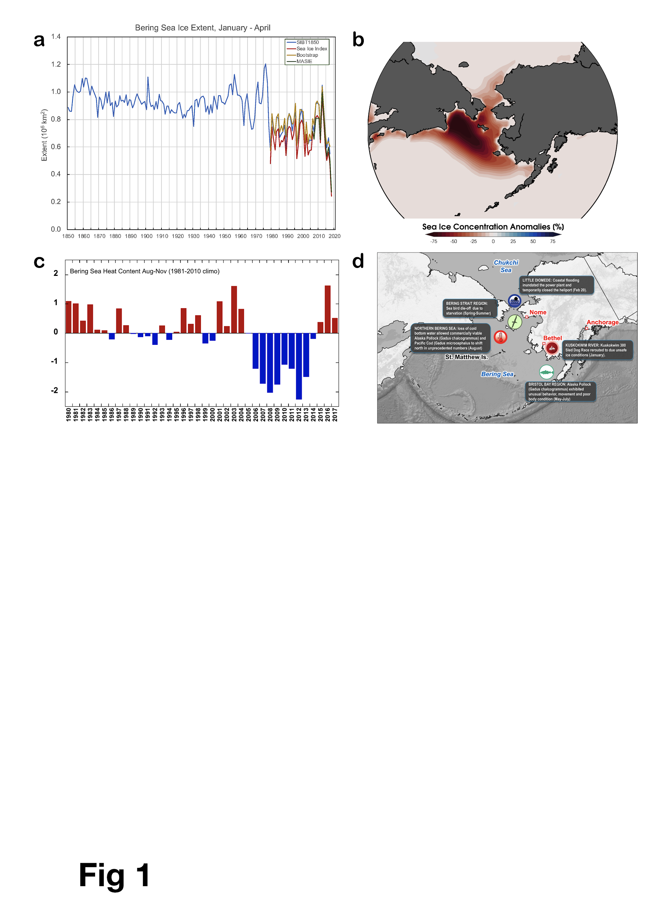

Fig. 1. a) Annual time series of the mean Jan-Apr Bering Sea ice extent since 1850. Extent from 1850-1978 extracted from Gridded Monthly Arctic Sea Ice Back to 1850 (Walsh et. al. 2017). Post 1978 extent from Sea Ice Index (Fetterer et. al. 2017), Bootstrap (Stove and Meier 2018), Multisensor Analyzed Sea Ice Extent (MASIE) (National Ice Center and National Snow and Ice Data Center; b) Mean Jan-Apr 2018 sea ice concentration anomalies calculated from a 1981-2010 climate baseline using PIOMAS, c) time series of normalized Aug-Nov upper 300m Bering Sea heat content from Global Ocean Data Assimilation System (Behringer 2007) , d) selected impacts of the low ice extent.

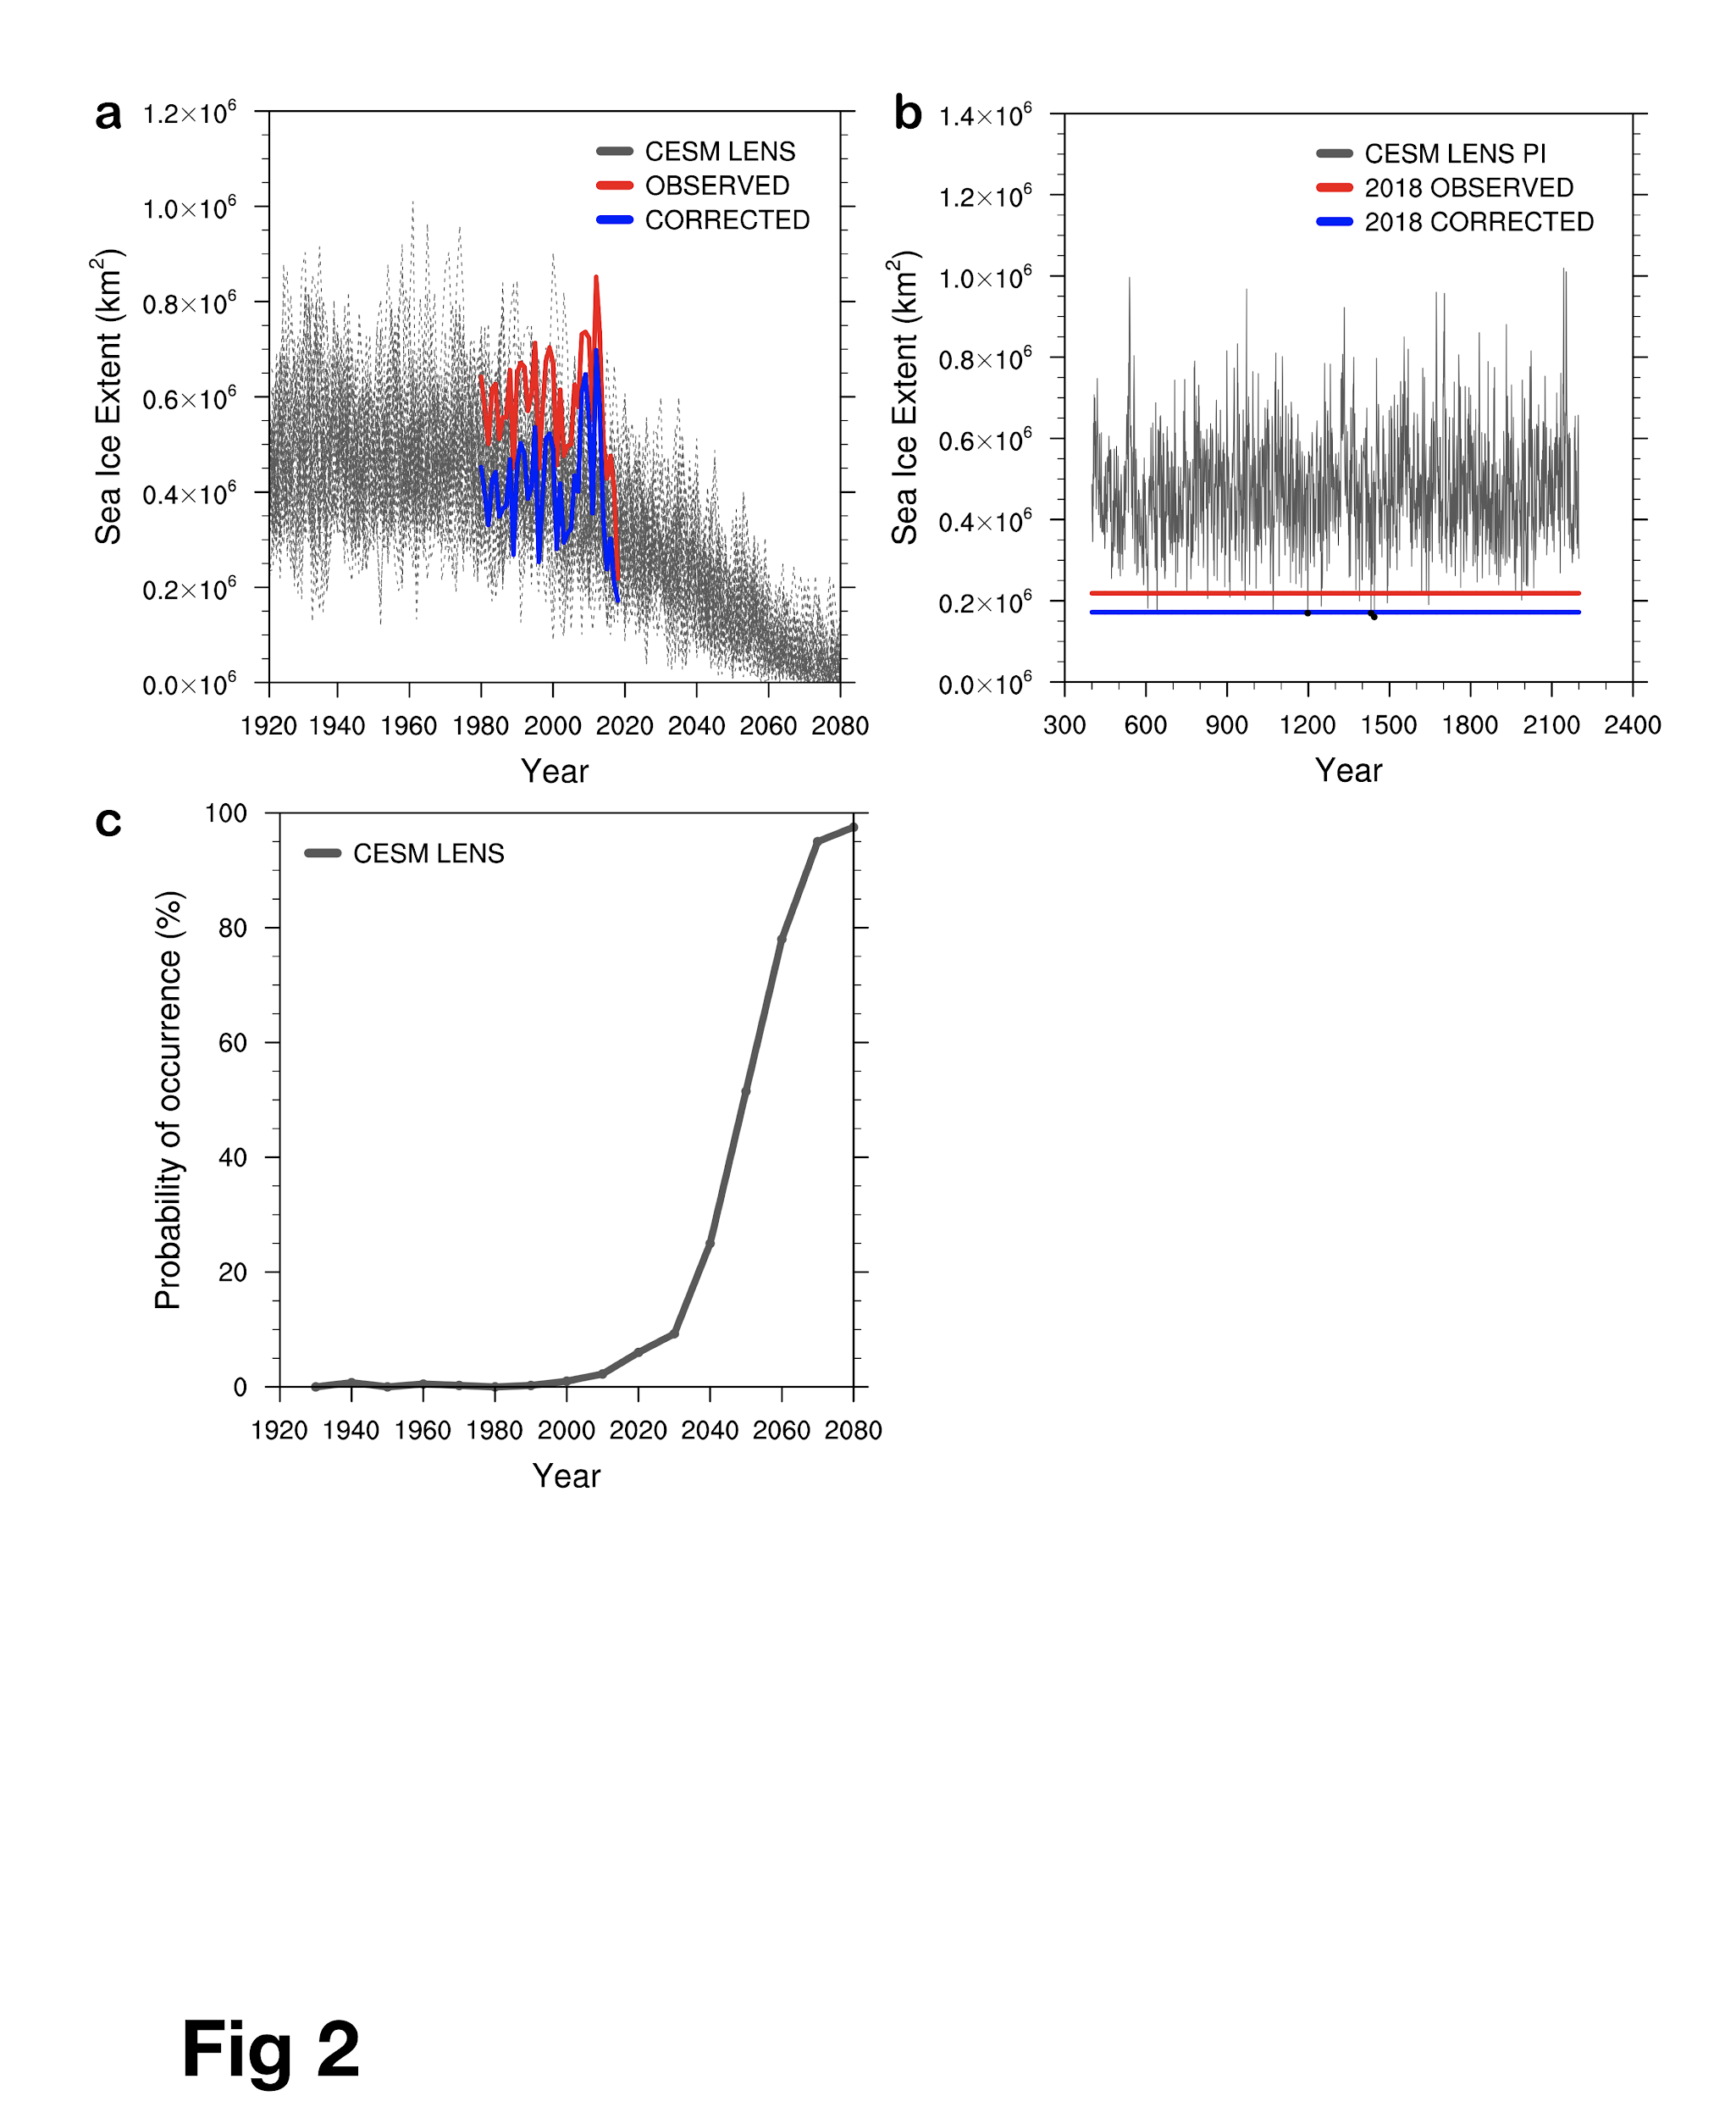

Figure 2a) Average Jan-Apr Bering Sea ice extent (km2) from: 40 members of the CESM-LENS (1920-2080; gray), observations (1980-2018; red) and bias-adjusted observations (1980-2018; blue); b) Average Jan-Apr ice extent for 1800 model years from a pre-Industrial (PI) simulation (gray) with the 2018 observed (red) and bias-adjusted (blue) values superimposed. Black markers indicate when the PI value is lower than the bias-corrected value; c) Decadal probability of having lower ice extent than the 2018 adjusted value. Each dot represents the average for the 10 preceding years (i.e., the 1930 point is the 1921-1930 average).

**ACKNOWLEDGEMENTS**

This material is based upon work supported by the National Science Foundation under award #OPP-1749081 (USB, PAB, JEW) and by NOAA’s Climate Program Office through Grant NA16OAR4310162 (RT, BRB, JEW).Heather Mcfarland (UAF/IARC) provided graphics support.

**REFERENCES**

Behringer, D.W., 2007. 3.3 The Global Ocean Data Assimilation System (GODAS) at NCEP. In *Proceedings of the 11th Symposium on Integrated Observing and Assimilation Systems for the Atmosphere, Oceans, and Land Surface*.

Fetterer, F., K. Knowles, W. N. Meier, M. Savoie, and A. K. Windnagel. 2017, updated daily. Sea Ice Index, Version 3. Regional Daily Data. Boulder, Colorado USA. NSIDC: National Snow and Ice Data Center. https://doi.org/10.7265/N5K072F8. April 2019.

Kay, J. E., and Coauthors, 2015: The Community Earth System Model (CESM) Large Ensemble Project: A community resource for studying climate change in the presence of internal climate variability. *Bull. Amer. Meteor. Soc.*, **96**, 1333–1349,<https://doi.org/10.1175/BAMS-D-13-00255.1>.

McRoy C.P. and Goering J.J., 1974. The influence of ice on the Primary productivity of the Bering Sea. In: Hood D, Kelley E (eds) The Oceanography of the Bering Sea. Institute of Marine Science, University of Alaska, pp 403–421.

Mueter, F.J. and Litzow, M.A., 2008. Sea ice retreat alters the biogeography of the Bering Sea continental shelf. *Ecological Applications*, 18(2), pp.309-320.

NASEM, 2016: *Attribution of extreme weather events in the context of climate change*. National Academies Press, 186 pp., doi:10.17226/21852.

National Ice Center and National Snow and Ice Data Center. Compiled by F. Fetterer, M. Savoie, S. Helfrich, and P. Clemente-Colón. 2010, updated daily. Multisensor Analyzed Sea Ice Extent - Northern Hemisphere (MASIE-NH), Version 1. Boulder, Colorado USA. NSIDC: National Snow and Ice Data Center. doi: <https://doi.org/10.7265/N5GT5K3K>

Overland, J.E., Hanna, E., Hanssen-Bauer, I., Kim, S.J., Walsh, J.E., Wang, M., Bhatt, U.S. and Thoman, R.L., 2018. Surface air temperature. [in Arctic Report Card 2018], <https://www.arctic.noaa.gov/Report-Card>.

Perovich, D., W. Meier, M. Tschudi, S. Farrell, S. Hendricks, S. Gerland, C. Haas, T. Krumpen, C. Polashenski, R. Ricker, and M. Webster, 2018: Sea Ice [in Arctic Report Card 2018], <https://www.arctic.noaa.gov/Report-Card>.

Siddon, E., and Zador, S. 2018. NOAA Fisheries. Ecosystem Status Report 2018: Eastern Bering Sea. Accessed 09 May 2019, https://www.fisheries.noaa.gov/resource/data/2018-status-eastern-bering-sea-ecosystem

Schweiger A., R. Lindsay, J. Zhang, M. Steele, H. Stern, and R. Kwok, 2011: Uncertainty in modeled Arctic sea ice volume. *J. Geophys. Res.,* 116, C00D06, doi:<https://doi.org/10.1029/2011JC007084>

Schumacher, J.D., Aagaard, K., Pease, C.H. and Tripp, R.B., 1983. Effects of a shelf polynya on flow and water properties in the northern Bering Sea. Journal of Geophysical Research: Oceans, 88(C5), pp.2723-2732.

Sheffield, G. 2018. Response to reported mass seal stranding at Wales, Alaska – June

2018. Trip Report to Alaska Marine Mammal Stranding Network, Juneau, Alaska, 8 p.

Stott, P., D. Stone, and M. Allen, 2004: Human contribution to the European heatwave of 2003. *Nature*, **432**, 610-614, doi:10.1038/nature03089.

Stroeve, J. and W. N. Meier. 2018. Sea Ice Trends and Climatologies from SMMR and SSM/I-SSMIS, Version 3. Boulder, Colorado USA. NASA National Snow and Ice Data Center Distributed Active Archive Center. doi: https://doi.org/10.5067/IJ0T7HFHB9Y6.

Tachibana, Y., Komatsu, K. K., Alexeev, V. A., Cai, L., & Ando, Y. (2019). Warm hole in Pacific Arctic sea ice cover forced mid-latitude Northern Hemisphere cooling during winter 2017–18. Scientific reports, 9(1), 5567.<https://doi.org/10.1038/s41598-019-41682-4>

Walsh, J.E., F. Fetterer, J. Scott Stewart, and W.L. Chapman, 2017. A database for depicting Arctic sea ice variations back to 1850. *Geographical Review*, doi:10.1111/j.1931-0846.2016.12195.x.

Walsh, J. 2018. Alaska Climate Dispatch – A State-wide Seasonal Summary and Outlook <https://accap.uaf.edu/sites/default/files/climate_dispatch_May_2018_FINAL.pdf>

Zhang, J., & Rothrock, D. A. (2003). Modeling global sea ice with a thickness and enthalpy distribution model in generalized curvilinear coordinates. *Mon. Wea. Rev.*, 131(5), 845-861.<https://doi.org/10.1175/1520-0493(2003)131><0845:MGSIWA>2.0.CO;2.