**Purpose:**

The custom script is to generate ICRF form for the scripts which we need to migrate from DEV to SIT or SIT to UAT. Since the task is conducted quite often as part of Development and migration of codes across environments, it would be helpful to use the script instead of manually filling the ICRF form for migration thereby decreasing manual activity to the minimum for the task.

**Who should use this tool:**

Developers who come across the scenario of creating/enhancing and migrating the scripts across environments can leverage this tool to migration there codes easily by simply providing the script names into a text file and running the custom script for migration request.

**How does it work:**

This tool ICRF_Form_Creator.py has been created on python platform. The tool basically takes a text file name which contains all the scripts (sh,parm,mail and lst) names. We do not need physical copies of the scripts for the migration. The process will run if all the mentioned scripts are placed in DEV env.

We need to provide the below information while running the ICRF creator:

1. Text File name that contains all the script names
2. RITM number as the ICRF form needs to be prepared with Valid RITM number in csv format.
3. AGID of the migrator, as the migrator details are mentioned in ICRF form.
4. Repository details between MRDM/CADL in case if BI.

After providing the aforementioned details, the script compiles each filenames and script type based on the extension e.g. .parm is a parameter file. Based on the file type, repository details, the source and Target env paths are updated in the csv file along with RITM and AGID details.

Once the ICRF file is created successfully, it is then placed in the Network path for ICRF migration and then CODE_ASSESSMENT_FORM_D.exe program is triggered by the script. The input parameters for Assessment program are also dynamically filled by the ICRF_Form_Creator.py.

Once all the details are validated, the scripts will then be migrated to higher env.

**Assumptions:**

1. The scripts need to be present in lower environment in designated locations.
2. RITM number and AGID should be valid as those will be filled during code assessment as well.

**Directions for use:**

Please refer the below set of screenshots for using the ICRF_MIGRATOR.exe Tool :

1)Place the script and the note.txt in the same folder , then place all the names of the scripts, mail, list, parm file name in the note.txt

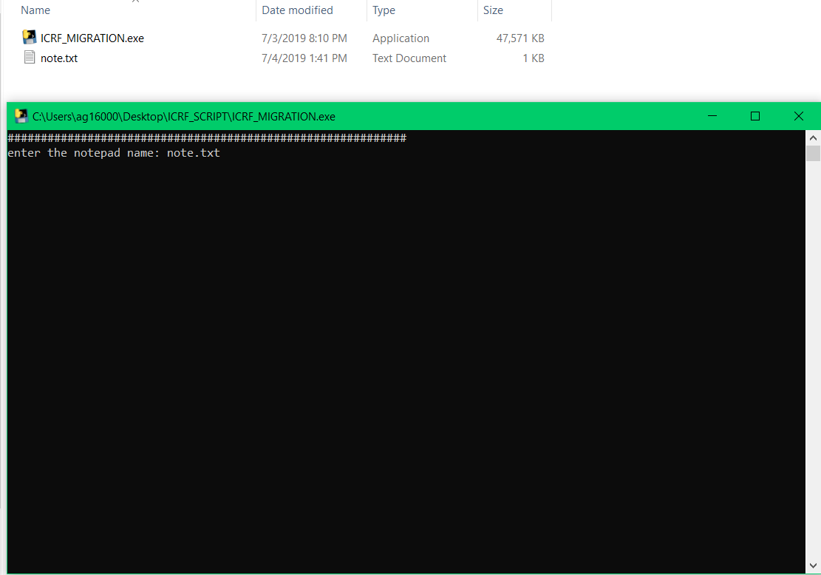

2)Then enter the RITM number of the required choice as per the standards.

3)Then choose between EDL and BI environment.

4)Enter the target environment SIT or UAT.

5)Enter the source environment dev or sit.

6)Then enter the migration reason.

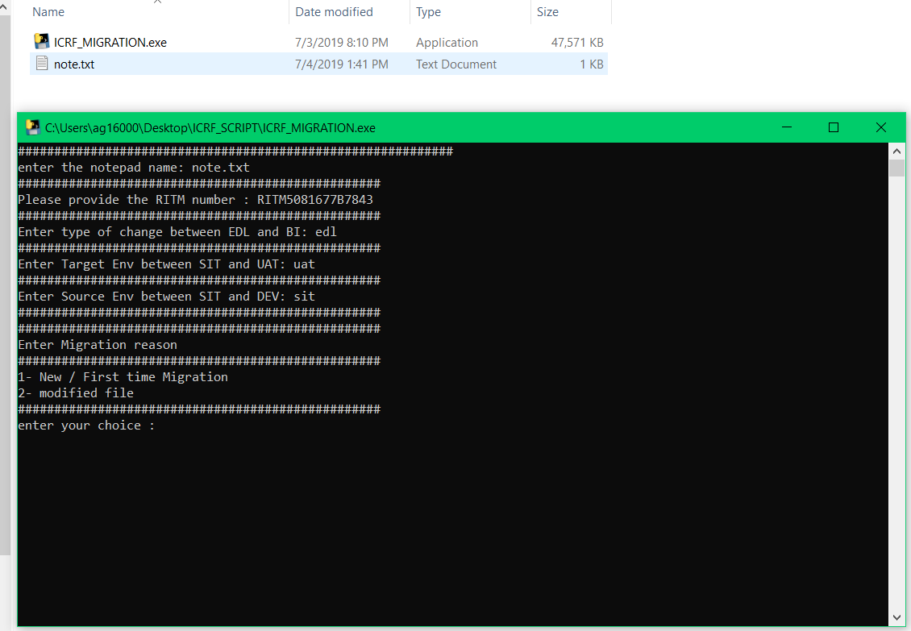

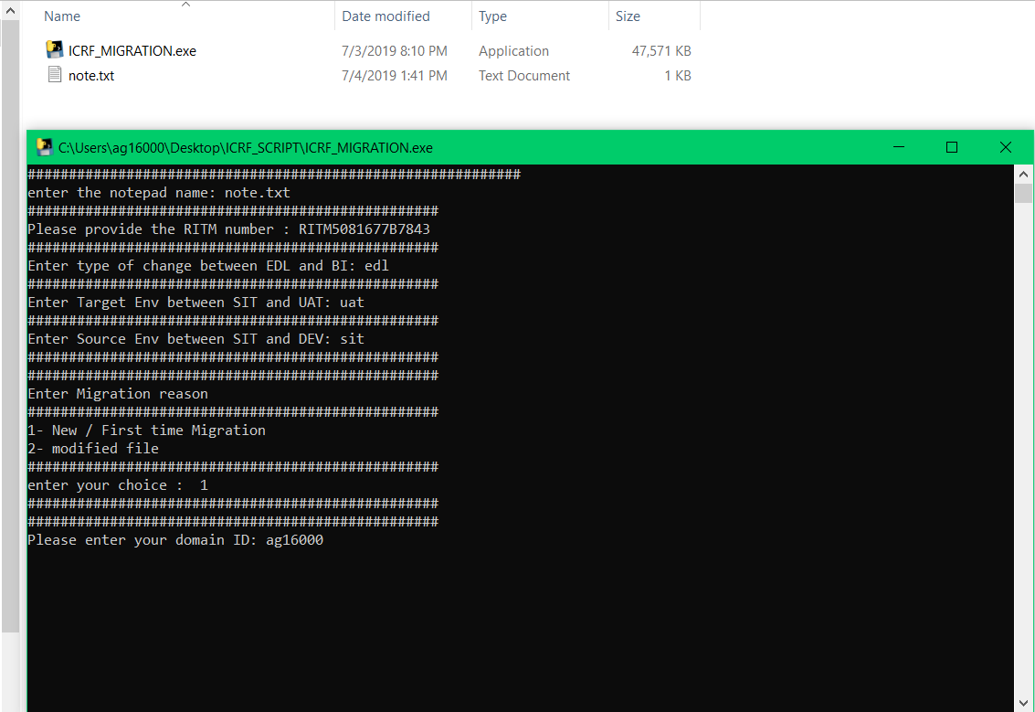

8)Then enter ICRF path location where to copy like : \\va10dwvcat300\UNISHARE$\SELF_CA_AG16000\ICRF_FORMS_D.

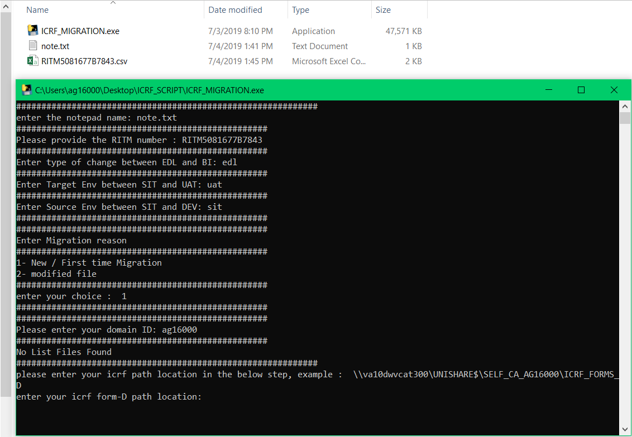

9)Then enter the .exe location example :

\\Va10dwvcat300\unishare$\SELF_CA_EXE\CODE_ASSESSMENT_D.exe

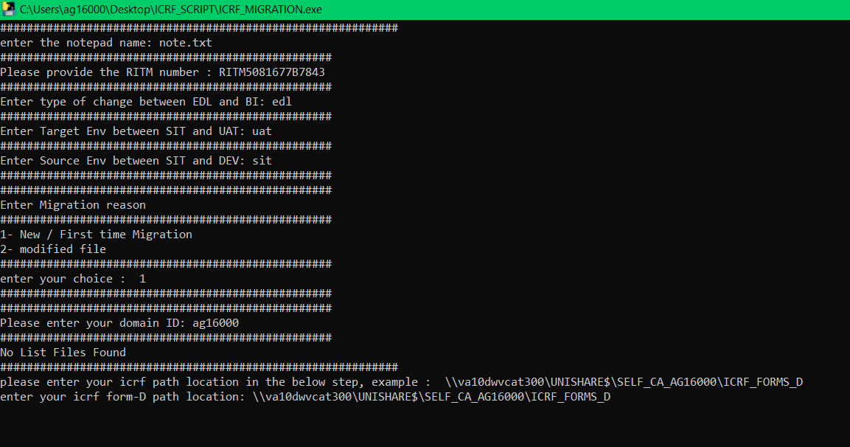

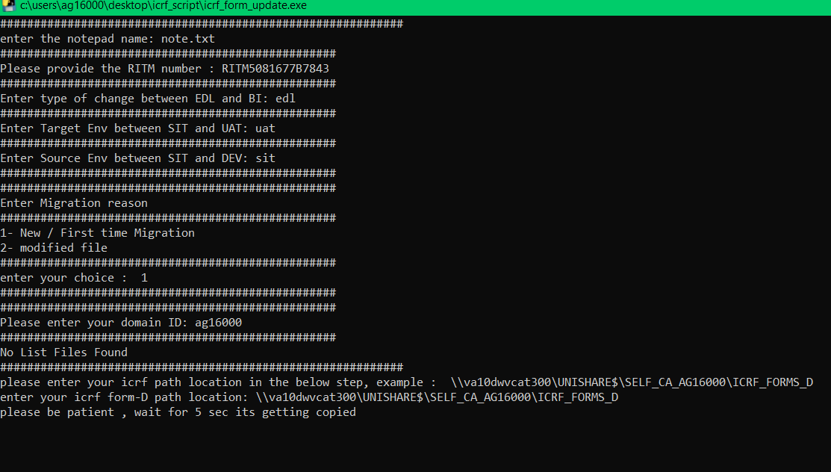

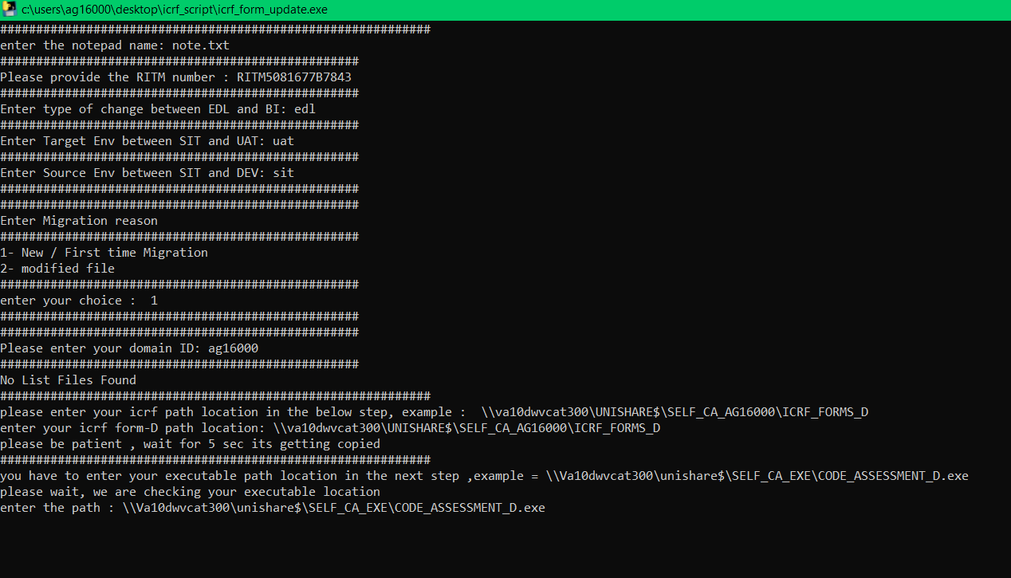

DOWNLOAD:

You can download the .exe file from the network location :

\\ntfs07.corp.anthem.com\isdshare\MRDM\ICRF

There are two .exe files in the location

1.ICRF_FORM.exe => which makes the ICRF form and we have to migrate manually

2.ICRF_MIGRATION.exe => which makes the ICRF from as wll as migration takes place automatically.