Insteon Hub Commands

I used House Link to set up devices on the Hub.

House Link uses port 9761

You can log on to your hub using web browser

http://192.168.1.30:25105/network.htm

25105 default port for Iphone application you can change this

IP address of the Hub 192.168.1.30

Port Address 25105

test Device Address 21A9A8

If you enter the following into your web browser you can the device on and off

On

http://192.168.1.30:25105/3?026221A9A80F11FF=I=3-

On Status Reply
026221A9A80F11FF06025021A9A825DC0B2F11FF000000000000000000000000000000000000000000000000000000000000

Off
http://192.168.1.30:25105/3?026221A9A80F13FF=I=3-

Off Status Reply

026221A9A80F13FF06025021A9A825DC0B2F13FF000000000000000000000000000000000000000000000000000000000000

Read the Buffer
http://192.168.1.30:25105/buffstatus.xml

Request 21A9A8 Device Status
http://192.168.1.30:25105/3?026221A9A80F19FF=I=3-

Looking At the On command

http://192.168.1.30:25105/3?026221A2A90F11FF=I=3-
Brake Down of Fields

026221A2A90F11FF=I=3-

21A2A9 Address

0262 Direct Command Flag

OF SD Flag Standard Command

11 Command (11=ON)

FF =level (FF=100%)

=I=3 ?? Number of re transmits

Looking at Buffer Status Reply
http://192.168.1.30:25105/buffstatus.xml

026221A9A80F19FF 06 0250 21A9A8 25DC0B 2 F 00 01
02620EA7220F117F 06 0250 0EA722 16A944 2 B 11 7F
02622044B00F6905 06 0250 2044B0 25DC0B A F 69 FD
Last Command+Response Flag + Return Flag + Target Device + SmartLinc + Ack + Hop Count+DB Delta+Level
- Last Command: The last command sent to the target device
- Response Flag: Indicates success (value 06) or failure (value 15)
- Return Flag: Indicates that this is a return message
- Target Device: The device you are querying
- SmartLinc: The device that sent the response (should be the SmartLinc address)
- Ack: Some kind of acknowledgment (should be a value 2)
- Hop Count: Not sure, but the value should be B, F, 7, or 3
- DB Delta: When a device's value changes, this value increments. (Not sure how this is useful)
- Level: The current level of the device.

To controll X10 devices you must send c commands

Off X10 Device Address M15

http://192.168.1.30:25105/3?02630400=I=3
http://192.168.1.30:25105/3?02630380=I=3

On

http://192.168.1.30:25105/3?02630400=I=3
http://192.168.1.30:25105/3?02630280=I=3

Response OFF
0263038006000000000000000000000000000000000000000000000000000000000000000000000000000000000000000000
Response On
0263028006000000000000000000000000000000000000000000000000000000000000000000000000000000000000000000

The Hub Buffer is very limited and only holds the last command

To Clear the Buffer

http://192.168.1.30:25105/1?XB=M=1

Response

0000000000000000000000000000000000000000000000000000000000000000000000000000000000000000000000000000

Hub Configuration
The Hub configurations are "hidden" from the default homepage; however, they are the same paths as used for the SmartLinc.
http://192.168.1.30:25105/network.htm

System Configuration
/network.htm is the main resource for viewing the network configuration. It provides you with the IP and Insteon network info. It also allows you to configure the system clock. Why isn't there NTP support?
/config.htm is used to configure your IP address settings. This is where DHCP is enabled/disabled.
/sun.htm allows for the configuration of your location and daylight savings time settings. In addition, it is used to set sunrise and sunset times.
/a.htm is the authentication resource. It allows you to set the user name and password.
/1?L=USER=1=PASS updates the user name, USER, and the password, PASS.

Room Configuration
/rooms.htm configures the room names. The visible check box is not used for the Hub. On the SmartLinc, it is used to control what rooms are visible on the homepage.
/rRN.htm displays the scenes configured for the room. The room number, RN, can be 01 to 16.
/scenes.htm?1=RN=F configures the scene names and visibility within a room.
/setup.htm?RN=SN=F is used to configure the scenes' features. Valid scene numbers, SN, are 1 to 16. This allows you to configure basic scheduling and enable notification for a device. As you'll see later, true scene/group control is done via the PLM.
/2?S215=Hall_Lights=2=t=00:00=ff=00:00=ff=f=f=f=f=f=f=f=f=f=f=t=AABBCC01=t=f22 Creates a new scene. Here's each option:
S#=name=2=show(t/f)=TimeStart=AM(t/f)PM(t/f)=TimeEnd=AM(t/f)PM(t/f)=Mon(t/f)=Tue(t/f)=Wen(t/f)=Thu(t/f)=Fri(t/f)=Sat(t/f)=Sun(t/f)=CntlUp(t/f)=CntlOn(t/f)=CntlOff(t/f)=CntlDown(t/f)=StatusDeviceID=ReportStatus(t/f)=DimCntlInc(t/f)StartTimeType(1/2/3,Sunset/Minute/Sunrise)TimeEndType(1/2/3,Sunset/Minute/Sunrise)
PLM Control
The PLM controls are the heart of the Hub. All Insteon device configurations are done with the PLM. The main PLM HTTP controls are detailed below.
/0?08=I=0 stops linking on the PLM. This can also be done with the generic PLM command resource.
/0?09GN=I=0 starts linking for a group number, GN. The group number can be 00 to FF.
/0?0AGN=I=0 starts unlinking for a group number, GN. The group number can be 00 to FF.
/Linkstatus.xml provides the current linking status. This can also be parsed from the buffer.
/3?PLM_CMD=I=3 is the generic PLM command. This sends whatever command (PLM_CMD) is provided to the PLM for execution. This is the most powerful of all the Hub resources.
/sx.xml?ID=SD_CMD is the synchronous standard Insteon command. This resource can be used to send a simple standard command (SD_CMD) to the Insteon device ID (ID). It will wait for the device to respond and provide the device's response in the HTTP response. This resource is unique to the Hub.
/buffstatus.xml retrieves the current PLM buffer. This is another difference between the Hub and the SmartLinc. The Hub's buffer is padded with zeros when empty. The XML format of the response is below.

/1?XB=M=1 clears the PLM buffer. The buffer will look like the examples above.

Name | Command 1 | Command 2
ON | 11 | Turn device on, ramping up  00 through FF (see Common Brightness Levels for values)
FAST ON | 12 | Turn device on immediately (no ramp)
OFF | 13 | Turn device off, ramping down
FAST OFF | 14 | Turn device off immediately (no ramp)
BRIGHT | 15 | 00
DIM  STATUS | 16  19 | 0  Get the current status of the device (returns level)
BEEP | 30 | 01

Levels
Similar to the commands above, we have a few levels we can send with our commands to change the brightness level. Unfortunately, we cannot send the level as a simple numeric integer, they are represented as hexadecimal values from 0 to 255. Here are some common levels I use:
Level Chars | Percentage
00 | 0 %
40 | 25 %
7F | 50 %
BF | 75 %
FF | 100.00%

Hex | Dec | Percentage
00 | 0 | 0.00%
40 | 64 | 25.00%
FF | 255 | 100.00%

You can specify any value from 0-100% by inserting the appropriate hexadecimal value
This URL will get you all the device ids on room 1 in XML format
http://X.X.X.X:25105/b.xml?01=1=F
This URL will get you all the device ids on room 1 in XML format
http://X.X.X.X:25105/b.xml?01=1=F
You may change the time directly from the HTML page on:
http://X.X.X.X:25105/network.htm
You may change network settings directly on:
http://X.X.X.X:25105/config.htm
Device names and scene configuration are stored only on the cloud.
There are 2 types of Insteon Commands Standard and Extended all of the above are standard.

Thermostats use extended commands.

To send Set Heat Set point 71
username:password@192.168.1.100:25105/3?0262XXYYZZ1F6D8E0000000000000000000000000005=I=3
02 62 - send an Insteon message
XX YY ZZ - the address of the thermostat of course
1F The difference is the number of retransmissions allowed,
1F indicate this will be an extended message.
6D - the command to adjust the set point.
8E - the temperature (71 * 2 = 142, converted to hex = 8E)
00 00 00 00 00 00 00 00 00 00 00 00 00 - extended data bytes D1-D13,
05 - checksum, you'll have to change this if you change the command or the temperature, but it will stay the same if you only change the flags byte
This will only work if the thermostat is already linked as a responder to the hub.

The formula for the checksum is
Checksum = ((Not(sum of cmd1..d13)) + 1) and 255
Since everything else is in hexadecimal we can be consistent and replace that decimal 255 with hexadecimal FF.
that calculation:
=((Not(6D + 8E + 00 + 00 + 00 + 00 + 00 + 00 + 00 + 00 + 00 + 00 + 00 + 00 + 00)) + 1) and FF
=((Not(FB)) + 1) and FF
Not(FB) means reverse all the bits in FB. In binary, FB = 11111011. So, Not(FB) = 00000100, which = 4.
=((4) + 1) and FF
=(5) and FF
"and FF" basically just means you are only looking at the first 8 binary bits. It's really only relevant if the value is > FF. If you have more than two hexadecimal digits, just drop all but the last two. E.g. if the total was 3FB you would drop the 3 and just keep the FB. (The fact that you can do it this way is one of the nice things about working in hexadecimal. It doesn't work so easily in decimal.) 5 is less than FF, so it's unchanged. So:
= 5
I was able to use OpenRemote to controll devices attached to the Hub

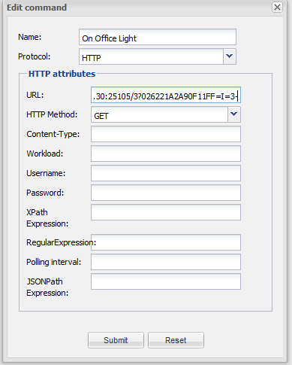
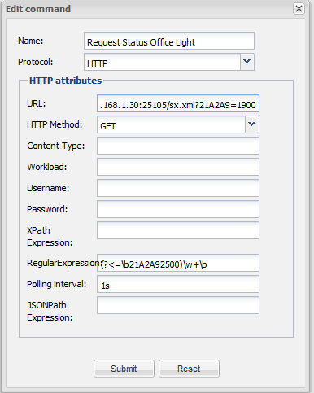
On Command as above http://192.168.1.30:25105/3?0262 21A9A8 0F11FF=I=3

Request Status http://192.168.1.30:25105/sx.xml?21A9A8=1900

Regex to extract On and Off (?<=\b21A9A82500)\w+\b
21A9A8 will need to be change to the address of each device having this in the Regex makes it possible to confirm the response is from the correct address

I used a custom Sensor and input under custom status
Name On Value On
Name Off Value Off

I also was tested sending change set point on thermostat by 2 degrees
http://192.168.1.30:25105/3?02622044A01F68040000000000000000000000000094=I=3

As the value returned are in Hex 8E (71 * 2 = 142, converted to hex = 8E)
You would have to convert this using a custom rule.

All of the above information is freely available on the Web and listed below are sites which I found a great help.
I believe making a custom protocol in OpenRemote would be the way forward.

http://www.leftovercode.info/
http://www.leftovercode.info/smartlinc.php
http://www.leftovercode.info/smartlinc_x10.html

http://www.insteon.com/sdk/files/dm/docs/
http://www.insteon.com/houselinc-insteon-custom-commands.html
http://efundies.com/guides/
http://fredricksensoftware.us/Insteon/Device%20Controller/index.htm
http://www.madreporite.com/insteon/commands.htm
http://blog.automategreen.com/post/under-the-insteon-hub-hood
http://www.smarthome.com/forum/topic.asp?TOPIC_ID=11063&whichpage=2
http://www.richstevenson.com/2014/01/06/insteon-direct-commands/

For Regex I found this link very good
http://www.codeproject.com/Articles/9099/The-30-Minute-Regex-Tutorial
The expresso program is great for working out the correct regex to use in Openremote

