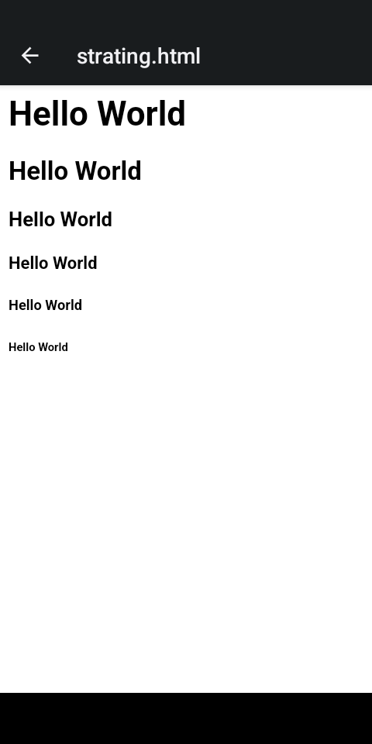

**Figure 1.0**

**Without BootStrap First Cond HTML**

**This output see in figure 1.0**

<html>

<head><head>

<body>

<h1>Hello World</h1>

<h2>Hello World</h2>

<h3>Hello World</h3>

<h4>Hello World</h4>

<h5>Hello World</h5>

<h6>Hello World</h6>

</body>

</html>

**With BootStrap First Cond HTML**

**This output see in figure 1.1**

<html>

<head>

<meta charset="utf-8">

<meta name="viewport" content="width=device-width, initial-scale=1">

<link href="https://cdn.jsdelivr.net/npm/bootstrap@5.3.3/dist/css/bootstrap.min.css" rel="stylesheet">

<script src="https://cdn.jsdelivr.net/npm/bootstrap@5.3.3/dist/js/bootstrap.bundle.min.js"></script>

</head>

<body>

<h1 class="text-success text-bg info">Hello World</h1>

<h2 class="text-info">Hello World</h2>

<h3 class="text-danger">Hello World</h3>

<h4 class="text-primary">Hello World</h4>

<h5 class="text-secondary">Hello World</h5>

<h6 class="text-info">Hello World</h6>

</body>

</html>

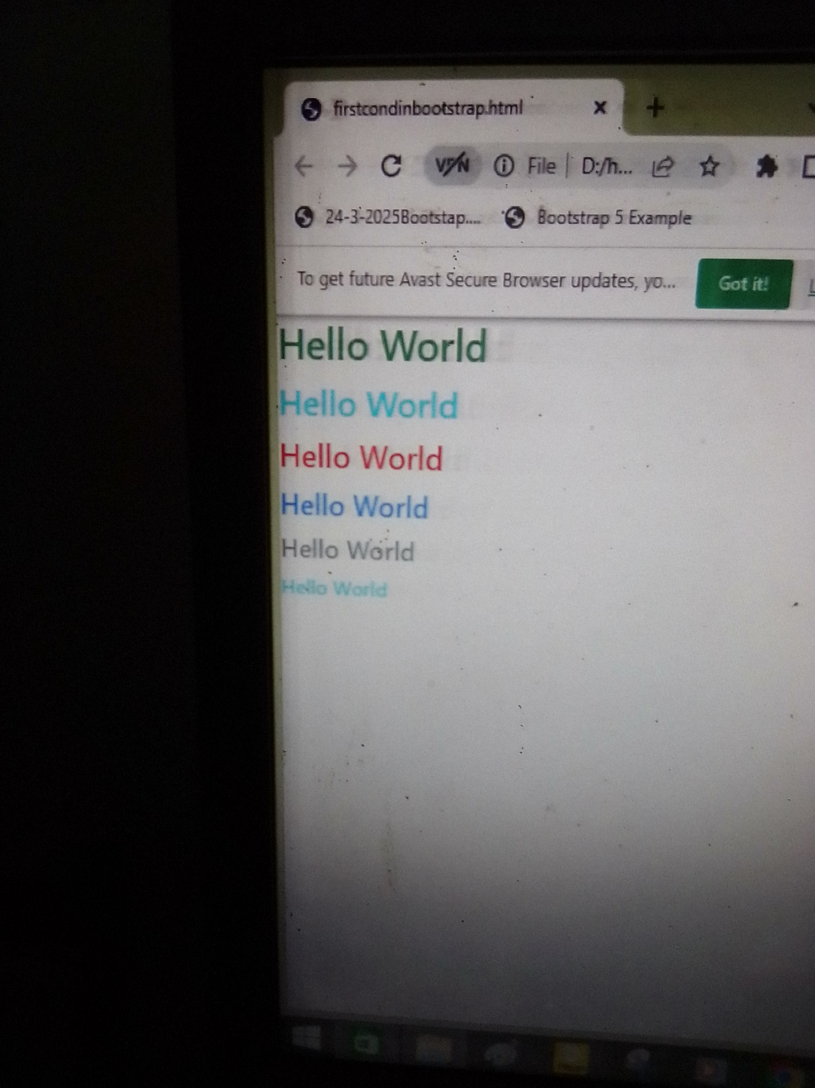

**Figure 1.1**

Bootstrapt

<html>

<head>

<tittle class="text-info text-center">Using Bootstrap</tittle>

<meta charset="UTF-8">

<meta name="viewport" content="width=device-width, initial-scale=1">

<link href="https://cdn.jsdelivr.net/npm/bootstrap@5.3.3/dist/css/bootstrap.min.css" rel="stylesheet">

<script src="https://cdn.jsdelivr.net/npm/bootstrap@5.3.3/dist/js/bootstrap.bundle.min.js"></script>

</head>

<body>

<div class="container-fluid p-5 bg-primary text-white text-center">

<h1>Hello World</h1>

<h2>Hello World</h2>

<h3>Hello World</h3>

<h4> Hello World</h4>

<h5>Hello World</h5>

<h6>Hello World</h6>

</div>

<div class="container-fluid p-5 bg-info text-white text-center">

<h1>Hello World</h1>

<h2>Hello World</h2>

<h3>Hello World</h3>

<h4> Hello World</h4>

<h5>Hello World</h5>

<h6>Hello World</h6>

</div>

</body>

</html>

