ASSIGNMENT-7
- Write a C++ program for each question using classes, inheritance, and virtual functions wherever required.
- Create a base class Animal with a virtual function sound(). Derive classes Dog and Cat that override sound() to display their respective sounds. Call the functions using base-class pointers.
CODE:-
#include <iostream>
using namespace std;

class Animal
{
public:
virtual void sound()
{
cout << "Animal makes sound" << endl;
}
};

class Dog : public Animal
{
public:
void sound()
{
cout << "Dog barks" << endl;
}
};

class Cat : public Animal
{
public:
void sound()
{
cout << "Cat meows" << endl;
}
};

int main()
{
Animal *ptr;

Dog d;
Cat c;

ptr = &d;
ptr->sound();

ptr = &c;
ptr->sound();

return 0;
}
OUTPUT:-
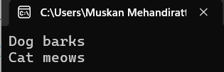
- Create a base class Shape with a virtual function area(). Derive classes Rectangle and Circle that override area() to calculate and display their respective areas. Demonstrate runtime polymorphism using a base-class pointer.
CODE:-
#include <iostream>
using namespace std;

class Shape
{
public:
virtual void area()
{
cout << "Area of Shape" << endl;
}
};

class Rectangle : public Shape
{
int length, breadth;

public:
Rectangle(int l, int b)
{
length = l;
breadth = b;
}

void area()
{
cout << "Rectangle Area = "
<< length * breadth << endl;
}
};

class Circle : public Shape
{
float radius;

public:
Circle(float r)
{
radius = r;
}

void area()
{
cout << "Circle Area = "
<< 3.14 * radius * radius << endl;
}
};

int main()
{
Shape *ptr;

Rectangle r(10, 5);
Circle c(7);

ptr = &r;
ptr->area();

ptr = &c;
ptr->area();

return 0;
}
OUTPUT:-
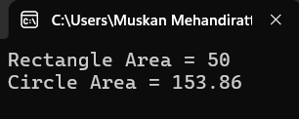
- Create a base class Employee with data members name and basicSalary and a virtual function calculateSalary(). Derive classes PermanentEmployee and ContractEmployee that calculate salary differently. Call the overridden functions using a base-class pointer
CODE:-
#include <iostream>
using namespace std;

class Employee
{
protected:
string name;
float basicSalary;

public:
Employee(string n, float s)
{
name = n;
basicSalary = s;
}

virtual void calculateSalary()
{
cout << "Employee Salary" << endl;
}
};

class PermanentEmployee : public Employee
{
public:
PermanentEmployee(string n, float s)
: Employee(n, s) {}

void calculateSalary()
{
float salary = basicSalary + (0.20 * basicSalary)
+ (0.10 * basicSalary);

cout << "Permanent Employee: " << name << endl;
cout << "Salary = " << salary << endl;
}
};

class ContractEmployee : public Employee
{
public:
ContractEmployee(string n, float s)
: Employee(n, s) {}

void calculateSalary()
{
float salary = basicSalary + (0.05 * basicSalary);

cout << "Contract Employee: " << name << endl;
cout << "Salary = " << salary << endl;
}
};

int main()
{
Employee *ptr;

PermanentEmployee p("Rahul", 30000);
ContractEmployee c("Aman", 20000);

ptr = &p;
ptr->calculateSalary();

ptr = &c;
ptr->calculateSalary();

return 0;
}
OUTPUT:-
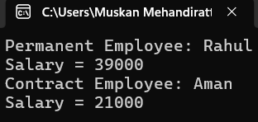
- Create a base class Vehicle with a virtual function displayInfo(). Derive classes Car, Bike, and Bus, and override the function in each class to display the vehicle's details. Demonstrate runtime polymorphism using a base-class pointer
CODE:-
#include <iostream>
using namespace std;

class Vehicle
{
public:
virtual void displayInfo()
{
cout << "Vehicle Information" << endl;
}
};

class Car : public Vehicle
{
public:
void displayInfo()
{
cout << "Car: Four Wheels" << endl;
}
};

class Bike : public Vehicle
{
public:
void displayInfo()
{
cout << "Bike: Two Wheels" << endl;
}
};

class Bus : public Vehicle
{
public:
void displayInfo()
{
cout << "Bus: Public Transport" << endl;
}
};

int main()
{
Vehicle *ptr;

Car c;
Bike b;
Bus bus;

ptr = &c;
ptr->displayInfo();

ptr = &b;
ptr->displayInfo();

ptr = &bus;
ptr->displayInfo();

return 0;
}
OUTPUT:-
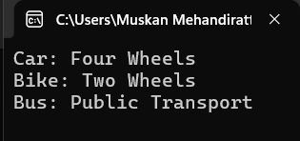
- Create an abstract class BankAccount with a pure virtual function calculateInterest(). Derive classes SavingsAccount and FixedDeposit that implement the function to calculate interest according to their respective rules. Demonstrate the program using base-class pointers.
CODE:-
#include <iostream>
using namespace std;

class BankAccount
{
public:
virtual void calculateInterest() = 0;
};

class SavingsAccount : public BankAccount
{
float amount;

public:
SavingsAccount(float a)
{
amount = a;
}

void calculateInterest()
{
cout << "Savings Interest = "
<< amount * 4 / 100 << endl;
}
};

class FixedDeposit : public BankAccount
{
float amount;

public:
FixedDeposit(float a)
{
amount = a;
}

void calculateInterest()
{
cout << "Fixed Deposit Interest = "
<< amount * 7 / 100 << endl;
}
};

int main()
{
BankAccount *ptr;

SavingsAccount s(10000);
FixedDeposit f(20000);

ptr = &s;
ptr->calculateInterest();

ptr = &f;
ptr->calculateInterest();

return 0;
}
OUTPUT:-
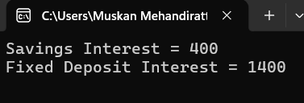
- Create a base class Person with a virtual destructor and a derived class Student with its own destructor. Create a dynamically allocated Student object using a base-class pointer and delete it. Observe and explain the order in which the destructors execute
CODE:-
#include <iostream>
using namespace std;

class Person
{
public:
virtual ~Person()
{
cout << "Person Destructor Called" << endl;
}
};

class Student : public Person
{
public:
~Student()
{
cout << "Student Destructor Called" << endl;
}
};

int main()
{
Person *ptr = new Student();

delete ptr;

return 0;
}
OUTPUT:-


