ASSIGNMENT-6 (OOPS)
1)Create a class Display with overloaded print() function to print an integer, a double value, and a string.
#include<iostream>
using namespace std;
class display {
public:
void print(int a)
{
cout<<"Integer:"<<a<<endl;
}
void print(double b)
{
cout<<"Double:"<<b<<endl;
}
void print(string c)
{
cout<<"String:"<<c<<endl;
}
};
int main() {
display d;
d.print(10);
d.print(3.14);
d.print("Muskan");
return 0;
}
OUTPUT:-
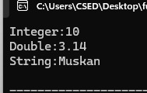
2) Create a class Area with overloaded calculate() functions to calculate the area of a square, rectangle, and circle.
#include<iostream>
using namespace std;
class area {
public:
int calculate(int side)
{
return side*side;
}
int calculate(int length, int breadth)
{
return length*breadth;
}
double calculate(double radius)
{
return 3.14*radius*radius;
}
};
int main() {
area a;
cout<<"Area of Square:"<<a.calculate(10)<<endl;
cout<<"Area of Rectangle:"<<a.calculate(3,4)<<endl;
cout<<"Area of Circle:"<<a.calculate(2.0)<<endl;
return 0;
}
OUTPUT:-
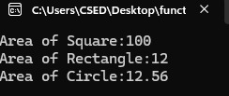
3) Calculate Sum Create a class Calculator with overloaded functions named sum(): • sum(int a, int b) — calculate the sum of two integers. • sum(int a, int b, int c) — calculate the sum of three integers. • sum(double a, double b) — calculate the sum of two decimal numbers. Demonstrate all three overloaded functions using an object of the class.
#include<iostream>
using namespace std;
class calculator {
public:
int sum(int a,int b)
{
return a+b;
}
int sum(int a, int b, int c)
{
return a+b+c;
}
double sum(double a, double b)
{
return a+b;
}
};
int main() {
calculator c;
cout<<"Sum of 2 integers:"<<c.sum(1,0)<<endl;
cout<<"Sum of 3 integers:"<<c.sum(3,4,7)<<endl;
cout<<"Sum of 2 Double integers:"<<c.sum(2.0,9.2)<<endl;
return 0;
}
OUTPUT:-
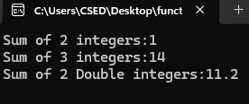
4) Create a class with overloaded result() functions to display marks in one subject, calculate the average of two subjects, and calculate the average of three subjects.
#include<iostream>
using namespace std;
class calculator {
public:
void result(int a)
{
cout<<"Marks in 1 Subject:"<<endl;
}
double result(double a , double b)
{
return (a+b)/2.0;
}
double result(double a, double b, double c)
{
return (a+b+c)/3.0;
}
};
int main() {
calculator c;
cout<<"Average of 2 Subjects:"<<c.result(79,81)<<endl;
cout<<"Average of 3 Subjects:"<<c.result(79,81,86)<<endl;
return 0;
}
OUTPUT:-
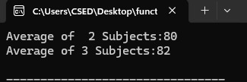
5) Find the Maximum (Moderate) Create a class Maximum with overloaded functions named findMax(): • findMax(int a, int b) — find the greater of two integers. • findMax(int a, int b, int c) — find the greatest of three integers. • findMax(double a, double b) — find the greater of two decimal numbers.
#include<iostream>
using namespace std;
class Maximum {
public:
int findMax(int a, int b)
{
if (a>b)

return a;
else
return b;

}
int findMax(int a, int b,int c)
{
if (a>=b&&a>=c)
return a;
else if(b>=a&&b>=c)
return b;
else
return c;
}
double findMax(double a, double b)
{
if(a>b)
return a;
else
return b;
}
};
int main() {
Maximum m;
cout<<"Maximum of 2 Integers:"<<m.findMax(79,81)<<endl;
cout<<"Maximum of 3 Integers:"<<m.findMax(79,81,86)<<endl;
cout<<"Maximum of 2 Decimals:"<<m.findMax(7.9,8.1)<<endl;
return 0;
}
OUTPUT:-
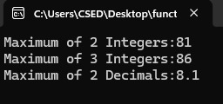
6) Shopping Bill Generator Create a class Bill with overloaded functions named calculateBill() to calculate: • The bill for one item using quantity and unit price. • The bill for two items using their quantities and prices. • The bill for a bill amount after applying a discount percentage. Use suitable parameter lists and return the final bill amount.
#include <iostream>
using namespace std;

class Bill {
public:
double calculateBill(int quantity, double price) {
return quantity * price;
}

double calculateBill(int q1, double p1,
int q2, double p2) {
return (q1 * p1) + (q2 * p2);
}

double calculateBill(double amount, double discount) {
return amount - (amount * discount / 100);
}
};

int main() {
Bill b;

cout << "Bill for one item: Rs. "
<< b.calculateBill(2, 100.0) << endl;

cout << "Bill for two items: Rs. "
<< b.calculateBill(2, 100.0, 3, 50.0) << endl;

cout << "Bill after discount: Rs. "
<< b.calculateBill(500.0, 10.0) << endl;

return 0;
}
OUTPUT:-


