ASSIGNMENT-8
- Write a C++ program to divide two numbers. If the denominator is zero, throw an exception and handle it using try and catch.

#include<iostream>
using namespace std;
int main()
{
int a,b;
cout<<"Enter Two No's:";
cin>>a>>b;
try {
if(b==0)
throw b;
cout<<"Division="<<(float)a/b;
}
catch(int x) {
cout<<"Error Division by zero isn't allowed!";
}
return 0
}
OUTPUT:-
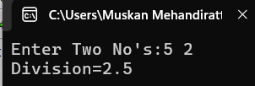
- Write a program to input a person's age. Throw an exception if the age is negative and display an appropriate error message.

#include<iostream>
using namespace std;
int main()
{
int age;
cout<<"Enter age";
cin>>age;
try {
if(age<0)
throw age;
cout<<"Age="<<age;
}
catch(int x) {
cout<<"Error Age cannot be Negative!";
}
return 0;
}
OUTPUT:-
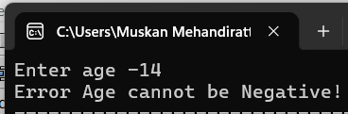
- Write a program that accepts an integer and throws different exceptions if the number is negative or greater than 100. Handle both exceptions separately.
#include<iostream>
using namespace std;
int main()
{
int n;
cout<<"Enter a Number:";
cin>>n;
try {
if(n<0)
throw 1;
else if(n>100)
throw 2;
cout<<"Valid Number:"<<n;
}
catch(int x) {
if(x==1)
cout<<"Error Number is Negative!";
else if(x==2)
cout<<"Error Number is > than 100!";
}
return 0;
}
OUTPUT:-
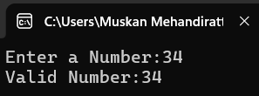
- Write a program to access an element of an array. Throw and handle an exception if the entered index is outside the valid range.
#include<iostream>
using namespace std;
int main()
{
int arr[100]={10,20,30,40,50,60};
int index;
cout<<"Enter array index(0-5):";
cin>>index;
try {
if(index<0||index>=5)
throw index;
cout<<"Element:"<<arr[index];
}
catch(int x) {
cout<<"Error Invalid Array Index!";
}
return 0;
}
OUTPUT:-
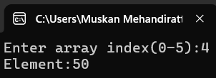
- Create a class LibraryAccount with a data member availableBooks and a function issueBook(). Throw an exception if the withdrawal amount exceeds the available balance.
#include<iostream>
using namespace std;
class LibraryAccount {
int availableBooks;
public:
LibraryAccount(int b) {
availableBooks=b;
}
void issueBook(int n) {
try {
if(n>availableBooks)
throw n;
availableBooks=availableBooks-n;
cout<<"Books issued successfully!"<<endl;
cout<<"Remaining books:"<<availableBooks;
}
catch(int x) {
cout<<"Error Not enough books available!";
}
}
};
int main() {
LibraryAccount obj(10);
int n;
cout<<"Enter number of books to issue:";
cin>>n;
obj.issueBook(n);
return 0;
}
OUTPUT:-
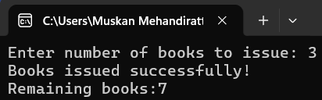
- Create a class Student that accepts marks in five subjects. Throw exceptions if any mark is outside the range 0–100. Handle invalid input and display the average only when all marks are valid.
#include<iostream>
using namespace std;
class Student {
int marks[5];
public:
void inputMarks() {
int sum=0;
try {
cout<<"Enter marks of 5 Subjects:"<<endl;
for(int i=0;i<5;i++)
{
cin>>marks[i];
if(marks[i]<0||marks[i]>100)
throw marks[i];
sum=sum+marks[i];
}
cout<<"Average Marks="<<sum/5.0;
}
catch(int x) {
cout<<"Error Invalid Marks!"<<x;
cout<<"Marks must be btw 0 and 100!";
}
}
};
int main() {
Student s;
s.inputMarks();
return 0;
}
OUTPUT:-


