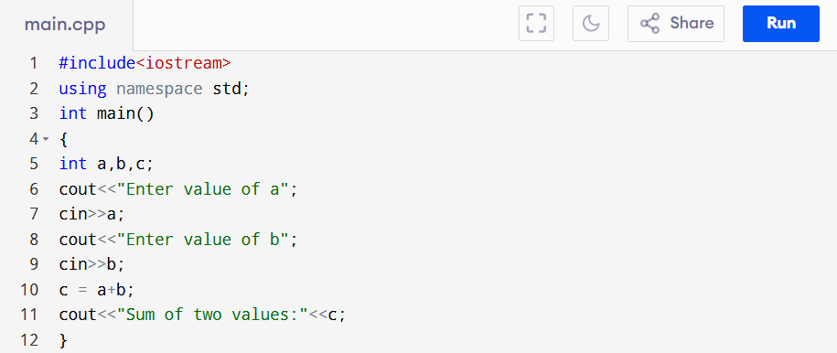
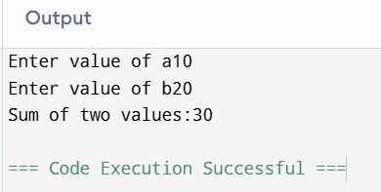
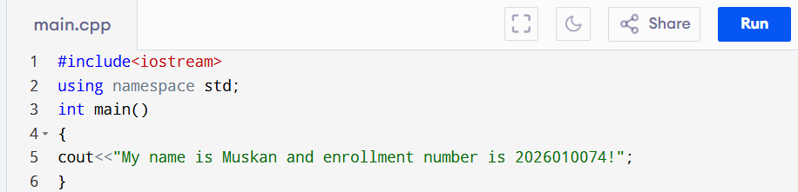
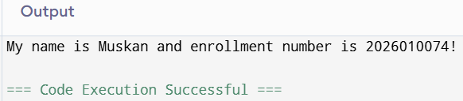
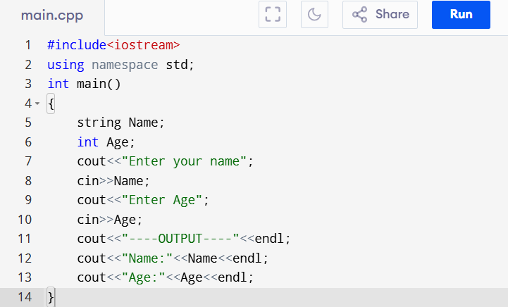
#include<iostream>
using namespace std;
int main()
{
string Name;
int Age;
cout<<"Enter your name";
cin>>Name;
cout<<"Enter Age";
cin>>Age;
cout<<"----OUTPUT----"<<endl;
cout<<"Name:"<<Name<<endl;
cout<<"Age:"<<Age<<endl;
}
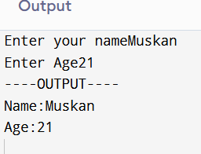
#include<iostream>
using namespace std;
int main()
{
int num;
cout<<"Enter number";
cin>>num;
if(num % 2==0)
cout<<"Number is Even";
else
cout<<"Number is Odd";
return 0;
}
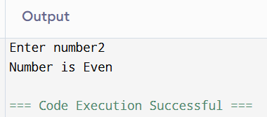
#include<iostream>
using namespace std;
int main()
{
int day;
cout<<"Day number";
cin>>day;
switch(day)
{
case 1:
cout<<"MONDAY";
break;
case 2:
cout<<"TUESDAY";
break;
case 3:
cout<<"WEDNESDAY";
break;
case 4:
cout<<"THURSDAY";
break;
case 5:
cout<<"FRIDAY";
break;
case 6:
cout<<"SATURDAY";
break;
case 7:
cout<<"SUNDAY";
break;
default:
cout<<"Invalid Day";
return 0;
}
}
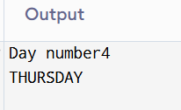
[1] #include<iostream>
using namespace std;
int main()
{
cout<<"Hello World!"<<endl;
}
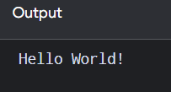
[2] #include<iostream>
using namespace std;
int main()
{
int C,F;
cout<<"Temperature in celsius"<<endl;
cin>>C;
F=(9*C)/5+32;
cout<<"Temperature in Fahrenheit:"<<F<<endl;
return 0;
}
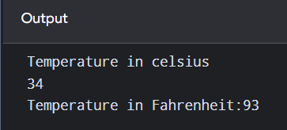
[3] #include<iostream>
using namespace std;
int main()
{
int num;
for(int i=0;i<10;i++)
{
cout<<i;
}
cout<<endl;
int i = 0;
for(;i<10;i++)
{
cout<<i;
}
cout<<endl;
i=0;
for(;i<10;)
{
cout<<i;
i++;
}
return 0;

}
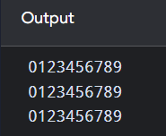
#include<iostream>
using namespace std;
int main()
{
int i;
while(i<=10)
{
cout<<i<<" ";
i++;
}
cout<<endl;
i=0;
while(i<=10)
{
i++;
cout<<i<<" ";
}
cout<<endl;
i=10;
while(i>=0)
{
cout<<i<<" ";
i--;
}
return 0;
}

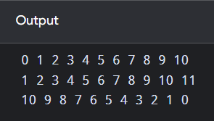
#include<iostream>
using namespace std;
int main()
{
int i;
do{
cout<<i;
i++;
}
while(i<=10);
cout<<endl;
i=10;
do{
cout<<i;
i--;
}
while(i>=0);
cout<<endl;
return 0;
}
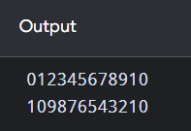
[4] #include<iostream>
using namespace std;
struct student
{
string Name;
int RollNo;
string Degree;
string Hostel;
float CurrentCGPA;
void addDetails()
{
cout << "Enter Name: ";
cin >> Name;

cout << "Enter Roll No: ";
cin >> RollNo;

cout << "Enter Degree: ";
cin >> Degree;

cout << "Enter Hostel: ";
cin >> Hostel;

cout << "Enter Current CGPA: ";
cin >> CurrentCGPA;
}

void updateDetails()
{
cout << "Enter New Name:"<<endl;
cin >> Name;

cout << "Enter New Roll No: ";
cin >> RollNo;

cout << "Enter New Degree: ";
cin >> Degree;
}

void updateCGPA()
{
cout << "\nEnter New CGPA: ";
cin >> CurrentCGPA;
}

void updateHostel()
{
cout << "\nEnter New Hostel: ";
cin >> Hostel;
}

void displaydetails()
{
cout << "\n----- Student Details -----" << endl;
cout << "Name: " << Name << endl;
cout << "Roll No: " << RollNo << endl;
cout << "Degree: " << Degree << endl;
cout << "Hostel: " << Hostel << endl;
cout << "Current CGPA: " << CurrentCGPA << endl;
}
};

int main()
{
student s;
s.addDetails();
cout << "\nOriginal Details:";
s.displaydetails();
s.updateDetails();
s.updateCGPA();
s.updateHostel();
cout << "\nUpdated Details:";
s.displaydetails();
return 0;
}
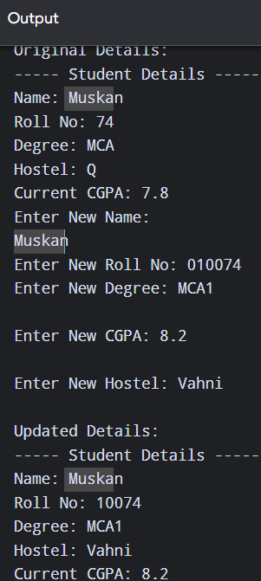
[5]
Public | Private
Members can be accessed from outside the class. | Members cannot be accessed directly from outside the class.
Declared using public: | Declared using private:
Used when we want to allow outside access. | Used for data hiding.
Public functions can be called from main(). | Private functions can only be called inside the class.
Example: s.displayDetails(); | Example: s.name; if name is private.
In a class, members are private by default unless specified otherwise. | In a class, this is the default access level.
FOR EXAMPLE: class Student
{
private:
string name;
float cgpa;

public:
void display()
{
cout << name << " " << cgpa;
}
};
CODE:
#include <iostream>
using namespace std;

class Student
{
private:
string name;
int rollNo;
string degree;
string hostel;
float currentCGPA;

void updateDetails()
{
cout << "Enter New Name: ";
cin >> name;

cout << "Enter New Degree: ";
cin >> degree;
}

public:

void addDetails()
{
cout << "Enter Name: ";
cin >> name;

cout << "Enter Roll No: ";
cin >> rollNo;

cout << "Enter Degree: ";
cin >> degree;

cout << "Enter Hostel: ";
cin >> hostel;

cout << "Enter CGPA: ";
cin >> currentCGPA;
}

void updateCGPA()
{
cout << "Enter New CGPA: ";
cin >> currentCGPA;
}

void updateHostel()
{
cout << "Enter New Hostel: ";
cin >> hostel;
}

void displayDetails()
{
cout << "\n--- Student Details ---" << endl;
cout << "Name: " << name << endl;
cout << "Roll No: " << rollNo << endl;
cout << "Degree: " << degree << endl;
cout << "Hostel: " << hostel << endl;
cout << "CGPA: " << currentCGPA << endl;
}

void updateAll()
{
updateDetails();
updateCGPA();
updateHostel();
}
};

int main()
{
Student s;

s.addDetails();

cout << "\nOriginal Details:" << endl;
s.displayDetails();

s.updateAll();

cout << "\nUpdated Details:" << endl;
s.displayDetails();

return 0;
}
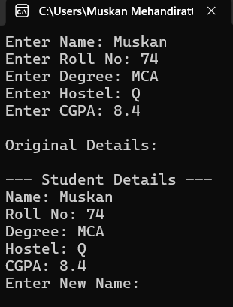
6.)
#include <iostream>
using namespace std;

class Student
{
private:

void privateFunction()
{
cout << "Private function is called." << endl;
}

public:

void publicFunction()
{
cout << "Public function is called." << endl;
privateFunction();
}
};

int main()
{
Student s;

s.publicFunction();

return 0;
}
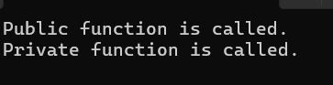
7.) #include<iostream>
using namespace std;

class Complex
{
private:
int real, imaginary;

public:
void set()
{
cout << "Enter real part: ";
cin >> real;

cout << "Enter imaginary part: ";
cin >> imaginary;
}

void display()
{
cout << real << " + " << imaginary << "i" << endl;
}

Complex sum(Complex c)
{
Complex temp;

temp.real = real + c.real;
temp.imaginary = imaginary + c.imaginary;

return temp;
}
};

int main()
{
Complex c1, c2, c3;

cout << "Enter first complex number:" << endl;
c1.set();

cout << "Enter second complex number:" << endl;
c2.set();

c3 = c1.sum(c2);

cout << "First complex number: ";
c1.display();

cout << "Second complex number: ";
c2.display();

cout << "Sum: ";
c3.display();

return 0;
}
OUTPUT:-
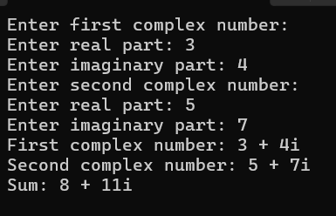
8.) #include<iostream>
using namespace std;

namespace First
{
int x = 10;

void display()
{
cout << "First namespace: " << x << endl;
}
}

namespace Second
{
int x = 20;

void display()
{
cout << "Second namespace: " << x << endl;
}
}

int main()
{
First::display();
Second::display();

cout << "First x = " << First::x << endl;
cout << "Second x = " << Second::x << endl;

return 0;
}
OUTPUT:-


