ASSIGNMENT-2
1). .#include <iostream>
using namespace std;
class Student
{
string name;
int rollNo;
public:
Student()
{
name = "Muskan";
rollNo = 74;
}
void display()
{
cout << "Student Name: " << name << endl;
cout << "Roll No: " << rollNo << endl;
}
};
int main()
{
Student s;
s.display();
return 0;
}
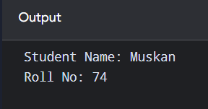
2). #include <iostream>
using namespace std;

class Rectangle
{
int length;
int breadth;

public:
Rectangle(int l, int b)
{
length = l;
breadth = b;
}

void displayArea()
{
int area = length * breadth;
cout << "Area of Rectangle = " << area << endl;
}
};

int main()
{
Rectangle r(10, 5);

r.displayArea();

return 0;
}
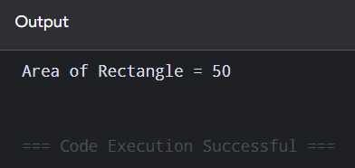
3). #include <iostream>
using namespace std;

class Employee
{
string name;
int id;
float salary;

public:

Employee(string n, int i, float s)
{
name = n;
id = i;
salary = s;
}

void display()
{
cout << "Employee Name: " << name << endl;
cout << "Employee ID: " << id << endl;
cout << "Employee Salary: " << salary << endl;
}
};

int main()
{

Employee e("Muskan", 74, 50000);
e.display();

return 0;
}

4). #include <iostream>
using namespace std;

class Box
{
int length;
int width;
int height;

public:

Box()
{
length = 1;
width = 1;
height = 1;
}

Box(int l, int w, int h)
{
length = l;
width = w;
height = h;
}

// Function to calculate and display volume
void displayVolume()
{
int volume = length * width * height;
cout << "Volume of Box = " << volume << endl;
}
};

int main()
{

Box b1;
cout << "Using Default Constructor:" << endl;
b1.displayVolume();

Box b2(10, 5, 4);
cout << "Using Parameterized Constructor:" << endl;
b2.displayVolume();

return 0;
}
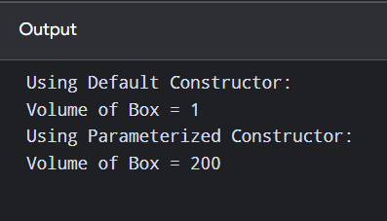
5. #include<iostream>
using namespace std;
class student
{
string name;
int rollno;
float cgpa;
public:
student()//default constructor
{
name="UNKNOWN";
rollno=0;
cgpa=0.0;
}
student(string n, int r)//name and rollno
{
name=n;
rollno=r;
cgpa=0.0;
}
student(string n,int r,float c)//name and rollno and cgpa
{
name = n;
rollno = r;
cgpa = c;
}
void display()
{
cout<<"Name:"<<name<<endl;
cout<<"RollNo:"<<rollno<<endl;
cout<<"CGPA:"<<cgpa<<endl;
}
};
int main()
{
student s1;
student s2("Muskan",101);
student s3("Muskan",101,8.5);
cout << "Student 1:" << endl;
s1.display();
cout << "Student 2:" << endl;
s2.display();
cout << "Student 3:" << endl;
s3.display();

return 0;
}
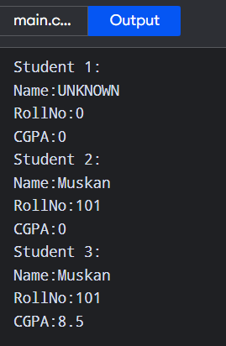
6. #include<iostream>
using namespace std;
class complex
{
float real;
float imaginary;
public:
complex()
{
real =0.0;
imaginary =0.0;
}
complex(float r, float i)
{
real =r;
imaginary =i;
}
void display()
{
cout<<"Complex Number:"<<real<<"+"<<imaginary<<"i"<<endl;
}
};
int main()
{
complex c1;
complex c2(5,3);
cout<<"Using Default Constructor:"<<endl;
c1.display();
cout<<"Using Parameterized Constructor:"<<endl;
c2.display();
return 0;
}
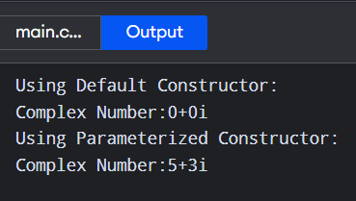
7. #include<iostream>
using namespace std;
class demo
{
public:
demo()
{
cout<<"Constructor called:"<<endl;
}
~demo()
{
cout<<"Destructor called:"<<endl;
}
};
int main()
{
demo obj1;
demo obj2;
demo obj3;
return 0;
}
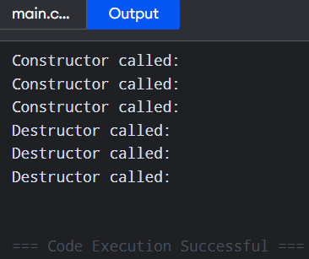
8. #include<iostream>
using namespace std;
class demo
{
public:
demo()
{
cout<<"Constructor called:"<<endl;
}
~demo()
{
cout<<"Destructor called:"<<endl;
}
};
void createObject()
{
demo obj2;
cout<<"Inside separate Function"<<endl;
}
int main()
{
cout<<"Inside Main"<<endl;
demo obj1;
cout<<"Calling separate Function"<<endl;
createObject();
cout<<"Back in main"<<endl;
return 0;

}


