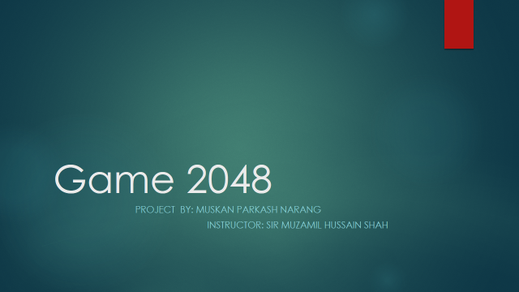

**INTRODUCTION:**

2048 is a single-player sliding block puzzle game designed by Italian web developer Gabriele Cirulli. The game's objective is to slide numbered tiles on a grid to combine them to create a tile with the number 2048. However, one can continue to play the game after reaching the goal, creating tiles with larger numbers. Solving this game is an interesting problem because it has a random component. It's impossible to correctly predict not only where each new tile will be placed.

**Benefits of playing 2048 game.**

• It teaches you to estimate, think quickly and strategize by planning your next moves and considering how it will affect the board and which combination of movements will have the desired outcome.

• It’s a single player game which means you can constantly challenge yourself to a better score.

 It offers hours of fun so you’ll never be bored.

• You decide how you want to pace it and because games are quick and easy to follow, there is no need to worry about losing game progress.

• The game is small and does not take up much space or data on your phone.

**Project libraries;**

import java.awt.Canvas;

import java.awt.Color;

import java.awt. Dimension;

import java.awt.Font;

import java.awt.Graphics2D;

import java.awt.image.BufferStrategy;

import java.awt.image.BufferedImage;

import java.awt.image.DataBufferInt;

import javax.swing.*;

import java.util.Random;

import java.awt.Color;

import java.awt.RenderingHints;

import java.awt.event.KeyEvent;

import java.util.ArrayList;

import java.util.List;

1. I will change all the graphics of the game.
2. As we know this game is made of 4x4 so i will convert this game into 5x5 or 6x6 boxes.
3. I can use different tile values other than power of 2. Like power of 3 ,4, 5.
4. I will change the name of game.
5. The code that I have , in this there is no proper setup like in this , there is not score board or how much moves we have made.. so I will implement that.
6. The highest score would be in this game exactly that you made,
7. When you lose the game, there would be message box. Try again or something like this..
8. I will change keys of playing game. There is s,a,d,w keys for playing game and it is complex to play so I will convert it into arrow keys.
9. I will speed of object that is too slow.
10. There will be other little changes.

To play this game, player must use the LEFT, RIGHT, UP, DOWN arrow keys to move tiles and try to collision the same two numbers, which will result in creation of new tile with entire sum of two numbers/tiles.