RoadGuard AI: An AI-Based Road Damage Detection, Centralized Reporting, and Inspection Prioritization System

Muskan Gupta  Computer Science and Engineering  (Data Science)  GL Bajaj  Greater Noida  muskangupta5465@gmail.com | Mansi Agarwal  Computer Science and Engineering  (Data Science)  GL Bajaj  Greater Noida  Mansiagarwal.9700@gmail.com | Pragya Rajput  Computer Science and Engineering  (Data Science)  GL Bajaj  Greater Noida  Pragyarajput7789@gmail.com

ABSTRACT

Road surface damage such as potholes and cracks affects safety and raises maintenance costs, yet inspection in many places still depends on manual surveys and citizen complaints that are slow and hard to prioritise. This paper proposes RoadGuard AI, a web-based decision-support system that lets users submit road photographs with a location, uses a YOLO-family object detector to suggest the type and position of visible damage, stores each submission as a structured report, requires verification by a human inspector, and ranks verified reports with a transparent inspection-priority score, P = 0.50S + 0.30R + 0.20W, where S, R, and W are severity, road-risk, and waiting/duplicate-report scores on a 0–100 scale. The paper describes the workflow, system architecture, database design, dataset and training strategy, priority mechanism, and a planned evaluation. Its contribution is the design of the end-to-end pipeline and of an explainable, auditable ranking rule, not an experimental result. RoadGuard AI is currently at the planning stage: no model has been trained, no application has been implemented, and no measured results are reported. The priority weights are preliminary design assumptions that must be validated with domain experts.
Index Terms—Road damage detection, pothole detection, computer vision, deep learning, YOLO, inspection prioritization, decision-support systems.
I. Introduction

- Background and Motivation

Roads deteriorate under traffic loads, ageing materials, and weather. The resulting cracks and potholes can contribute to accidents, increase vehicle wear, and make travel uncomfortable [1]. Keeping a road network in acceptable condition therefore depends on two decisions: finding damage early, and choosing which locations to repair first when staff and budget are limited.
In practice, finding damage often starts with visual inspection, which is relatively inexpensive but subjective and labour-intensive [1]. Specialised survey vehicles fitted with laser scanners, profilers, and cameras can collect better data, but many municipalities and road agencies lack the technology,

know-how, and funds for such equipment [2]. A cheaper alternative is to use ordinary smartphone images. Maeda et al. showed that a deep object-detection model trained on smartphone images captured from a car can locate and classify road damage, and they released a dataset of 9,053 images with 15,435 annotated damage instances [3]. Later work extended the idea to images from several countries and built public challenges around them [4]–[6].

- Problem Context

Accurate detection is only the first step. Maeda et al. point out that road managers need to understand the type of damage in order to take effective action [3]. An agency also has to decide which of many incoming reports deserves an inspector's visit first. In the literature we reviewed, most work concentrates on detection models and datasets, whereas the surrounding workflow receives less attention: how reports are collected, how a person checks them, how they are stored, and how they are ordered for inspection. Prioritisation methods exist [1], but they are typically presented separately from learned detectors, and we did not find a published description that joins image-based detection, human verification, and an explainable ranking in one reporting pipeline. This is a statement about the sources we examined, not a claim that no such system exists.

- Project Overview and Contributions

This paper presents RoadGuard AI, a proposed web-based system for road-damage reporting and inspection prioritisation. A reporter uploads a road photograph with a location. A detection service suggests the damage type and position. The suggestion is stored as a draft report, an inspector confirms or corrects it, and a priority score then places the report in a ranked queue on a dashboard. The contributions of this paper are: (i) an end-to-end workflow in which AI output is always a suggestion that a person verifies; (ii) a modular architecture and database design that supports this workflow; (iii) an explainable inspection-priority score whose inputs, scales, and weights are visible to the user; and (iv) a staged evaluation plan covering detection quality, system behaviour, robustness, and agreement with expert rankings. Fig. 1 gives an overview of the proposed architecture, which Section V describes in detail.
RoadGuard AI is at the planning stage. We have not implemented the application, trained a model, or run experiments, and no measured result appears in this paper. We use proposed language throughout and separate findings reported by earlier researchers from features that we propose.
The rest of the paper is organised as follows. Section II reviews related work. Section III states the problem and objectives. Sections IV and V describe the methodology and architecture. Section VI covers the dataset and training strategy, Section VII the priority mechanism, and Section VIII the evaluation methodology. Section IX presents expected outcomes and the planned evaluation, Section X discusses limitations and future work, and Section XI concludes.
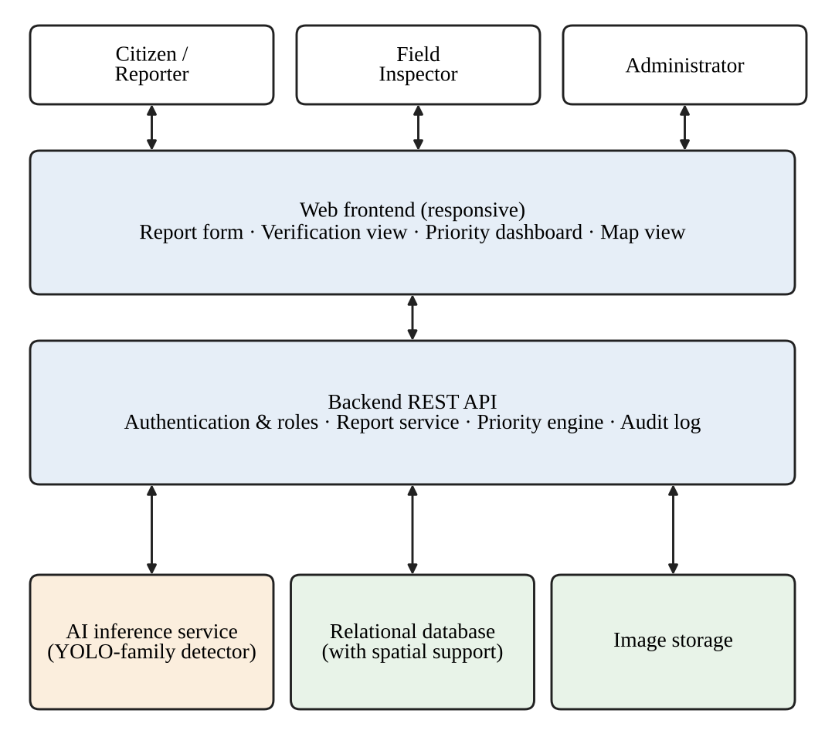
Fig. 1. Proposed RoadGuard AI system architecture.

II. Related Work

- Deep-Learning-Based Road Damage Detection

Many early studies asked only whether damage was present in an image. Maeda et al. argued that this is not enough for road managers and trained a detector that returns both the location and the type of damage; their dataset distinguishes eight damage categories, and they compared accuracy and running time on a GPU server and on a smartphone [3].
Object detectors fall into two broad families. Two-stage detectors such as Faster R-CNN first propose candidate regions with a region proposal network and then classify them [7]. One-stage detectors such as YOLO treat detection as a single regression problem from the full image to bounding boxes and class probabilities, which makes them fast; the original YOLO model processed images at 45 frames per second [8]. A Mask R-CNN solution submitted to the 2018 IEEE Big Data Cup reported a mean F1 score of 0.528 at an intersection-over-union (IoU) threshold of 50% and about 0.105 s per image on an NVIDIA GTX 1080 Ti [9]. In the 2020 Global Road Damage Detection Challenge (GRDDC), the best of the top 12 submissions used a YOLO-based ensemble and reached F1 scores of 0.67 and 0.66 on the two test sets [5]. YOLOv8 is distributed through the Ultralytics software package [10]; Ultralytics asks users to cite the software because no separate paper was published for this version, so we cite it as software.

- Datasets and Cross-Country Generalisation

RDD2020 contains 26,336 images from India, Japan, and the Czech Republic with more than 31,000 damage instances in four classes: longitudinal cracks (D00), transverse cracks (D10), alligator cracks (D20), and potholes (D40) [4]. Arya et al. studied how a model trained in one country performs in others and proposed models that work across more than one country [2], [11]. RDD2022 extends the collection to 47,420 images from six countries (Japan, India, the Czech Republic, Norway, the United States, and China) with more than 55,000 annotated instances of the same four damage types, and the data article reports an F1 score of 76.9% for the best model of the associated 2022 challenge across all six countries [6]. The 2024 optimised-detection challenge again used RDD2022 [6], [12]. Federated learning across heterogeneous global road-damage datasets has also been explored [13], which is relevant if agencies cannot share raw images. These studies make clear that cross-country generalisation is hard: models that work well on one data source cannot be assumed to work equally well on another [2], [11].

- Maintenance Prioritisation and Decision Support

Deciding where to repair first is a multi-criteria decision. Fawzy et al. combined image processing, used to quantify pavement distress, with the Analytic Hierarchy Process (AHP) to rank distress types by severity and by impact on road users [1]. AHP derives criterion weights from pairwise expert comparisons and checks them with a consistency ratio, where a value below 0.10 is conventionally considered acceptable [1], [14]. The same paper summarises earlier AHP studies that used criteria such as crack severity, traffic volume, road-network importance, and economic cost [1]. Their own method relies on classical image processing (edge detection and morphological operations) rather than a learned detector, was demonstrated on a 1 km road section using 38 images, and is reported by the authors to reach about 95% accuracy [1]. They also note that, in practice, automated methods are suited to large-scale screening while human inspection is preferred for verification [1], an observation that supports the human-in-the-loop design adopted here.

- Summary and Research Gap

Table I summarises the studies discussed above. The findings listed are those reported by the cited authors; we did not reproduce any of them. Detection research provides datasets, models, and benchmarks. Prioritisation research provides decision rules. RoadGuard AI proposes to connect the two in one workflow that keeps a human verifier between the detector and the ranking, and that exposes the ranking logic to its users. We do not claim that it will outperform any system in Table I; its contribution is the integration and its explainable design, both of which remain to be evaluated.

Table I
Comparison of Relevant Existing Research
Ref. | Focus and data | Reported finding | Relevance to RoadGuard AI
[3] | Smartphone images from cars; 9,053 images, 15,435 instances | Detector locates and classifies damage (eight types); GPU and smartphone speed compared | Basis for image-based reporting; detection only
[9] | Mask R-CNN, 2018 Big Data Cup | Mean F1 0.528 at IoU 50%; 0.105 s/image on GTX 1080 Ti | Two-stage baseline; shows speed/accuracy trade-off
[5] | GRDDC 2020 summary; 26,336 images, three countries | Best entry, YOLO ensemble: F1 0.67 and 0.66 on two test sets | Shows YOLO-family suitability and task difficulty
[2], [11] | Multi-country models; India, Japan, Czech Republic | Models proposed for more than one country; transfer of the Japanese model assessed | Motivates local validation data
[6] | RDD2022; 47,420 images, six countries, >55,000 instances | Best 2022 challenge model: F1 76.9% over all six countries | Primary candidate dataset
[1] | Image processing + AHP; 1 km section, 38 images | Authors report about 95% accuracy; AHP ranks distress types | Prioritisation precedent; no deep detector
[13] | Federated learning over heterogeneous global datasets | Explored for road-damage detection | Possible future privacy-preserving training

III. Problem Statement and Research Objectives

- Problem Statement

Road-maintenance staff receive information about damage from several channels, including inspections, complaints, and photographs, usually without a common structure. Reports differ in quality, may be duplicated, and carry no consistent measure of urgency. Automated detection can reduce the effort of reading images, but detector output is imperfect and cannot by itself tell staff which report to handle first. The specific problem addressed here is how to turn image-based reports into verified, structured records and order them for inspection in a way that is consistent, traceable, and understandable to the people who must act on it.

- Research Question

The central research question is: can a detection-assisted, human-verified reporting workflow combined with an explainable weighted priority score give maintenance staff a consistent and understandable ordering of road-damage reports? It is divided into three sub-questions. RQ1: how well can a YOLO-family detector trained on public data identify the four RDD2022 damage classes in images similar to those a reporter would submit? RQ2: does the end-to-end pipeline behave reliably and respond quickly enough for interactive use? RQ3: how closely does the priority ranking agree with the ordering chosen by experienced road-maintenance engineers?

- Objectives

The objectives are: (O1) design a reporting workflow that accepts a photograph and a location and produces a structured report; (O2) specify a modular architecture with separate frontend, backend, inference service, and database; (O3) define a training and validation strategy for a road-damage detector using public data; (O4) define an explainable priority score and a procedure for validating it; (O5) define a human-verification step with an audit trail; and (O6) define an evaluation plan for detection quality, runtime behaviour, robustness, and ranking agreement.

- Scope and Assumptions

The scope is limited to single-image reports of surface damage on paved roads, using the four damage classes of RDD2022 [6]. RoadGuard AI is intended to support inspectors, not to replace them, and it does not estimate structural condition, repair cost, or depth. Video input, automatic work-order dispatch, and integration with municipal asset-management systems are outside the present scope. We assume that location can be obtained from the device or entered on a map, that inspectors are available to verify reports, and that a limited pilot area will be chosen for later validation.

- Functional and Non-Functional Requirements

The functional requirements follow from the objectives. A reporter can submit an image and a location. The system returns draft detections. An inspector can confirm, correct, or reject them. The system computes and stores a priority score together with its components. Staff can filter and sort the queue and change report status, and administrators can manage users and roles. The non-functional requirements are: understandable output, meaning that every score must be explainable; traceability, meaning that every decision is logged; responsiveness suitable for interactive use; maintainability through separable components; and protection of personal data. Specific response-time targets will be set after baseline measurements, not before.
IV. Proposed Methodology

- Overview

Fig. 2 shows the proposed end-to-end workflow. A report passes through six stages: submission and validation, AI detection, report storage, human verification, priority calculation, and dashboard operation. The detector never acts on its own; every report that enters the ranked queue has been confirmed by an inspector.
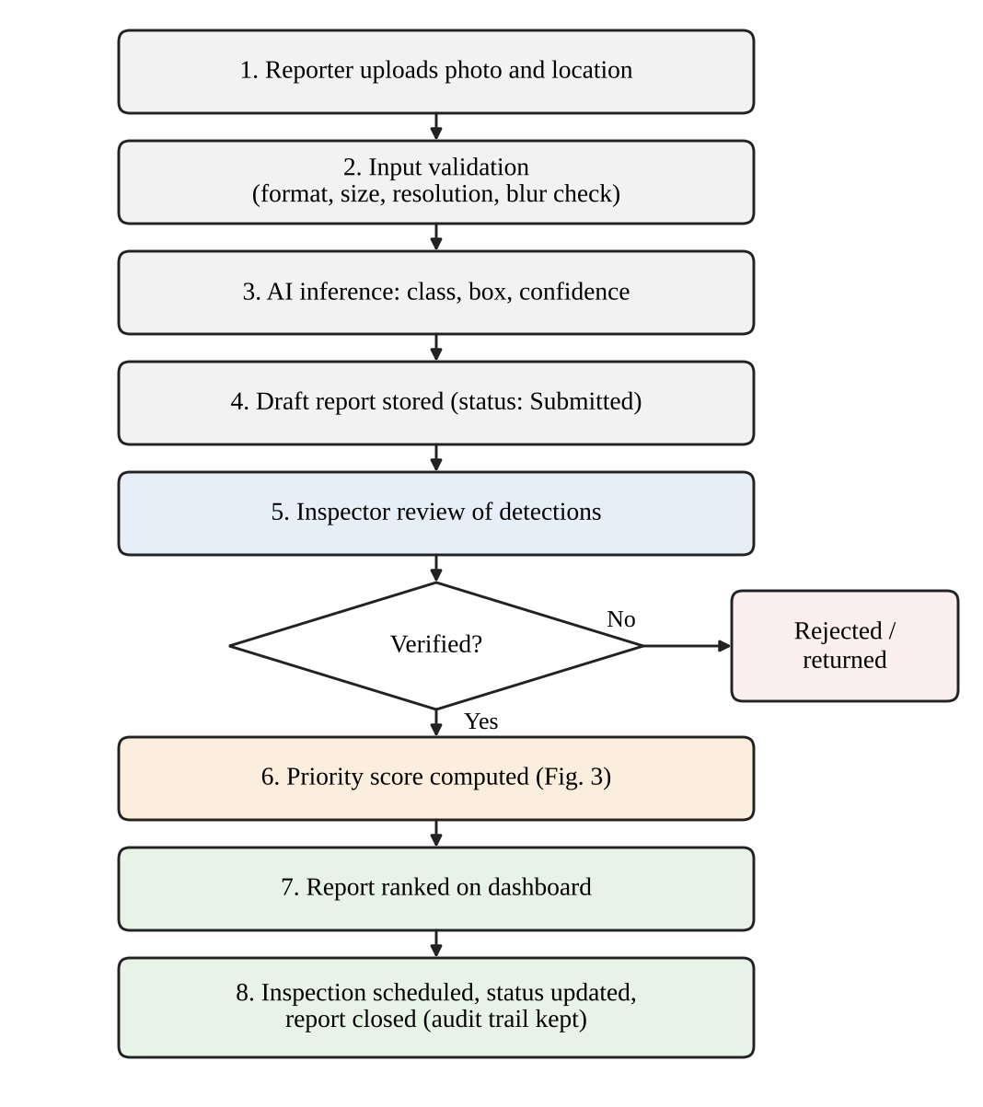
Fig. 2. Proposed end-to-end road-damage reporting and verification workflow.

- Image Submission and Validation

A reporter takes a photograph with the device camera or selects one from the gallery, confirms the location (device GPS or a pin placed on a map), and may add a short description. Before inference, the backend checks the file type, file size, and minimum resolution, and runs a simple sharpness test such as the variance of the Laplacian to warn about heavily blurred images. These thresholds are not fixed yet; they will be tuned on sample images during development. To limit privacy risk, the system will keep the coordinates the reporter confirms rather than the full camera metadata, and the interface will advise users not to include faces or vehicle registration plates.
- Detection Workflow

The validated image is sent to an inference service that returns, for each detection, a damage class, a bounding box, and a confidence score. We propose two confidence thresholds. Detections above the upper threshold are pre-selected as suggestions, those between the two thresholds are shown with a warning, and detections below the lower threshold are discarded. If nothing passes the lower threshold, the report is not silently dropped: it is marked "no damage detected" and remains in an inspector's review list, so that false negatives can be caught by a person. The threshold values will be chosen on a validation set after the baseline model is trained.

- Report Storage and Status Lifecycle

Each submission becomes a report record linked to its image, location, detections, and reporter. We propose the status lifecycle Submitted, Under review, Verified or Rejected, Scheduled, Inspected, and Closed. Every status change is stored with the user and a timestamp, giving an audit trail that supports later accountability and evaluation.

- Human Verification

An inspector opens a report, sees the image with the suggested boxes, and can confirm the detection, change the class, adjust or add a box, or reject the report with a reason. Corrections are stored separately from the original model output. With the reporter's consent and appropriate data governance, they could later serve as additional labelled data for retraining, which is listed as future work.

- Duplicate Handling

Several people may report the same damage. Verified reports of the same class within a small radius (we propose starting with about 15 m) will be grouped into one cluster using a spatial index. The number of independent reports in a cluster is later used in the waiting/duplicate component of the priority score. The radius is a provisional parameter that must be checked against GPS accuracy in the pilot area.

- Priority Calculation and Dashboard Operation

When a report is verified, the backend computes its priority score (Section VII) and stores it with its three components. The dashboard lists verified reports in descending order of score, offers map and filter views by status, area, and damage class, and shows a breakdown of each score so that the inspector can see why a report is ranked where it is. Fig. 3 summarises this calculation and display.
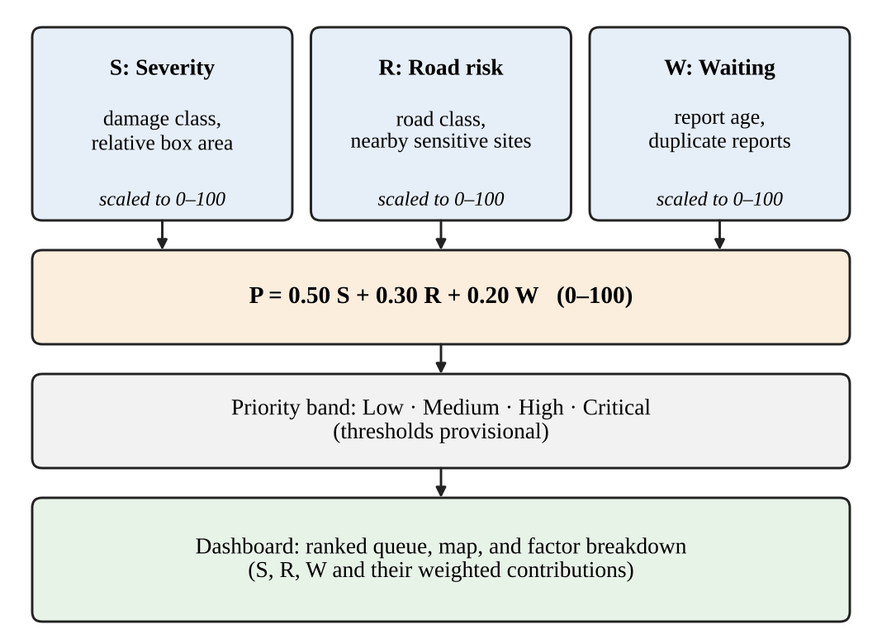
Fig. 3. Proposed inspection-priority calculation and dashboard workflow.

- Illustrative Usage Scenario

Consider a hypothetical case. A resident photographs a pothole near a school gate and submits it from a phone. The image passes validation, and the detector proposes one pothole with moderate confidence. The report appears in an inspector's review list with the box drawn on the image. The inspector confirms the class, slightly enlarges the box, and verifies the report. The priority engine notes the school nearby and a second resident's report of the same pothole in the cluster, computes the score, and moves the report up the queue. The inspector schedules a visit and later closes the report with a note, and every step is recorded in the status history. This scenario illustrates the intended design; it is not an observation from a deployed system.
V. System Architecture and Implementation Design

- Architectural Overview

As Fig. 1 shows, three user roles interact with a web frontend, which communicates with a backend application programming interface (API). The backend coordinates three supporting components: the AI inference service, a relational database with spatial support, and image storage. Keeping the inference service behind its own interface means that the detector can be replaced or retrained without changing the rest of the system.

- Components and Technologies

Table II lists the proposed components and candidate technologies. These are design choices made for familiarity, community support, and fit with the workflow; none has been implemented yet, and alternatives may be substituted during development.
Table II
Proposed System Components and Technologies
Component | Proposed technology | Responsibility
Frontend | React single-page web app (responsive) | Report form, map, verification view, dashboard
Backend API | Python with FastAPI (REST) | Authentication, report logic, priority engine, audit log
AI inference | Ultralytics YOLO model [10] on PyTorch | Return class, box, and confidence for each image
Database | PostgreSQL with PostGIS | Structured records, spatial queries, duplicate clustering
Image storage | Object storage or server file system | Original and annotated images
Security | HTTPS, token-based auth, role checks | Protect data and restrict actions by role
Deployment | Docker containers | Reproducible setup for development and pilot

- Data Flow

The frontend sends the image and location to the backend, which validates and stores the image and forwards a copy to the inference service. The service returns detections, which the backend saves as a draft report. During verification, the frontend retrieves the report and image, and the inspector's decision is written back as a verification record. On confirmation the priority engine reads the verified detections, the location attributes, and the duplicate cluster, computes the three components and the final score, and stores them. The dashboard queries the stored scores and the status history.

- Database Entities

Table III lists the main database entities. The separation between detections and verifications is deliberate: it preserves the original model output next to the human decision, which is needed for evaluation and for any future retraining.

Table III
Database Entities and Their Responsibilities
Entity | Main attributes | Responsibility
User | id, role, contact, status | Identity and role-based access
Report | id, location, description, status, cluster id | Core record of one submission
Image | report id, file path, size, resolution | Link to the stored photograph
Detection | report id, class, box, confidence, model version | Original model output
Verification | report id, inspector, decision, corrected class/box | Human decision kept beside model output
PriorityRecord | report id, S, R, W, P, band, timestamp | Score and its components for explanation
StatusHistory | report id, old/new status, user, time | Audit trail
RoadSegment | id, road class, geometry, nearby sites | Context for the road-risk score

- Security and Privacy Considerations

Reports contain locations and photographs that may show people or vehicles. We propose role-based access control, encrypted transport, validation and size limits on uploads, rate limiting to reduce spam, and restricted visibility of reporter identity. Retention periods and access rules for stored images should follow the policies of the deploying agency and applicable data-protection rules.

- Proposed Interface Design

The backend would expose a small set of REST endpoints: creating a report with an image upload; retrieving a report with its detections and priority record; submitting a verification decision; listing reports with filters for status, area, damage class, and priority band; and updating report status. Every endpoint requires authentication and checks the caller's role before acting. The inference service would expose one internal endpoint that accepts an image and returns detections together with a model version identifier. The identifier is stored with each detection so that a result can always be traced to the model that produced it.

- Non-Functional Design Goals

Inference is the most expensive step, so the inference service can be scaled separately from the rest of the application, and incoming requests can be queued so that a burst of uploads does not block other users. If the inference service is unavailable, the backend would still accept the report and mark it as awaiting detection, so that reporters are not blocked and an inspector can review the image manually. Loosely coupled components, documented interfaces, and automated tests are intended to keep the system maintainable. These are design goals; none of them has been measured.

VI. Dataset and Model Training Strategy

- Dataset Selection

We propose RDD2022 as the primary training and benchmarking dataset [6]. It is public, covers six countries including India, and uses four damage classes (D00, D10, D20, D40), which map directly to the categories the priority mechanism needs. Earlier RDD releases [4] can serve as a cross-check. Because earlier work found that models do not transfer equally well between countries [2], [11], we also plan to collect a small, locally photographed validation set in the pilot area, with permission, to measure how far the public data represent local conditions. The licence terms and the exact structure of each downloaded release must be confirmed before use.

- Preprocessing and Annotation Requirements

Bounding-box annotations will be converted to the label format required by the training framework if the release uses a different format. The pipeline will remove corrupt or unreadable files, check class names and label ranges, resize images to a fixed input size with aspect-preserving padding, and review a random sample of annotations by eye to estimate label noise. Any new local images will be annotated with the same class definitions used by RDD2022, using a written guideline and a second reviewer for a subset to estimate annotator agreement.

- Data Splitting

The dataset will be divided into training, validation, and test subsets, with a starting plan of roughly 80%, 10%, and 10% where the original release does not already provide a labelled split; the official partitions will be respected where they exist. Splits will be stratified by country and class. Images captured in the same drive are often near-duplicates, so splitting will be done by capture sequence or location where this information exists, to avoid leakage between subsets. The test subset will remain untouched until the final evaluation.

- Training Approach

We plan to fine-tune a small and a medium YOLOv8 variant [10] starting from publicly available pre-trained weights, which is a form of transfer learning. A two-stage detector such as Faster R-CNN [7] may be trained as a comparison baseline if time allows. Image size, learning rate, batch size, and number of epochs will be tuned on the validation subset. Augmentation will be moderate, for example horizontal flipping, brightness and contrast changes, and mosaic composition, and its effect will be tested rather than assumed. Class imbalance will be examined, and class weighting or oversampling used if a class is rare.

- Validation Strategy

Models will be selected on validation performance and then evaluated once on the test subset. To reflect the cross-country issue, we also plan leave-one-country-out experiments in which a model is trained on some countries and tested on another. Each configuration will be run with several random seeds so that the spread of results can be reported along with the mean. Early stopping on the validation metric will limit overfitting.

- Model Serving and Reproducibility

The trained model will be loaded once when the inference service starts and exposed through the single endpoint described in Section V-F. Weights, configuration, training-data version, random seeds, and library versions will be recorded so that experiments can be repeated. If the chosen model proves too slow on the available hardware, a smaller variant or a reduced input size will be considered, and the effect on detection quality will be measured instead of assumed.

VII. Explainable Inspection-Priority Mechanism

- Design Rationale

Inspectors are more likely to trust and correct a ranking whose logic they can see. We therefore propose a weighted sum of three sub-scores rather than a learned black-box ranker. The idea follows the multi-criteria approach used in AHP-based prioritisation [1], [14], but replaces pairwise expert elicitation with fixed, documented weights that can be inspected, challenged, and later calibrated.

- Priority Equation

The proposed inspection-priority score of a verified report is
P = 0.50 S + 0.30 R + 0.20 W (1)
where P is the priority score on a 0–100 scale (higher means more urgent); S is the severity score (0–100), derived from the verified damage; R is the road-risk score (0–100), describing how much harm damage at that location could cause; and W is the waiting and duplicate-report score (0–100), reflecting how long the problem has been known and how many independent reports confirm it. Because the weights sum to one and every sub-score is limited to 0–100, P also lies in 0–100. The weights 0.50, 0.30, and 0.20 are preliminary design assumptions that express the judgement that the condition of the road matters most. They have no empirical support yet and require validation (Section VII-G).
- Sub-Score Definitions

The severity score uses the damage class and the relative size of its bounding box:
S = max_{d} B_{c(d)} (0.7 + 0.3 a_{d}) (2)
where the maximum is over verified detections d in the report, B_{c} is a base score for class c, and a_{d} = min(1, A_{box}/(0.25 A_{img})) is the normalised box area, with A_{box} and A_{img} the box and image areas. As a starting assumption, B is 30 for longitudinal and transverse cracks (D00, D10), 60 for alligator cracks (D20), and 85 for potholes (D40). Detector confidence is deliberately not a multiplier: uncertain detections are handled by the verification step, not hidden inside the score.
The road-risk score combines the road class and nearby sensitive sites:
R = 0.5 R_{class} + 0.5 R_{sens} (3)
where R_{class} is 25 for a local street, 60 for an arterial road, and 100 for a highway, and R_{sens} is 100 if a school, hospital, or major junction lies within about 200 m and 0 otherwise. If the road data are missing, a neutral value of 50 is used and the report is flagged for manual review.
The waiting and duplicate-report score is
W = 100 [0.6 min(1, t/T) + 0.4 min(1, (n − 1)/N)] (4)
where t is the number of days since verification, T = 30 days, n is the number of independent verified reports in the cluster, and N = 4. Capping both terms prevents old or heavily reported cases from dominating the score.

- Normalisation and Bands

All sub-scores are clipped to the 0–100 range before weighting. We propose four provisional bands: Low (0–39), Medium (40–59), High (60–79), and Critical (80–100). The thresholds only affect display colours and filters; the queue is always sorted by the numeric score.

- Illustrative Example

The following example uses hypothetical inputs to show how the calculation works; it is not data from any experiment. Suppose a verified pothole (B = 85) covers 6% of the image, so a = 0.24 and S = 85 × (0.7 + 0.3 × 0.24) ≈ 65.6. It lies on an arterial road (60) within 200 m of a school (100), so R = 80. It was verified 10 days ago and has three independent reports, so W = 100 × (0.6 × 0.333 + 0.4 × 0.5) ≈ 40. Then P = 0.50 × 65.6 + 0.30 × 80 + 0.20 × 40 ≈ 64.8, which falls in the High band. A second hypothetical report, an alligator crack (B = 60) covering 20% of the image on a local street with no sensitive site, verified 2 days ago and reported once, gives S ≈ 56.4, R = 12.5, W ≈ 4.0, and P ≈ 32.8, which falls in the Low band. The dashboard would show these three components and their weighted contributions for each report.

- Assumptions and Limitations

The base scores, thresholds, and weights are subjective. Severity from a single two-dimensional image cannot capture pothole depth. The road-risk score depends on map data that may be incomplete. Counting duplicate reports can favour areas with more active users, so a poorly connected neighbourhood may appear less urgent; the cap on the duplicate term and the age term partly limit this, but the effect must be examined during the pilot.

- Proposed Validation

We propose three checks. First, a panel of road-maintenance engineers will rank a set of verified cases, and the agreement between their rankings and the score ranking will be measured with a rank correlation coefficient and top-k overlap, together with the agreement among the experts themselves. Second, a sensitivity analysis will vary each weight by a fixed amount and measure how much the ranking changes. Third, if the panel disagrees with the preliminary weights, they will be recalibrated through AHP pairwise comparisons, accepting the result only when the consistency ratio is below 0.10 [14].
VIII. Evaluation Methodology

Table IV lists the planned metrics and procedures. Acceptance targets will be fixed after baseline runs, so that they are based on measured behaviour and not on guesses.

Table IV
Planned Evaluation Metrics and Testing Procedures
Aspect | Metric / procedure | Data and conditions
Detection quality | Precision, recall, F1 at IoU 0.5; AP per class; mAP | Held-out test subset; per-class and per-country
Cross-country | Leave-one-country-out F1 and mAP | RDD2022 country subsets
Runtime | Inference time per image; end-to-end latency (median, 95th percentile) | Stated hardware, repeated runs
Functional testing | Unit, API, role, status-transition, and duplicate-merge tests | Test accounts, valid and invalid uploads
Robustness | Metric change under low light, blur, shadow, compression, camera differences | Perturbed and real phone images
Priority ranking | Rank correlation with experts; top-k overlap; weight sensitivity | Verified cases ranked by expert panel
Usability | Short task-based questionnaire | Small group of reporters and inspectors

- Detection Metrics

A predicted box is counted as correct when its IoU with a ground-truth box of the same class passes a threshold:
IoU = |A ∩ B| / |A ∪ B| (5)
where A is the predicted box and B the ground-truth box. With true positives (TP), false positives (FP), and false negatives (FN), precision and recall are
Prec = TP/(TP + FP), Rec = TP/(TP + FN) (6)
and the F1 score is
F1 = 2 · Prec · Rec / (Prec + Rec). (7)
Following the Big Data Cup challenges, we will report F1 at an IoU threshold of 0.5 so that results can be compared with published numbers [5], [6], [9], and add per-class average precision (AP) and mean AP (mAP) over classes. Per-class results are important because rare or thin damage such as cracks may be detected less reliably than potholes.

- Functional Testing and Runtime Measurement

Functional tests will cover input validation (wrong file types, oversized files, missing location), role permissions, status transitions, duplicate merging, and score calculation, checked against hand-computed examples such as those in Section VII-E. Runtime will be measured as the model's inference time per image on CPU and on a GPU if available, and as the end-to-end latency from upload to stored draft report. Median and 95th-percentile values will be reported with the hardware description and the number of repetitions.

- Robustness Testing

Detection quality will be measured on perturbed versions of the test images (reduced brightness, motion blur, Gaussian noise, strong JPEG compression) and on photographs taken with different phones, in shade, in strong sun, and on wet roads where possible. We will report the drop relative to unperturbed images, which indicates the conditions in which the human verification step is most needed.

- Evaluation of Priority Rankings

Experts will rank a fixed set of verified cases, ideally independently and without seeing the score. We will compute a rank correlation coefficient between each expert's ranking and the score ranking, the overlap between the top-k cases chosen by each, and the agreement among experts as a ceiling for what to expect from the score. A weight-perturbation study will show how stable the ranking is when weights change.

- Ethical Handling of Evaluation Data

Any photographs collected for evaluation will be gathered with permission, stripped of unnecessary metadata, and checked for identifiable people or plates before being used or shared. Expert participation will be voluntary.

- Statistical Reporting

Detection metrics will be reported as a mean and spread over several training seeds. A single test set gives only one sample of performance, so confidence intervals for the key metrics will be estimated by resampling the test images with replacement. When two models are compared, both will be evaluated on the same images, and differences will be reported with their uncertainty and not as bare point values. Latency will be reported as a distribution and not as a single number.

IX. Expected Outcomes and Planned Evaluation

Measured results are not yet available. No model has been trained, no application has been built, and no experiment has been run. This section therefore states what we expect to learn, not what we found.

- Expected Outcomes

Published results give a realistic reference point. The best entry of the 2020 challenge reached an F1 score of 0.67 and 0.66 on its two test sets [5], and the best 2022 model reached 76.9% across six countries [6]. Those numbers come from other systems, data, and evaluation settings, and we do not expect, or claim, a particular score for RoadGuard AI. We do expect that a YOLO-family detector will make errors, especially on cracks and on images unlike the training data, which is why detections are treated as suggestions. We hypothesise that the verification step and the visible score breakdown will make the ranking easier to inspect and challenge than an unexplained ranking, and that the pipeline can respond fast enough for interactive use. These are hypotheses to be tested, not findings.

- Planned Evaluation Phases

The evaluation will proceed in four phases. Phase 1 trains baseline detectors and reports offline detection metrics, including leave-one-country-out results. Phase 2 implements a prototype of the workflow in Fig. 2. Phase 3 carries out functional and runtime tests and robustness experiments. Phase 4 runs the expert ranking study, the weight-sensitivity analysis, and, if possible, a small supervised pilot in one area. Results from each phase will be reported in full, including unfavourable ones.
- Pilot Study Design

If a road agency or an institution campus can host a pilot, it would run for a fixed period in a limited area. Before it starts, the team would define the questions to be answered: how many reports are submitted, what share of detections inspectors confirm, correct, or reject, how long verification takes, and whether inspectors find the ranking useful and understandable. Inspectors would be asked to flag cases in which they disagree with the order, and these cases would feed into the calibration of the priority weights. Participation, data handling, and photograph consent would follow Section VIII-E. No pilot has been carried out.

- Threats to Validity

Public datasets may not represent local roads, cameras, or reporting behaviour. Annotation noise limits the reliability of reported metrics. The expert panel will probably be small, so correlation estimates will be uncertain. Provisional thresholds and weights may fit the cases used to tune them. We will report these limits next to the results.

X. Limitations and Future Work

- Model and Image-Quality Limitations

The detector will recognise only the four classes it is trained on and may miss other defects such as patches, rutting, or edge failures. Thin cracks and small potholes are likely to be harder than large ones. Blur, low light, glare, shadows, water on the road, occlusion by vehicles, and unusual camera angles can all reduce reliability. A single photograph does not provide depth or physical size, so severity is only an approximate indicator.
- Human Oversight

Human verification reduces the risk of acting on a wrong detection but adds workload and can introduce its own errors, for example if inspectors accept suggestions without looking carefully. The interface should therefore show confidence, make rejection easy, and record decisions so that review practices can be audited.
- Data Security and Fairness

Location data and photographs can be sensitive. Misuse, spam, and deliberately false reports must be moderated. As noted in Section VII-F, ranking that depends on report counts can disadvantage areas with fewer active reporters, and this should be monitored.
- Future Work

Next steps include implementing the prototype, training and evaluating the baselines, and conducting the expert study. Later extensions include using verified corrections for retraining under proper consent, privacy-preserving training across agencies [13], video or dashcam input, segmentation for more precise damage extent, depth or size estimation, a multilingual interface and offline capture, and calibration of the priority weights through AHP [14]. A supervised pilot with a road agency would be the most meaningful validation.
XI. Conclusion
This paper proposed RoadGuard AI, a web-based system that turns road photographs into verified, structured reports and ranks them with an explainable priority score. The main contributions are the end-to-end workflow with human verification, a modular architecture and database design, and the transparent score P = 0.50S + 0.30R + 0.20W with a plan for validating its weights. The project is at the planning stage, so the paper reports no measured results and makes no claim about accuracy or benefit. The next steps are to train and evaluate baseline detectors, build the prototype, and test the ranking with experienced road-maintenance engineers.
References
[1] M. M. Fawzy et al., "Enhancing sustainability for pavement maintenance decision-making through image processing-based distress detection," Innov. Infrastruct. Solut., vol. 9, Art. no. 58, 2024, doi: 10.1007/s41062-024-01370-3.
[2] D. Arya et al., "Transfer learning-based road damage detection for multiple countries," arXiv:2008.13101, 2020.
[3] H. Maeda, Y. Sekimoto, T. Seto, T. Kashiyama, and H. Omata, "Road damage detection and classification using deep neural networks with smartphone images," Comput.-Aided Civ. Infrastruct. Eng., vol. 33, pp. 1127–1141, 2018, doi: 10.1111/mice.12387.
[4] D. Arya, H. Maeda, S. K. Ghosh, D. Toshniwal, and Y. Sekimoto, "RDD2020: An annotated image dataset for automatic road damage detection using deep learning," Data Brief, vol. 36, Art. no. 107133, Jun. 2021.
[5] D. Arya et al., "Global road damage detection: State-of-the-art solutions," in Proc. IEEE Int. Conf. Big Data, Atlanta, GA, USA, Dec. 2020, pp. 5533–5539, doi: 10.1109/BigData50022.2020.9377790.
[6] D. Arya et al., "RDD2022: A multi-national image dataset for automatic road damage detection," Geosci. Data J., 2024, doi: 10.1002/gdj3.260.
[7] S. Ren, K. He, R. Girshick, and J. Sun, "Faster R-CNN: Towards real-time object detection with region proposal networks," IEEE Trans. Pattern Anal. Mach. Intell., vol. 39, no. 6, pp. 1137–1149, Jun. 2017, doi: 10.1109/TPAMI.2016.2577031.
[8] J. Redmon, S. Divvala, R. Girshick, and A. Farhadi, "You only look once: Unified, real-time object detection," in Proc. IEEE Conf. Comput. Vis. Pattern Recognit. (CVPR), 2016, pp. 779–788, doi: 10.1109/CVPR.2016.91.
[9] J. Singh and S. Shekhar, "Road damage detection and classification in smartphone captured images using Mask R-CNN," arXiv:1811.04535, Nov. 2018.
[10] G. Jocher, A. Chaurasia, and J. Qiu, "Ultralytics YOLOv8," software, 2023. [Online]. Available: https://github.com/ultralytics/ultralytics
[11] D. Arya et al., "Deep learning-based road damage detection and classification for multiple countries," Autom. Constr., vol. 132, Art. no. 103935, 2021, doi: 10.1016/j.autcon.2021.103935.
[12] D. Arya, H. Omata, H. Maeda, and Y. Sekimoto, "ORDDC'2024: State of the art solutions for optimized road damage detection," in Proc. IEEE Int. Conf. Big Data, 2024.
[13] S. K. Dwivedi, D. Arya, and Y. Sekimoto, "Enhanced road damage detection with federated learning across diverse and heterogeneous global datasets," in Proc. 32nd ACM SIGSPATIAL Int. Conf. Adv. Geographic Inf. Syst., 2024.
[14] T. L. Saaty, "How to make a decision: The analytic hierarchy process," Eur. J. Oper. Res., vol. 48, no. 1, pp. 9–26, 1990, doi: 10.1016/0377-2217(90)90057-I.

