WEEK 4 PROJECT REPORT

TV Show Explorer
API Integration and Data Handling with ReactJS
Project: React Week 4 | API: TVMaze Public API

1. Project Overview
The Week 4 project is a ReactJS application called TV Show Explorer. Its purpose is to integrate a publicly available API and fetch television-show information dynamically. The application provides a search field and presents matching shows as visual cards containing available poster images, show titles, premiere years, ratings, summaries, and genres.
The project was developed by extending the existing React/Webpack project used for earlier internship work. The Week 3 files were retained while the application entry screen was updated for the Week 4 API-integration task.

2. Objective and Scope
The objective was to practise communicating with an external data service from a React client application. The work focused on asynchronous requests, processing JSON responses, rendering data through reusable components, and presenting useful loading, empty-result, and error feedback.
- Connect to a free, publicly accessible API without requiring an API key.
- Search for television shows and display the returned information.
- Separate API communication, data-fetching logic, and presentation components.
- Handle request failures and empty search results.
- Use responsive CSS rules for narrower screens.

3. API Selection and Endpoint
The application uses the TVMaze public API. The search endpoint used by the project is https://api.tvmaze.com/search/shows?q={search-term}. For example, the search term “friends” is sent as a query parameter. The endpoint returns JSON search results; each result contains a show object that the application uses to render the interface.
The API was selected because it offers publicly accessible show-search data and allowed the project to demonstrate a real client-side API request without setting up an API key.

4. Application Architecture
The implementation separates responsibilities into an API service, a custom React Hook, and reusable display components.
- src/services/showApi.js — builds the search URL, sends the fetch request, checks the response, parses JSON, and returns the show objects.
- src/hooks/useShows.js — manages the shows, loading, and error state; starts requests when the query changes; and supports retry and request cancellation.
- src/components/shows/SearchBar.jsx — provides the controlled search input.
- src/components/shows/ShowCard.jsx — displays an individual show, including available image and metadata.
- src/components/shows/ShowList.jsx — renders the collection of show cards.
- src/App.jsx — connects the state and components and selects the appropriate loading, error, empty, or results view.
- src/styles/components.css — contains the TV Show Explorer styling and responsive layout rules.

5. Data Fetching and Processing
The search input is controlled by React state in App.jsx. When its value changes, the useShows Hook receives the updated query. The Hook calls the searchShows function from showApi.js. The service trims the query, encodes it for use in a URL, and sends a fetch request to the TVMaze search endpoint.
After receiving the response, the service checks response.ok. If the response is successful, it parses the response as JSON, checks that the result is an array, and maps each result to its show property. The Hook stores the resulting show objects in state. ShowList maps those objects into ShowCard components.

6. Asynchronous State and Error Handling
The custom useShows Hook maintains three main state values: shows, loading, and error. Before a request, loading is set to true and the previous error is cleared. When data is received, the show list is updated. If a request fails, an error message is stored and the show list is cleared. The finally block resets the loading state when the request has not been cancelled.
- Loading state: the interface displays a spinner and the message “Finding amazing shows...” while a request is in progress.
- Request errors: the interface displays an error message and a Try Again button.
- Empty results: when a valid search returns no shows, the interface displays “No shows found”.
- Empty query: the interface prompts the user to enter a show name.
- Request cancellation: AbortController is used to cancel an outdated request when the query changes or the effect is cleaned up.

7. React Concepts and Techniques
- useState stores the search query in App.jsx and the fetched data, loading state, and error state in useShows.js.
- useEffect starts the asynchronous request when the query-dependent fetch function changes and cleans up by aborting the request.
- useCallback memoizes the fetch function used by the effect.
- Reusable components keep search input, individual show presentation, and result-list rendering separate.
- Conditional rendering ensures the user sees the appropriate status rather than an empty or confusing result area.
- Lazy loading is applied to show poster images through the img loading="lazy" attribute.

8. User Interface and Responsiveness
The application uses a dark interface with a centered title area, search input, and a responsive grid of show cards. Each card displays an available poster or a placeholder when no image is provided. The CSS uses an auto-fitting grid for larger screens and a two-column layout at the narrower-screen breakpoint. The supplied screenshot set includes browser views of search results and the empty-result state. A separate clearly identifiable mobile-emulation screenshot was not present in the uploaded evidence archive.

9. Testing and Evidence
The uploaded evidence archive contains nine screenshots. They show the application with search results for Dark, Friends, and another search term; a no-results message; code in the development environment; and an additional browser view. The screenshots are included below as the visual evidence supplied for this report.
The archive did not include a screenshot proving successful ESLint or production build execution. Those checks should only be marked complete after running npm run lint and npm run build in the project terminal and confirming their results.

Screenshot 1 — Search results for “Dark”
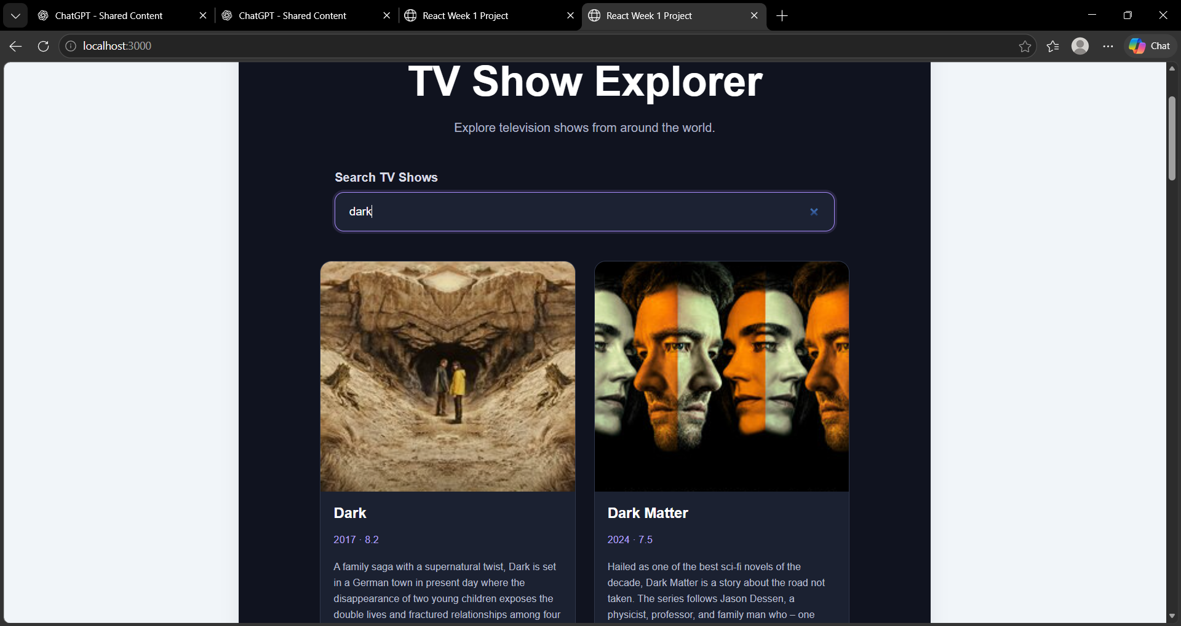
Screenshot 2 — Search results for “Friends”
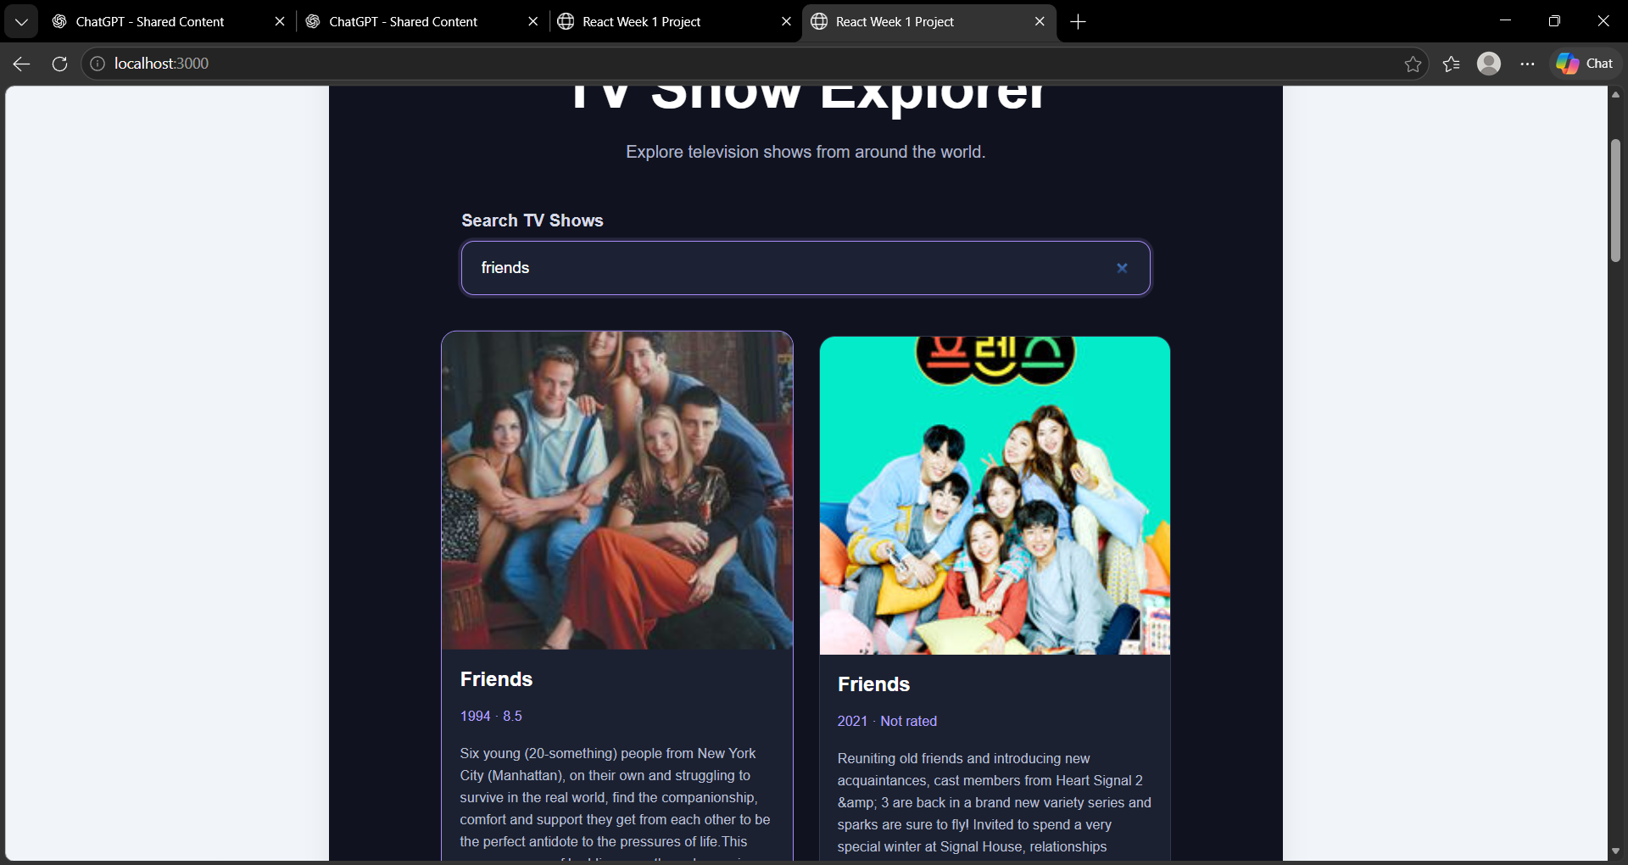
Screenshot 3 — Empty search results message
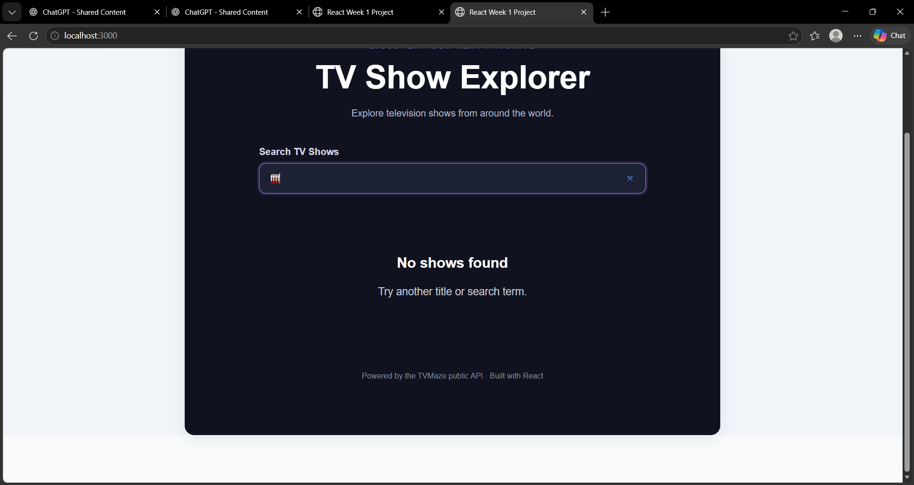

Screenshot 4 — Development environment and application code
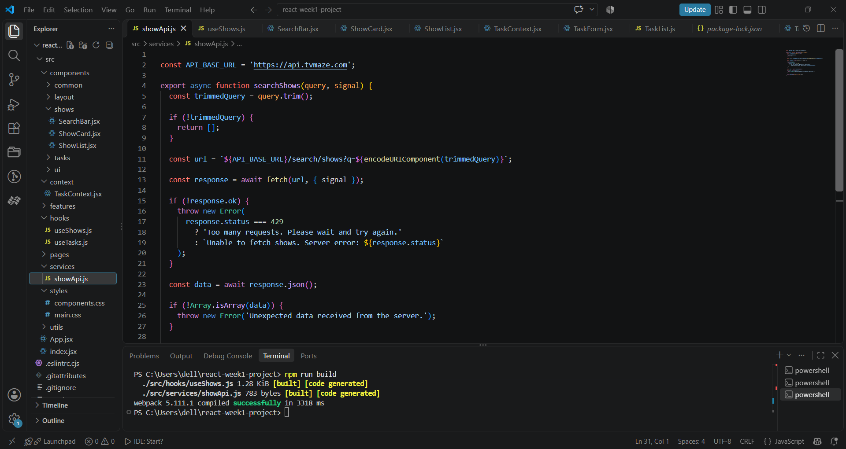
Screenshot 5 — Custom Hook / data-fetching code
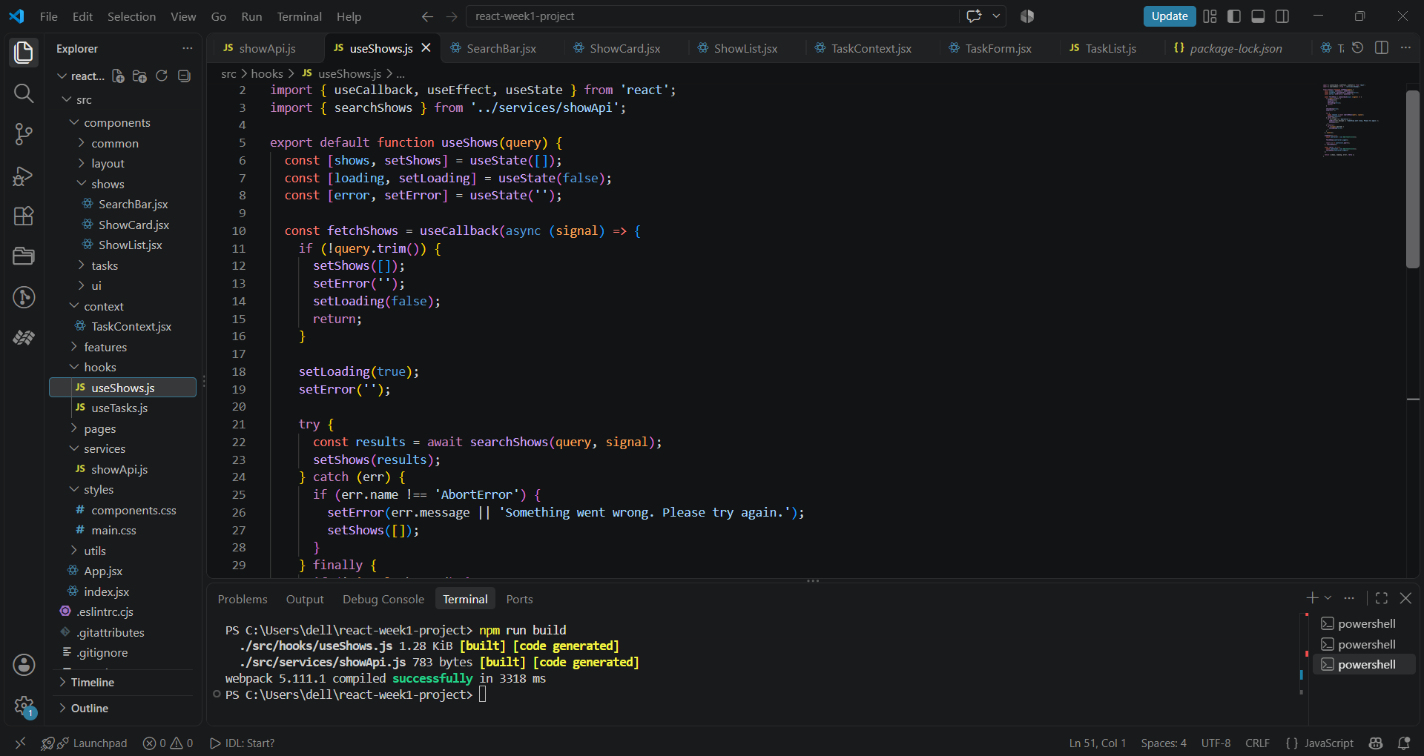
Screenshot 6 — Project code and terminal view
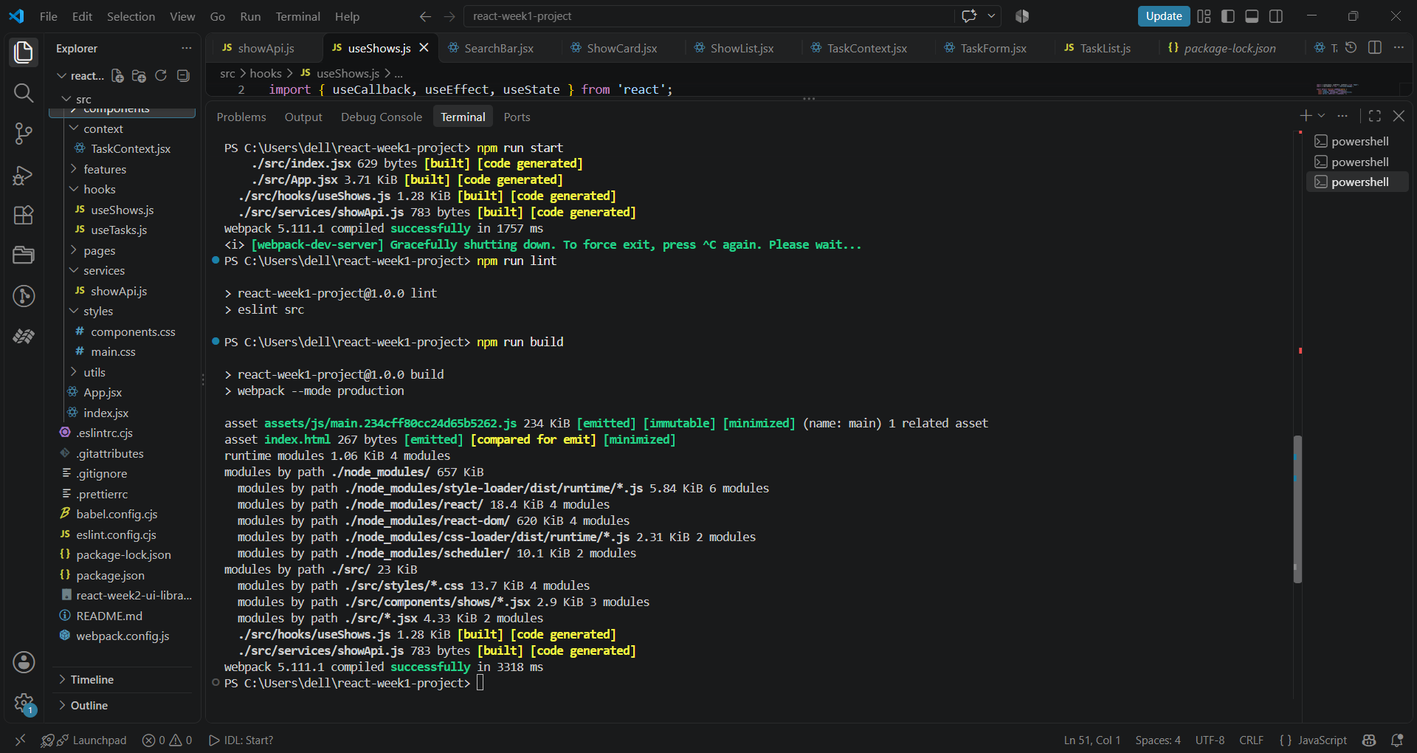

Screenshot 7 — Additional code implementation view
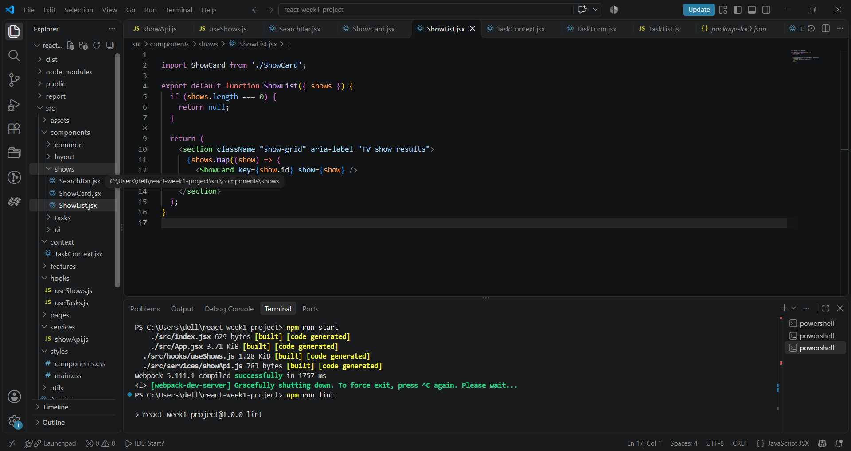
Screenshot 8 — Browser view of the TV Show Explorer
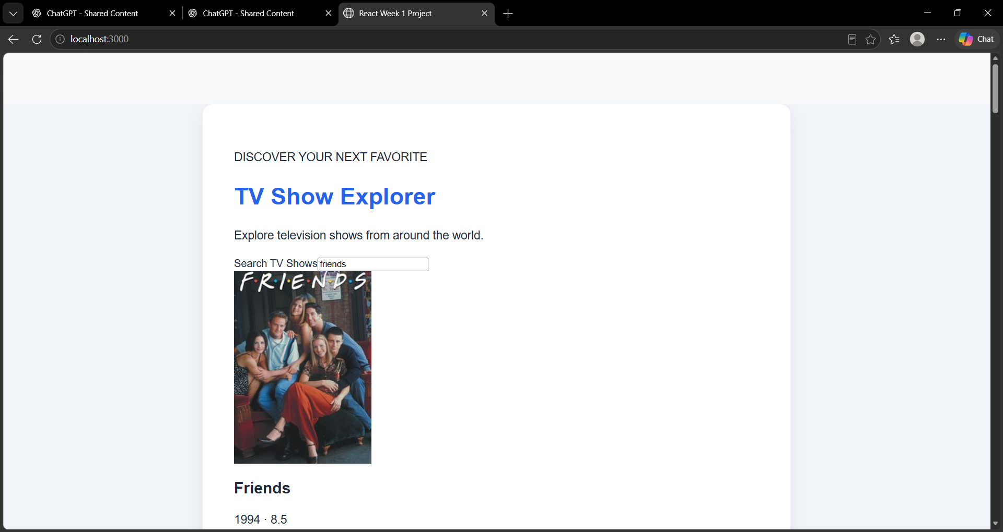
Screenshot 9 — Initial / start-exploring interface
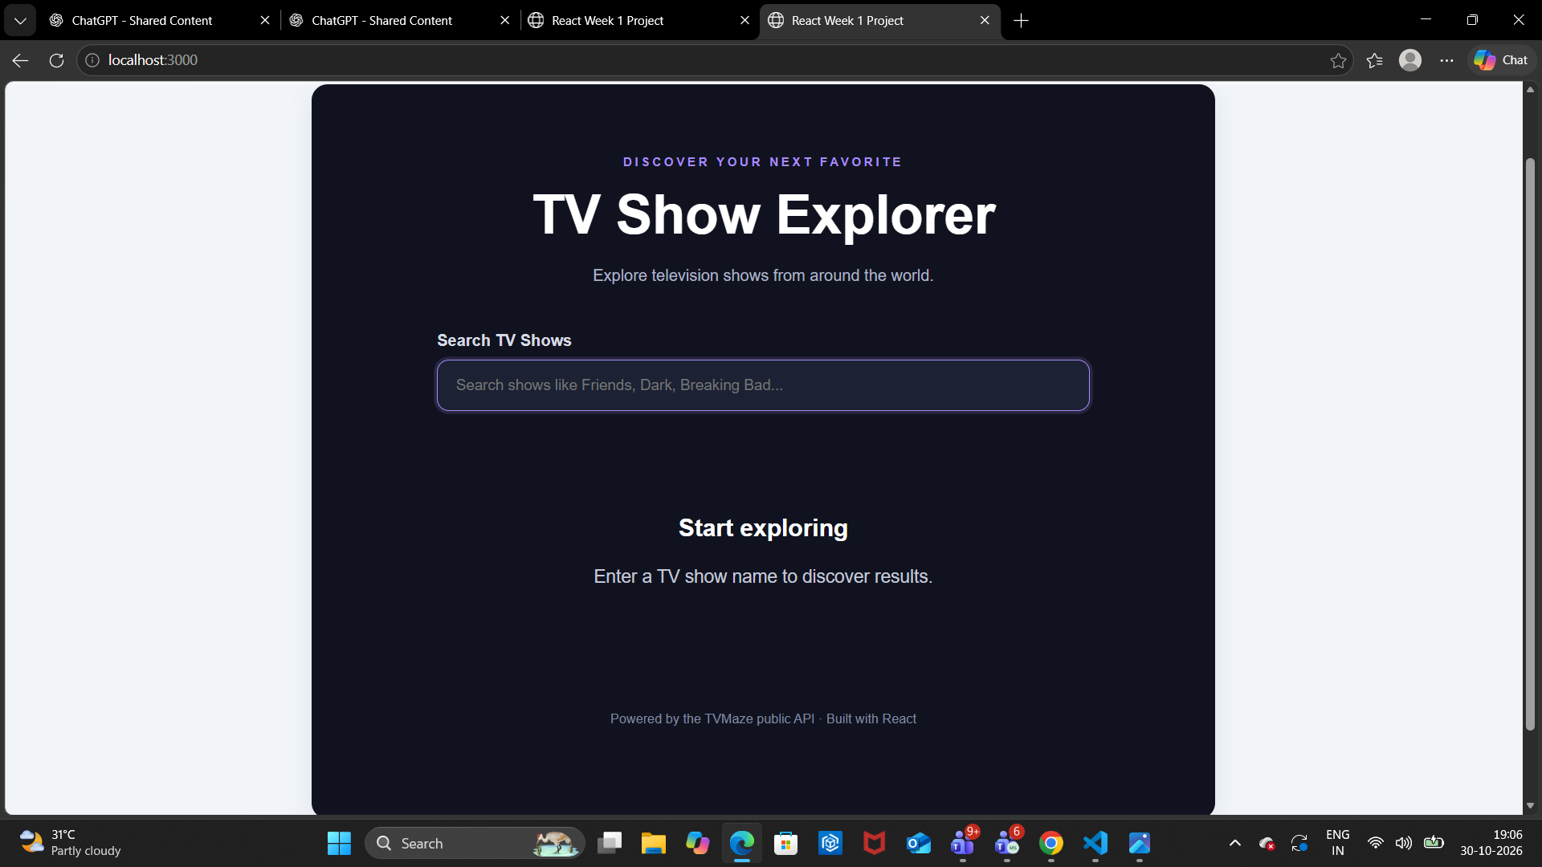

10. Challenges and Resolutions
Handling API responses: The service checks the HTTP response before parsing JSON and validates that the returned data has the expected array structure.
Avoiding stale requests: AbortController is used so an earlier search request can be cancelled when a newer query is entered.
Variable API data: ShowCard uses optional chaining and fallback text for missing images, premiere dates, ratings, and summaries.
Different UI states: The application conditionally renders loading, error, empty-query, no-results, and result-list states.

11. Conclusion and Learning Outcomes
The Week 4 TV Show Explorer demonstrates how a React application can retrieve information from a public API and present it through reusable components. The work provided practical experience with fetch, JSON processing, asynchronous operations, React Hooks, request cancellation, conditional rendering, and basic error handling. It also reinforced the value of separating service logic, state management, and user-interface components.

12. Final Submission Checklist
☐ Confirm the complete Week 4 source code is saved in the project repository.
☐ Run npm run lint and record the actual result.
☐ Run npm run build and record the actual result.
☐ Check the application at desktop and mobile-sized widths.
☐ Confirm all screenshots in this report match the final application.
☐ Push the latest Week 4 changes to the GitHub repository.

Project Repository
https://github.com/muskanpython/react-week1-project
API documentation: https://www.tvmaze.com/api

