WEEK 3 REPORT
Advanced Data Analysis and Visualization in Logistics
Logistics Delivery Analysis Project
Prepared by: Muskan Rathore
Week 3 – Internship Task

1. Objective
The objective of Week 3 was to perform advanced exploratory data analysis and visualization on logistics delivery data using Python. The analysis focused on delivery distance, package weight, delivery cost, customer ratings, vehicle types, and delivery partners. Pandas and NumPy were used for analysis, while Matplotlib and Seaborn were used to create visualizations that support data-driven logistics decision-making.

2. Dataset Overview
The cleaned logistics dataset contains 25,000 records and 15 columns. It includes delivery partner, package type, vehicle type, delivery mode, region, weather condition, distance, package weight, delivery time, expected time, delay status, delivery status, delivery rating, and delivery cost.
Metric | Value | Interpretation
Records | 25,000 | Large dataset for logistics analysis
Variables | 15 | Operational and delivery-related attributes
Missing Values | 0 | No missing values detected
Average Distance | 150.39 km | Typical delivery distance
Average Package Weight | 25.15 kg | Typical shipment weight
Average Delivery Cost | 864.94 | Average delivery cost
Average Rating | 3.67 / 5 | Moderate-to-good delivery experience

3. Methodology and Python Tools
The analysis followed a structured workflow: loading the cleaned CSV dataset, inspecting the first records and data types, checking missing values, calculating descriptive statistics, selecting numeric variables for correlation analysis, generating visualizations, and interpreting the resulting patterns. Pandas was used for data manipulation and grouping, NumPy for numerical operations, Matplotlib for plotting, and Seaborn for statistical visualizations.

4. Exploratory Data Analysis
The dataset contains 25,000 records across 15 variables. All columns contain 25,000 non-null records, so no missing values were detected. The average delivery distance is 150.39 km and the average package weight is 25.15 kg. Delivery cost has a mean of 864.94 and a standard deviation of 435.71, showing substantial variation in transportation expenses. The average delivery rating is 3.67 out of 5.

5. Descriptive Statistics
Variable | Mean | Median | Std. Deviation
Distance (km) | 150.39 | 151.00 | 86.41
Package Weight (kg) | 25.15 | 25.15 | 14.37
Delivery Rating | 3.67 | 4.00 | 1.15
Delivery Cost | 864.94 | 867.54 | 435.71

6. Visualizations and Interpretation

Figure 1: Distribution of Delivery Distance
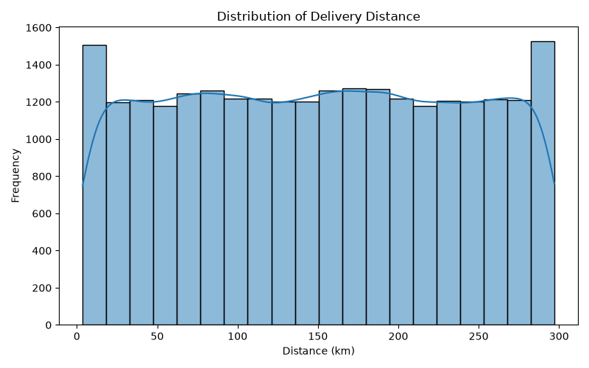
This histogram shows the distribution of delivery distances. The dataset covers a broad range of routes, from short deliveries to routes close to 300 km. The average distance is 150.39 km.

Figure 2: Distribution of Delivery Cost
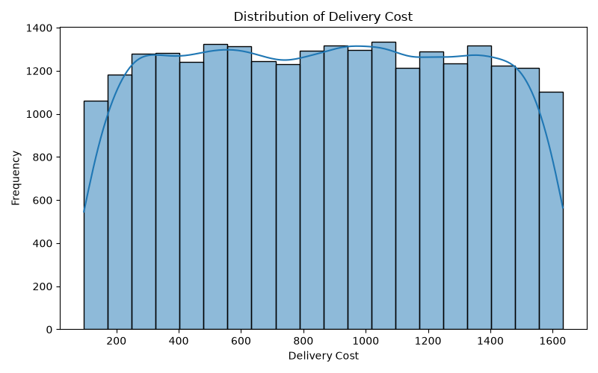
This histogram shows the distribution of delivery costs. Costs span a wide range, with an average of 864.94 and a maximum of 1,632.72, indicating considerable variation in logistics expenses.

Figure 3: Delivery Cost by Vehicle Type
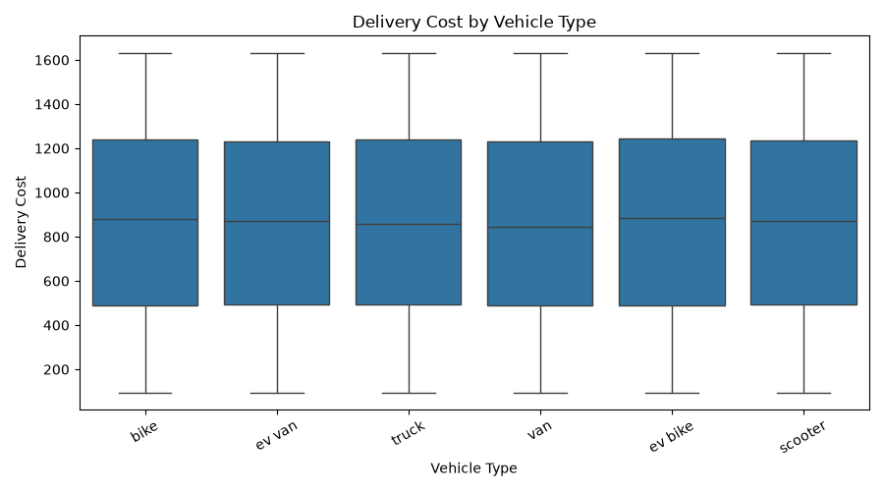
The box plot compares delivery-cost distributions for different vehicle types. The medians and spreads are broadly similar, but the visualization helps identify variation and potential differences in vehicle operating costs.

Figure 4: Distance vs Delivery Cost
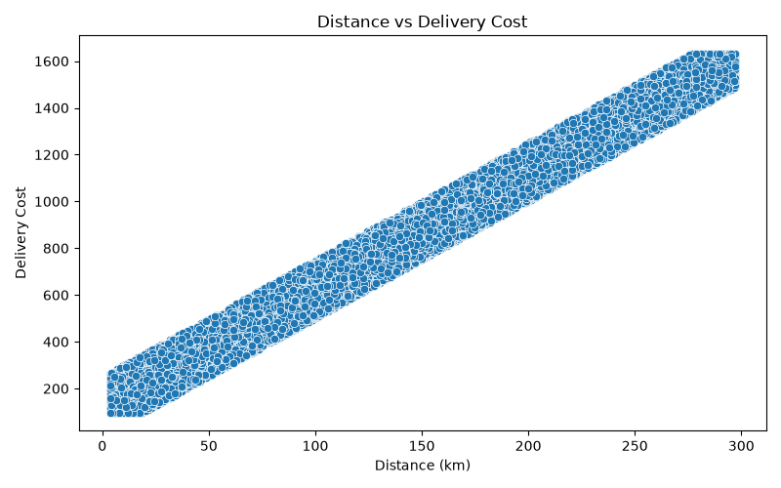
The scatter plot shows a very strong positive relationship between delivery distance and delivery cost. The calculated correlation is 0.990772, indicating that route distance is a major driver of cost.

Figure 5: Correlation Heatmap
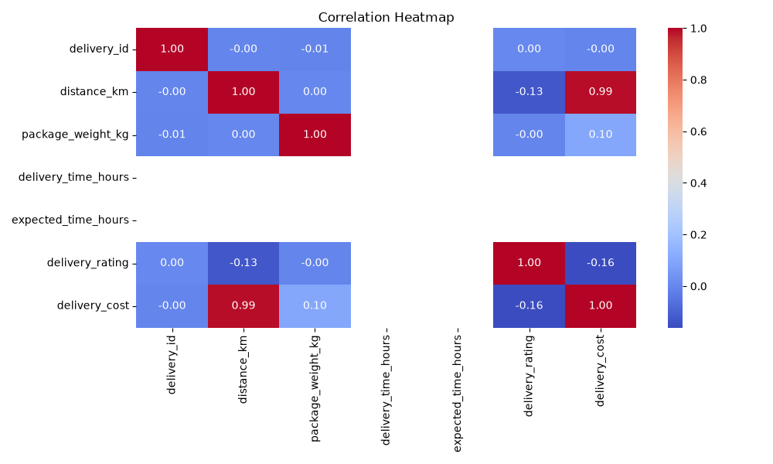
The heatmap summarizes relationships among numeric variables. The strongest relationship is between distance and delivery cost (approximately 0.99). Delivery rating has a weak negative relationship with distance and delivery cost.

Figure 6: Average Delivery Cost by Delivery Partner
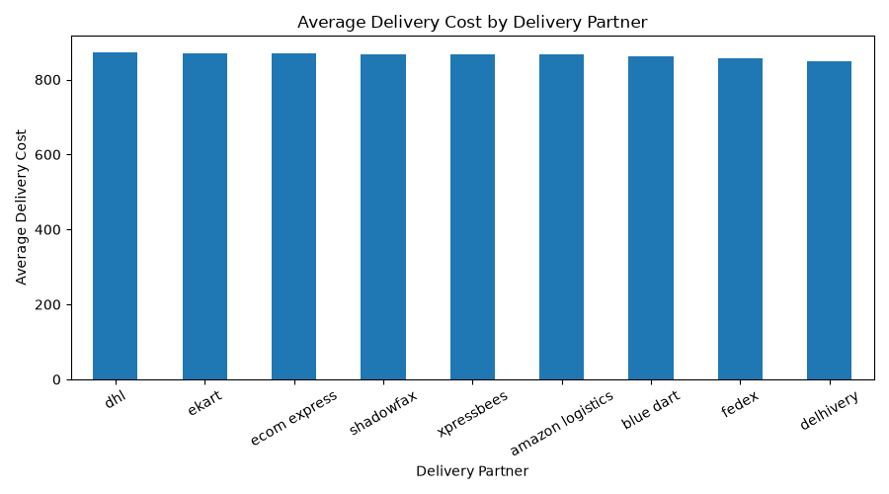
The bar chart compares average delivery costs across delivery partners. DHL has the highest average delivery cost in this dataset, while Delhivery has the lowest.

7. Key Analytical Insights
- The dataset contains 25,000 records with no missing values across the 15 variables.
- The average delivery distance is 150.39 km and the maximum observed distance is 297.10 km.
- The average delivery cost is 864.94 and the maximum observed cost is 1,632.72.
- Distance and delivery cost have an extremely strong positive correlation of 0.990772, making distance a major cost driver.
- The average delivery rating is 3.67 out of 5, indicating scope for improving customer delivery experience.
- DHL has the highest average delivery cost among the delivery partners, while Delhivery has the lowest.
- Package weight has a much weaker relationship with delivery cost than distance.

8. Data Quality Observation
During analysis, delivery_time_hours and expected_time_hours were found to contain zero values throughout the dataset. Since these columns have no meaningful variation, they were not used for delivery-time performance conclusions. In a real logistics system, these fields should be validated or corrected before using them for delay or on-time delivery analysis.

9. Recommendations
- Use route distance as a primary factor when estimating delivery cost and planning routes.
- Review high-cost routes for route optimization and alternative transportation options.
- Compare delivery partners using both cost and customer rating rather than cost alone.
- Monitor vehicle-level cost variation to identify potentially inefficient vehicle categories.
- Correct and validate delivery-time fields so future analysis can accurately measure delays and on-time performance.
- Track customer rating as a service-quality KPI alongside cost and distance.

10. Python Code Excerpt
The analysis was implemented in week3_analysis.py using Pandas, NumPy, Matplotlib, and Seaborn. The main workflow included loading the cleaned dataset, descriptive analysis, correlation analysis, and generation of six visualizations.
df = pd.read_csv("../data/cleaned_delivery_logistics.csv")
numeric_df = df.select_dtypes(include=np.number)
print(df.describe())
print(numeric_df.corr())
sns.histplot(df["distance_km"], bins=20, kde=True)
sns.scatterplot(data=df, x="distance_km", y="delivery_cost")
sns.heatmap(numeric_df.corr(), annot=True)

11. Conclusion
The Week 3 analysis demonstrates how exploratory data analysis and visualization can support logistics decision-making. The dataset was systematically inspected, summarized, and visualized to identify cost patterns and operational relationships. The strongest finding was the very high positive correlation between delivery distance and delivery cost, highlighting distance as a key cost driver. Delivery-partner and vehicle comparisons provide additional operational insight. The zero-valued delivery-time fields should be corrected before detailed delay analysis is performed. Overall, the analysis provides a useful foundation for cost optimization, partner evaluation, and future predictive logistics work.

