WEEK 4 INTERNSHIP REPORT
Predictive Modeling & Optimization
YuvaIntern – Logistics Data Analyst Internship
Project: Logistics Delivery Analysis
Student: Muskan Rathore
Dataset: 25,000 records × 15 columns
Primary target: Delivery Cost

1. Executive Summary
Week 4 focused on predictive modeling and operational optimization for the Logistics Delivery Analysis project. The cleaned logistics dataset contained 25,000 delivery records and 15 original columns. The objective was to predict delivery cost from numerical and categorical delivery attributes, compare two regression models, identify the strongest cost drivers, and translate the results into evidence-based logistics recommendations.
The data was divided into 20,000 training records and 5,000 testing records. After preprocessing, the feature matrix contained 47 processed features. Linear Regression and Random Forest Regression were trained and evaluated using MAE, MSE, RMSE and R².
Random Forest produced the lower RMSE (3.27 versus 4.67 for Linear Regression), while Linear Regression produced the lower MAE (1.57 versus 2.37). Both models achieved an R² of 0.9999, indicating extremely high predictive fit on this dataset. Feature importance showed that distance_km was by far the dominant predictor, with an importance of 0.982335 (98.23%). Distance-band analysis also showed that 200+ km deliveries had the highest average delivery cost (1,365.76), while 0–50 km deliveries had the highest average cost per kilometre (13.33/km).

2. Objectives
- Build regression models to predict delivery cost.
- Compare Linear Regression and Random Forest Regression using multiple evaluation metrics.
- Identify the variables that contribute most strongly to predicted delivery cost.
- Analyse delivery cost across distance and package-weight bands.
- Translate quantitative findings into practical logistics optimization recommendations.
- Document the methodology, evidence, limitations and business interpretation clearly.

3. Dataset Overview
Item | Value
Total records | 25,000
Original columns | 15
Training records | 20,000 (80%)
Testing records | 5,000 (20%)
Processed training shape | (20,000, 47)
Processed testing shape | (5,000, 47)
Target variable | delivery_cost
Missing values after cleaning | 0

The modeling workflow used the cleaned delivery dataset prepared in earlier internship weeks. The numerical predictors used in the model were distance_km, package_weight_kg and delivery_rating. Categorical predictors included delivery_partner, package_type, vehicle_type, delivery_mode, region, weather_condition, delayed and delivery_status. Categorical variables were transformed into numerical indicator features using one-hot encoding.

4. Methodology and Data Preparation

4.1 Train-Test Split
The dataset was split into 80% training data and 20% testing data. This produced 20,000 training records and 5,000 unseen testing records. The testing set was kept separate from model fitting so that model performance could be evaluated on data not used during training.
X_train, X_test, y_train, y_test = train_test_split(
X, y, test_size=0.20, random_state=42
)

4.2 Numerical and Categorical Features
numerical_features = [
"distance_km",
"package_weight_kg",
"delivery_rating"
]
categorical_features = [
"delivery_partner",
"package_type",
"vehicle_type",
"delivery_mode",
"region",
"weather_condition",
"delayed",
"delivery_status"
]

4.3 Preprocessing
Numerical and categorical variables were handled separately. Numerical variables were passed as numerical inputs, while categorical variables were converted into binary indicator columns. The resulting processed feature matrix contained 47 columns for both training and testing data.
preprocessor = ColumnTransformer(
transformers=[
("num", StandardScaler(), numerical_features),
("cat", OneHotEncoder(handle_unknown="ignore"), categorical_features)
]
)

5. Predictive Modeling

5.1 Linear Regression
Linear Regression was used as the baseline model because it is simple, interpretable and provides a useful reference point for comparing a more flexible machine-learning model.
linear_model = Pipeline([
("preprocessor", preprocessor),
("model", LinearRegression())
])
linear_model.fit(X_train, y_train)
linear_predictions = linear_model.predict(X_test)

5.2 Random Forest Regression
Random Forest Regression was selected as the non-linear comparison model. It can capture non-linear relationships and interactions between delivery characteristics that a simple linear model may not capture as effectively.
random_forest = Pipeline([
("preprocessor", preprocessor),
("model", RandomForestRegressor(
n_estimators=100,
random_state=42,
n_jobs=-1
))
])
random_forest.fit(X_train, y_train)
rf_predictions = random_forest.predict(X_test)

6. Model Evaluation and Comparison
Metric | Linear Regression | Random Forest | Interpretation
MAE | 1.57 | 2.37 | Lower is better; Linear Regression is lower.
MSE | 21.81 | 10.69 | Lower is better; Random Forest is lower.
RMSE | 4.67 | 3.27 | Lower is better; Random Forest is lower.
R² | 0.9999 | 0.9999 | Both show extremely high fit on the test set.

The comparison should not be reduced to a single metric. Linear Regression has the lower MAE (1.57), meaning its average absolute prediction error is smaller by that measure. Random Forest has the lower MSE (10.69) and RMSE (3.27), indicating better performance when larger prediction errors are penalized more heavily. Both models have an R² of 0.9999.
For operational cost forecasting where controlling larger errors is important, Random Forest is a strong candidate because of its lower RMSE. However, Linear Regression remains valuable as an interpretable baseline and performs better on MAE in this experiment.
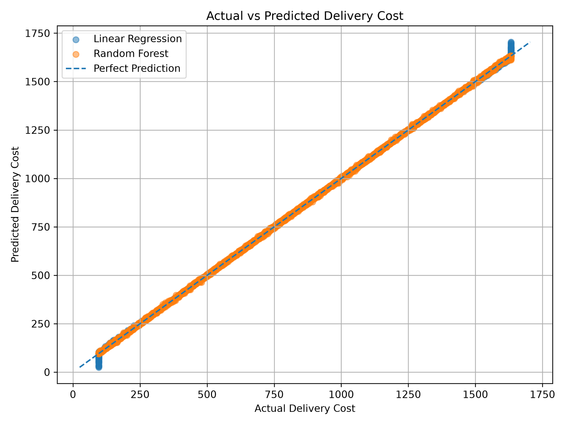
Figure 1. Actual versus predicted delivery cost for the two models.
The points cluster closely around the perfect-prediction line, visually supporting the high R² values. The Random Forest predictions remain closely aligned with actual delivery costs across the observed range.
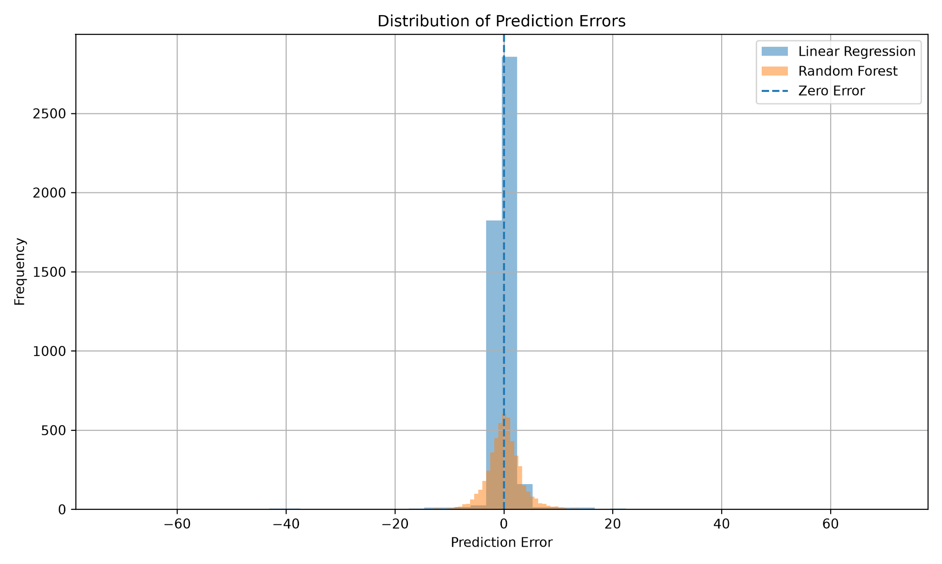
Figure 2. Distribution of prediction errors.
The error distributions are concentrated around zero, indicating that most predictions are relatively close to the observed delivery cost. The plot also shows a wider spread for Linear Regression than for Random Forest in the displayed distribution.

7. Feature Importance Analysis
Random Forest feature importance was examined to understand which variables contributed most to the model's predictions. The results were highly concentrated in a small number of variables.
Feature | Importance
distance_km | 0.982335 (98.23%)
package_weight_kg | 0.009486 (0.95%)
delivery_mode – same day | 0.006233 (0.62%)
delivery_mode – express | 0.001851 (0.19%)
delivery_rating | 0.000006

Distance is overwhelmingly the dominant feature. Package weight is the second-largest contributor, followed by delivery mode. The remaining encoded variables have very small individual importance values in this model.
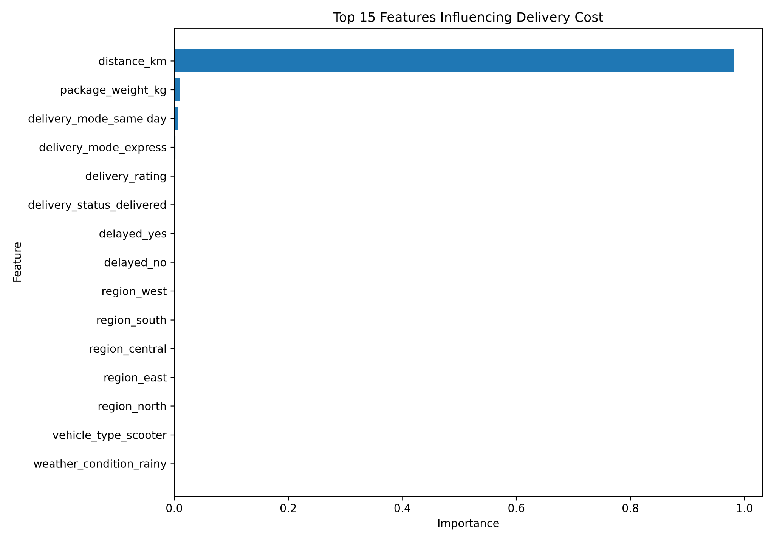
Figure 3. Top 15 model features influencing delivery cost.
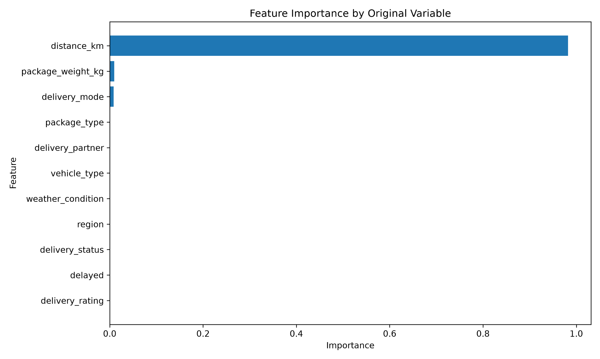
Figure 4. Feature importance grouped back to original variables.
When one-hot encoded features are regrouped by their original variables, distance_km still dominates with 0.982335 importance, followed by package_weight_kg at 0.009486 and delivery_mode at 0.008086. This grouping makes the result easier to interpret from a business perspective.

8. Distance-Based Cost Analysis
Distance band | Deliveries | Avg. distance (km) | Avg. delivery cost | Avg. cost/km
0–50 km | 4,101 | 25.18 | 239.64 | 13.33
50–100 km | 4,216 | 75.23 | 488.50 | 6.55
100–150 km | 4,102 | 125.01 | 737.51 | 5.91
150–200 km | 4,313 | 175.05 | 988.64 | 5.65
200+ km | 8,268 | 250.55 | 1,365.76 | 5.46

Average delivery cost rises consistently as the distance band increases, from 239.64 for 0–50 km deliveries to 1,365.76 for 200+ km deliveries. The 200+ km group contains 8,268 deliveries, equal to 33.07% of the dataset. Based on the grouped averages, this group represents approximately 52.22% of the estimated total delivery cost across the five distance bands.
An important efficiency signal is the average cost per kilometre. The 0–50 km band has the highest average cost/km at 13.33, while the 200+ km band has the lowest at 5.46. This does not by itself prove the cause, but it indicates that short-distance deliveries should be investigated for fixed handling, pickup, dispatch and last-mile overheads.
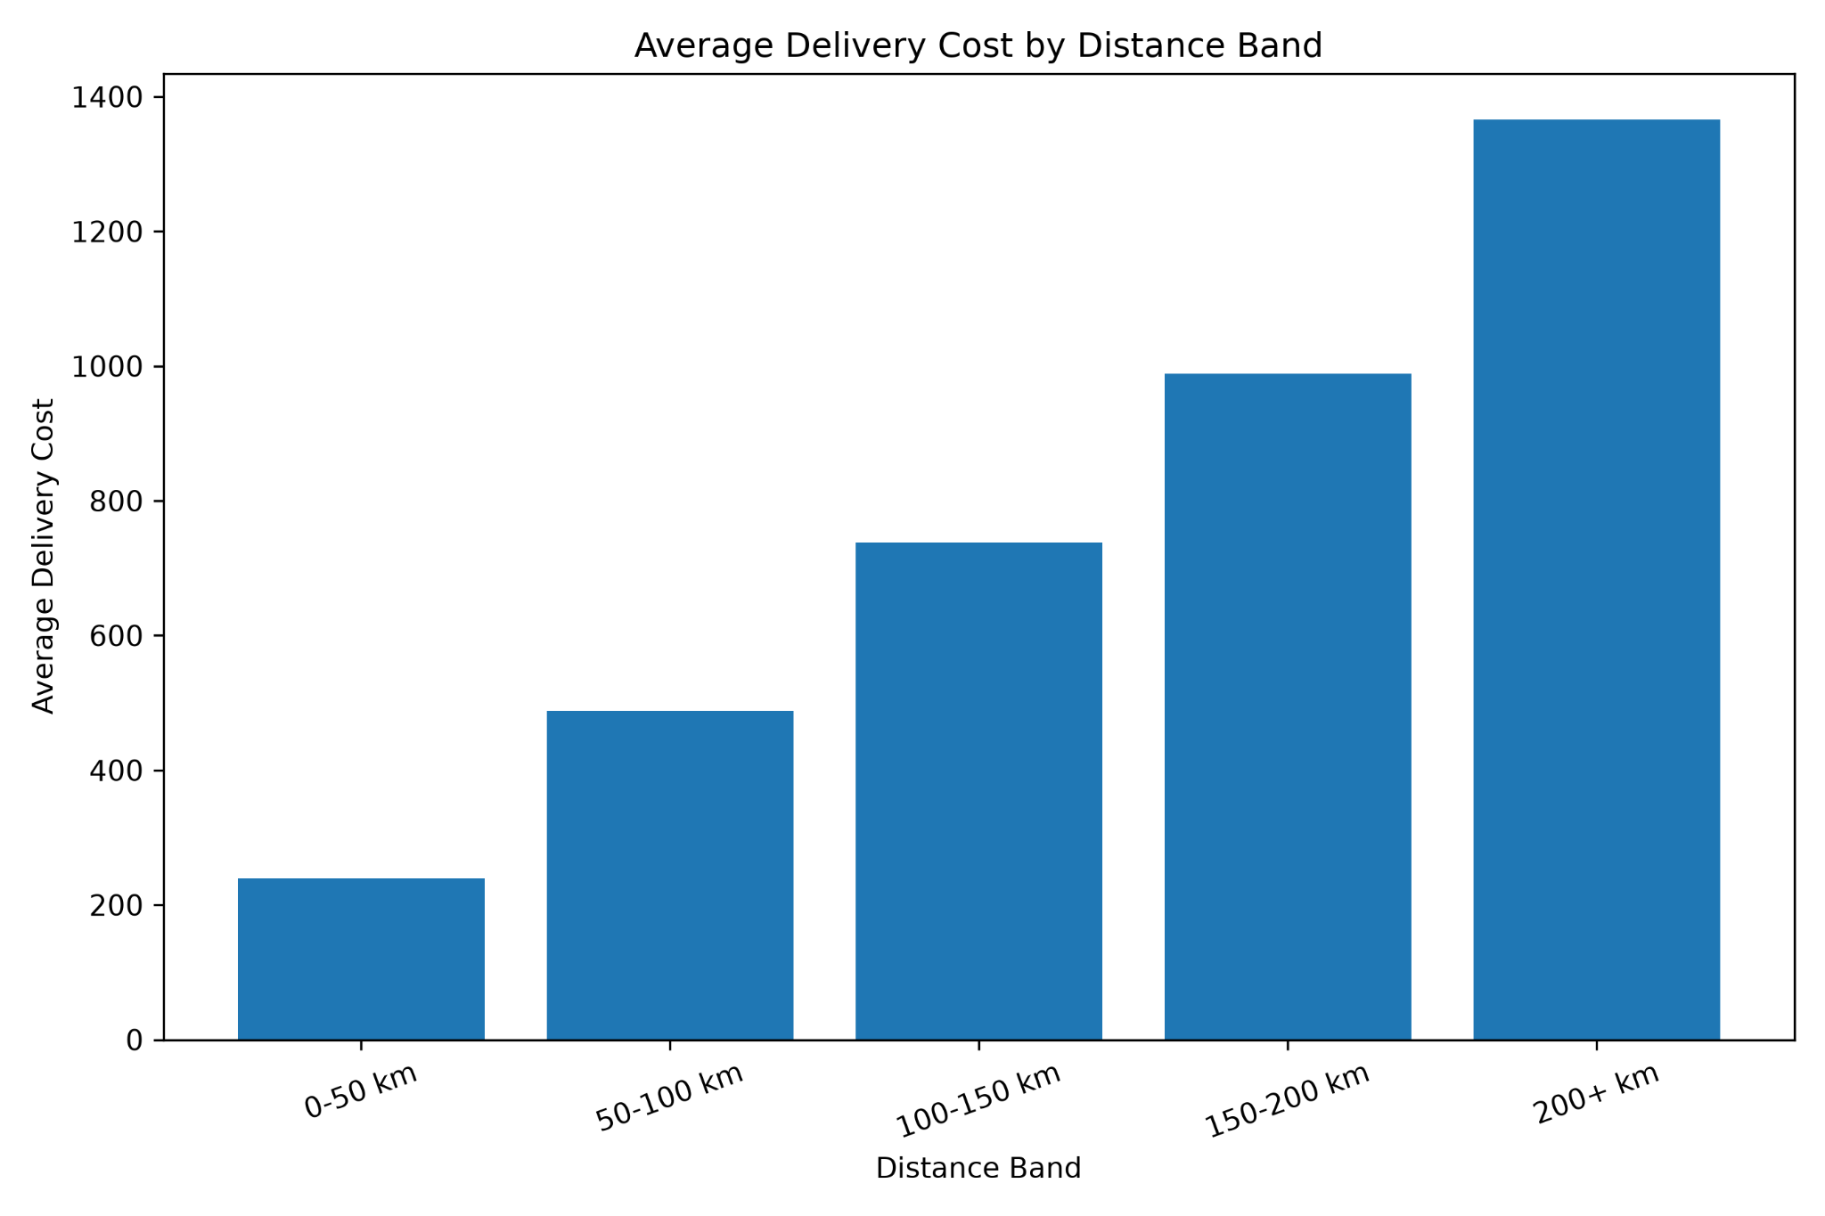
Figure 5. Average delivery cost by distance band.

9. Package Weight-Based Cost Analysis
Weight band | Deliveries | Avg. weight (kg) | Avg. delivery cost
0–10 kg | 4,886 | 5.09 | 801.70
10–20 kg | 5,021 | 15.02 | 832.95
20–30 kg | 5,090 | 25.05 | 872.12
30–40 kg | 4,973 | 35.07 | 891.16
40+ kg | 5,030 | 45.01 | 925.15

Average delivery cost increases across every package-weight band, from 801.70 for 0–10 kg packages to 925.15 for 40+ kg packages. This is an increase of approximately 15.4%. Therefore, package weight has a measurable relationship with delivery cost, although its model importance (0.9486%) is much smaller than distance importance (98.23%).
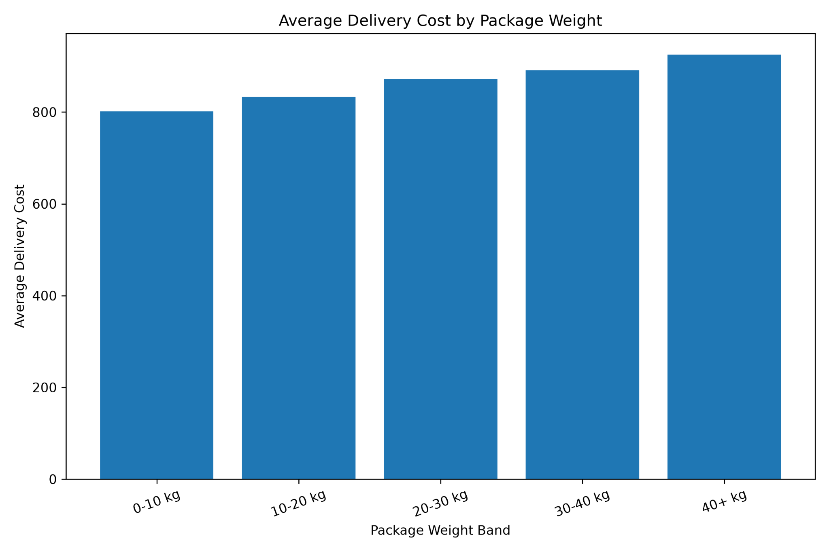
Figure 6. Average delivery cost by package weight band.

10. Optimization Recommendations
Prioritize long-distance route optimization: The 200+ km segment contains 8,268 deliveries (33.07% of records) and has an average cost of 1,365.76. Because distance is also the dominant model feature at 98.23% importance, route planning and distance reduction should be the first optimization priority.
Investigate short-distance cost efficiency: The 0–50 km segment has the highest average cost per kilometre at 13.33/km compared with 5.46/km for 200+ km deliveries. Operations teams should examine pickup, handling, dispatch and last-mile fixed costs in this segment.
Use distance-aware cost forecasting: Distance should be a primary input in delivery-cost estimation and operational planning. The predictive model can support early cost estimates before dispatch.
Improve load and package planning: Because average cost rises from 801.70 to 925.15 across the weight bands, suitable shipment consolidation and vehicle/load planning can be evaluated for heavier packages.
Use model predictions for budgeting and exception monitoring: A trained model can provide expected delivery costs and help flag cases where actual cost differs substantially from predicted cost, enabling further operational investigation.

11. Business Interpretation
The analysis indicates that logistics cost is primarily distance-driven in this dataset. This conclusion is supported by three independent pieces of evidence: the distance-to-cost correlation from Week 3 was 0.990772, Random Forest assigned 98.23% feature importance to distance_km, and the distance-band analysis showed a monotonic increase in average delivery cost.
At the same time, the results show that absolute cost and cost efficiency are different concepts. Long-distance shipments have the highest absolute costs, whereas short-distance shipments have the highest cost per kilometre. This distinction is important for management because reducing total cost may require different actions from improving unit-cost efficiency.

12. Limitations
- The dataset's delivery_time_hours and expected_time_hours were 0 throughout, so delivery-time conclusions were not made from these fields.
- Feature importance indicates predictive contribution within the trained Random Forest; it should not be interpreted as proof of causation.
- The short-distance cost/km pattern identifies an investigation area but does not establish which operational cost component causes the higher unit cost.
- The very high R² values may partly reflect the structure of the dataset and the strong relationship between distance and delivery cost. Additional validation on future or external data would strengthen confidence.
- Model performance was evaluated using a single train-test split. Cross-validation and external validation could be added in a production setting.

13. Conclusion
Week 4 successfully extended the logistics project from descriptive analysis to predictive modeling and optimization. Two regression approaches were implemented using 20,000 training records and evaluated on 5,000 testing records after preprocessing the data into 47 features. Random Forest achieved the lower RMSE of 3.27, while Linear Regression achieved the lower MAE of 1.57; both achieved an R² of 0.9999.
The strongest business finding is the dominance of delivery distance. Distance accounted for 98.23% of Random Forest feature importance, and average delivery cost increased from 239.64 in the 0–50 km band to 1,365.76 in the 200+ km band. Package weight also showed a consistent increase in average cost, from 801.70 for 0–10 kg to 925.15 for 40+ kg.
Overall, the analysis supports a distance-first optimization strategy, supplemented by investigation of short-distance unit costs and better planning for heavier shipments. The predictive workflow can be extended in future work with cross-validation, model tuning, additional operational variables and deployment for real-time cost estimation.

14. Representative Python Code Snippets
The following snippets summarize the key implementation steps used in the Week 4 analysis. They are included to make the methodology transparent and reproducible.
# Evaluation metrics
mae = mean_absolute_error(y_test, predictions)
mse = mean_squared_error(y_test, predictions)
rmse = np.sqrt(mse)
r2 = r2_score(y_test, predictions)
print(f"MAE : {mae:.2f}")
print(f"MSE : {mse:.2f}")
print(f"RMSE : {rmse:.2f}")
print(f"R² : {r2:.4f}")
# Distance bands
df_analysis["distance_band"] = pd.cut(
df_analysis["distance_km"],
bins=[0, 50, 100, 150, 200, float("inf")],
labels=["0-50 km", "50-100 km", "100-150 km",
"150-200 km", "200+ km"],
include_lowest=True
)
distance_analysis = (
df_analysis.groupby("distance_band", observed=True)
.agg(
deliveries=("delivery_cost", "count"),
average_distance_km=("distance_km", "mean"),
average_delivery_cost=("delivery_cost", "mean")
)
.reset_index()
)
# Weight bands
df_analysis["weight_band"] = pd.cut(
df_analysis["package_weight_kg"],
bins=[0, 10, 20, 30, 40, float("inf")],
labels=["0-10 kg", "10-20 kg", "20-30 kg",
"30-40 kg", "40+ kg"],
include_lowest=True
)

15. Week 4 Deliverables Checklist
- ✓ Predictive modeling script: week4_predictive_model.py
- ✓ Linear Regression and Random Forest evaluation
- ✓ Actual vs predicted cost visualization
- ✓ Prediction error distribution visualization
- ✓ Top 15 feature importance visualization
- ✓ Grouped feature importance visualization
- ✓ Distance-band cost analysis and visualization
- ✓ Package-weight cost analysis and visualization
- ✓ Evidence-based optimization recommendations
- ✓ Professional Week 4 report

Concrete Examples from the Analysis
The following examples use actual aggregated results from the 25,000-record dataset. They are included to demonstrate how the numerical findings translate into practical logistics decisions.
Example 1 – Long-distance cost exposure: There were 8,268 deliveries in the 200+ km distance band, representing 33.07% of all 25,000 deliveries. Their average delivery cost was 1,365.76. Using the band-level averages, this group represents approximately 52.22% of the estimated total delivery cost across the five distance bands. This makes long-distance operations a clear priority for route and cost optimization.
Example 2 – Short-distance cost-per-kilometre issue: A 0–50 km delivery had an average cost of 239.64 and an average cost of 13.33 per kilometre. By comparison, a 200+ km delivery averaged 1,365.76 but only 5.46 per kilometre. This means the long-distance shipment costs more in absolute terms, while the short-distance shipment is less efficient on a cost-per-kilometre basis. The short-distance segment should therefore be investigated for fixed handling, pickup, dispatch and last-mile overheads.
Example 3 – Effect of package weight: Average delivery cost increased from 801.70 for packages weighing 0–10 kg to 925.15 for packages weighing 40+ kg. This is an increase of approximately 15.4%. For example, a 45 kg average package in the 40+ kg group costs about 123.45 more on average than a 5 kg average package in the 0–10 kg group. Weight is therefore relevant, although much less influential than distance.
Example 4 – Model performance: On the 5,000-record test set, Linear Regression achieved MAE 1.57 and RMSE 4.67, while Random Forest achieved MAE 2.37 and RMSE 3.27. For example, if the business prioritizes reducing larger prediction errors, the lower Random Forest RMSE is preferable; if average absolute error is the primary criterion, Linear Regression has the advantage.
Example 5 – Dominant cost driver: Random Forest assigned 0.982335, or 98.23%, of feature importance to distance_km. This is consistent with the Week 3 distance-to-delivery-cost correlation of 0.990772. For example, when prioritizing which operational variable to monitor first for cost estimation, distance should receive substantially more attention than package weight, whose importance was 0.009486 (0.95%).
Note: These examples use aggregated groups rather than invented individual delivery records. This keeps the report evidence-based while avoiding unsupported claims about a specific shipment.

Evidence-Based Interpretation
The examples above show the recommended evidence chain used throughout this report: actual dataset result → numerical interpretation → operational implication. For instance, 8,268 deliveries in the 200+ km group and an average cost of 1,365.76 support prioritizing long-distance route optimization; they do not, by themselves, prove that a particular routing method will reduce cost. Similarly, the 13.33/km cost for 0–50 km deliveries identifies a cost-efficiency signal that should be investigated rather than treated as proof of a specific cause.

