**OS-ASSIGNMENT**

1. Define cross-toolchain and explore what is inside a cross-compiling toolchain.

Sol:

**Cross-Toolchain Definition:**

* A set of tools for cross-compiling software.
* Enables building for a target architecture different from the host.

Components Inside a Cross-Compiling Toolchain:

* **Cross-Compiler**: Generates code for the target architecture.
* **Linker**: Connects and creates the final executable.
* **Assembler**: Translates assembly code to machine code.
* **Standard C Library (libc**): Adapted for the target system.
* **Header Files:** Target-specific declarations and definitions.
* **Runtime Libraries:** Support for executing programs.
* **Loader**: Loads and executes programs on the target.
* **Debugging Tools:** (e.g., GDB) for target-specific debugging.

1. Read the datasheet, user manual/ getting started manual specific to your Embedded Linux-board. Write a 4 page summary based on your understanding about board details such as CPU architecture & type, memory types supported by the board, on-board buses, booting sequence, peripherals supported, various booting options and any other relevant information.

Sol:

**CPU Architecture & Type:**

* CPU: Texas Instruments Sitara AM3358/9 ARM Cortex-A8 processor.
* Architecture: ARMv7-A architecture.
* Memory Types Supported:
* RAM: 512MB DDR3.
* Storage: 4GB 8-bit eMMC on-board flash storage.
* MicroSD: External storage option.
* On-board Buses:
* GPIO: General Purpose Input/Output pins.
* I2C, SPI, UART: Various communication interfaces for connecting peripherals.

**Booting Sequence:**

* The BeagleBone Black can boot from different sources, including the on-board eMMC, microSD card, or USB.

**Peripherals Supported:**

* Ethernet: 10/100 Ethernet.
* USB: USB 2.0 ports for connecting peripherals.
* HDMI: HDMI interface for video output.
* Audio: Stereo output/input.
* CAN: Controller Area Network interface.
* PWM: Pulse Width Modulation for controlling motors and other devices.

**Various Booting Options:**

* eMMC: Booting from the on-board eMMC storage.
* microSD: Booting from a microSD card.
* USB: Booting from a USB device.

1. Boot up an Embedded Linux Board, login into the system and grab a shell. Try basic Linux commands on the shell.

Sol:

1. Download Debian Beaglebone Black Image File :-

<https://www.beagleboard.org/distros/am335x-12-2-2023-10-07-4gb-microsd-iot>

1. Download Balena etcher for flashing the Image file SD card:

[https://etcher.balena.io/#download-etcher](https://etcher.balena.io/%23download-etcher%20)

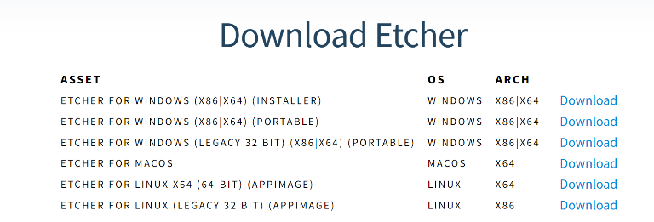

1. Install the balena etcher and transfer the image to SD card

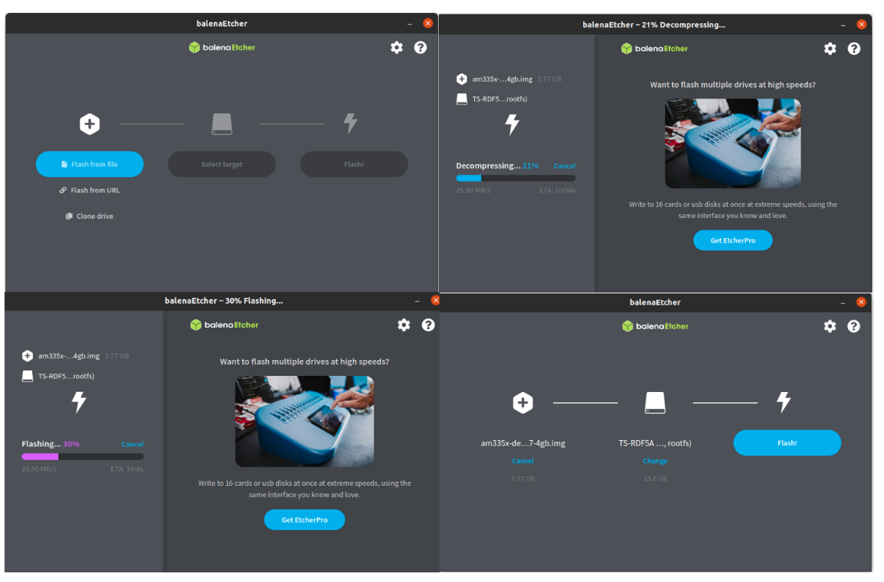

1. Complete serial connection on the beagleboneboard

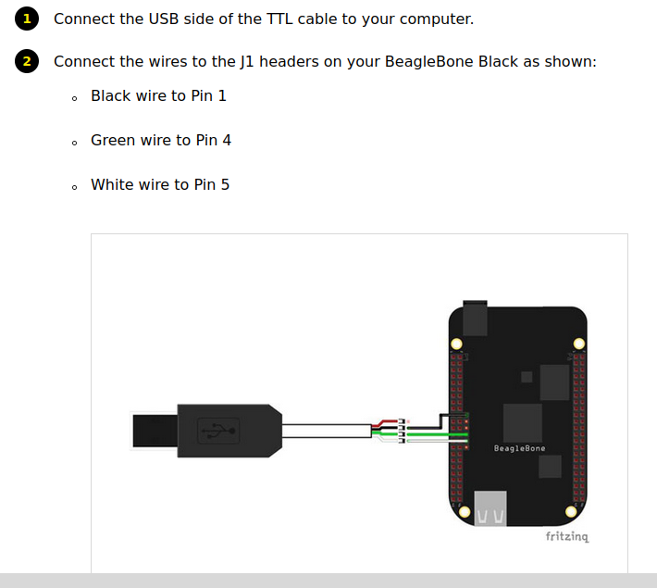

1. Place the card inside the BBB; provide power supply to board
2. $
3. Use the shell commands to find details about CPU, Memory capacity, Memory and I/O maps, persistent storage details.

Sol:

**1. CPU Details:**

* **$ cat /proc/cpuinfo** 
  + 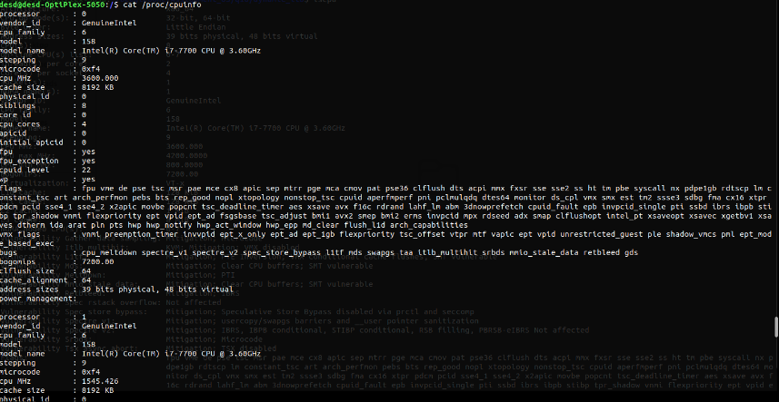Displays detailed information about the CPU, including model, architecture, and clock speed etc.
* **$ lscpu**
  + 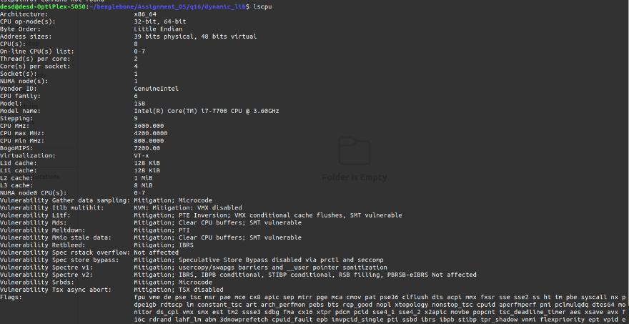Provides detailed information about the CPU, including its architecture, number of cores, threads per core, and other relevant details in a concise format.

**2. Memory Capacity:**

* **$ free -h** 
  + Shows information about system memory usage and capacity in a human-readable format.

**3. Memory Map:**

* **$ cat /proc/iomem** 
  + 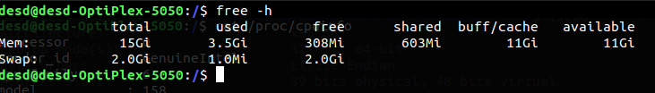Provides a list of current memory ranges used by different devices, showing the memory map of the system.

**4. I/O Map:**

* + **$ lspci** 
    - Lists all PCI buses and devices connected to them, providing information about I/O devices and their addresses.

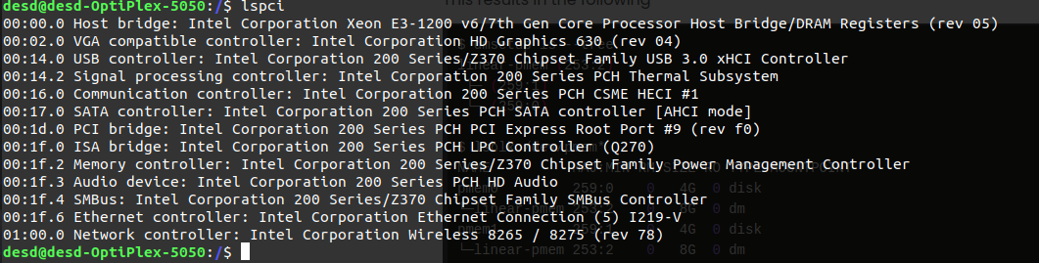

1. **Persistent Storage Details:**
   * **$ df -h** 
     + Displays information about disk space usage, including details about mounted filesystems and their capacities.

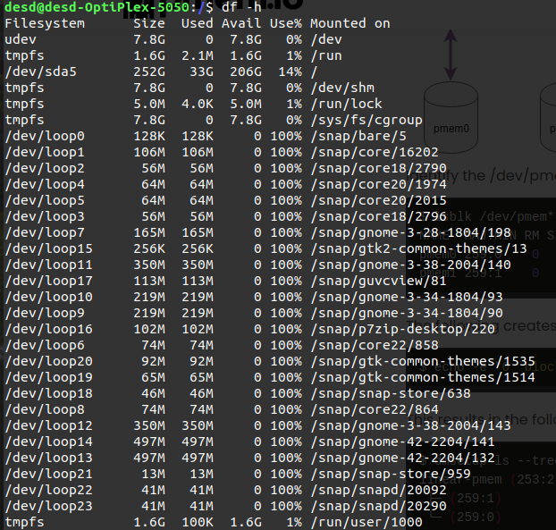

* + **$ lsblk**
  + Lists information about block devices, including disks and partitions, providing details about their sizes and mount points.

