1. Boot up an Embedded Linux Board, login into the system and grab a shell. Try basic Linux commands on the shell.
2. Download Debian Beaglebone Black Image File:-

<https://www.beagleboard.org/distros/am335x-12-2-2023-10-07-4gb-microsd-iot>

1. Download Balena etcher for flashing the Image file SD card:

[https://etcher.balena.io/#download-etcher](https://etcher.balena.io/%23download-etcher%20)

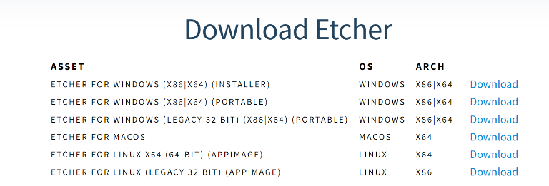

1. Install the balena etcher and transfer the image to SD card

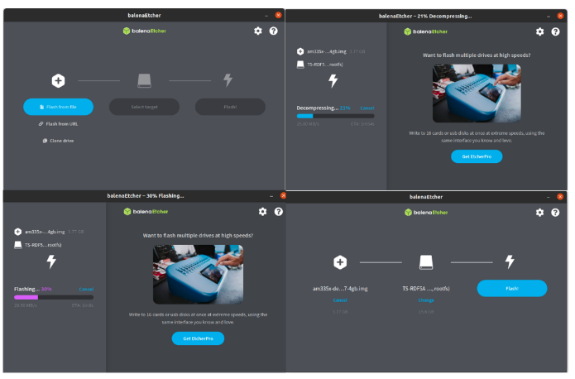

1. Complete serial connection on the beagleboneboard

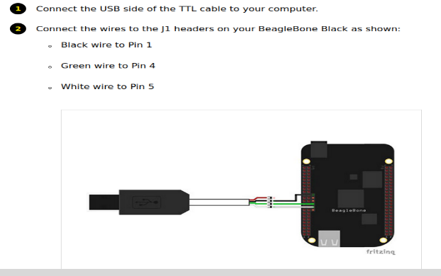

1. Install minicom:

**$ sudo apt-get install minicom**

1. **$ sudo minicom -D /dev/ttyUSB0**



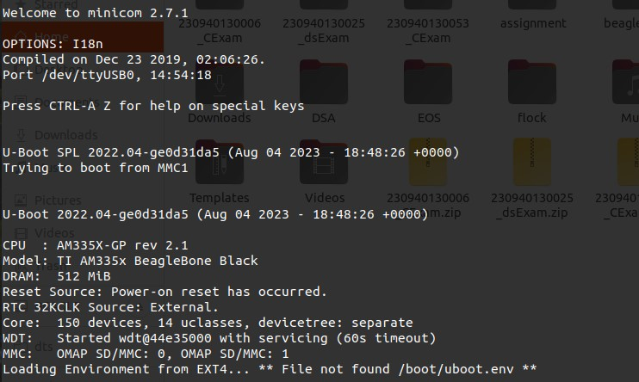Place the card inside the BBB; provide power supply to board

1. Check device details

**$ ifconfig | more**

1. Login to BBB board

**$ ssh** [**debian@192.168.7.2**](mailto:debian@192.168.7.2)

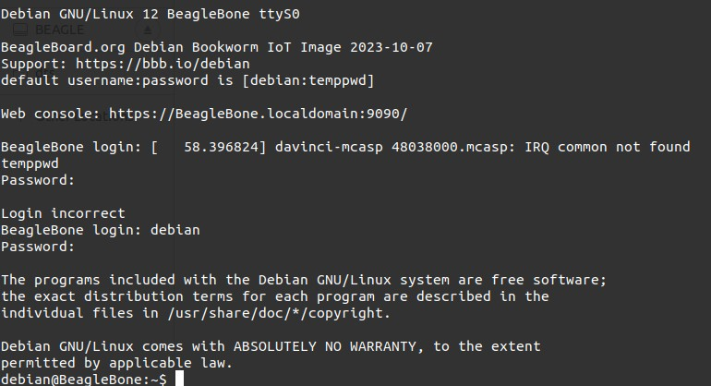

1. Checing and confirming device connection setup or not

**$ dmesg | more**

