1. Use the shell commands to find details about CPU, Memory capacity, Memory and I/O maps, persistent storage details.

**1. CPU Details:**

* **$ cat /proc/cpuinfo** 
  + Displays detailed information about the CPU, including model, architecture, and clock speed etc.

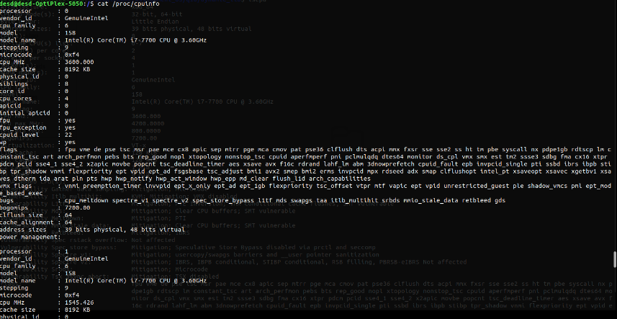

* **$ lscpu**
  + Provides detailed information about the CPU, including its architecture, number of cores, threads per core, and other relevant details in a concise format.

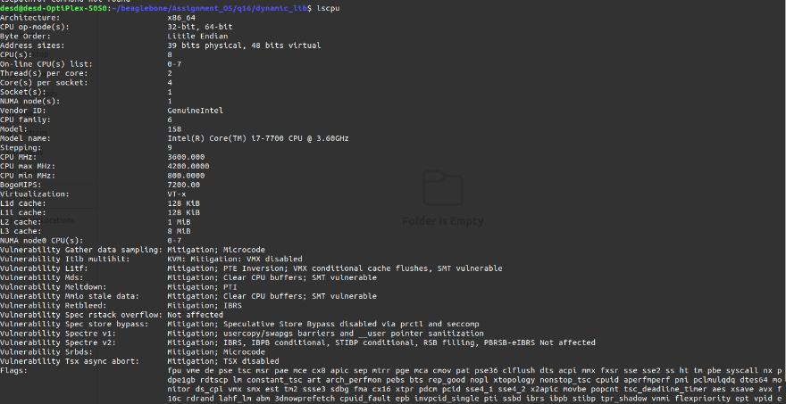

**2. Memory Capacity:**

* **$ free -h** 
  + Shows information about system memory usage and capacity in a human-readable format.

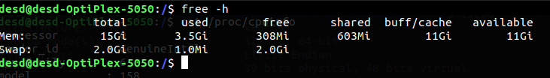

**3. Memory Map:**

* **$ cat /proc/iomem** 
  + Provides a list of current memory ranges used by different devices, showing the memory map of the system.

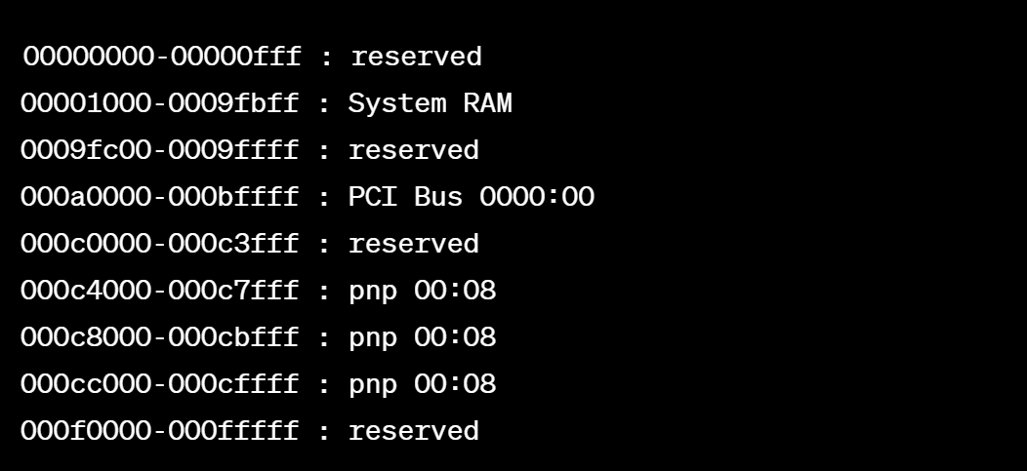

**4. I/O Map:**

* + **$ lspci** 
    - Lists all PCI buses and devices connected to them, providing information about I/O devices and their addresses.

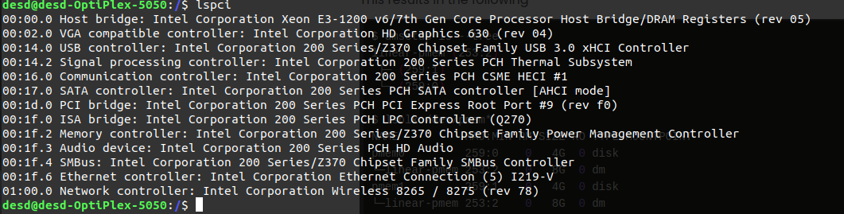

1. **Persistent Storage Details:**
   * **$ df -h** 
     + Displays information about disk space usage, including details about mounted filesystems and their capacities.

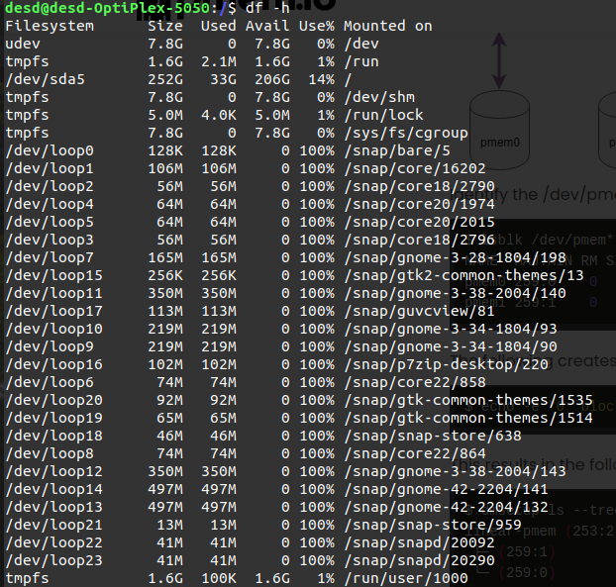

* + **$ lsblk**
  + Lists information about block devices, including disks and partitions, providing details about their sizes and mount points.

