1. Find the IP address of your target board. Find a tool / mechanism to a certain if your host and target machines are connected.

* Finding the IP address of the board

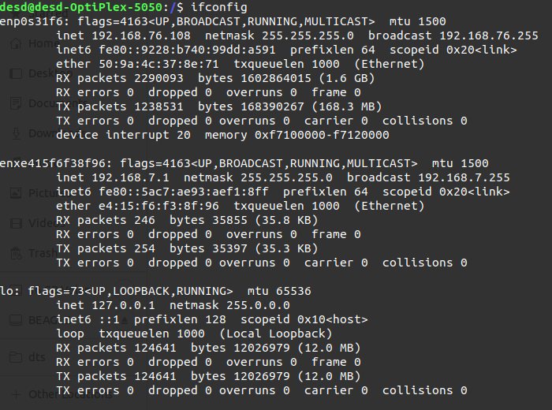**$ if config**

* Host and target connection check

**$ ssh debian@192.168.7.2**

