1. Use the secure copy (scp) tool to copy files from host machine to target machine and vice versa.

* Copy file from host machine to BBB board

**$ scp -r <file name> deabian@192.168.7.2 :~/.**

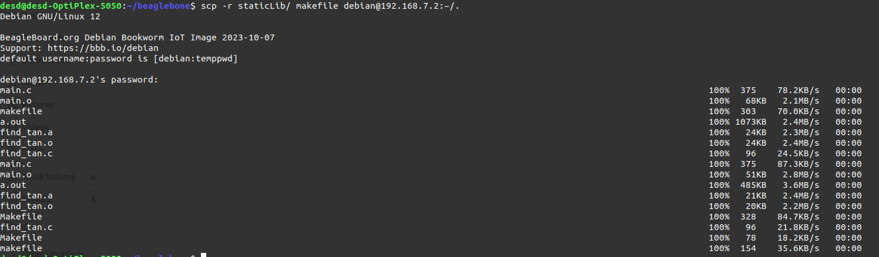

* Copy file from host machine to BBB board

**$ scp -r <file name> desd@192.168.7.1**

