1. Cross-Compile a simple C program on the Host machine and transfer it to the Embedded Linux Board (target machine). Execute it on the board.

**CREATING, COMPILING and EXECUTING FILE ON HOST**

* Create a simple C program or a directory

**$ vim <filename>.c (for file)**

**$ mkdir <name> (for creating directory)**

* Run the program on gcc compiler on host machine (intel x86)

**$ gcc <filename>.c -o <filename>.out**

* Execute the file

**$ ./<filename>.out**

**( Print the output message successfully)**

* Now run the program on arm linux compiler on host machine

**$ arm-linux-gnueabihf-gcc <filename>.c -o <filename>.out**

* Execute the file

**$ ./<filename>.out**

**( Print the error message : Exec format error)**

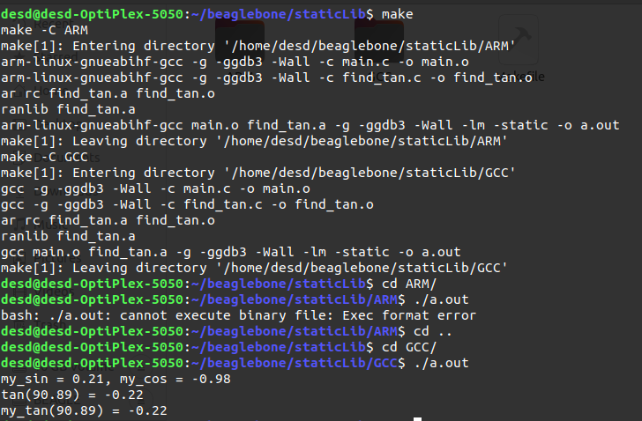

**TRANSFER DATA TO BBB BOARD**

* Command to transfer secure copy of data

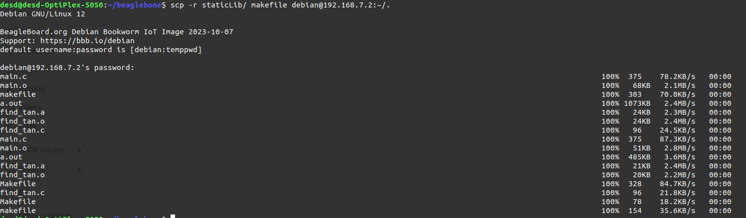**$ scp -r <filename> debian@192.168.7.2:~/.**

**CHECK and EXECUTING FILE ON BBB board**

* Checking if file/directory received or not

**$ ls**

* Execute the file compile by gcc compiler

**$ ./<filename>.out**

**( Print the error message : Exec format error)**

* Execute the file compile by arm-linux compiler

**$ ./<filename>.out**

**( Print the output message successfully)**

