1. Compile a simple C program on the Embedded Linux Board and execute it on the board

* Login to BBB board

**$ ssh debian@192.168.7.2**

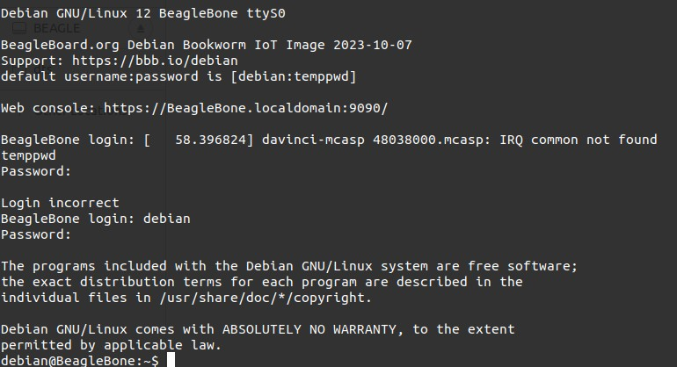

* Create a simple C program

**$ vim <filename>.c**

* Run the program

**$ gcc <filename>.c**

* Execute the file

**$ ./<filename>.out**

**( Print the output message successfully)**

