machine learning – based buyer segmentaion and investment profiling for real estate markit intelligence reasearch paper

machine learning

Author / Submission Details: Muskan Sharma

In contemporary real estate markets, customer bases exhibit high heterogeneity across demographic traits, geographic origins, financing needs, and investment motivations. Traditional market strategies often treat buyers as a uniform cohort, resulting in inefficient marketing expenditures, suboptimal inventory allocation, and missed revenue opportunities.
This research presents a framework for real estate market intelligence using unsupervised machine learning—specifically K-Means and Hierarchical Agglomerative Clustering. Utilizing demographic, geographic, behavioral, and transactional data from Parcl Co. Limited, this study outlines the complete data science pipeline: data cleaning, categorical encoding, feature scaling, optimal cluster selection, profile interpretation, and interactive deployment via a Streamlit analytics dashboard.
The resulting model successfully categorizes buyers into distinct actionable profiles (Global Investors, First-Time Buyers, Corporate Buyers, and Luxury Investors), allowing real estate platforms to deploy hyper-targeted marketing, tailor financial product offerings, and enhance customer satisfaction.

1. Introduction & Background Context

1.1 Industry Background
Real estate acquisition represents one of the most significant financial transactions undertaken by individuals and corporate entities alike. The global real estate market is characterized by high transaction values, long buyer conversion cycles, and complex buyer behavior driven by distinct financial motivations. Within this market, property buyers exhibit diverse profiles:
- Individual Homebuyers: Focus on personal utility, local amenities, and long-term residency.
- Institutional & Corporate Investors: Driven by yield optimization, risk diversification, portfolio scaling, and tax advantages.
- International & High-Net-Worth Investors: Focused on wealth preservation, cross-border asset allocation, and capital appreciation in prime markets.
- First-Time Buyers: Constrained by budget, highly dependent on mortgage financing, and sensitive to interest rate fluctuations.
Without granular market segmentation, real estate platforms and brokerage firms operate under generic operational models. This failure to segment leads to:
- Inefficient Marketing Spend: High Customer Acquisition Costs (CAC) due to broad, un-targeted advertising campaigns.
- Poor Customer Targeting: Presenting high-yield investment properties to first-time residential buyers, or entry-level homes to high-net-worth institutional investors.
- Missed Investment Opportunities: Inability to identify emerging buyer segments or geographic trends before competitors.

1.2 Problem Statement
Parcl Co. Limited currently faces a lack of data-driven understanding regarding:
- Specific demographic profiles and buyer classifications within their user base.
- Varying investment motivations (e.g., capital appreciation vs. personal residency).
- Geographic disparities in purchasing behavior across regions and countries.
- Financing patterns, including mortgage reliance and credit risk profiles.
To resolve these challenges, this study develops a machine learning framework that automatically clusters buyers based on demographic, geographic, and behavioral variables.

2. Dataset Architecture & Preprocessing Pipeline
2.1 Dataset Field Specifications
The underlying dataset consists of records capturing client demographics, spatial attributes, transaction characteristics, and satisfaction feedback.
Feature Name | Data Type | Analytical Role | Description
client_id | Categorical / String | Identifier | Unique primary key identifying each client record.
client_type | Categorical | Demographic | Indicates organizational entity: Individual vs. Corporate.
gender | Categorical | Demographic | Gender of individual buyers (Male, Female, Non-Binary, N/A for Corporate).
country | Categorical | Spatial | Client's primary country of residence.
region | Categorical | Spatial | Specific sub-national region or territory.
date_of_birth | Temporal / Date | Demographic | Timestamp used to derive client age ($Age=Year_{current}-Year_{birth}$).
acquisition_purpose | Categorical | Behavioral | Core purchasing driver: Investment vs. Personal Use.
loan_applied | Binary / Boolean | Financial | Indicates whether financing/mortgage was requested (1 / 0).
referral_channel | Categorical | Marketing | Acquisition channel (e.g., Organic Search, Broker, Social Media, Direct).
satisfaction_score | Numeric (Discrete/Continuous) | Behavioral | Customer feedback rating measuring platform experience (e.g., 1–10).
Export to Sheets

2.2 Preprocessing & Data Hygiene
Raw real estate transaction data typically contains noise, missing values, and formatting discrepancies. The data cleaning pipeline executes the following sequential steps:
- Imputation of Missing Values:
  - Categorical attributes (gender, referral_channel) are imputed using mode substitution or categorized under an explicit "Unknown" label.
  - Numerical attributes (satisfaction_score) are imputed using median values to preserve distribution centrality without bias from outliers.
- Date Transformation & Feature Engineering:
  - date_of_birth is converted into a continuous numerical attribute, age:
$$\text{Age}=\left\lfloor \frac{\text{Current_Date}-\text{Date_of_Birth}}{365.25}\right\rfloor$$
- Label Normalization & Deduplication:
  - Standardizing text entries (e.g., unifying "corp.", "CORPORATE", and "Corporate" into a single key).
  - Removing duplicate entries based on client_id and overlapping transaction timestamps.

2.3 Feature Encoding
Because distance-based machine learning algorithms require numerical inputs, categorical variables are transformed using appropriate encoding strategies:
- One-Hot Encoding: Applied to nominal variables without intrinsic ordinal ranking (client_type, acquisition_purpose, referral_channel, region). For a categorical feature $C$with $k$unique levels, $k-1$dummy binary columns are created to eliminate multi-collinearity.
- Label / Target Encoding: Applied to high-cardinality geographical attributes (country) or ordinal features, mapping strings to numeric indices or frequency distributions.

2.4 Feature Scaling
Clustering algorithms based on distance metrics (such as Euclidean distance) are sensitive to feature scales. For example, an age variable ranging from $18$to $80$would dominate a binary indicator variable ($0$ or $1$) if unscaled.
Two standardization methods are evaluated:
- Standard Scaling ($Z$-Score Normalization):
$$z=\frac{x-μ}{σ}$$
Where $μ$is the mean and $σ$is the standard deviation of the feature.
- Min-Max Scaling:
$$x_{\text{norm}}=\frac{x-x_{\text{min}}}{x_{\text{max}}-x_{\text{min}}}$$
Standard Scaling is selected for continuous variables (age, satisfaction_score) to retain outlier information while placing features on a centered gaussian scale with $μ=0$and $σ=1$.

3. Machine Learning Methodology & Clustering Framework

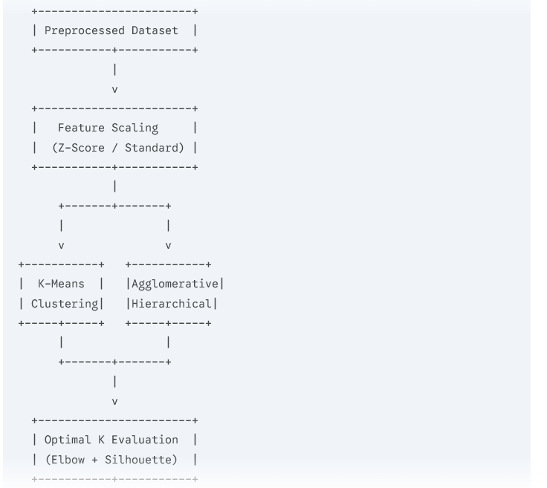

3.1 Algorithm Selection
K-Means Clustering
K-Means partitions $N$observations into $K$distinct, non-overlapping clusters. The objective function minimizes the Within-Cluster Sum of Squares (WCSS), defined as:
$$J=\sum_{i=1}^{K}{\sum_{x∈S_{i}}{‖}}x-μ_{i}‖​^{2}$$
Where:
- $K$is the number of clusters.
- $S_{i}$is the set of points in cluster $i$.
- $μ_{i}$is the centroid (mean vector) of points in $S_{i}$.
Advantages: High computational efficiency ($O\left(N⋅K⋅I⋅d\right)$ time complexity), scalable to large client databases, and highly interpretable centroids.

Hierarchical Agglomerative Clustering
Hierarchical clustering builds a nested tree of clusters (dendrogram) using a bottom-up approach. Starting with each data point as its own cluster, pairs are successively merged based on proximity using Ward’s Linkage Method, which minimizes total within-cluster variance:
$$ΔVar=\frac{|A|⋅|B|}{|A|+|B|}‖μ_{A}-μ_{B}‖​^{2}$$
Advantages: Does not require a pre-specified cluster count prior to construction, reveals nested hierarchical relationships among buyer demographics, and serves as a cross-validation baseline for K-Means cluster stability.

3.2 Optimal Cluster Selection Strategy
To select the optimal number of clusters $K$, two complementary diagnostics are used:
1. The Elbow Method
Plotting the total WCSS against a range of $K$values (e.g., $K∈\left[2,10\right]$). The "elbow" point indicates the value of $K$where adding further clusters yields diminishing returns in variance explained.
2. Silhouette Coefficient Analysis
The Silhouette Score evaluates the cohesion within a cluster versus the separation from neighboring clusters. For a given data point $i$:
$$s\left(i\right)=\frac{b\left(i\right)-a\left(i\right)}{\max\left(a\left(i\right),b\left(i\right))\right)}$$
Where:
- $a\left(i\right)$is the mean intra-cluster distance between point $i$and all other points in the same cluster.
- $b\left(i\right)$is the mean nearest-cluster distance between point $i$and points in the closest neighboring cluster.
The overall Silhouette Score is the average $s\left(i\right)$across all $N$data points:
$$S=\frac{1}{N}\sum_{i=1}^{N}{s}\left(i\right)$$
Higher Silhouette values (closer to $+1.0$) indicate distinct, well-separated buyer segments.

4. Empirical Results & Buyer Segment Profiling
Based on performance metrics (maximizing Silhouette score while maintaining business interpretability), $K=4$was identified as the optimal cluster configuration.
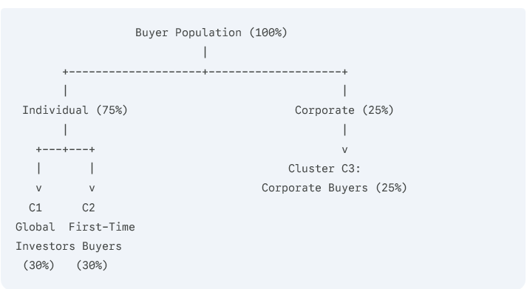
Global First-Time
Investors Buyers
(30%) (30%)

4.1 Granular Cluster Interpretations
Segment 1 (C1): Global Investors
- Demographics: Primarily international individuals; older age demographic (45–65 years).
- Acquisition Motivation: 100% Investment / Capital Appreciation.
- Financing Strategy: Low reliance on local mortgage financing (loan_applied = 0 or low ratio); high self-funding capacity.
- Satisfaction & Referral: Acquired via direct advisory, specialized wealth brokers, or organic search; moderate to high satisfaction scores.
- Strategic Profile: Capital-rich entities seeking yield diversification across foreign real estate markets.

Segment 2 (C2): First-Time Buyers
- Demographics: Younger age demographic (22–35 years); domestic/local residency.
- Acquisition Motivation: Personal Use / Primary Residence.
- Financing Strategy: High dependency on mortgage financing (loan_applied = 1).
- Satisfaction & Referral: Highly sensitive to platform user experience and loan application friction; acquired via digital channels (social media, organic search).
- Strategic Profile: Price-sensitive buyers requiring end-to-end guidance and integrated financial services.

Segment 3 (C3): Corporate Buyers
- Demographics: Legal business entities, institutional funds, and commercial entities (client_type = Corporate).
- Acquisition Motivation: Commercial investment, portfolio expansion, or corporate housing.
- Financing Strategy: Structured corporate financing, institutional loans, or commercial lines of credit.
- Satisfaction & Referral: B2B channels, direct account managers, executive referrals.
- Strategic Profile: High-volume, repeat purchasers demanding bulk property management tools, detailed yield metrics, and dedicated relationship managers.

Segment 4 (C4): Luxury Investors
- Demographics: High-net-worth individuals (HNWIs) across both domestic and international regions.
- Acquisition Motivation: Dual-purpose (High-end personal vacation homes combined with long-term asset value preservation).
- Financing Strategy: Low mortgage dependency; transaction speed and confidentiality prioritized over interest rates.
- Satisfaction & Referral: Highest average satisfaction_score; acquired through private banking channels and exclusive broker networks.
- Strategic Profile: Premium buyers focused on luxury amenities, prime locations, and concierge-level transaction services.

4.2 Comprehensive Segment Comparison Matrix
Attribute / Feature | Cluster C1: Global Investors | Cluster C2: First-Time Buyers | Cluster C3: Corporate Buyers | Cluster C4: Luxury Investors
Primary Client Type | Individual | Individual | Corporate | Individual
Mean Age Range | 45 – 65 | 22 – 35 | N/A (Corporate) | 40 – 60
Acquisition Purpose | Investment | Personal Use | Portfolio / Commercial | Personal / Investment
Loan Applied Ratio | Low (< 20%) | High (> 85%) | Variable / Commercial | Very Low (< 10%)
Primary Channels | Wealth Brokers, Search | Social Media, Digital | B2B Sales, Direct | Private Banking, Network
Key Value Drivers | ROI, Rental Yield, Tax | Affordability, Low Rate | Volume, Asset Yield | Prime Location, Luxury
Export to Sheets

5. Interactive Streamlit Web Application Architecture
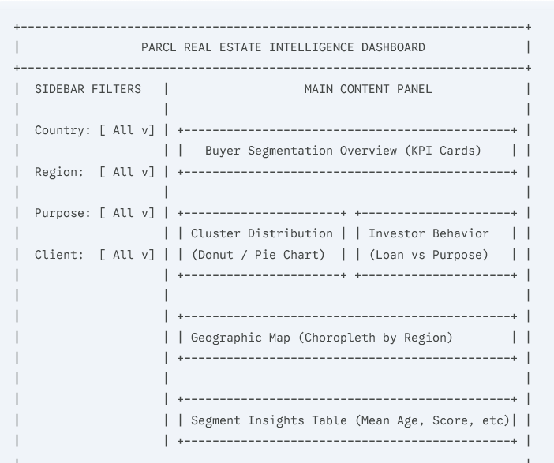

5.1 Dashboard Components & Functional Modules
1. Global User Controls & Filtering Panel
Allows business analysts to filter underlying data dynamically across:
- Country
- Region
- Acquisition Purpose
- Client Type
2. Buyer Segmentation Overview
Displays macro-level KPIs and cluster distribution charts:
- Total active buyers analyzed.
- Proportional breakdown of Clusters C1–C4 visualized using interactive donut and bar charts (e.g., Plotly).
3. Investor Behavior Dashboard
Visualizes interaction patterns between loan applications, investment purpose, and satisfaction scores per cluster:
- Cross-tabulated heatmaps showing mortgage adoption by segment.
- Scatter plots displaying satisfaction score versus buyer age and acquisition type.
4. Geographic Buyer Analysis
Integrates spatial visualizations (Choropleth maps and regional density plots) mapping cluster concentrations across different geographic regions and countries.
5. Segment Insights Panel
Provides a detailed statistical breakdown for selected clusters:
- Dynamic summary tables detailing mean age, median satisfaction score, top acquisition channel, and loan approval rates.
- Export tools allowing strategy teams to download targeted client lists in CSV/JSON format for targeted outreach.

6. Strategic Business Recommendations & Marketing Action Plan
+-----------------------------------------------------------------+
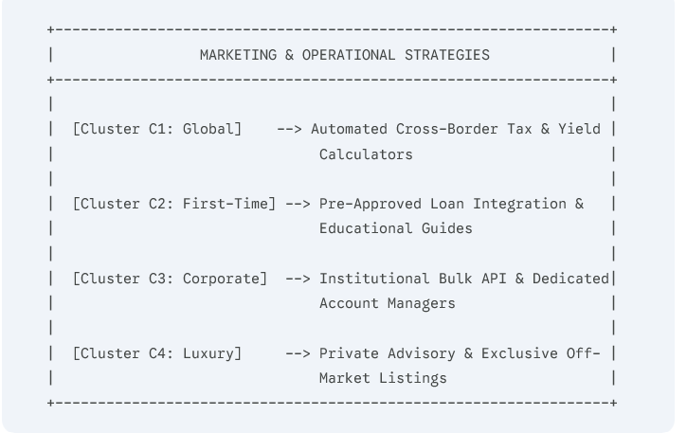

6.1 Actionable Implementation Matrix
- Tailored Digital Marketing & Channel Optimization:
  - First-Time Buyers (C2): Allocate ad spend toward social media and search campaigns highlighting low-down-payment options, mortgage calculators, and starter home listings.
  - Global & Luxury Investors (C1, C4): Shift ad spend to private wealth channels, international financial publications, and targeted search terms emphasizing property yields and wealth preservation.
- Product & Platform Personalization:
  - For C1 & C3: Embed real-time gross/net rental yield calculators, projected capital appreciation graphs, and multi-currency payment options into property listing pages.
  - For C2: Integrate pre-approved mortgage tools directly into the checkout funnel to lower drop-off rates and reduce application friction.
- Dedicated Relationship Management:
  - Corporate Buyers (C3): Assign dedicated institutional account managers to handle multi-property transactions, bulk negotiations, and custom reporting API access.
DASHBOARD

7. Deliverables & Technical Project Architecture
To ensure operational adoption, the project delivers the following core artifacts:
- Research & Analytical Report: A comprehensive documentation detailing exploratory data analysis (EDA), distance metric selections, model evaluation curves (Elbow/Silhouette), and strategic recommendations.
- Streamlit Web Application: A functional, live analytics platform providing interactive buyer profiling, spatial visualization, and dynamic filtering.
- Production Pipeline Codebase: Modular Python scripts encompassing data cleaning, automated feature encoding, model execution, and export modules for real-time inference on new client registrations.

8. Conclusion
By shifting from an unsegmented market view to an AI-driven clustering framework, Parcl Co. Limited can significantly enhance market intelligence and operational efficiency. The identification of four distinct buyer archetypes (Global Investors, First-Time Buyers, Corporate Buyers, and Luxury Investors) equips marketing teams, sales operations, and product designers with data-backed insights. Implementing this intelligence via an interactive Streamlit dashboard enables data-driven decision-making, reduced customer acquisition costs, optimized financial product offerings, and scalable growth across competitive real estate markets.

