PYTHON INTRODUCTION

LAB

ASSIGNMENT – 1

Submitted By:

Name: Muskan Singh

Class: CSE – 2

Enrolment No: 42313202717

Github link: https://github.com/muskansingh11/Assignment1

Problem : 1

To create a program that asks the user to enter their name and their age and prints out a message addressed to them that tells them the year that they will turn 100 years old. Additionally, the program asks the user for another number and prints out that many copies of the previous message on separate lines.

Pseudo Code :

Set Name <- User Input

Set Age <- User Input

Set Year <- 2021 – Age + 100

Set Number<- User Input

For i<-0 to num do

OUTPUT "Welcome " + name + " , you are " + age + " year old . You will turn 100 year old in " + year + " ." + "\n"

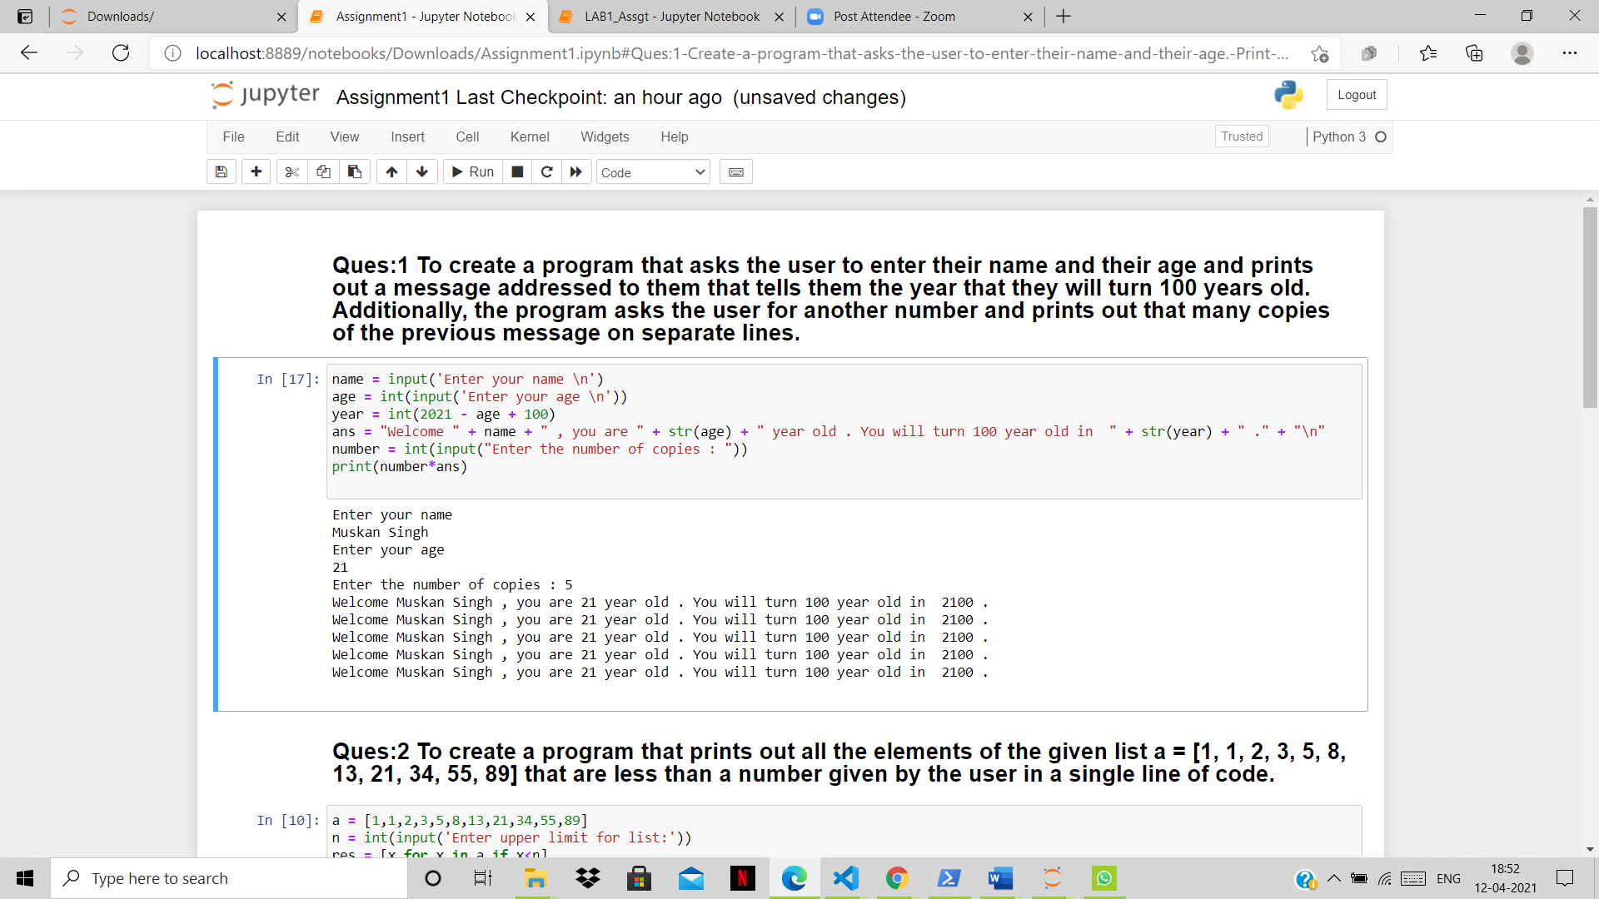

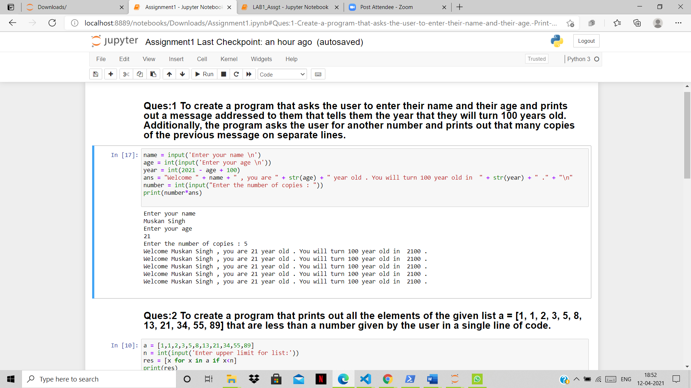

Problem 2:

To create a program that prints out all the elements of the given list a = [1, 1, 2, 3, 5, 8, 13, 21, 34, 55, 89] that are less than a number given by the user in a single line of code.

Pseudo Code:

**Pseudocode:**

Set a 🡨 [1, 1, 2, 3, 5, 8, 13, 21, 34, 55, 89]

Set n 🡨 USER INPUT

Set num 🡨 length(a)

Set res 🡨 []

for i 🡨 0 to num do

if a[i] < n then do

Add a[i] to res

OUTPUT res

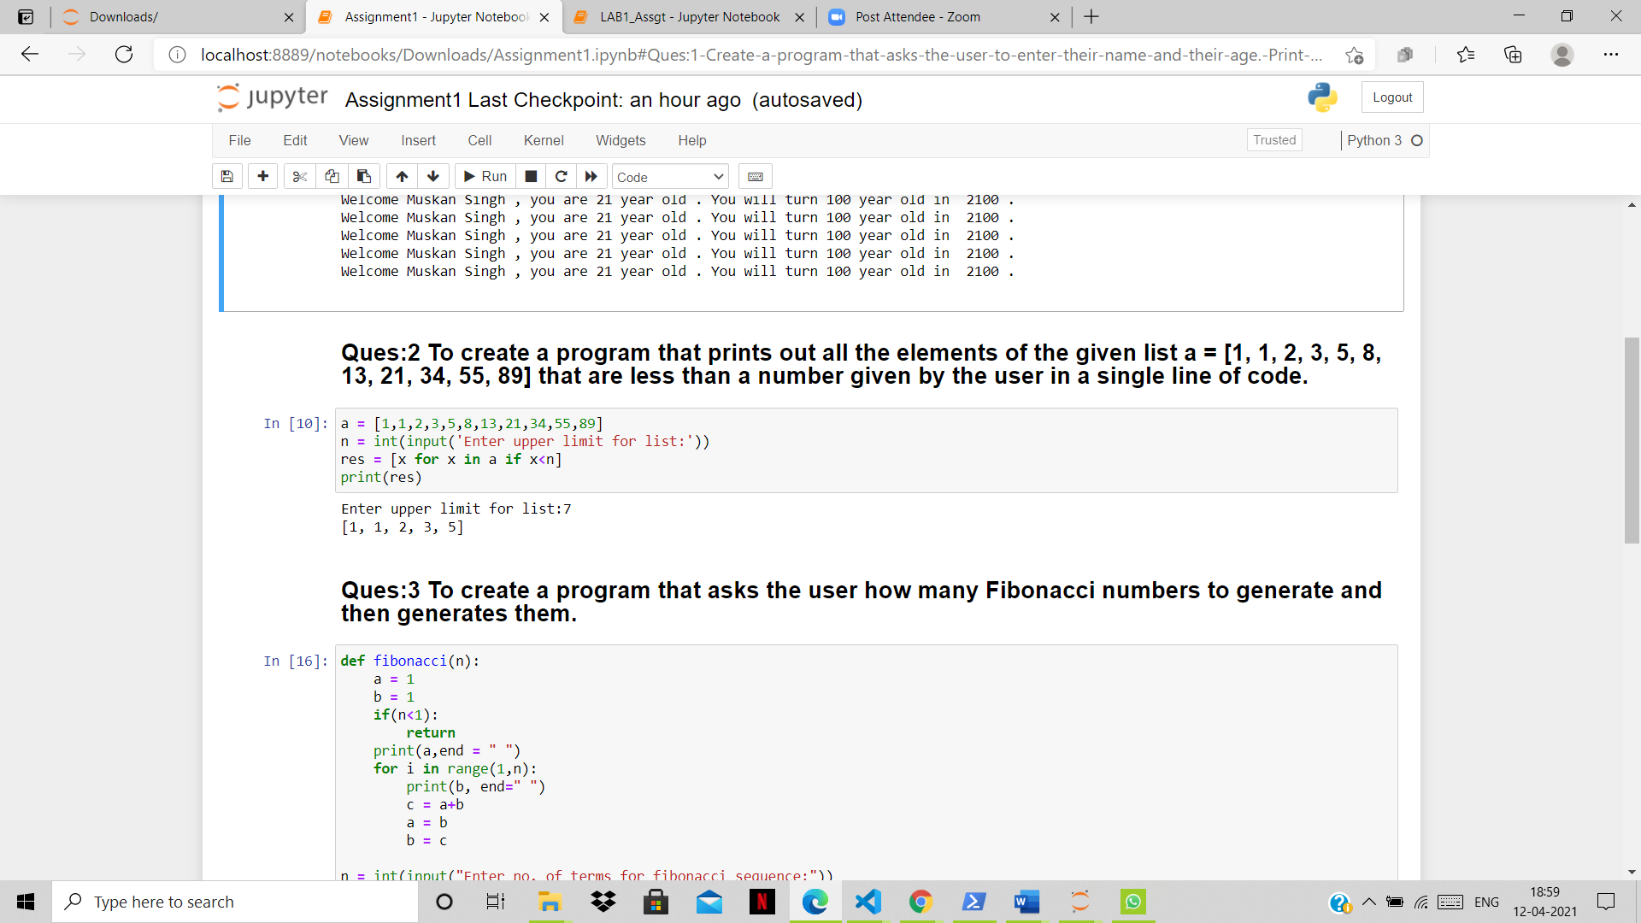

Problem 3:

To create a program that asks the user how many Fibonacci numbers to generate and then generates them.

Pseudo Code:

Set a 🡨 1

Set b 🡨 1

Set n 🡨 USER INPUT

If n < 1 then return

OUTPUT(a)

for i 🡨 1 to n do

OUTPUT(b)

Set c 🡨 a + b

Set a 🡨 b

Set b 🡨 c

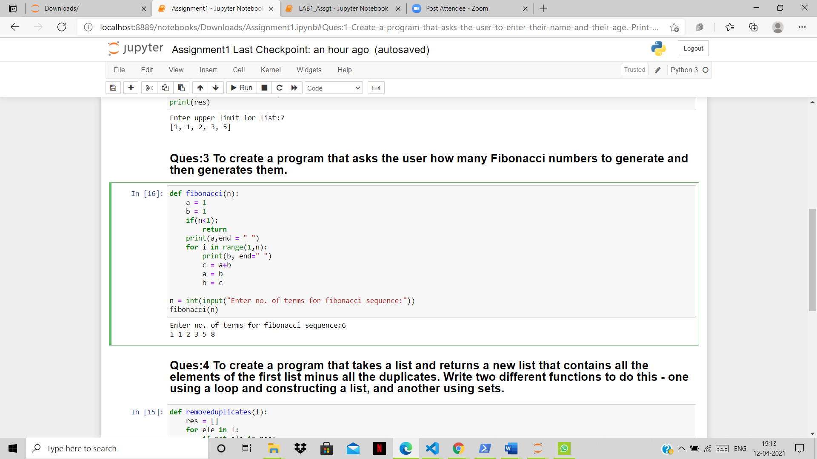

Problem 4:

To create a program that takes a list and returns a new list that contains all the elements of the first list minus all the duplicates. Write two different functions to do this - one using a loop and constructing a list, and another using sets.

Pseudo Code:

*Removeduplicate (l)*

Set res 🡨 []

for element in l do

if element not in res then do

add element to res

return res

*Removeduplicatetwo (l)*

res = set(l)

return list(res)

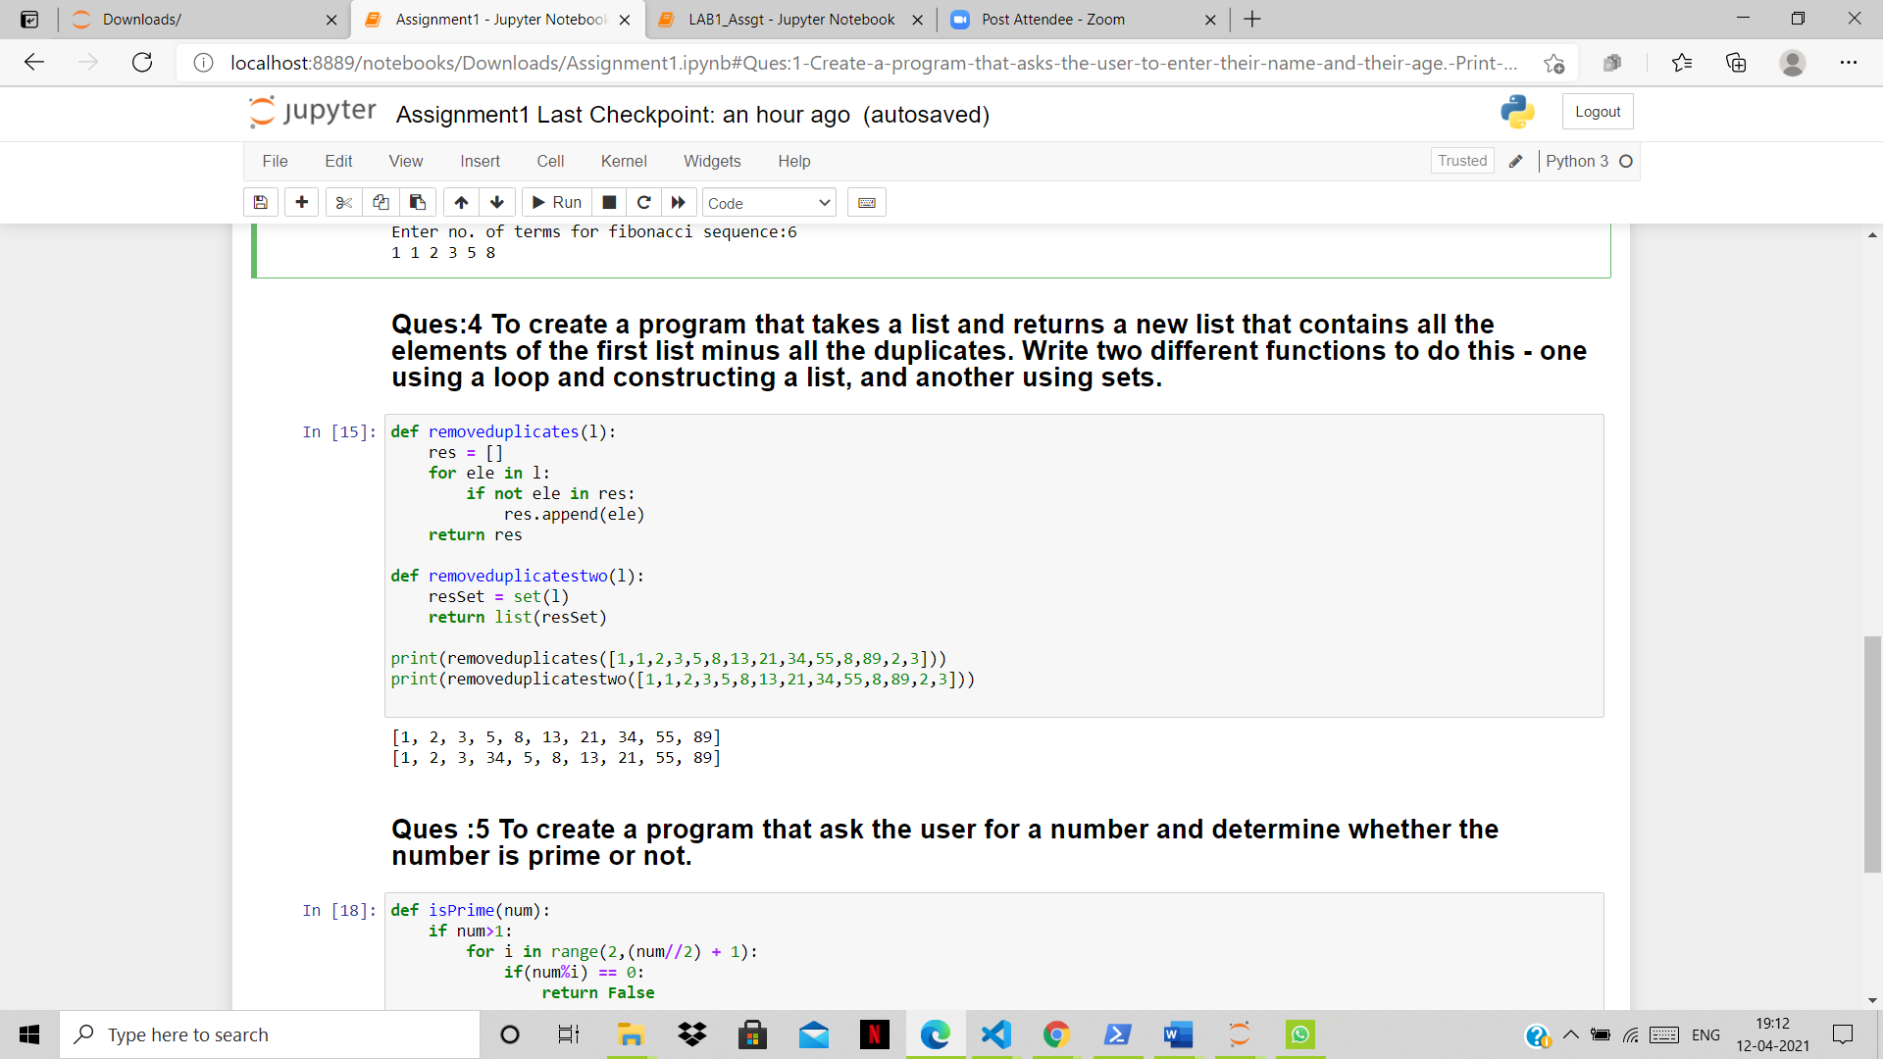

Problem 5:

To create a program that ask the user for a number and determine whether the number is prime or not.

**Pseudo Code:**

Set num 🡨 USER INPUT

If num > 1 then do

For I 🡨 2 to num/2 + 1 do

If num % I == 0

OUTPUT (“NOT PRIME”)

Return

OUTPUT (“PRIME”)

