  - What is a model Learning Rate? We should choose a high learning rate for getting quick results on training data. Comment on the statement.

  - Explain One-Hot Encoding. Does the dimensionality of the dataset increase, decrease or remain constant after applying this technique?

  - A financial institution has just hired you to build a system which will decide what car insurance package to offer to different clients. The information recorded about the clients are -gender, age group (under 20, 20-35, 35-55 and over 55), credit rating, occupation, number of accidents in the last year, car make, model, year and the city where the person lives.
The financial institution has a database of roughly 20000 current clients. Explain step by step how you would use a logistic regression approach to build the system.
Your answer should contain:
    - Type of problem you are dealing with
    - How would you cater the categorical data e.g. occupation, car make, model, city etc using them as features in your logistic regression model
    - Other relevant details

  - Write the steps in designing an Unsupervised Machine Learning model. How do we change the penalty parameter in case we have a condition of underfitting using regularization technique?

  - What would be the expected output of the follow code snippet?
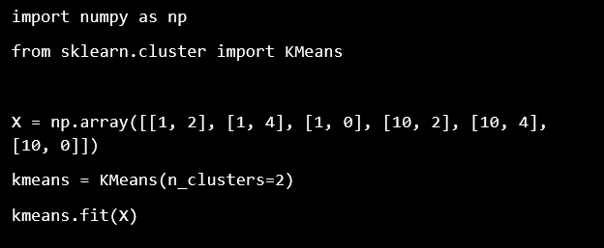

Consider that you have been hired as a Data Scientist for Zomato, the Indian multinational restaurant aggregator and food delivery company, assume the following scenario and visualize the questions that follow by using test_zomato.csv dataset:
  - Out of the first 10 restaurants,
- Which city or cities have the most expensive restaurants?
- Which city or cities have the cheapest restaurants?
- Which city or cities have the highest rated restaurants?
- Which restaurant or restaurants do not provide table booking facilities?

  - For Indian restaurants in between index numbers 1400 to 1405(excluding),
- Which restaurant has less than 4/5 rating?
- Which restaurant is the most expensive?
- Which restaurant is the cheapest?

