Smart Laundry Management System

Project Report
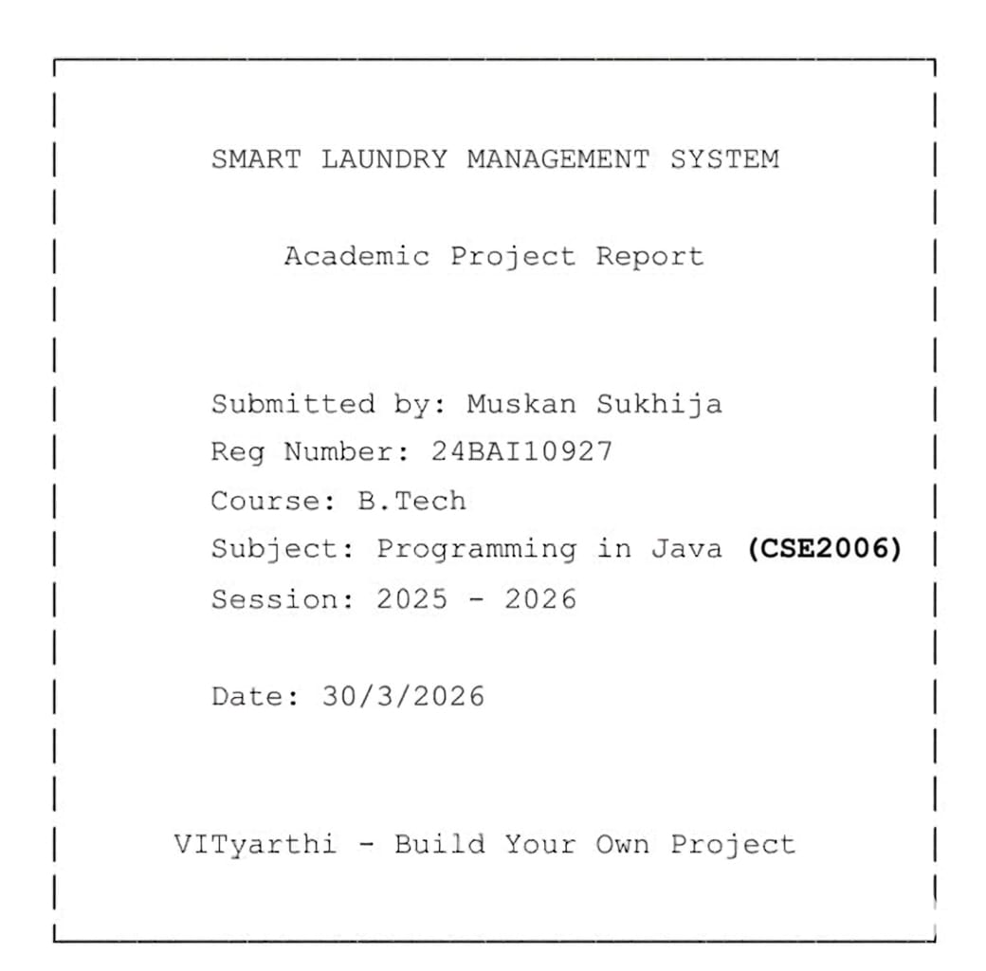

Introduction
In today’s fast-paced lifestyle, efficient management of daily tasks is essential, especially in shared living environments such as hostels and apartment complexes. Laundry management in these places is often handled manually using registers or informal methods, which leads to inefficiencies such as misplaced clothes, lack of order tracking, delays, and human errors.
The Smart Laundry Management System is a Java-based console application developed to address these challenges. It provides a structured and automated way to manage laundry services, enabling users to place orders, track their status, and maintain records digitally.
This system is specifically designed for small-scale environments like hostels and apartments, where a lightweight, easy-to-use solution is more practical than complex enterprise systems.
Problem Statement
Laundry services in hostels and small residential setups lack automation. The absence of a proper system results in:
- Manual record-keeping prone to errors
- Difficulty in tracking order status
- Inefficient handling of multiple users
- Lack of transparency for users
- No persistent storage of data
Hence, there is a need for a simple, reliable, and efficient system to manage laundry operations.
Objectives
The objectives of this project are:
- To design and develop an automated laundry management system
- To provide a user-friendly interface for placing and managing orders
- To implement dynamic pricing based on service type and cloth type
- To store and retrieve data using file handling
- To minimize manual errors and improve efficiency
- To provide a scalable system that can be enhanced in the future

Scope of the project
This system is designed specifically for:
- Hostels
- Small apartment complexes
- Small-scale laundry services
- Scope Limitations:
- No database integration (uses file handling)
- No multi-user authentication
- No online payment system
- Console-based interface
Despite these limitations, the system effectively fulfills its purpose in small environments.

Existing System
The existing laundry system is mostly manual and involves maintaining records in notebooks.
- Drawbacks:
- Time-consuming process
- High probability of human errors
- No proper tracking mechanism
- Risk of data loss
- Difficult to manage large number of orders

Proposed System
The proposed system is a Smart Laundry Management System that automates the process.
- Key Features:
- Menu-driven interface
- Order placement functionality
- Order viewing functionality
- Order status update feature
- Support for multiple service types:
  - Wash
  - Iron
  - Wash + Iron
- Support for cloth types:
  - Normal
  - Woolen
- Dynamic pricing mechanism
- File-based data persistence

System Design
Use Case Diagram
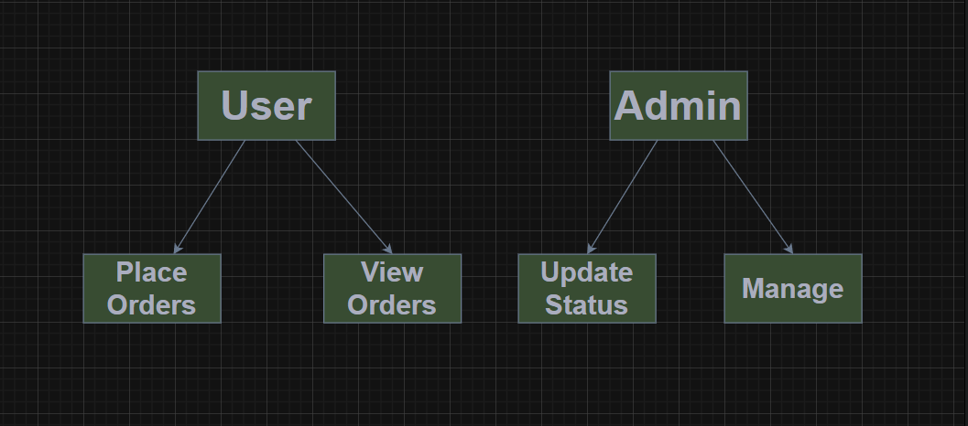
Explanation:
This diagram shows the interaction between the user and the system. The user can place orders and view them, while the admin can update the status of orders and manage it.
Class Diagram
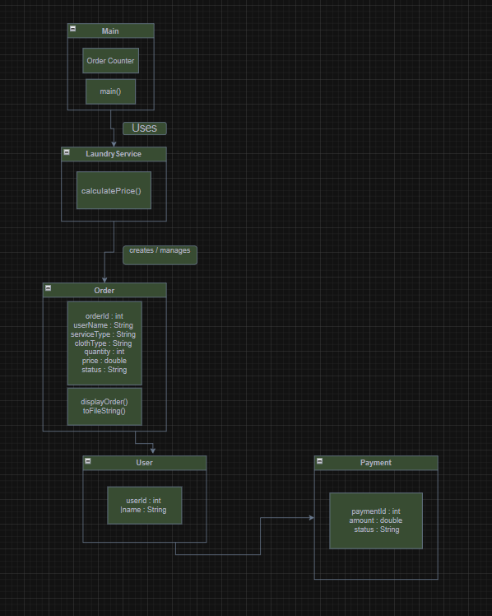
Explanation:
The class diagram represents the structure of the system. Key classes include:
- Main: Controls program execution
- Order: Stores order details
- LaundryService: Handles pricing logic
- User: Represents customer
- Payment: Represents transaction details
Flowchart
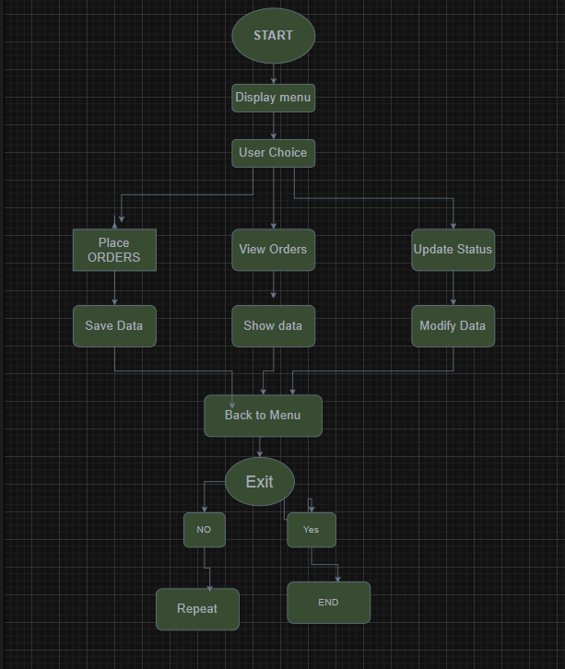
Explanation:
The flowchart shows the step-by-step process from program start to termination.

System Architecture
The system follows a modular architecture:
- Presentation Layer: Console interface
- Business Logic Layer: LaundryService class
- Data Layer: File handling (orders.txt)
This separation improves maintainability and scalability.

Implementation Details
Technologies Used
- Java (Core Java)
- Object-Oriented Programming Concepts
- File Handling (FileReader, FileWriter, BufferedReader)
- GitHub Codespaces
Modules Description
- Main Module
- Handles user input
- Displays menu
- Controls flow of execution
- Order Module
Stores:
- Order ID
- Customer Name
- Service Type
- Cloth Type
- Quantity
- Price
- Status
- Status
- LaundryService Module
Implements pricing logic using conditional statements based on:
- Service type
- Cloth type
- File Handling Module
- Saves orders into file
- Loads previous orders at startup
- Updates file when status changes

Pricing Mechanism
The system uses a dynamic pricing model:

Service | Normal | Woolen
Wash | ₹10 | ₹15
Iron | ₹5 | ₹8
Wash + Iron | ₹15 | ₹20

- Explanation:
Woolen clothes require special care and handling, resulting in higher pricing compared to normal clothes.

Algorithm / Working
- Start the program
- Load existing orders from file
- Display menu options
- Take user input
- Perform selected operation:
  - Place Order
  - View Orders
  - Update Status
- Save data to file
- Repeat until exit

Output Screenshots
MENU:
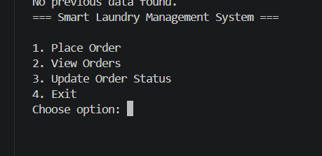
Order Placement:

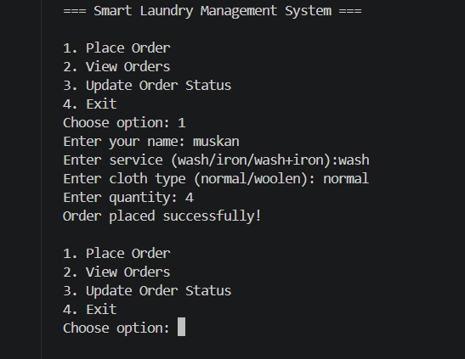

Order Display:
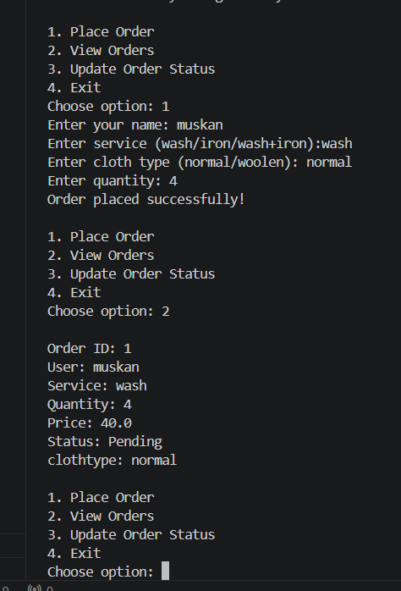
Status Update:
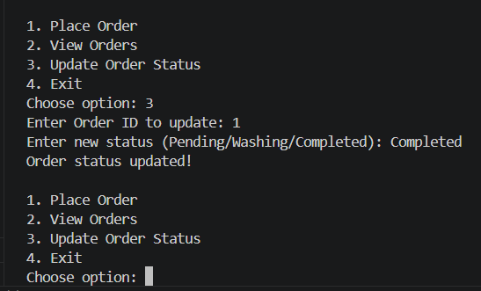
Exit:
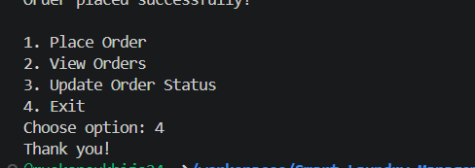
Include:
- Menu
- Order placement
- Order display
- Status update
Orders.txt where all the orders will be stored and updated when the admin will update.
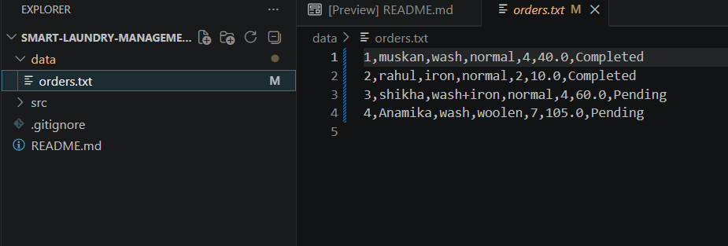

Testing
- Test Scenarios:
- Valid inputs
- Invalid service type
- File reading/writing
- Multiple order handling
- Result:
The system worked successfully for all tested scenarios.

Test Cases
Test Case 1: Place Order (Valid Input)
- Test Case ID: TC01
- Objective: To verify that a user can successfully place an order
- Input:
  - Name: Muskan
  - Service: wash
  - Cloth Type: normal
  - Quantity: 3
- Expected Output:
  - Order is created successfully
  - Price calculated correctly (₹10 × 3 = ₹30)
  - Data stored in orders.txt
- Actual Output: Order placed successfully
- Status: Pass

Test Case 2: Place Order with Wash + Iron
- Test Case ID: TC02
- Objective: To verify combined service pricing
- Input:
  - Name: Rahul
  - Service: wash+iron
  - Cloth Type: woolen
  - Quantity: 2
- Expected Output:
  - Price calculated correctly (₹20 × 2 = ₹40)
  - Order stored successfully
- Actual Output: Order placed successfully
- Status: Pass

Test Case 3: Invalid Service Input
- Test Case ID: TC03
- Objective: To verify system handles invalid service type
- Input:
  - Service: dryclean
- Expected Output:
  - Display error message: "Invalid service!"
  - Order should NOT be created
- Actual Output: Error displayed and order not saved
- Status: Pass

Test Case 4: View Orders (Non-empty List)
- Test Case ID: TC04
- Objective: To verify viewing of existing orders
- Precondition: At least one order exists
- Input: Choose option 2
- Expected Output:
  - All order details displayed correctly
- Actual Output: Orders displayed
- Status: Pass

Test Case 5: View Orders (Empty List)
- Test Case ID: TC05
- Objective: To verify behavior when no orders exist
- Precondition: orders.txt is empty
- Input: Choose option 2
- Expected Output:
  - Message: "No orders found!"
- Actual Output: Message displayed
- Status: Pass

Test Case 6: Update Order Status (Valid ID)
- Test Case ID: TC06
- Objective: To verify updating order status
- Input:
  - Order ID: 1
  - New Status: Washing
- Expected Output:
  - Status updated successfully
  - File updated with new status
- Actual Output: Status updated
- Status: Pass

Test Case 7: Update Order Status (Invalid ID)
- Test Case ID: TC07
- Objective: To verify system behavior for invalid order ID
- Input:
  - Order ID: 999
- Expected Output:
  - Message: "Order not found!"
- Actual Output: Message displayed
- Status: Pass

Test Case 8: File Persistence
- Test Case ID: TC08
- Objective: To verify data is stored permanently
- Steps:
  - Place an order
  - Exit program
  - Restart program
- Expected Output:
  - Previously stored orders should be loaded
- Actual Output: Orders loaded successfully
- Status: Pass

Test Case 9: Multiple Orders Handling
- Test Case ID: TC09
- Objective: To verify system handles multiple orders
- Input: Place multiple orders
- Expected Output:
  - All orders stored and displayed correctly
- Actual Output: Works correctly
- Status: Pass

Test Case 10: Price Calculation Accuracy
- Test Case ID: TC10
- Objective: To verify correct price calculation
- Input:
  - Service: iron
  - Cloth Type: woolen
  - Quantity: 4
- Expected Output:
  - Price = ₹8 × 4 = ₹32
- Actual Output: Correct price displayed
- Status: Pass

Advantages
- Simple and user-friendly
- Reduces manual errors
- Efficient order tracking
- Persistent data storage
- Easy to maintain

Limitations
- No graphical interface
- No database integration
- Limited scalability
- No user authentication

Future Enhancements
- GUI using Java Swing
- Database integration (MySQL)
- Online payment system
- Mobile application
- Notification system
- Multi-user login system

Conclusion
- The Smart Laundry Management System successfully automates the process of managing laundry services in small environments. It improves efficiency, ensures accurate record-keeping, and provides a structured approach to handling orders.
- The project demonstrates the practical application of Java programming, object-oriented principles, and file handling techniques.

