|  |  |  |
| --- | --- | --- |
| MOTORS | April 5  2016 | |
| Muskan Tantia | |  |

Contents

Introduction 1

E-R Diagram 1

Database Schema 1

Queries 1

Solutions 1

# 

# INTRODUCTION

**A**.Problem Statement

XYZ is a leading two-wheeler motor company and wants to increase its market share in a city .It has also launched a cardholder program and a detailed analysis is performed to see the results(financial).

**1.** Introduction to cardholder program

The cardholder Program is an innovative and unique customer relationship program to provide to its customers additional value, beyond just the product.

**2.** Objectives of the case study

A detailes analysis would reveal the following points as the objectives of the company in launching this program.

• To develop a closer and meaningful relationship with the customer.

• To reward the customers during every point of interaction.

• To encourage customers to use the authorized service stations of the company.

• To motivate existing customers to recommend Hero Honda motorcycles to their friends/ relatives. • To focus its advertising efforts on a clear targeted group.

• To enable the customers to have a direct contact/ channel with the company.

# 

# E-R Diagram

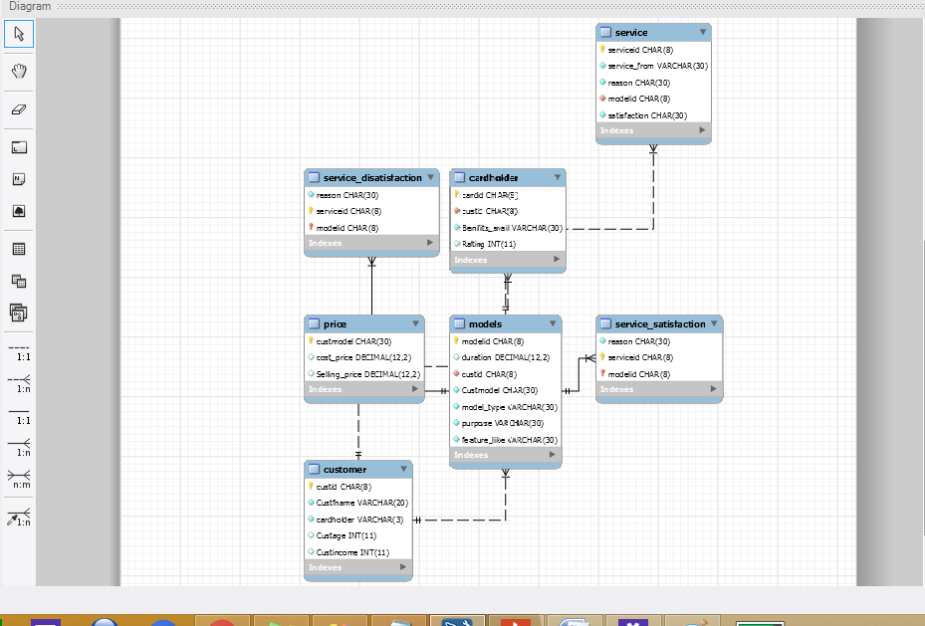

# 

# Queries

**1. which age group to focus and advertising accordingly?**

ANS-

select concat(round((a.p/e.tot)*100,2),'%')as 'Above18 and up to 25 Years',

concat(round((b.p/e.tot)*100,1),'%') as 'Above 25 up to 30',

concat(round((c.p/e.tot)*100,1),'%') as'Above 30 up to 50',

concat(round((d.p/e.tot)*100,1),'%') as'Above 50'

from(select count(Custage) as p

from customer

where custage between 18 and 25) a,

(select count(Custage) as p from customer

where custage between 26 and 30) b,

(select count(Custage) as p

from customer

where custage between 31 and 49) c,

(select count(Custage) as p

from customer

where custage>=50) d,

(select count(custage) tot from customer ) e;

OUTPUT-

Above18 and up to 25 Years, Above 25 up to 30, Above 30 up to 50, Above 50

'50.00%', '25.0%', '18.8%', '6.3%'

OBSERVATION-

Most of the respondents fall in the category between 25 to 30 years, followed by the category between 25 to 30 years.It can be observed that most of the respondents, i.e. more than seventy percent of them belonged to the age group between 18 to 30 years.

**2. Profile of Monthly Income of Respondents?**

ANS-

select concat(round((a.p/e.tot)*100,2),'%')as 'Up to Rs.5000 ',

concat(round((b.p/e.tot)*100,1),'%') as 'Above Rs.5000 up to Rs.10,000 ',

concat(round((c.p/e.tot)*100,1),'%') as'Above Rs.10,000 up to Rs.15,000',

concat(round((d.p/e.tot)*100,1),'%') as'Above Rs.15,000'

from(select count(custincome) as p

from customer

where custincome <=5000) a,

(select count(Custincome) as p

from customer

where custincome between 5001 and 10000) b,

(select count(Custincome) as p

from customer

where custincome between 10001 and 15000) c,

(select count(Custincome) as p

from customer

where custincome>15000) d,

(select count(custincome) tot from customer ) e;

OUTPUT-

# Up to Rs.5000 , Above Rs.5000 up to Rs.10,000 , Above Rs.10,000 up to Rs.15,000, Above Rs.15,000

'18.75%', '6.3%', '31.3%', '43.8%'

OBSERVATION-

Most of the respondents (43%) fall under the income category of above Rs.15000/- per month,

followed by the income category of Above Rs.10,000 up to Rs.15,000 (accounting for 31%),

It can be observed that more than fifty percent of the respondents belonged to the income category

between Rs.10000 and above.

So a model with price around 15000 can be launched.

**3. Motor Cycle Models Used by MOST PEOPLE**

ANS-

select count(custmodel) as 'No. of Responses ',custmodel as 'MOTOR CYCLE MODEL',

(count(custmodel)/a.m)*100 as 'percentage(%)'

from models,(select count(CUSTMODEL) m

FROM models) a

group by custmodel;

OUTPUT-

Responses , MOTOR CYCLE MODEL, percentage(%)

|  |  |  |
| --- | --- | --- |
| 3 | Ambition | 9.6774 |
| 3 | CBZ | 9.6774 |
| 4 | CD 100 | 12.9032 |
| 5 | Passion | 16.1290 |
| 12 | Splendor | 38.7097 |
| 4 | Splendor plus | 12.9032 |
|  |  |  |

OBSERVATION-

Splendor is obviously the leading model with a 38% share of respondent,

Splendor is the largest selling motor cycle in the world

**4. Are two wheelers Demad driving as a personal transportation?**

ANS-

select model_type,count(model_type) as 'no. of responses',

round((count(model_type)/a.m)*100,2) as 'percentage(%)'

from models,

(select count(model_type) m from models) a

group by model_type;

OUTPUT-

model_type responses, percentage(%)

|  |  |  |
| --- | --- | --- |
| New Motor Cycles | 24 | 77.42 |
| Second Hand Motor Cycles | 7 | 22.58 |

OBSERVATION-

It is quite obvious from the inspection of data that most of the respondents (78%) are using new (first hand) motor cycles. It is notable in this context that the demand drivers for two- wheelers included factors like increased availability of cheap consumer financing and a growing need for personal transportation

**5.Name of the cardholder customers(not expired) and benefits avail by them and are highly satisfied and least satisfied.?**

ANS-

select b.Custfname,b.Benifits_avail,b.Rating

from

(select a.Custfname,a.custid,Benifits_avail,Rating

from cardholder,(

select custid,Custfname

from customer

where cardholder='yes') a

where

a.custid=cardholder.custid)b

where

b.Rating in (

(select min(rating)

from(

select a.Custfname,a.custid,Benifits_avail,Rating

from cardholder,(

select custid,Custfname

from customer

where cardholder='yes') a

where

a.custid=cardholder.custid)b),(select max(rating)

from(

select a.Custfname,a.custid,Benifits_avail,Rating

from cardholder,(

select custid,Custfname

from customer

where cardholder='yes') a

where

a.custid=cardholder.custid)b));

OUTPUT-

Custfname Benifits_avail Rating

|  |  |  |
| --- | --- | --- |
| Sheri | Free service | 3 |
| ASHA | Free service | 3 |
|  |  |  |
| TANU | Gifts | 8 |
| AMAN | Gifts | 8 |
|  |  |  |

OBSERVATION-

point of contact to take reviews

free service need to be improved

and people are happy with gifts

**6. Which product has maximum profit and revenue((profit and revenue wise model)?**

ANS-

select price.custmodel,qty*Selling_price as revenue,

concat(round(((Selling_price-cost_price)/cost_price)*100,2),'%')as profit from

price,

(select Custmodel,count(Custmodel) qty

from models

group by Custmodel) a

where a.custmodel=price.custmodel;

OUTPUT-

custmodel revenue profit

|  |  |  |
| --- | --- | --- |
| Ambition | 127035.00 | 32.33% |
| CBZ | 149628.00 | 21.69% |
| CD 100 | 165296.00 | 19.52% |
| Passion | 225000.00 | 30.18% |
| Splendor | 648000.00 | 29.29% |
| Splendor plus | 186172.00 | 29.65% |

OBSERVATION-

Ambition has highest profit so need to focus on this product and also we can launch an updated price model of Splendor to increase profit.

**7. Who is your top most customer?**

ANS-

select a.Custfname,a.revenue

from

(select custfname,models.custid,sum(Selling_price) as revenue

from price,models,customer

where models.custmodel=price.custmodel

and customer.custid=models.custid

group by custid)a

where

a.revenue =(

select max(revenue) from

(

select custfname,models.custid,sum(Selling_price) as revenue

from price,models,customer

where models.custmodel=price.custmodel

and customer.custid=models.custid

group by custid) a);

OUTPUT-

cusfname revenue

|  |  |
| --- | --- |
| ANYA | 149324.00 |

**8. What is the % breakdown of revenue after launching the cardholder program? (revenue generated by customers who are card holders and who are not)**

ANS-

select cardholder,sum(Selling_price) as revenue,

round((sum(Selling_price) *100) / (select sum(Selling_price) as revenue

from price,models,customer

where models.custmodel=price.custmodel

and customer.custid=models.custid),2) as 'percentage(%)'

from

price,models,customer

where models.custmodel=price.custmodel

and customer.custid=models.custid

group by cardholder;

OUTPUT-

cardholder revenue percentage(%)

NO 592619.00 39.48

YES 908512.00 60.52

OBSERVATION-

(increase in revenue due to card program)

**9.**

**a) Where do people go for service and why?**

select service_from,round((count(service_from)*100/(select count(service_from) from service)),2) as 'percentage(%)',reason

from service

group by service_from,reason

OUTPUT-

service_from percentage(%) reason

|  |  |  |
| --- | --- | --- |
| Any other | 2.33 | Good service outside |
| Any other | 20.93 | lack of time |
| Hero Honda | 11.63 | Faith |
| Hero Honda | 27.91 | Free service |
| Hero Honda | 11.63 | Good service |
| Hero Honda | 13.95 | Near to station |
| Hero Honda | 11.63 | Skilled  staff |

OBSERVATION --

more than 70% of service is from Hero honda.shows people trust

**b) what is the main factor for service from honda and any other.**

select service_from,percent as 'max percentage(%)',reason

from

(select service_from,

round((count(service_from)*100/(select count(service_from) from service)),2) as percent,reason

from service

group by service_from,reason) a

where (service_from,percent) in

((select a.service_from,max(a.percent)

from(

select service_from,

round((count(service_from)*100/(select count(service_from) from service)),2) as percent,reason

from service

group by service_from,reason) a

where a.service_from='Any other'),

(select a.service_from,max(a.percent)

from(

select service_from,

round((count(service_from)*100/(select count(service_from) from service)),2) as percent,reason

from service

group by service_from,reason)a

where a.service_from='Hero Honda'));

OUTPUT-

|  |  |  |
| --- | --- | --- |
| Any other | 20.93 | lack of time |
| Hero Honda | 27.91 | Free service |

-- OBSERVATION

HERO HONDA

Free service offered by the company happens to be the dominating factor for majority of the respondents’ decision to choose company authorized service center, but this factor is closely followed by the faith in Company’s authorized service centre.

ANY OTHER

These responses indicate that geographic distribution of service centers is important in terms of providing accessibility to the customers, and the importance of quality of the skills offered by the service personnel. */

**c) What is the main reason of satisfaction for people going for authorized service?**

select reason,count(reason) as responses

from service_satisfaction

where (serviceid, modelid) in

(select serviceid, modelid

from service

where service_from='Hero Honda'

and satisfaction >= 5)

group by reason ;

OUTPUT-

reason responses

|  |  |
| --- | --- |
| On time delivery | 5 |
| skilled mechanics | 19 |

OBSERVATION

The main reason for satisfaction is the service offered by the skilled mechanics of the companyauthorized service centers, followed by on time delivery of the motor cycle.

This observation indicates that the perceptions of customers about the skills of the mechanics (service personnel) are quite important in determining the satisfaction of the customers.

-- **d)** **Why people are disatisfied and giving low ratings to the service offered by honda?**

select reason,count(reason) as responses

from service_disatisfaction

where (serviceid, modelid) in

(select serviceid, modelid

from service

where service_from='Hero Honda'

and satisfaction < 5)

group by reason ;

OUTPUT-

reason responses

|  |  |
| --- | --- |
| improper Checking | 6 |
| Bad skilled | 2 |
| mileage is low | 1 |

OBSERVATION

The main reason for dissatisfaction is attributed to the factor that the motor cycle is not

thoroughly checked for the problems at the company owned show room.

**10.**

**a) What is your main purpose of using the Hero Honda Motor Cycle?**

Ans-

select purpose,count(purpose) as responses,round((count(purpose)/a.m)*100,2) as 'percentage(%)'

from models,(select count(purpose) m from models) a

group by purpose;

OUTPUT-

purpose responses percentage(%)

|  |  |  |
| --- | --- | --- |
| School/ College | 7 | 22.58 |
| business purpose | 6 | 19.35 |
| family | 4 | 12.90 |
| Other purposes | 2 | 6.45 |
| work Place | 12 | 38.71 |

OBSERVATION-

It is obvious from the above data that majority of the respondents use Hero Honda motor cycles

to commute to work.so offers should be made accordingly.

**b)** **What do you like most about Hero Honda Motor Cycle**

select feature_like,count(feature_like) responses,round((count(purpose)/a.m)*100,2) as 'percentage(%)'

from models,(select count(feature_like) m from models) a

group by feature_like;

OUTPUT-

feature_like responses percentage(%)

|  |  |  |
| --- | --- | --- |
| Mileage | 15 | 48.39 |
| Durability | 6 | 19.35 |
| Other features | 2 | 6.45 |
| Stylish Design | 6 | 19.35 |
| Trouble free use | 2 | 6.45 |

OBSERVATION

Mileage is the feature that is most liked by respondents,

Vehicle can be modelled as a fuel efficient vehicle in future---can serve as USP