PRDA – 01 Profit Analysis

- OBJECTIVE:-
The objective of this project is to analyze how R&D Spend, Marketing Spend, and Administration affect company profit using SQL, Python Regression Analysis, and Power BI visualization.

- DATASET DESCRIPTION: -
The dataset contains information about 50 startups from New York, California, and Florida. The dataset includes:
• R&D Spend
• Administration Spend
• Marketing Spend
• State
• Profit

- Dataset Source: -
The dataset was initially analyzed using MySQL database and later exported as a CSV file (startup.csv) for Python regression analysis and Power BI visualization.

- SQL ANALYSIS: -

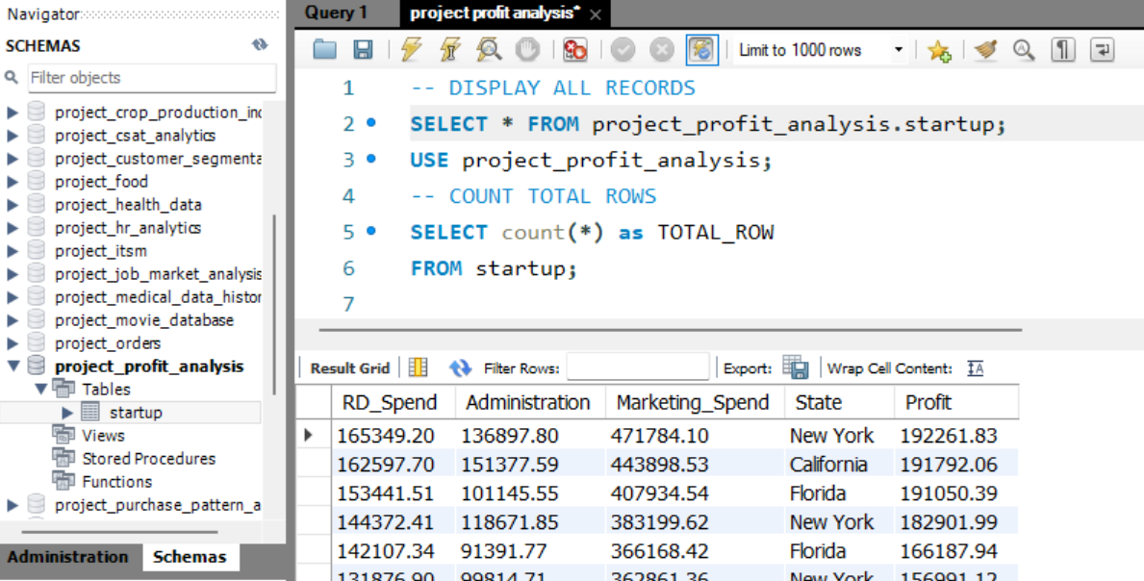

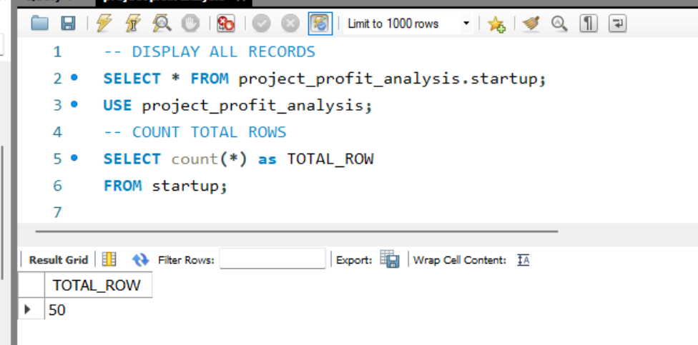

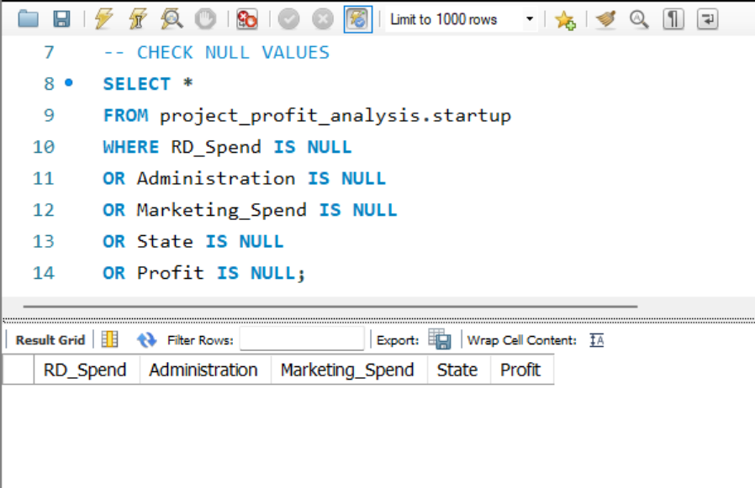

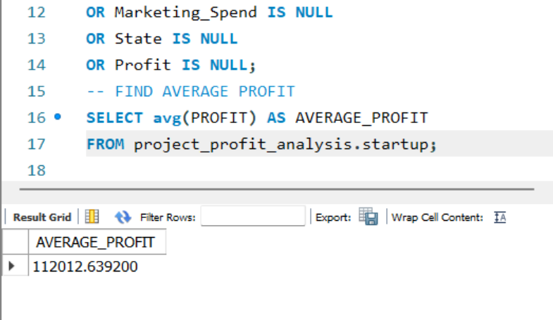

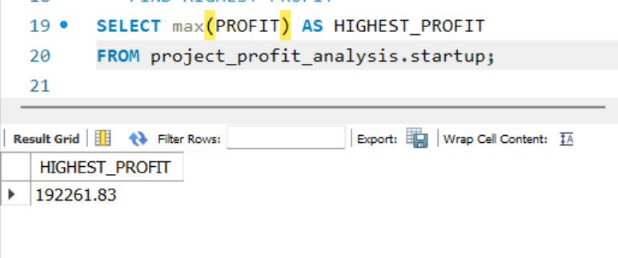

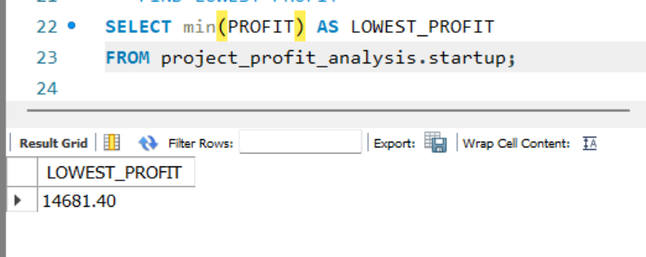

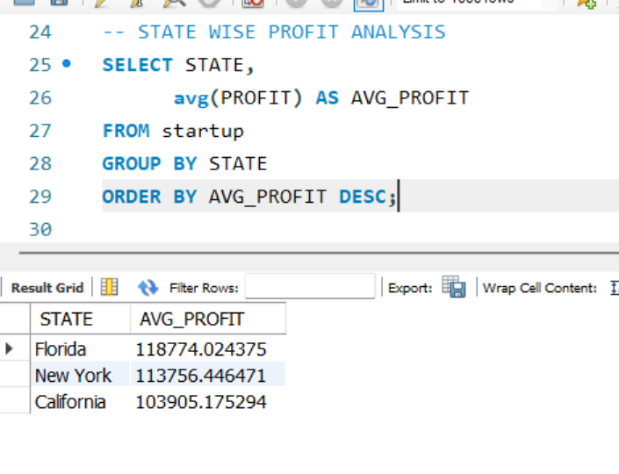
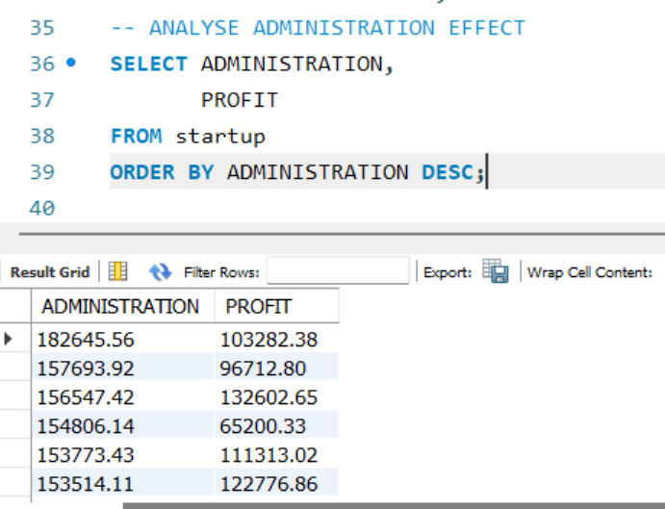

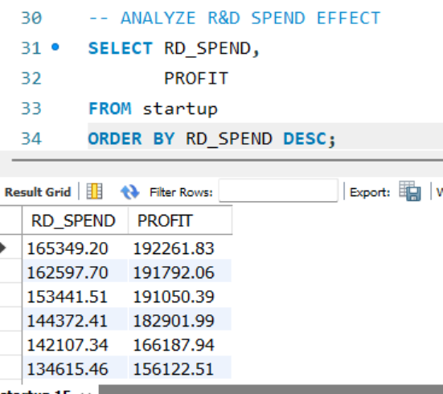

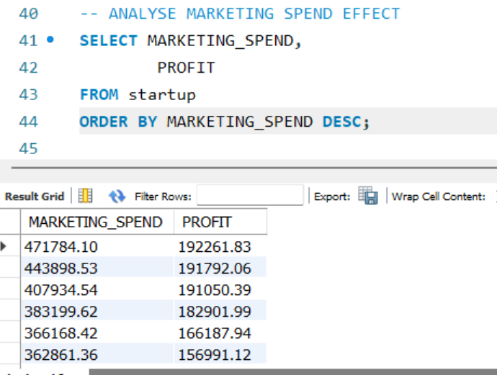

NOTE: -
SQL was used for data extraction, validation, and initial analysis.

- REGRESSION ANALYSIS (JUPYTER): -
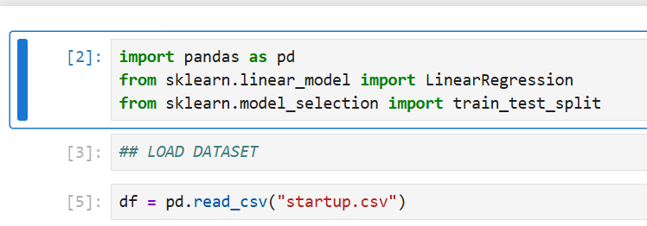

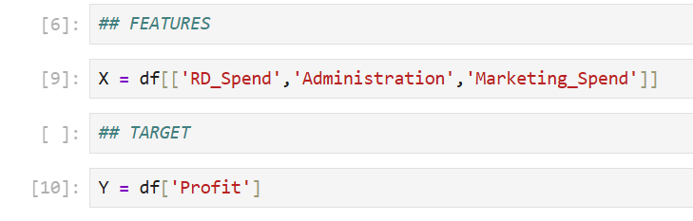

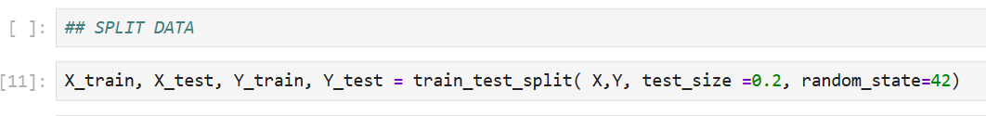

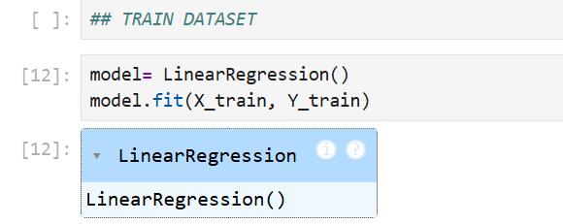

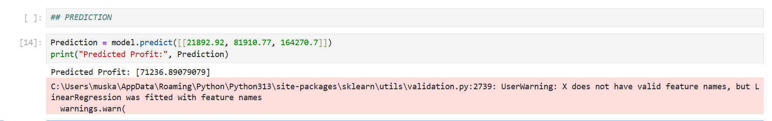

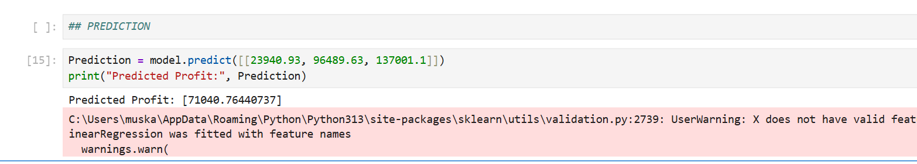

NOTE: -
Linear Regression was used to identify relationships between spending features and company profit.

- PREDICTION RESULTS: -
Prediction 1:
R&D Spend = 21892.92
Administration = 81910.77
Marketing Spend = 164270.7

Predicted Profit = 71236.89

Prediction 2:
R&D Spend = 23940.93
Administration = 96489.63
Marketing Spend = 137001.1

Predicted Profit = 71040.76

- POWER BI DASHBOARD: -

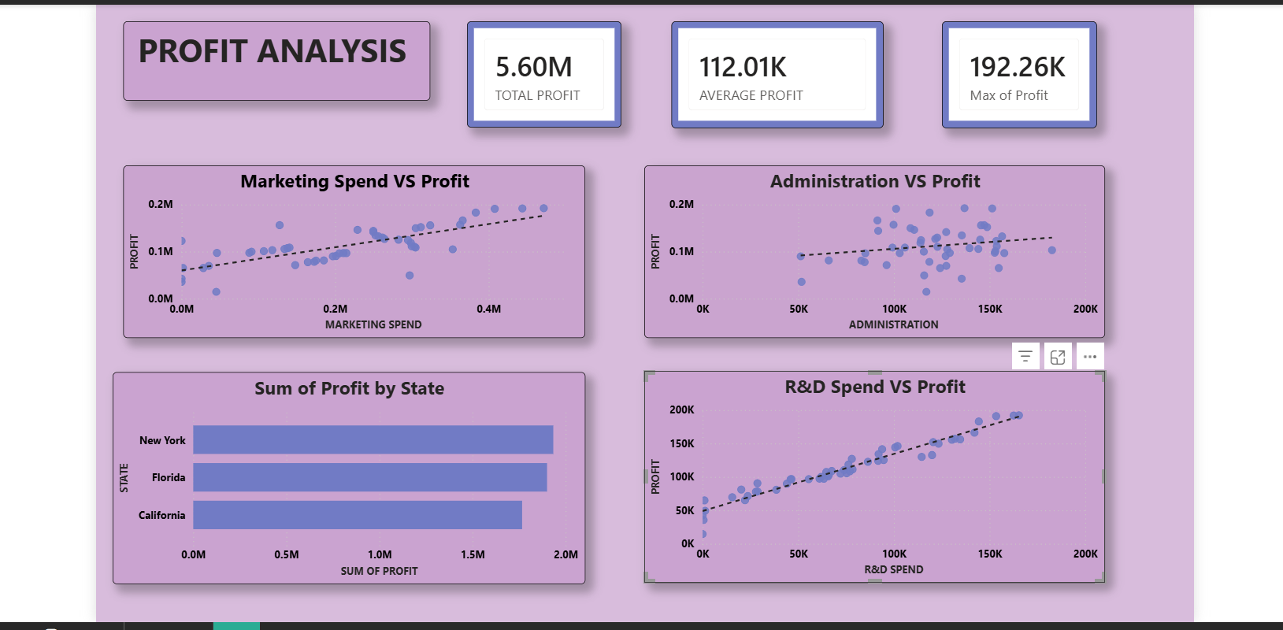

📊 1️⃣ Marketing Spend vs Profit
This scatter plot shows the relationship between Marketing Spend and Profit. The upward trend line indicates a positive relationship, meaning that companies with higher marketing investments generally achieve higher profits. This suggests that marketing activities contribute positively to business growth and revenue generation.

📊 2️⃣ Administration vs Profit
This chart represents the relationship between Administration expenses and Profit. The trend line is relatively flatter compared to R&D and Marketing charts, indicating that Administration spending has a weaker impact on profit generation.

📊 3️⃣ R&D Spend vs Profit
This scatter plot shows a strong positive relationship between R&D Spend and Profit. The trend line clearly indicates that as R&D investment increases, company profit also increases significantly. This suggests that R&D is the most influential factor affecting profitability.

📊 4️⃣ Profit by State
This bar chart compares the total profit generated across different states. New York has the highest overall profit, followed closely by Florida, while California has comparatively lower profit among the three states.

📊 5️⃣ KPI Cards Explanation
Total Profit: -
The total profit generated by all startups in the dataset is 5.60 million.
Average Profit: -
The average profit earned by startups in the dataset is 112.01K.
Maximum Profit: -
The maximum profit achieved by a startup in the dataset is 192.26K.

NOTE: -
The dashboard analysis indicates that R&D Spend and Marketing Spend positively influence company profit, while Administration expenses show a weaker relationship with profitability. Among all factors, R&D investment has the strongest impact on profit growth.

- Final Conclusion: -

The analysis shows that R&D Spend has the strongest positive impact on company profit, followed by Marketing Spend. Administration expenses have a weaker relationship with profit generation.
The regression model successfully predicted company profits based on spending patterns. Power BI visualizations also confirmed positive relationships between R&D, Marketing, and Profit.
Based on the analysis, the company should focus more on strategic investments in R&D and Marketing to improve profitability while maintaining controlled administrative expenses.

- Suggestions / Recommendations: -

• Increase investment in R&D activities.
• Optimize marketing strategies for better returns.
• Control unnecessary administrative expenses.
• Use data-driven decision making for future investments.

PROFIT ANALYSIS USING SQL, PYTHON & POWER BI
Submitted By:
Muskan Chib
Role:
Data Analyst Intern
Tools Used:
MySQL, SQL, Python, Jupyter Notebook, Power BI
Project:
PRDA-01 – Startup Profit Analysis

