Amazon Sales Analysis Using SQL

1. Introduction
Amazon is one of the world’s largest e-commerce platforms, generating millions of transactions across multiple product categories. This project aims to analyse Amazon sales data using SQL to uncover valuable business insights related to revenue, customer behaviour, product performance, discounts, payment methods, and geographical sales distribution.
The analysis was performed using SQL queries on a dataset containing over 205,000 sales records.

2. Dataset Overview
The dataset contains detailed information about amazon sales transactions
Dataset Information:
Attribute | Description
Order ID | Unique order identifier
Order Date | Date of order placement
Customer ID | Unique customer identifier
Customer Name | Customer name
Product ID | Product identifier
ProductName | Product name
Category | Product category
Brand | Product brand
Quantity | Quantity purchased
Unit Price | Price per unit
Discount | Discount offered
Tax | Tax amount
Shipping Cost | Shipping charges
Total Amount | Final order amount
Payment Method | Payment method used
Order Status | Order status
City | Customer city
State | Customer state
Country | Customer country
Seller ID | Seller identifier
Dataset Size: 205,956 records
Columns: 20
Domain: E-commerce Sales
Tools: MySQL, DBeaver

3.Project Objectives
• Analyse total sales performance.
• Identify top-performing categories and brands.
• Analyse customer purchasing behaviour.
• Evaluate discount and order fulfilment metrics.
• Identify top-performing regions and payment methods.

4.Project Architecture
Amazon.csv Dataset
↓
Data Import using DBeaver
↓
MySQL Database (amazon_project)
↓
SQL Queries & Analysis
↓
Business Insights & Findings

5. Queries
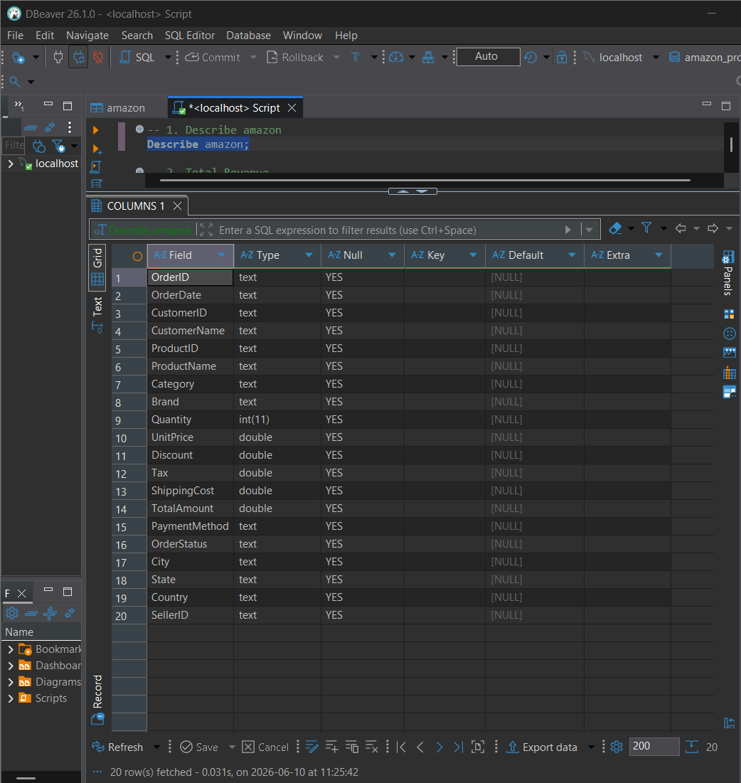
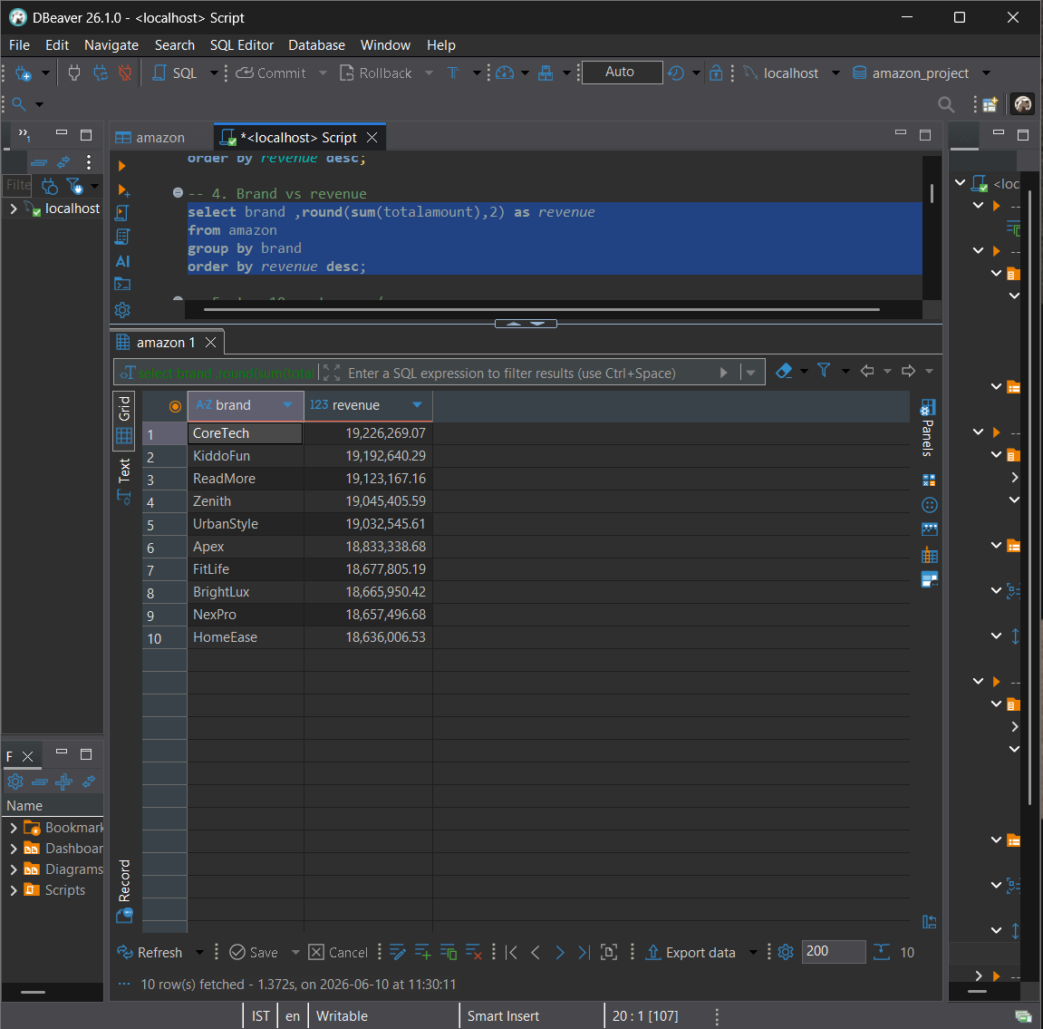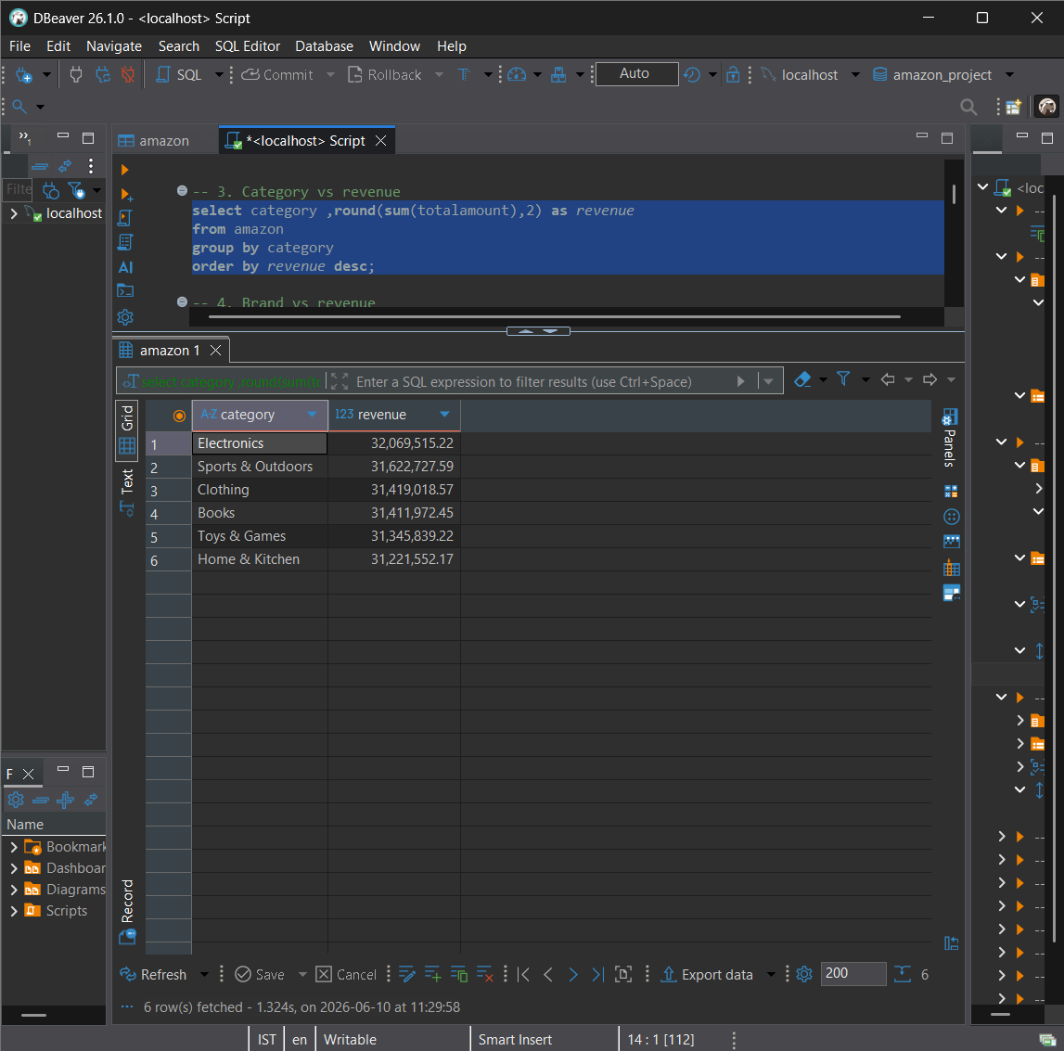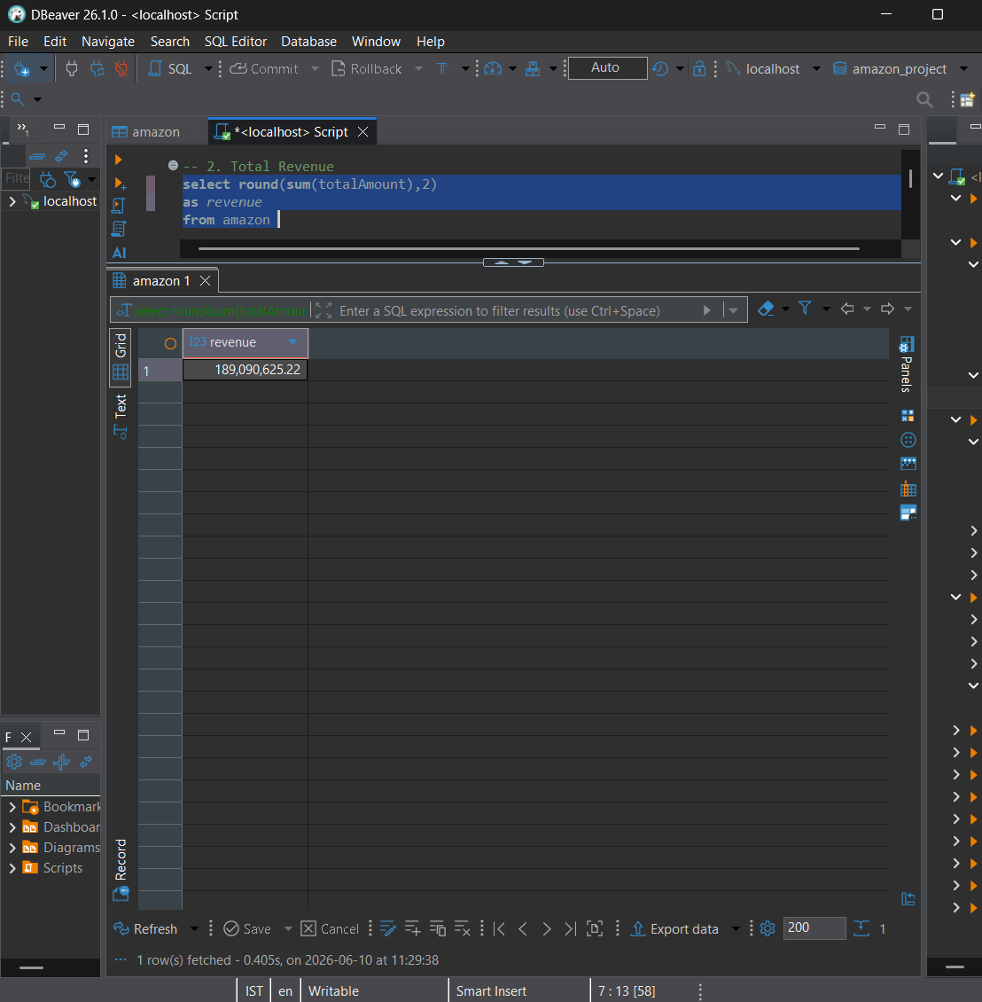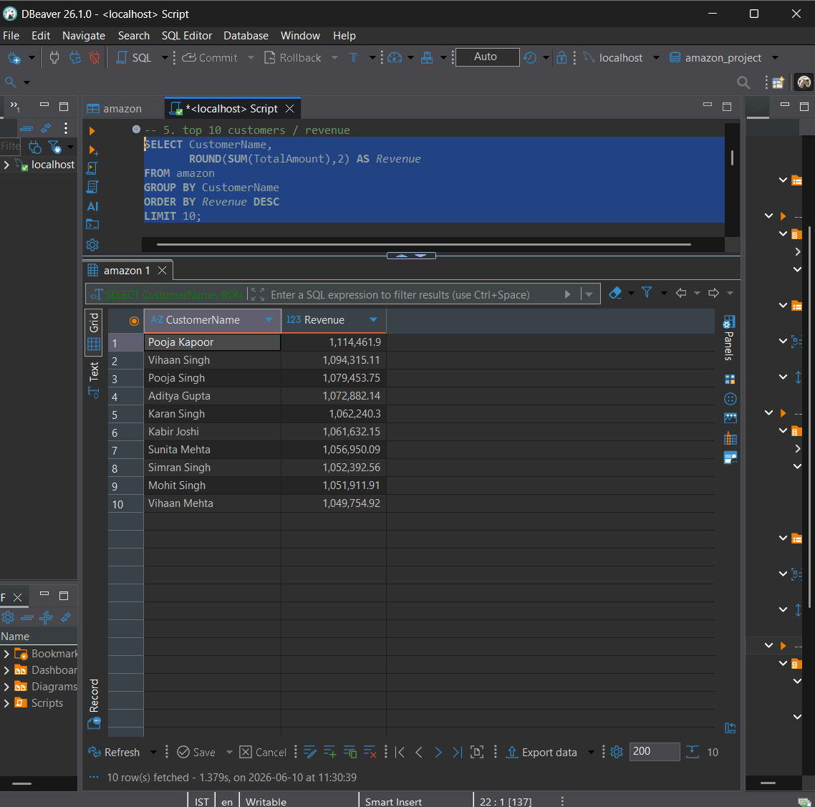
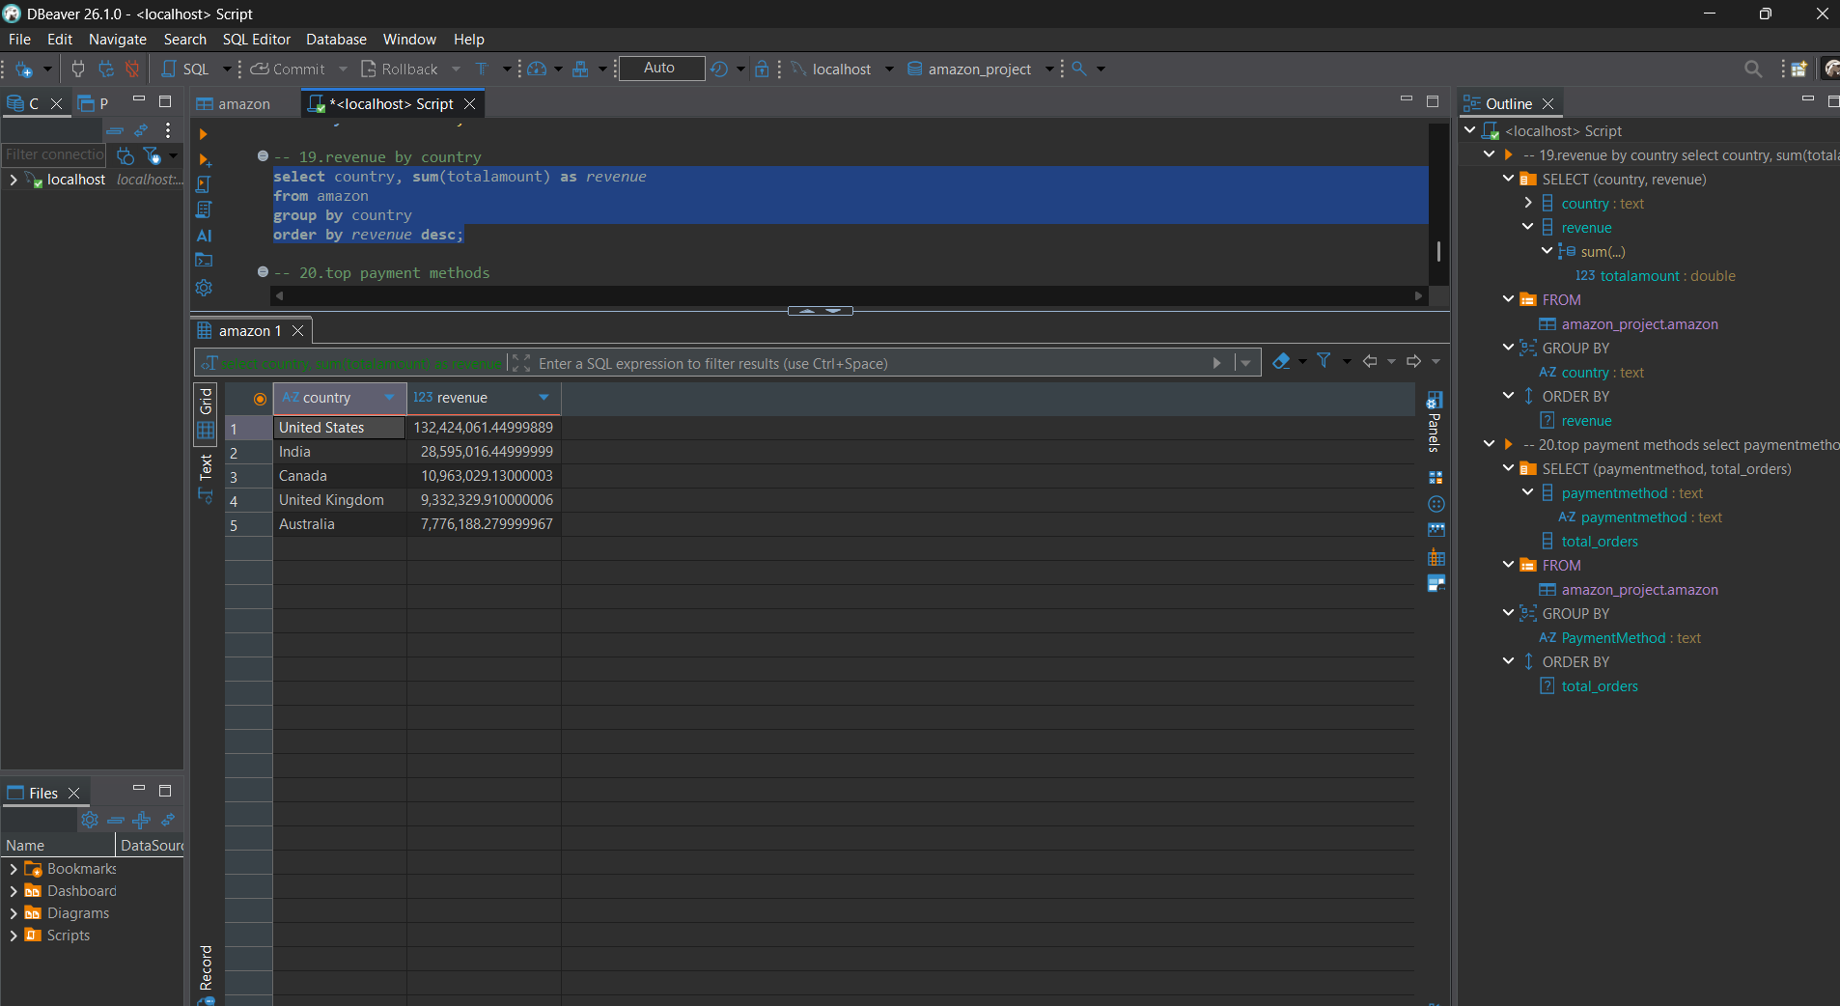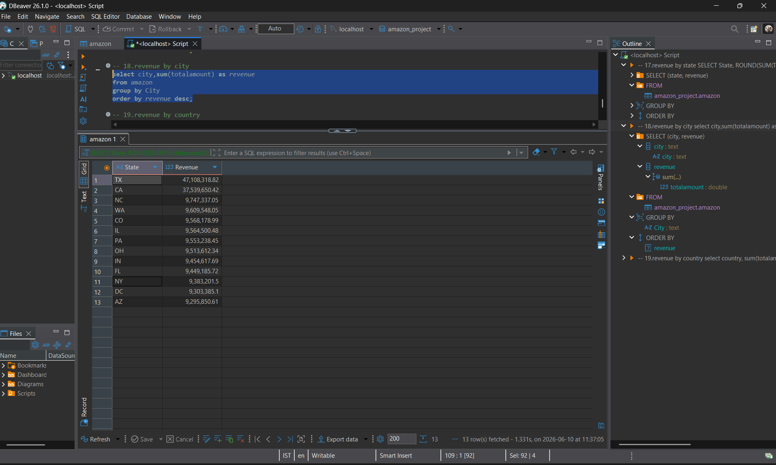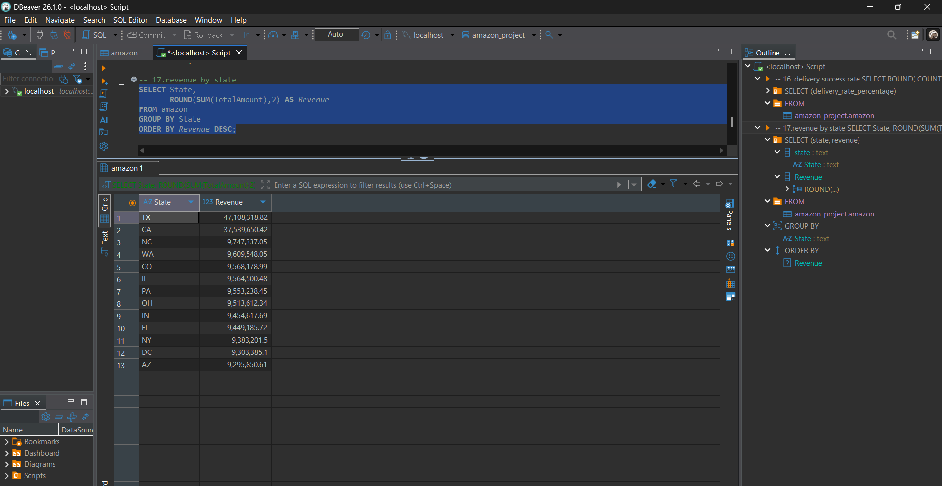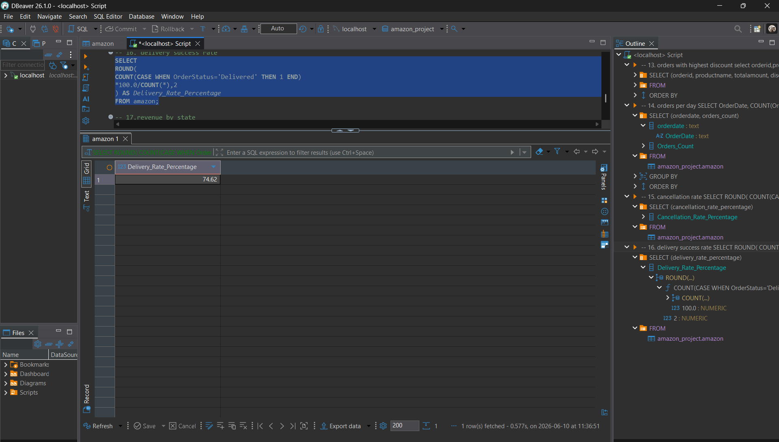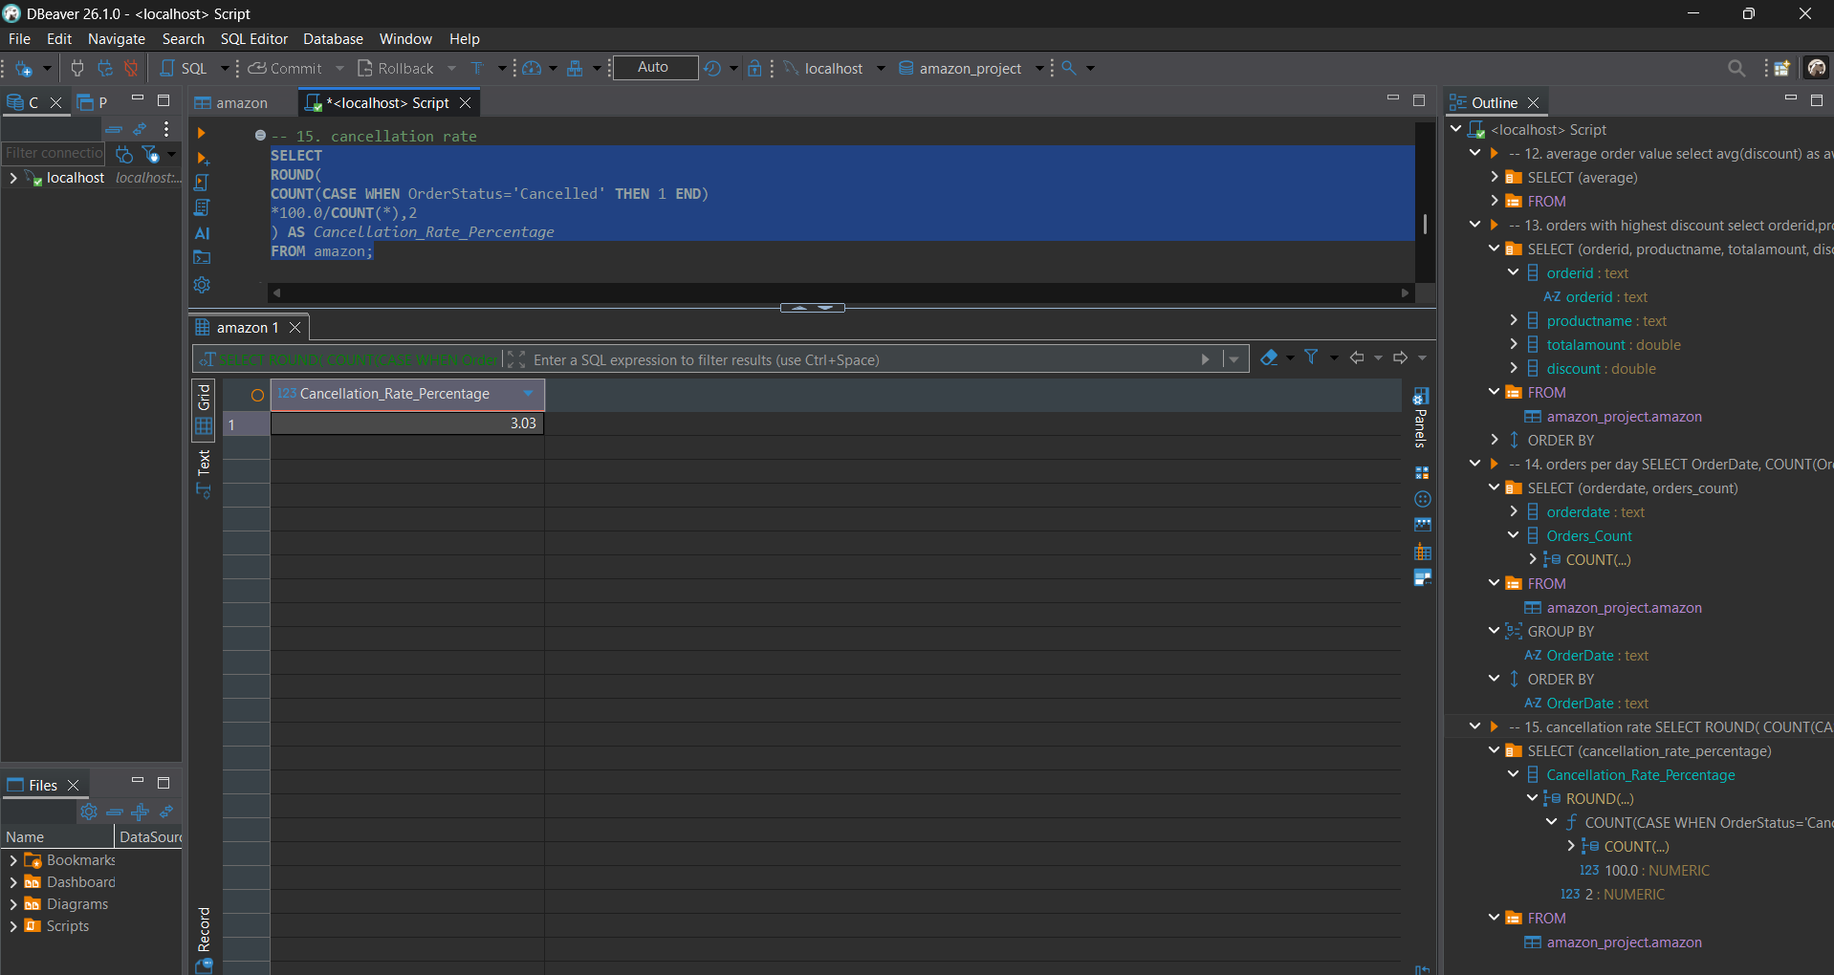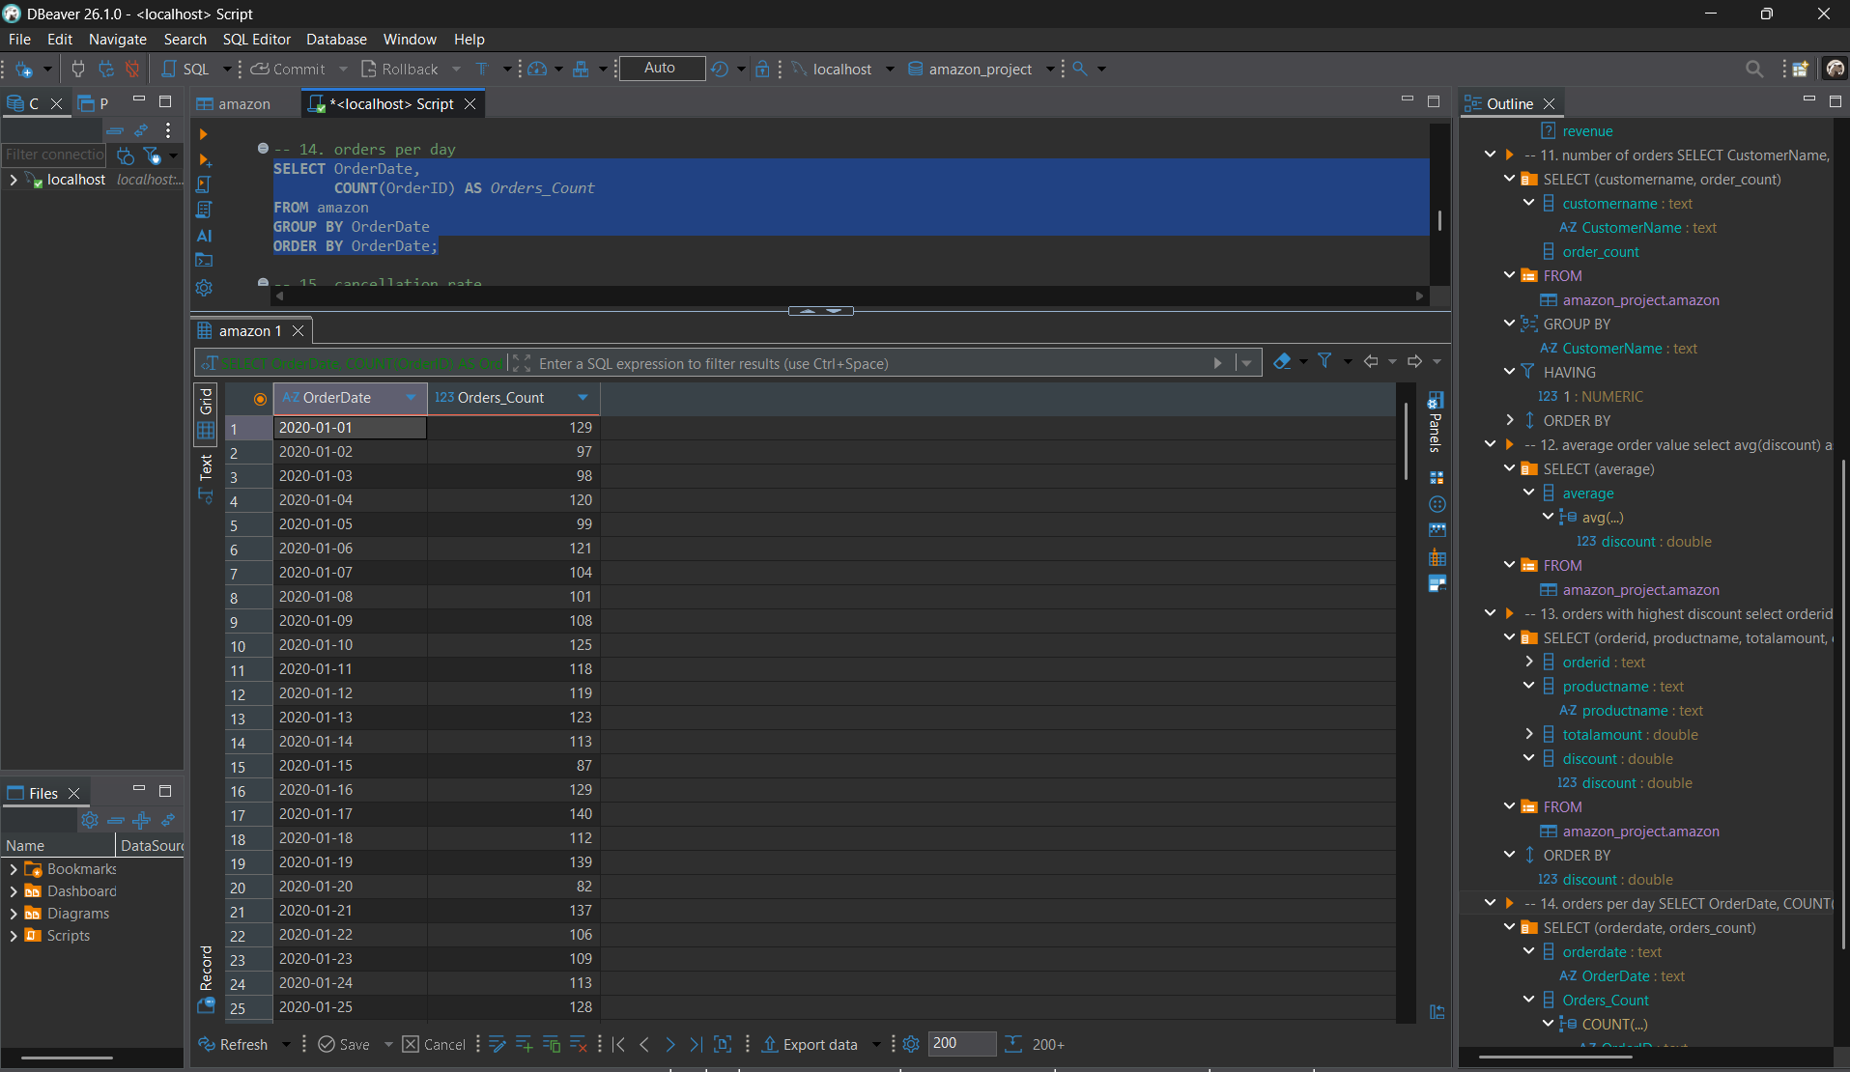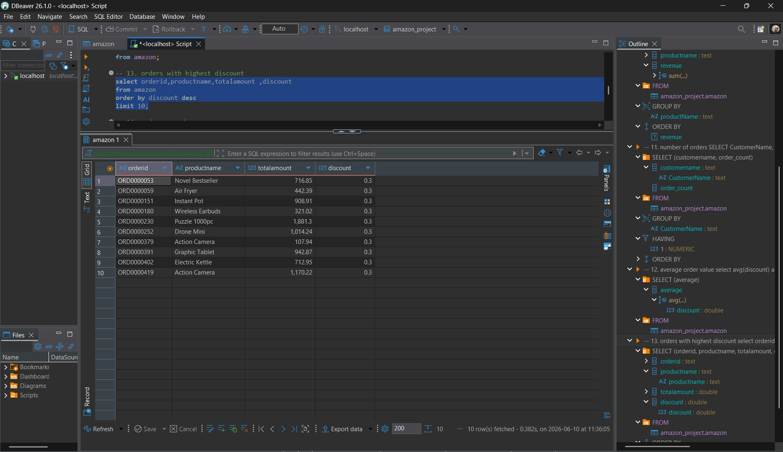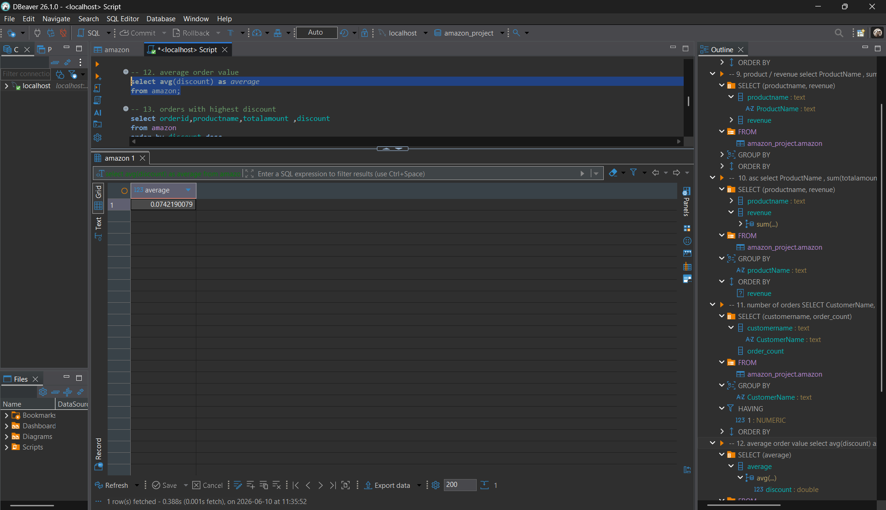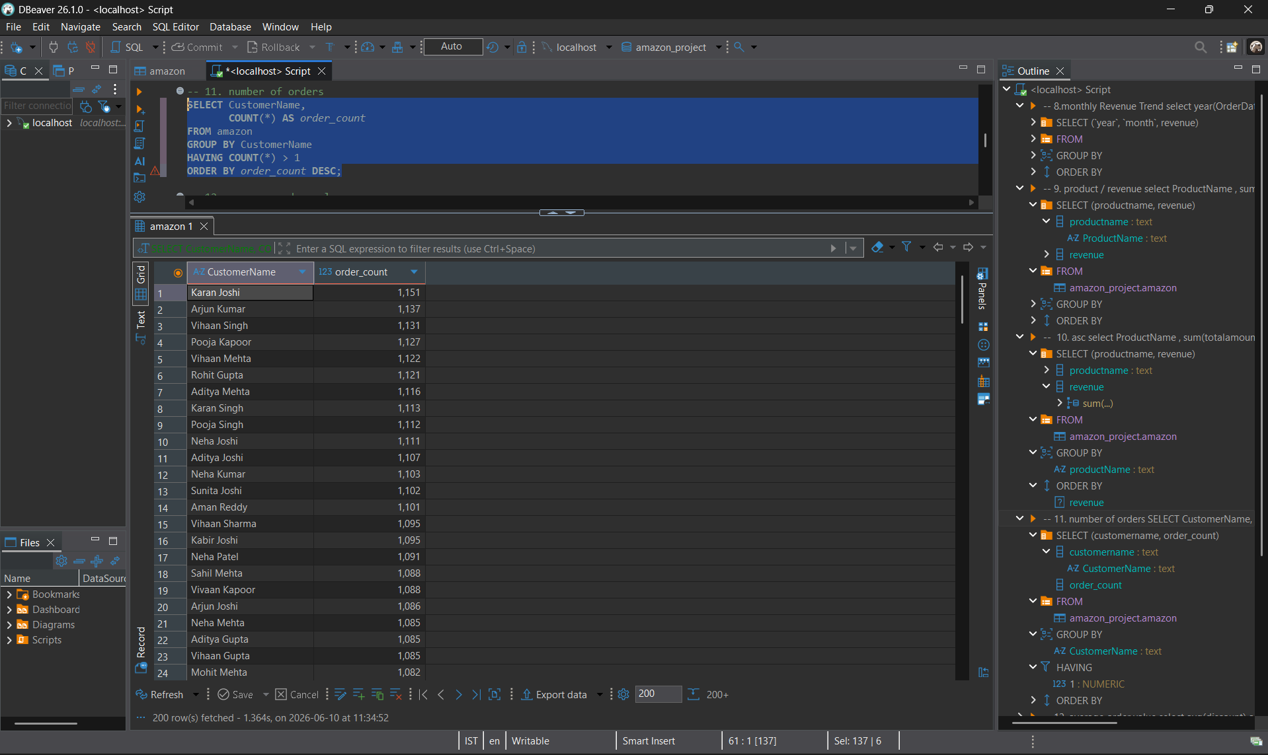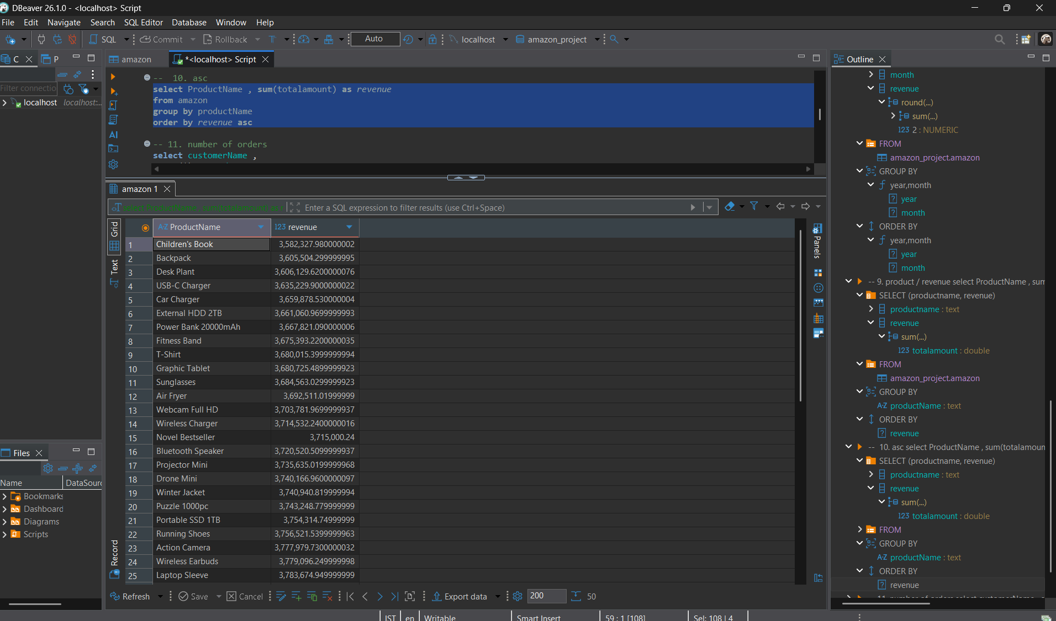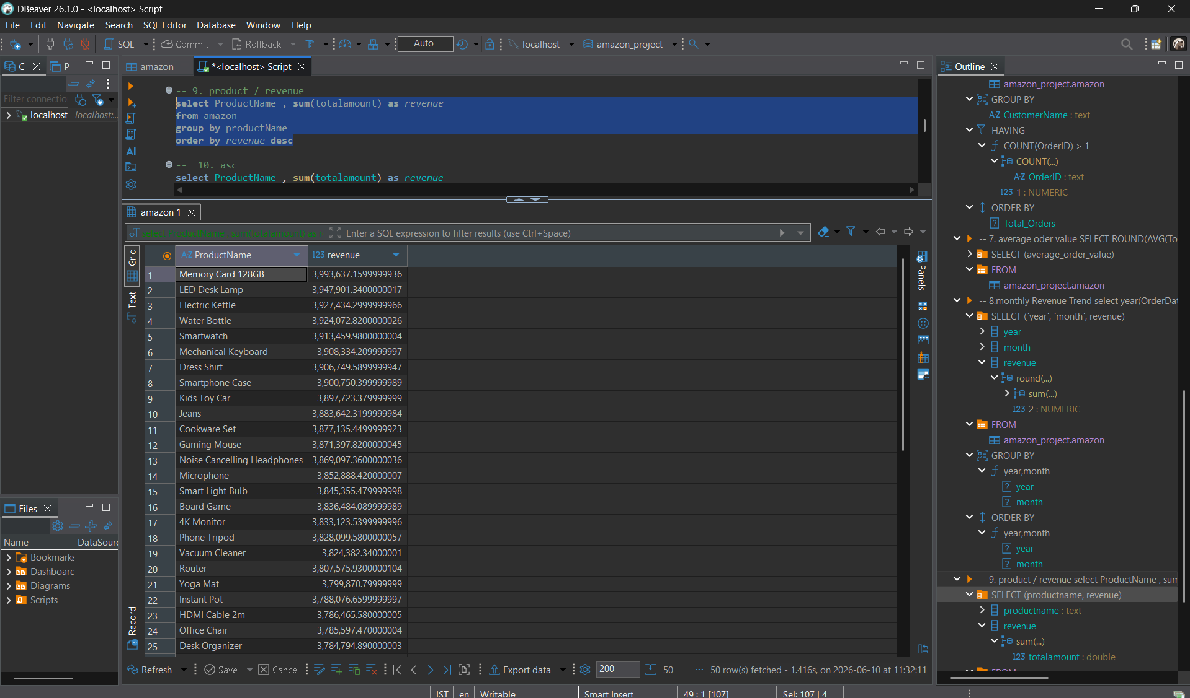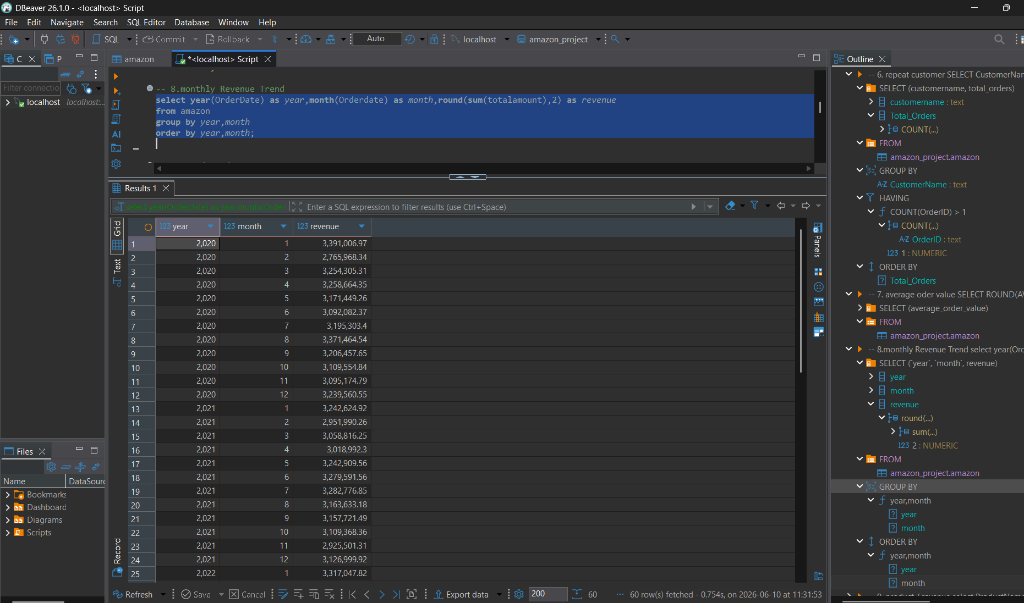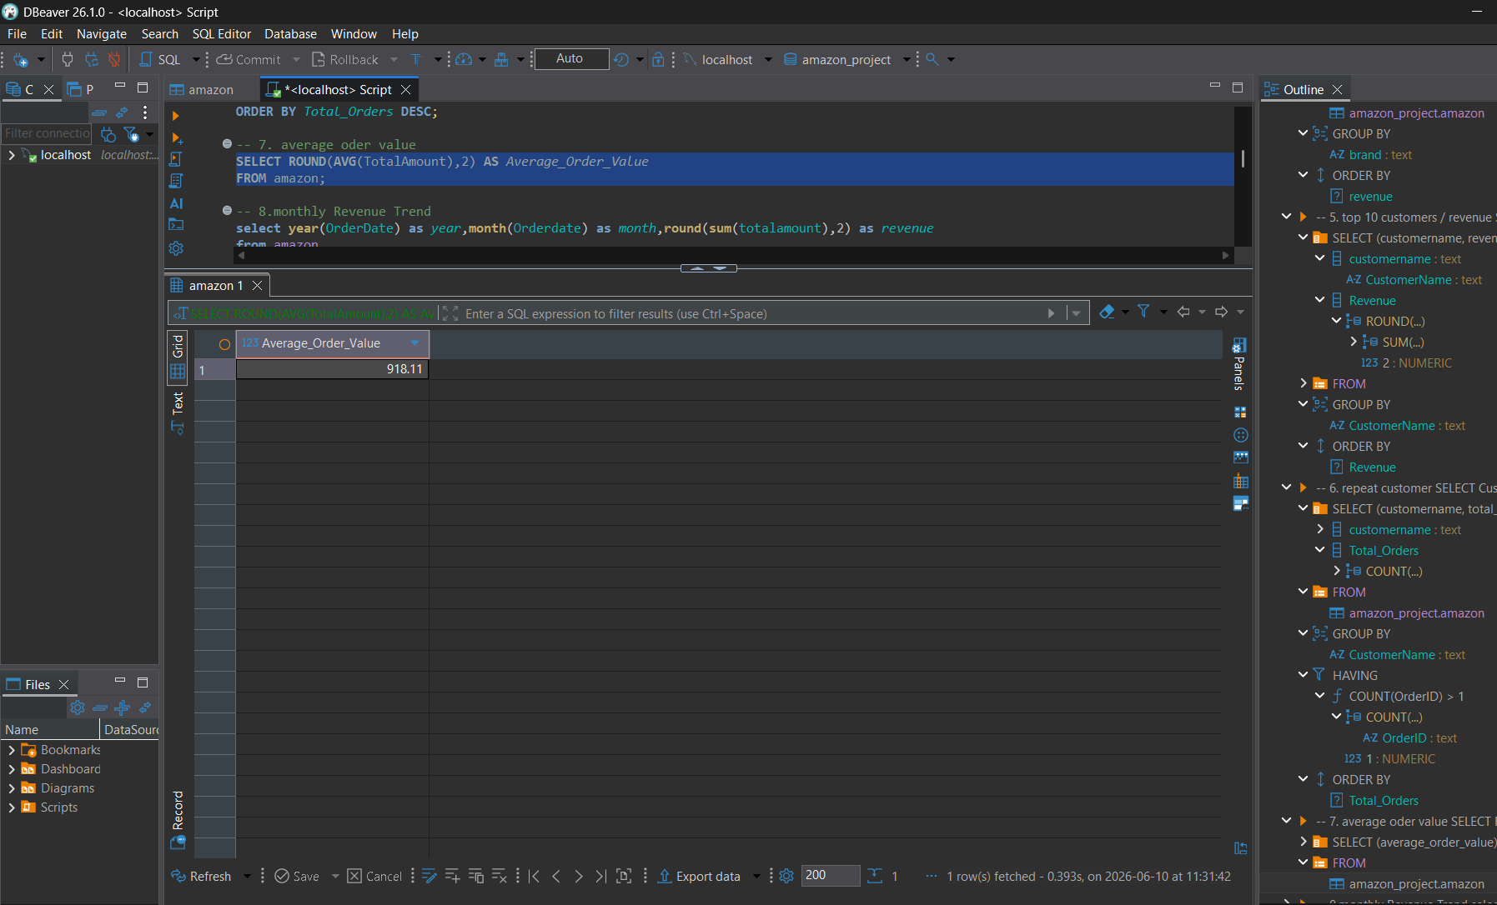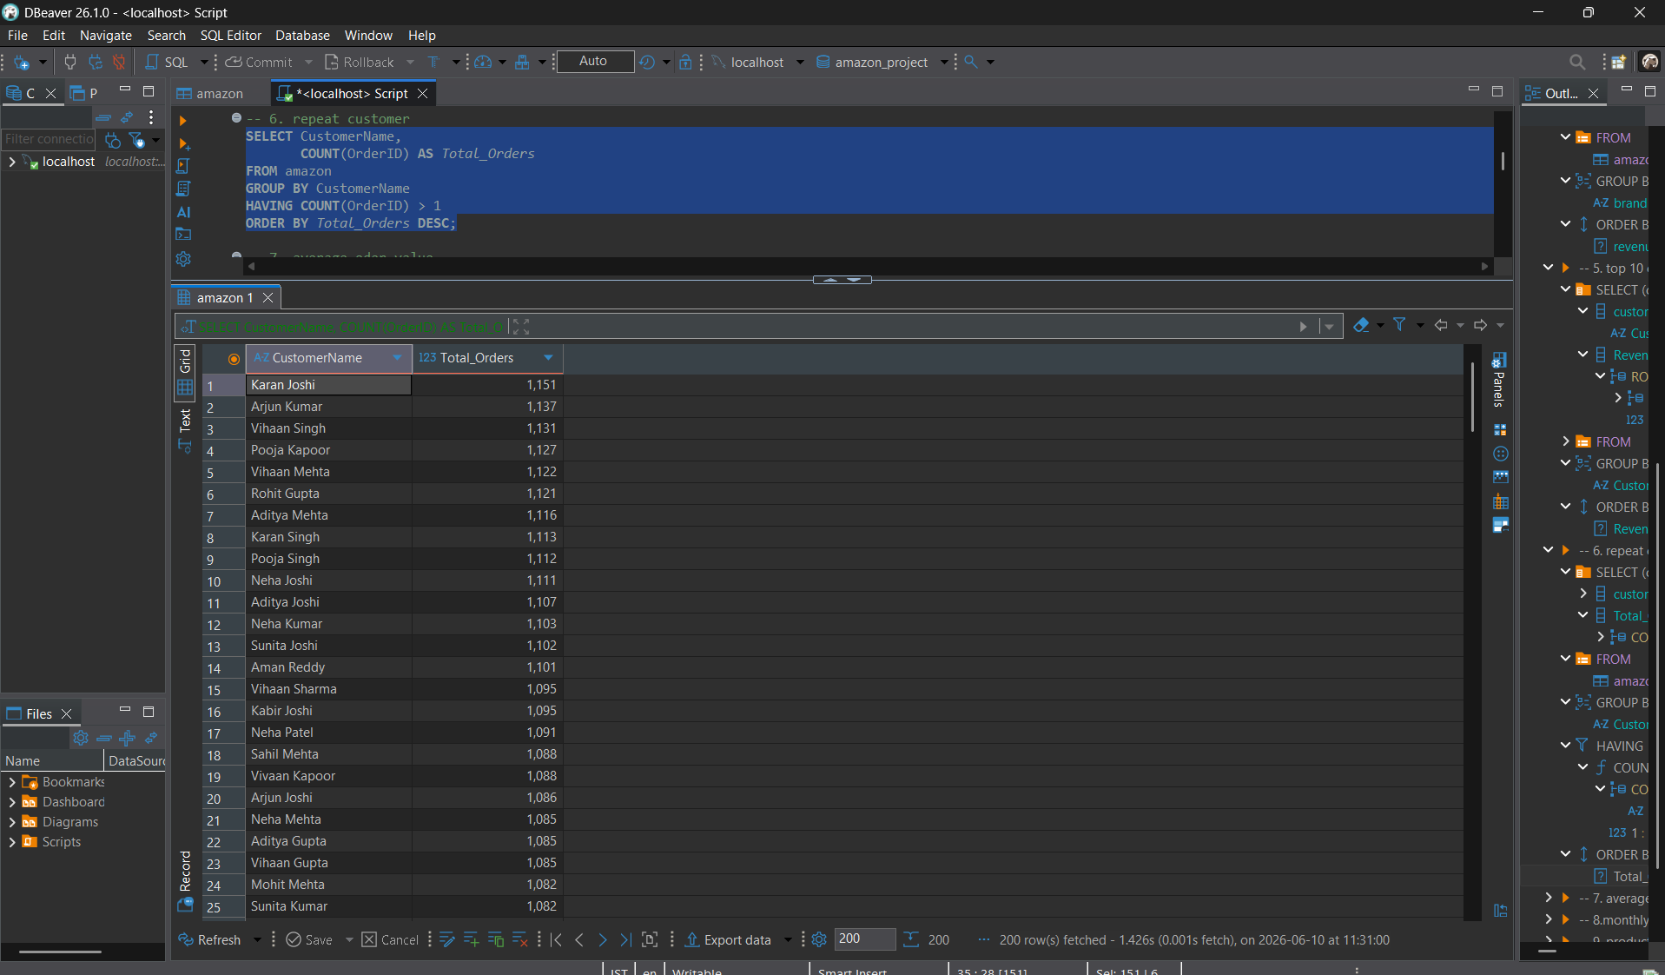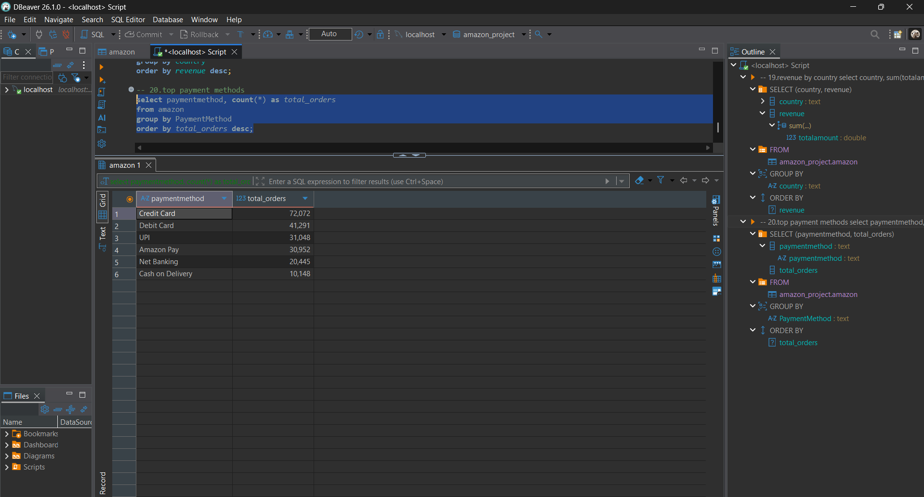

6. Findings & Insights
Total Revenue:
Finding
- The total revenue generated from all orders was ₹189,090,625.22
- This indicates the overall sales performance of the business.
- Higher revenue reflects strong customer demand across product categories.

Revenue by Category:
Finding
- Electronics generated the highest revenue among all categories.
- Home & Kitchen generated the lowest revenue.
- The company should focus on high-performing categories while improving marketing for low-performing categories.

Revenue by Brand:
Finding
- Brand Core Tech contributed the highest revenue.
- Top-performing brands have a strong impact on total sales.
- Maintaining partnerships with these brands can improve profitability.

Top 10 Customers:
Finding
- The top customers generated a significant portion of total revenue.
- Customer loyalty programs can help retain these valuable customers.
- Repeat buyers are important for long-term growth.

Repeat Customers:
Finding
- A large number of customers placed multiple orders.
- Repeat purchases indicate customer satisfaction and trust.
- Retention strategies can further increase customer lifetime value.

Average Order Value:
Finding
- The average amount spent per order was ₹918.11
- Increasing average order value can directly boost revenue.

Best Selling Products:
Finding
- Product Memory Card 128GB recorded the highest number of units sold.
- Popular products should be prioritized in inventory management.
- High demand products can be promoted further.

Worst Selling Products:
Finding
- Certain products like Children’s Book recorded very low sales.
- These products may require promotions or discontinuation.

Product Revenue Contribution:
Finding
- A few products generated most of the revenue.
- Revenue concentration highlights key business drivers.
- Monitoring these products is crucial for maintaining sales.

Highest Discount Orders:
Finding
- Some orders received significantly have higher discounts.
- Large discounts can increase conversions but reduce profit margins.
- These orders should be monitored carefully.

Orders Per Day:
Finding
- Order volume fluctuates across different days.
- High-order periods may require additional operational support.
- Daily tracking helps forecast demand.

Cancellation Rate:
Finding
- The cancellation rate was 3.03%.
- A lower cancellation rate indicates efficient order management.
- Reducing cancellations improves customer satisfaction and revenue.

Delivery Success Rate:
Finding
- The delivery success rate was 74.62%, indicating that most orders were delivered successfully, although there is room for improvement.
- Reliable delivery contributes to positive customer experiences.

Revenue by State:
Finding
- State Texas generated the highest revenue.
- Regional performance varies significantly.
- Marketing efforts can be focused on high-growth regions.

Revenue by City:
Finding
- City Dallas contributed the highest revenue.
- Urban markets show stronger purchasing activity.
- Location-based strategies can improve sales performance.

Revenue by Country:
Finding
- Country United States, India, Canada generated the highest revenues (Top Three).
- International sales contribute significantly to business growth.
- Expanding in top-performing countries can increase market share.

Payment Method Analysis:
Finding
- Credit Card/Debit Card/UPI, were the most frequently used payment methods
- Understanding payment preferences helps improve checkout experience.
- Supporting popular payment methods can increase conversion rates.

6.Conclusion:
The Amazon Sales dataset containing 205956 records was analysed using
SQL to evaluate revenue performance, customer behaviour product demand, discount effectiveness, logistics performance, and geographical trends.

7.Key Insights:
- Total revenue exceeded ₹189 million.
- Electronics emerged as the highest revenue-generating category.
- Core Tech was the leading brand by revenue.
- Memory Card 128GB was the best-selling product.
- Texas generated the highest state-wise revenue.
- Dallas was the top-performing city.
- The cancellation rate remained low= at 3.03%.
- Average order value was ₹918.11.

