NAME: MUSKAN ZEESHAN
REG_NO: FA24B1-SE-054
SECTION: BSSE V-B
COURSE: CLOUD COMPUTING
ASSIGNMENT # 01
Task 1: Install Gitea and Push a Repository from the Ubuntu Server
Step 1.1: Install and Run Gitea on the Ubuntu Server
- Updated Ubuntu packages and installed Docker Engine, curl, and the Docker Compose plugin.
- Started Docker, configured user permissions, and verified Git, Docker, and Docker Compose installations.
- Cloned the provided Gitea setup repository and started Gitea and PostgreSQL using Docker Compose.
- Verified that both containers were running and checked the Gitea HTTP response..
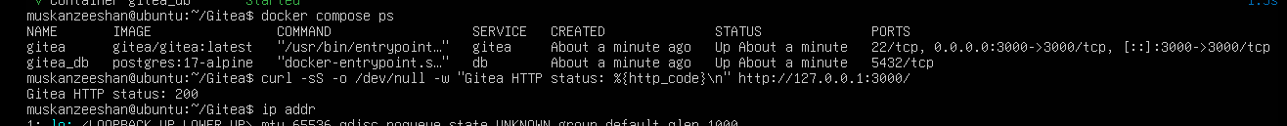
Figure 1: task1_gitea_running.png
Step 1.2: Create and Push the Initial Repository
- Created a public Gitea repository named Assignment01.
- Created a separate local Git repository on the Ubuntu server and switched to the main branch.
- Added my full name and registration number to README.md and committed the file.
- Configured the Gitea remote and successfully pushed the initial commit using my access token.
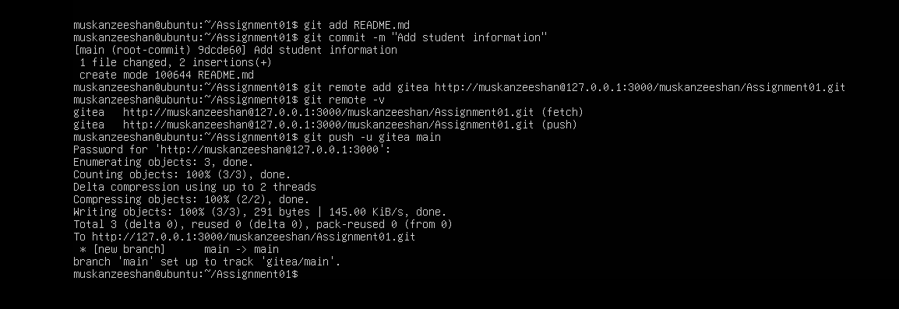
Figure 2: task1_gitea_push.png
Step 1.3: Verify the Gitea Repository
- Opened the Assignment01 repository in Gitea.
- Verified the repository owner and repository name.
- Confirmed that the repository was public.
- Checked that the README displayed my full name and registration number.
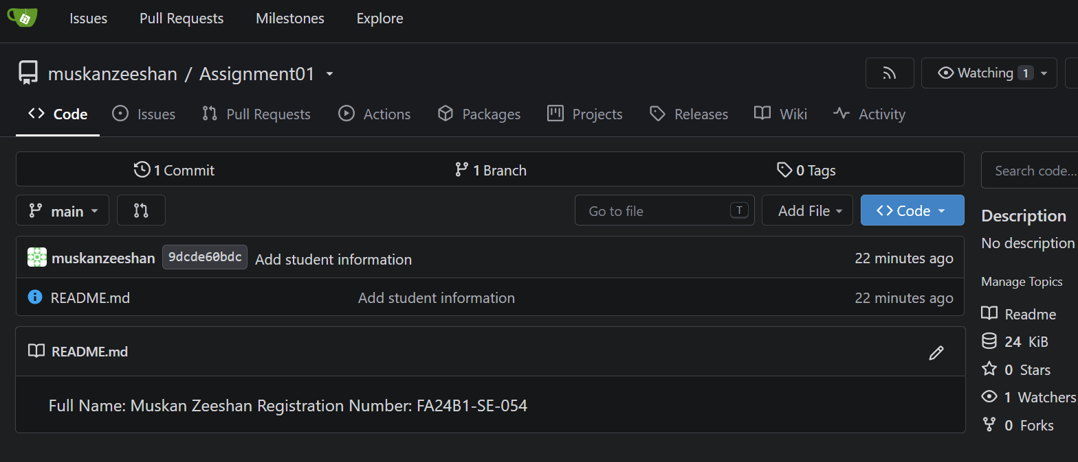
Figure 3: task1_gitea_repository.png

Task 2: Push the Same Repository to GitHub
Step 2.1: Create the GitHub Repository and Verify Both Remotes
- Created a public GitHub repository named Assignment01.
- Connected the existing local repository to GitHub using the github remote.
- Verified the gitea and github remote URLs using git remote -v.
- Confirmed that neither remote URL contained a password or access token.
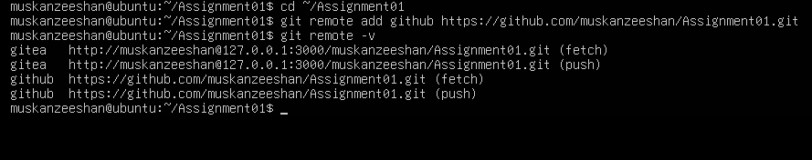
Figure 4: task2_remotes.png

Step 2.2: Push to GitHub
- Opened the existing local Assignment01 repository on the Ubuntu server.
- Pushed the main branch to GitHub using git push -u github main.
- Verified that the push completed successfully.
- Confirmed that the local repository was connected to the GitHub repository.
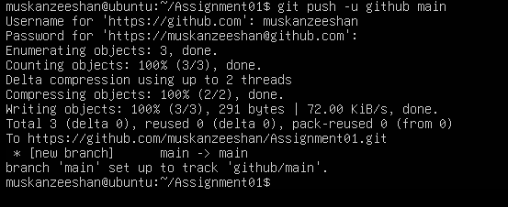
Figure 5: task2_github_push.png
Step 2.3: Verify the GitHub Repository
- Opened my public GitHub Assignment01 repository in a browser.
- Verified the repository owner and repository name.
- Confirmed that the repository was public.
- Checked that the rendered README displayed my full name and registration number.
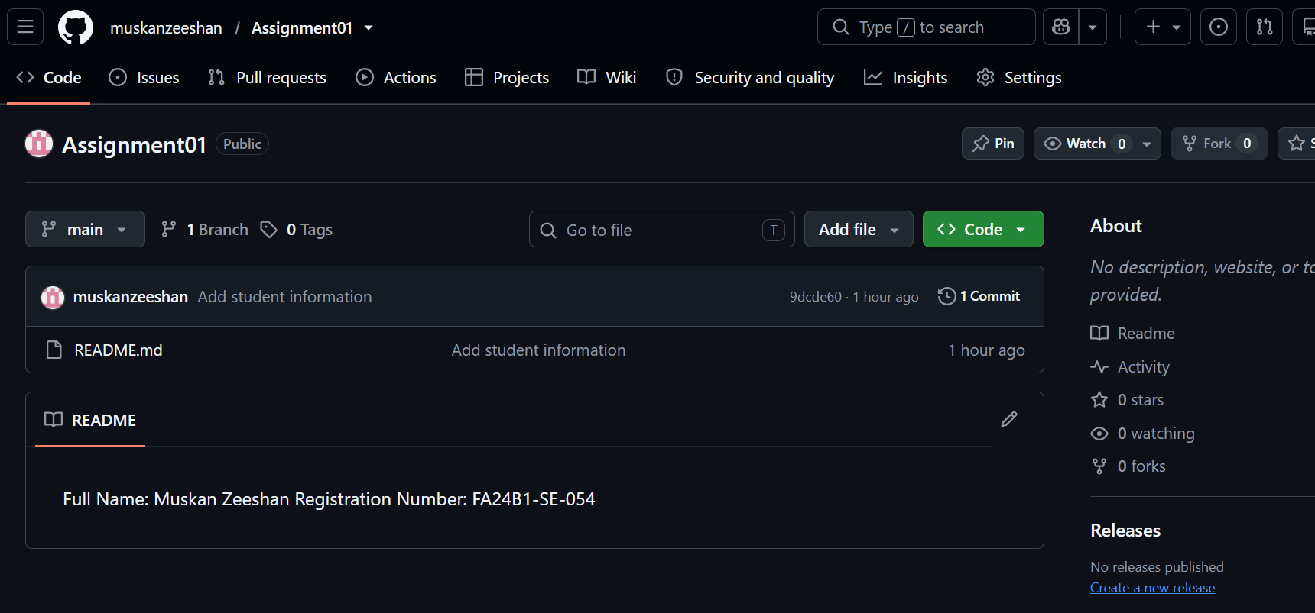
Figure 6: task2_github_repository.png

Task 3: Track Three Large Files with Git LFS
Step 3.1: Configure Git LFS
- Opened the local Assignment01 repository on the Ubuntu server.
- Initialized Git LFS using git lfs install.
- Checked the installed Git LFS version.
- Configured Git LFS to track .bin files and verified the rule in .gitattributes.
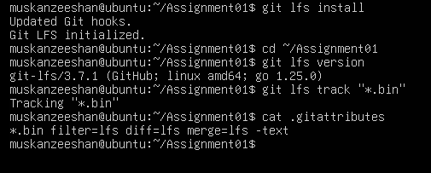
Figure 7: task3_lfs_setup.png
Step 3.2: Create and Verify Three LFS Files
- Created three binary files named large-file-1.bin, large-file-2.bin, and large-file-3.bin.
- Set their sizes to 101 MiB, 102 MiB, and 103 MiB, respectively.
- Added the three files and .gitattributes to Git.
- Used git lfs ls-files --size to verify that all three files were tracked by Git LFS and exceeded 100 MiB.
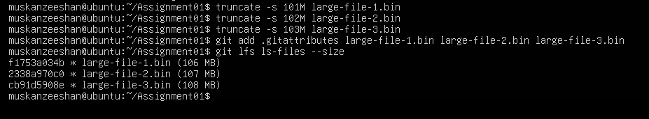
Figure 8: task3_lfs_setup.png
Step 3.3: Commit and Push the LFS Files
- Committed the Git LFS configuration and three large files.
- Pushed the main branch to the GitHub Assignment01 repository.
- Verified that the Git LFS objects uploaded successfully.
- Confirmed that the large files were included in the repository's version-controlled content.
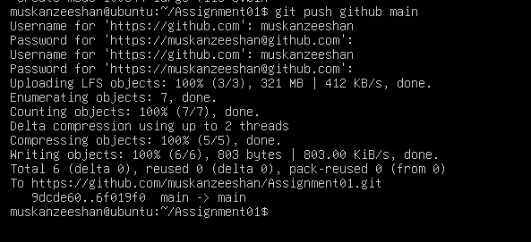
Figure 9: task3_lfs_files.png

Task 4: Create a Portfolio or CV with GitHub Pages
Step 4.1: Create and Push the Portfolio Repository
- Used my public GitHub portfolio repository named muskanzeeshan.github.io.
- Created or updated the HTML and CSS files for my portfolio/CV.
- Included the required sections: About Me, Education, Skills, and Projects.
- Committed the portfolio source files to the main branch and verified the repository contents.

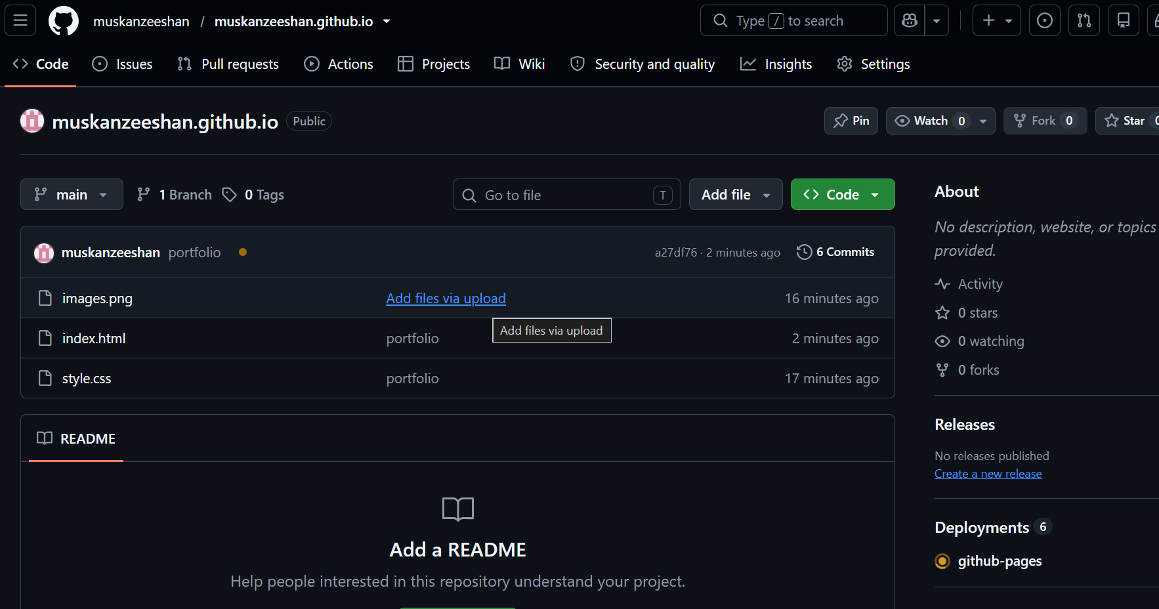
Figure 10: task4_pages_repository.png
Step 4.2: Publish with GitHub Pages
- Opened the portfolio repository settings on GitHub.
- Navigated to Settings → Pages.
- Configured GitHub Pages to deploy from the main branch and the root folder.
- Waited for publication and checked the deployment status and website URL.
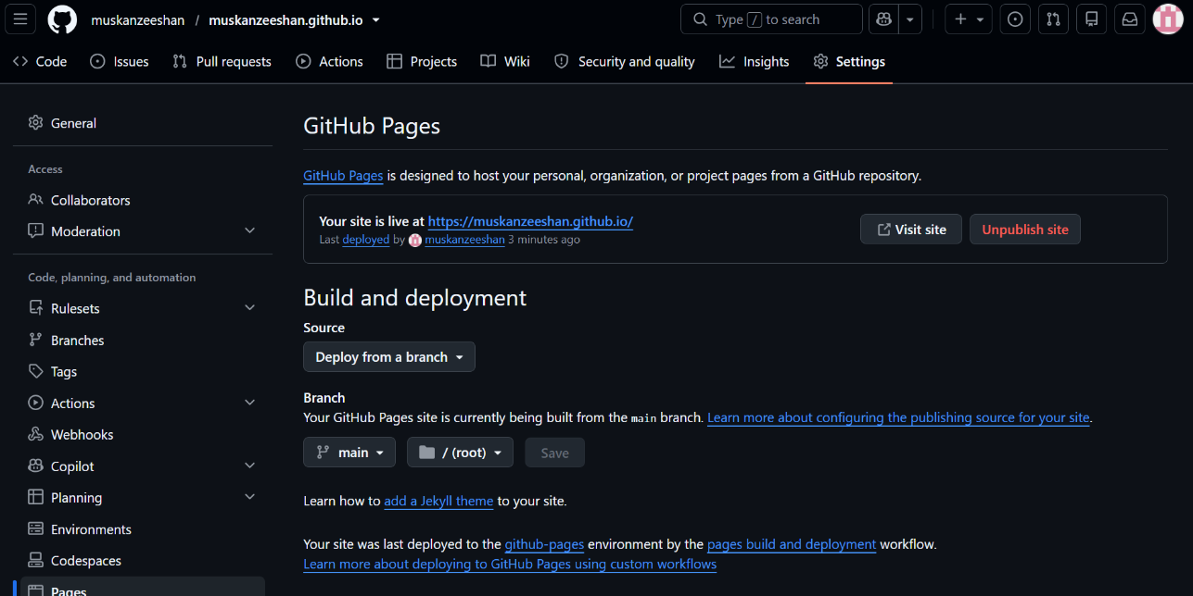
Figure 11: task4_pages_deployment.png
Step 4.3: Verify the Live Portfolio
- Opened https://muskanzeeshan.github.io/ in a web browser.
- Verified that the portfolio website loaded successfully.
- Checked that the portfolio content and required sections were visible.
- Captured a screenshot showing the live website URL and portfolio content.
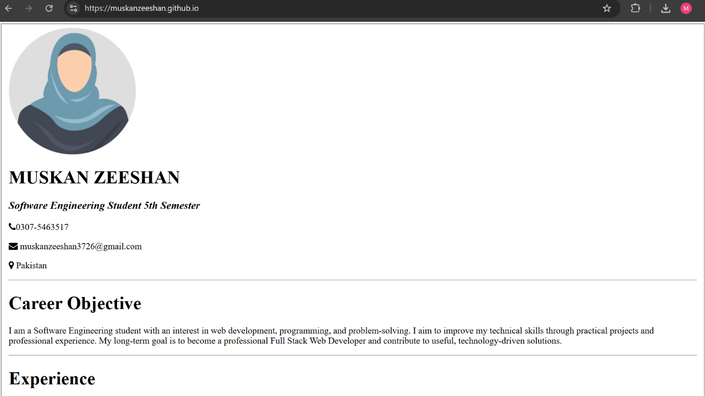
Figure 12: task4_portfolio_live.png

