1. Introduction

Material selection is a crucial step in design process and plays a vital role on success of the product [2]. A wide variety of materials are available today in the market and new materials are continuously being added, thanks to the extensive research in this area. Although, it is beneficial to have availability of such a large variety materials, selecting most appropriate material for a given product is always a challenge [3].

Traditionally, material selection procedure takes into account mainly the functional requirements of the product. Several techniques have been suggested in recent past for selection of materials. Ashby pioneered concept of materials selection in design, in his book. [8] Ashby suggested different strategies for materials selection. The strategies integrate function, constraints, objectives, and free variables as criteria for screening and ranking of materials. Ashby strategies are easy to implement with few number of parameters, however, when more number of attributes needs to be considered in material selection, multi attributes decision making (MADM) performs better. Among the MADM approaches, Jee and Kang used (TOPSIS) method which lays stress on making decisions closest to the ideal solution and farthest from the non-ideal solution. [9]. Also, Shanian and Savadogo [10] used graph theory for material selection and proposed ELECTRE (ELimination and Choice Expressing the REality) method. The method builds a material selection decision matrix and carries out sensitivity analysis to obtain a more precise material selection for a particular application. Rao build a material selection model using graph theory and matrix approach [11]. Manshadi et al. proposed a numerical method for materials selection.[12] However, the method does not make a provision for considering the qualitative material selection attributes. Rao proposed a compromise ranking method known as VIKOR and Chatterjee et al. [13] proposed VIKOR and ELECTRE methods for material selection. Fayazbakhsh et al. used Z-transformation in statistics for normalization of material properties for materials selection in mechanical design. Khabbaz et al. [14] proposed a fuzzy logic approach for material selection. Jahan et al. [15] reviewed various material screening and choosing methods. Jahan et al has also proposed linear assignment model for material selection. A subjective and objective integrated with MADM was proposed by Rao et al. [16] However, all these methods and procedures have analytical approach for material selection with more focus on quantitative attributes, and attributes such as aesthetics; perceptions and emotions of the user are generally ignored. The job of product designer will be simplified if there is a method which takes into account the user interaction aspects in conjunction with technical parameters to choose or screen materials which can aid product designer.

The user interaction attributes are not taken into consideration, primarily due to the subjective nature of the user interaction attributes (few more reasons with citation). Also, it is difficult for non-designers to talk about user interaction attributes they want in the product [18].However, in user centric design process, it is essential to account for these user interaction attributes as they are key part of user interaction process [19]. Finally, for the material selection to be truly comprehensive these user interaction factors do need to be taken into consideration in material selection procedure. [20]

In the recent past, few researchers have tried to include user interaction in design process. Van Kesteren proposed three tools for procuring user interaction requirements in a product. These are namely: ‘Pictures Tool’, ‘Samples Tool’ and ‘Questions Tool’ [19]. The tools attempt to build consensus between user and designer over linguistic terms, which is time consuming. As designer tries to interpret the user interaction attributes specified by user in linguistic terms as per his subjective understanding and knowledge of these terms, leaving room for misinterpretations and leading to incorrect expression of requirements, both by the user and the designer. Grovers et. al[24] has highlighted importance of product personality on user preference, product personality which is a cumulative effect of various user interaction aspects is considered as a whole for study of user preference and hence it fails to indicate effect of individual user interaction attributes. Moreover, candidate materials as per user’s subjective interpretation, may affirm to more than one personality or no personality, thus making material selection procedure cumbersome and time consuming.

In this paper, we proposed a simple and easy to implement, analytical approach for material selection incorporating user interaction attributes such as smoothness, glossiness. In proposed approach, attempt is made towards bridging the gap between user’s and designers perception of sensory aspects by making user rate pre-evaluated training set, these ratings are converted into objective values by fuzzy method and finally materials are ranked using on MADM approach. The paper describes procedure for data collection followed by description of method in algorithmic format. In addition, theory behind the developed algorithm is described and significance of each step is explained. Furthermore, the algorithm is coded in Matlab® and applications of Watch Strap, Shoe, McWheel, Mouse are given to depict applicability and usability of algorithm in designing of products. The results are then discussed followed by conclusion.

2. Research Methodology

In order to simulate actual materials selection process taking into consideration the user interaction attributes, two respondents groups with members each, one to mimic behaviour of users and other to mimic behaviour of designers were created. Thirty commonly used materials were given to user and designer groups. Groups were then asked to rate these materials on four user interaction scales namely smoothness - roughness, softness - hardness, gloss - matt and pattern. The detail step by step procedure for selection is mentioned below.

3.1 Material Selection Procedure

**Step 1:** Select significant user interaction attributes for the application in consideration.

**Step 2**: For each attribute, assign ordinal linguistic terms, formulate a rating scale and assign equally spaced nominal numerical values to these linguistic terms. The materials are then rated by users group and designer group separately as per the rating scale created in step 1.

**Step 3**: After selecting user interaction attribute under consideration for given application, a plot is created with X-axes as the user’s rating and Y axes as designer’s rating (as numeric values). Then, for each material, plot a point corresponding to user and designer rating of a particular material on training set and repeat procedure for other materials of the training set, forming a scatter plot. After that, fit a Line of best fit through points.

**Step 4**: For each numeric value on the user’s scale, determine corresponding value on designer’s scale. This value, which lies on fitted line is assigned M(i), where i is the numeric value of the client’s scale. The minimum and maximum numeric rating for designer rating for same numeric rating of user is assigned as Min(i) and Max(i) respectively. The above process is repeated for all linguistic terms on the scale for selected user interaction attribute. Repeat the above steps for other user interaction attributes.

**Step 5**: A triangular fuzzy set is created for linguistic term having numeric value ‘i’, by taking the mininum value of Designer numeric rating (Min(i)) as the lower limit, M(i) as mean and the maximum value(Max(i)) as the upper limit of the fuzzy set, defininig a fuzzy set as Mbi = { (Min(i), 0), (M(i), 1), (Max(i), 0) }

**Step 6**: Make plot of fuzzy sets with membership grade along Y-axis and universal set i.e numeric scale of the user interaction attribute on the X-axis. The fuzzy set is represented as a triangle centroid of which is calculated, x-coordinate of the centroid point represnts the entire fuzzy set, effectively replacing he minimum, maximum and mean by a single point.

**Step 7**: User interaction attributes for application as criteria are selected in MADM Table and appropriate weightage is given to each criteria by the user. User’s material requirements of user interaction attributes are specified and its corrosponding equivalent designer rating value are set as Target values.

**Step 8**: Enter designer’s evaluation of user interaction attributes for candidate materials in liguistic terms and their corrosponding nominal rating values. Apply VIKOR MADM decision making procedure is used to select the best candiidate material

* 1. Explanation of Procedure

Implementation of proposed algorithm is application specific i.e. user interaction attributes contributing to decision making process depens on application. Moreover, linguistic terms used to define these attributes alogn with nominal values depend on level of detail in epression of attribute which may vary with application. Thus it becomes necessary to explain implementation of algorithm using an example. This section deals with the explaination of proposed algorithm considering material selection for a “Watch Strap”. The different phases of algorithm are discussed below.

Consider an application of development of a new Watch strap as mentioned above. For this application, user interaction attributes contributing to material selection are smoothness, gloss, hardness and pattern.

The first step is construction of a linguistic scale for each attribute and form a rating scale by assigning a nominal numerical value to each linguistic term. For example, table below shows linguistic scale along-with nominal assignments for smoothness user interaction attribute.

Table 2:

|  |  |  |  |  |  |
| --- | --- | --- | --- | --- | --- |
| Linguistic terms on scale | Extremely Smooth | Smooth | Moderate | Rough | Extremely Rough |
| Assigned numerical value | 1 | 2 | 3 | 4 | 5 |

The next step of the algorithm deals with the evaluation of the materials of the training set by the user and the designer on ground of the user interaction attributes relevant to the decision making process. It must be noted that the materials used for the training set may vary from application to application and a set of materials that clearly reveals the significant user interaction attributes must be chosen.

The training set is evaluated by the user and the designer on the linguistic scales. The linguistic terms can then be converted into their nominal numerical ratings which were assigned earlier.

Now, we want to see how materials are simultaneously rated by user and designer it is desired to obtain a trend ratings given by the user and the designer. Hence, a plot of user rating v/s designer rating for a sensorial attribute is created. Once this scatter plot is created, for the same user rating, we check how the designer rating is varying the range of variation of designer rating for the same user rating is obtained. We regress a line through the points In order to derive meaning of the general trend of the data; which, in this case is the relation between the designer rating and user rating, a line is passed through the data known as the 'Line of Best Fit'. For a user rating ‘i’, the lowest/minimum designer rating is denoted as Min(i), highest rating as Max(i) and the rating value obtained from the fitted line as M(i). The figure below shows the scatter plot obtained for smoothness. Now, for a user rating value of 2 i.e. i=2, the maximum designer rating is 4 (Max(i)=4), mean designer rating is 2.766 (M(i)=2.766) and the minimum designer rating is 1 (Min(i)=1).

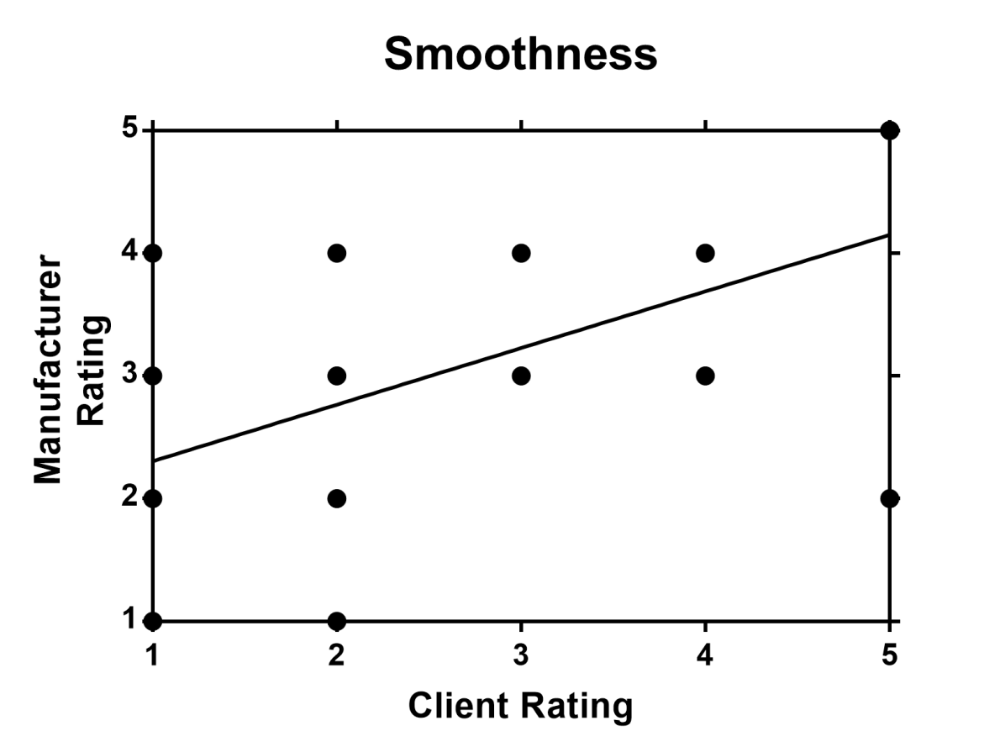

Figure 1: Designer vs. Client Rating

Now, all rated values are dependent on observer’s perception of user interaction attribute. These values as such cannot be used for further analytical evaluation in their raw form. Even, the numerical values assigned are random in nature. Hence, we need to translate these fuzzy values into some definite numerical values which we can use for further analytical values.

To do this, select a user interaction attribute (say we choose smoothness), any linguistic term (say Rough) corresponding to that linguistic term is chosen. Now, we want to create a triangular fuzzy set for the numeric rating with Min (i) as lower limit, M (i) as the mean and the Max (i) as the upper limit of the fuzzy set.

Make plot of the fuzzy sets with membership grade along the Y axis and the universal set i.e. the numeric scale of the user interaction attribute on the X axis. Now, we pass a horizontal line with membership grade as the mean value obtained from Mean, Median and Mode. We have chosen this membership grade as the value is at the middle and we want to take average of the two values. We now get two values and we take mean of these values. The steps are repeated for all the linguistic terms on the scale. (i.e. if we have taken scale as smoothness we will carry this out for Extremely smooth, smooth, moderate, rough, Extremely rough). We also repeat this for all other user interaction attributes for the application. (i.e. for gloss, pattern, warmth of colour and softness)

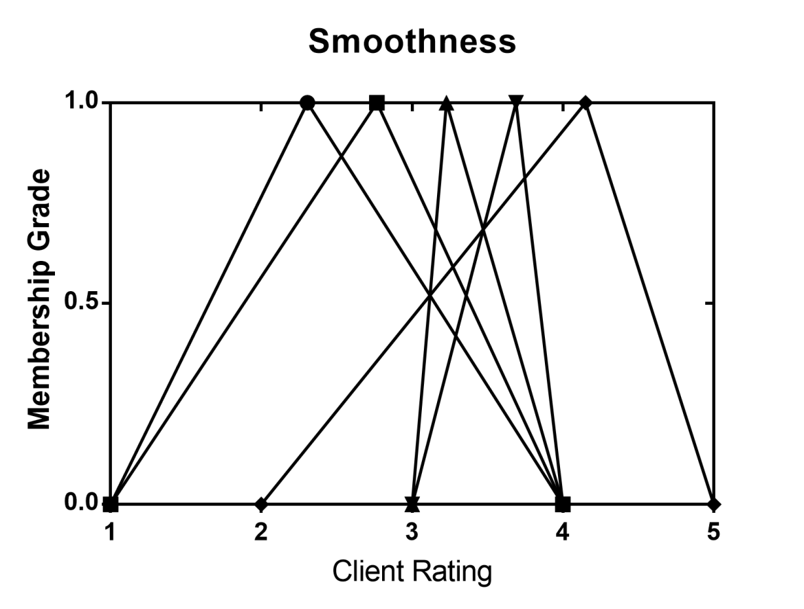

Figure 2: Fuzzy Graph for smoothness

Once, we have converted random values into definite values in terms of designers perception, we can use them for ranking of the materials. As there are multiple attributes and multiple candidate materials to be considered, we use multiple attribute decision making method. Now, once we know the user’s material requirements, we will convert them to the corresponding designer rating and normalise these ratings. We will then use these ratings and use weighted average method to create a score for each candidate material. The materials are then ranked as per their scores.

3. Results

In order to demonstrate usability of algorithm, three real world applications are chosen – Mobile case, watch strap and Automobile wheel. Application of mobile case is chosen as it depicts that algorithm can be successfully used for mass produced consumer products which have heavy dependence on user interaction attributes of look and feel for their commercial viability. Application of watch strap showed that algorithm can be successfully used for design of subpart of a product which depends heavily on sensory appeasement of user through touch. Finally, application of Automobile wheel shows that algorithm can also be used for applications where aesthetics are not a major consideration but increase desirability of products amidst competition lacking these qualities. For all the applications, candidate materials are chosen based on criteria of being oft-used and availability. The participant group mimicking designers has rated the candidate material and this forms the Target(Designer) rating. Target (Designer) signifies the requirements specified by the user or in our case, the group mimicking user.

* 1. **Example 1 - Mobile Case**

**Table 2: MADM Table**

|  |  |  |  |  |  |  |  |  |
| --- | --- | --- | --- | --- | --- | --- | --- | --- |
|  | Smoothness | | Gloss | | Hardness | | Pattern | |
| **Target (User)** | Moderate | | Matte | | Soft | | Recurring | |
| 3 | | 3 | | 2 | | 1 | |
| **Weights** | **0.35** | | **0.25** | | **0.3** | | **0.1** | |
| **Target(Designer)** |  | 3.409 |  | 2.264 |  | 2.527 |  | 1.98 |
| Polyurethane | smooth | 2 | Gloss | 2 | moderate | 3 | no-pattern | 3 |
| Polycarbonate | moderate | 3 | Matte | 3 | Soft | 2 | no-pattern | 3 |
| Carbon Fibre | smooth | 2 | very-high-gloss | 1 | extremely hard | 5 | Recurring | 1 |
| Natural Leather | rough | 4 | Matte | 3 | moderate | 3 | non-recurring | 2 |
| Silicone | moderate | 3 | Gloss | 2 | Soft | 2 | no-pattern | 3 |

In this application, we have simulated a situation wherein designer wants to introduce a new Mobile Case in the market. Now, while purchasing/using a mobile case, user generally focuses on how it looks and how it feels. Hence, we have considered predefined user interaction attributes of Smoothness, Gloss, Hardness and Pattern for this application. Weightages are to be given by user depending on what user interaction attributes he feels product must have more.

**Table 3:**

|  |  |  |  |  |
| --- | --- | --- | --- | --- |
| **Vij** | Smoothness | Gloss | Hardness | Pattern |
| Polyurethane | 0.7045 | 0.132 | 0.1577 | 0.51 |
| Polycarbonate | 0.2045 | 0.368 | 0.1757 | 0.51 |
| Carbon Fibre | 0.7045 | 0.632 | 0.8243 | 0.49 |
| Natural Leather | 0.2955 | 0.368 | 0.1577 | 0.01 |
| Silicone | 0.2045 | 0.132 | 0.1757 | 0.51 |

**Table 4: Utility Scores**

|  |  |  |  |
| --- | --- | --- | --- |
|  | **Ri** | **Si** | **Qi** |
| Polyurethane | 0.7045 | 0.3779 | 0.5409 |
| Polycarbonate | 0.51 | 0.2673 | 0.2155 |
| Carbon Fibre | 0.8243 | 0.7009 | 1 |
| Natural Leather | 0.368 | 0.2437 | 0.0359 |
| Silicone | 0.51 | 0.2083 | 0.1556 |

The material with lowest utility score will be the best choice for application. Lowest utility score signifies lowest deviation from target values.

* 1. **Example 2 - Watch Strap**

For application of watch strap, user interaction attributes of primary importance is tactile feel and secondary is looks. Hence, more weightage is given to predefined user interaction attributes of hardness ad smoothness than pattern, warmth and gloss.

**Table 5:**

|  |  |  |  |  |  |  |  |  |
| --- | --- | --- | --- | --- | --- | --- | --- | --- |
|  | Smoothness | | Gloss | | Hardness | | Pattern | |
| **Target (User)** | Moderate | | Matte | | Soft | | non-recurring | |
| 3 | | 3 | | 2 | | 2 | |
| **Weights** | **0.25** | | **0.2** | | **0.25** | | **0.2** | |
| **Target(Designer)** |  | 3.409 |  | 2.264 |  | 2.527 |  | 2.07 |
| Stainless Steel- Grade 316 | smooth | 2 | very high gloss | 1 | Moderate | 3 | non recurring | 2 |
| Silicone | moderate | 3 | gloss | 2 | Soft | 2 | no-pattern | 3 |
| Cloth | extermely rough | 5 | Matte | 3 | Moderate | 3 | recurring | 1 |
| plastic(grey) | smooth | 2 | Matte | 3 | Hard | 4 | no pattern | 3 |
| Leather | moderate | 3 | Matte | 3 | Moderate | 3 | non-recurring | 2 |

**Table 6:**

|  |  |  |  |  |  |
| --- | --- | --- | --- | --- | --- |
| **Vij** | Smoothness | Gloss | Hardness | Pattern | Warmth |
| Stainless Steel- Grade 316 | 0.4697 | 0.632 | 0.2365 | 0.035 | 0.1379 |
| Silicone | 0.1363 | 0.132 | 0.2635 | 0.465 | 1 |
| Cloth | 0.5303 | 0.368 | 0.2365 | 0.535 | 0.1379 |
| plastic(grey) | 0.4697 | 0.368 | 0.7365 | 0.465 | 0.1379 |
| Leather | 0.1363 | 0.368 | 0.2365 | 0.035 | 1 |

**Table 7: Utility Scores**

|  |  |  |  |
| --- | --- | --- | --- |
|  | **Ri** | **Si** | **Qi** |
| Stainless Steel- Grade 316 | 0.632 | 0.31 | 0.336 |
| Silicone | 1 | 0.21935 | 0.577 |
| Canvas | 0.535 | 0.3723 | 0.337 |
| Plastic | 0.7365 | 0.46815 | 0.717 |
| Leather | 1 | 0.1738 | 0.5 |

Stainless Steel is the preferred choice with lowest utility score.

* 1. **Example 3 - Automobile Wheel**

For this application, as it has a substantial mechanical design part, only those materials are rated which satisfy the required mechanical properties. People perceive automobile wheel as strong, hard and smooth. Also, glossiness of wheel depicts class and hence it is an important user interaction attribute to be considered.

**Table 8 : MADM Table**

|  |  |  |  |  |  |  |
| --- | --- | --- | --- | --- | --- | --- |
|  | Smoothness | | Gloss | | Hardness | |
| **Target (User)** | Smooth | | high-gloss | | Hard | |
| 2 | | 1 | | 4 | |
| **Weights** |  | **0.2** |  | **0.5** |  | **0.3** |
| **Target(Designer)** |  | 2.589 |  | 2.372 |  | 3.773 |
| Magnesium Alloy | Smooth | 2 | very-high gloss | 1 | Moderate | 3 |
| Aluminium Alloy | Moderate | 3 | Gloss | 2 | Hard | 4 |
| Cast Iron | Rough | 4 | Matte | 3 | extremely hard | 5 |

**Table 9:**

|  |  |  |  |
| --- | --- | --- | --- |
| **Vij** | Smoothness | Gloss | Hardness |
| Magnesium Alloy | 0.2945 | 0.686 | 0.3865 |
| Aluminium Alloy | 0.2055 | 0.186 | 0.1135 |
| Cast Iron | 0.7055 | 0.314 | 0.6135 |

**Table 10**

|  |  |  |  |
| --- | --- | --- | --- |
|  | **Ri** | **Si** | **Qi** |
| Magnesium Alloy | 0.686 | 0.5179 | 0.9862 |
| Aluminium Alloy | 0.2055 | 0.1682 | 0.308 |
| Cast Iron | 0.7055 | 0.4822 | 0.9655 |

Aluminium alloy is highest ranked among the three candidate materials with lowest utility score. It is not a surprise because many of the popular brands of cars use this.

Table 10: Translation table

|  |  |  |  |  |  |
| --- | --- | --- | --- | --- | --- |
|  | Numeric Rating Value | Lower Limit | Mode | Upper Limit | Equivalent Value |
| Smoothness-Roughness | 1 | 1 | 2.305 | 4 | 2.435 |
| 2 | 1 | 2.766 | 4 | 2.589 |
| 3 | 3 | 3.228 | 4 | 3.409 |
| 4 | 3 | 3.689 | 4 | 3.563 |
| 5 | 2 | 4.150 | 5 | 3.717 |
| Glossiness | 1 | 2 | 2.116 | 3 | 2.372 |
| 2 | 2 | 2.453 | 3 | 2.484 |
| 3 | 1 | 2.790 | 3 | 2.264 |
| Softness-Hardness | 1 | 1 | 2.212 | 3 | 2.071 |
| 2 | 1 | 2.581 | 4 | 2.527 |
| 3 | 2 | 2.950 | 4 | 2.984 |
| 4 | 3 | 3.319 | 5 | 3.773 |
| 5 | 2 | 3.689 | 4 | 3.23 |
| Pattern | 1 | 1 | 1.939 | 3 | 1.98 |
| 2 | 1 | 2.209 | 3 | 2.07 |
| 3 | 1 | 2.478 | 3 | 2.16 |
| Warmth of color | 1 | 1 | 1.756 | 3 | 1.919 |
| 2 | 2 | 2.118 | 3 | 2.373 |
| 3 | 1 | 2.481 | 3 | 2.16 |

Translation table gives equivalent value of designer rating corresponding to user rating obtained from fuzzy graph.

1. Discussion

A linguistic ordinal scale has been developed so that user will be able to specify user interaction attributes he desires in less ambiguous terms. The scatter plot of user vs. designer rating helps us to understand how different perception of user and designer for same material is. These materials constitute the training set. The line which is regressed through points is line which signifies agreement of user and designer with their perception of the given material. Hence, greater the number of materials in training set, greater will be the number of points that can be plotted and hence a better idea of agreement gap between user and designer can be obtained.

The numerical rating values assigned to linguistic terms are nominal in nature and are subject to the same level of impreciseness of linguistic terms they represent. In order to tackle this impreciseness, we employ fuzzy sets which represent linguistic term as a fuzzy set about their numerical values. Essentially, fuzzy method converts user rating to designer rating. It is a method of representing imprecise nature of linguistic terms while providing nominal numerical values for future calculations. The triangular membership function is preferred over other functions for sake of simplicity.

Once user has specified requirements in linguistic terms, designer will then convert these terms in corresponding designer terms i.e how designer thinks user will perceive material. The designer has already rated set of candidate materials for given application, important point to consider is that ratings are influenced by weightages given to attributes. These weightages are given by user depending on what user interaction attribute he desires product to have more. Thus, indirectly user is influencing the material selection, laying stress on user interaction aspect of the process

MADM is then used to choose materials for given application. In this method, each material gets a utility score. Lower is utility, lower is deviation from target values which are requirements as specified by the user. As designer has rated candidate material from his perspective, there is certain bias introduced, hence method can be used as an auxiliary supporting method. The designer must do further research about materials to choose best one based on other factors like cost, availability.

1. Conclusion

The focus of product design has gradually shifted from designing products satisfying utility criteria to products which are user interactionly pleasing. An analytical method has been proposed which helps designer understand what user interaction attributes the user desires in product. Due to subjective nature of the attributes, they are difficult to specify and even more difficult for other person to grasp. This is mainly because each individual has a different idea of relative linguistic terms like beauty, happiness etc.

In spite of the large number of different materials available and complexity of decision making, more is information available, better is decision making. In traditional material selection methods, perception of linguistic terms used to define ordinal data is considered to be constant for different sources of that data. However in real world applications, material evaluations and requirements come from different sources and thus perception cannot be considered to be same across these sources. Also, imprecise nature of this data cannot be expressed by use of constant numeric values. The translation of perception of these linguistic terms across sources can help to better represent meaning of these linguistic terms. The use of fuzzy sets during translations can help deal with imprecise nature of received data. This study proposed a model to deal with subjective nature of the linguistic terms used to define user interaction attributes in engineering problems involving material selection.

As illustrated by examples considered in paper, proposed algorithm successfully translated user rating values onto designers/designers rating scales in the form of fuzzy sets, which are then used in decision making procedure. To summarize, steps involved are,

1. Generation of rating scales for user interaction attributes.
2. Training model by a training set.
3. Creating an Agreement plot and using linear regression to find bounds of translated rating values.
4. Generating fuzzy Rating scales from translated values and determining equivalent rating values.
5. Applying these rating values as target values in the decision making procedure.

The sizes of the rating scales are flexible and so is the size of the training set. Thus any appropriate size may be taken for an application. As such the model will provide results for any size of the training set, however it is recommended to use a training set of the largest possible size to obtain accurate results. Moreover it is recommended that greater number of materials with properties in the extreme ends of the rating scales be chosen so as to reduce distortion of the scales at the ends. The distortion may lead to inaccurate translations at the extreme ends of the scales at reduce the overall accuracy of the entire method.

A target based VIKOR method was used to illustrate the material selection procedure, but model was developed to work with any kind of target based MADM method. It can be shown that model can be employed for data from more than two sources where each source of data can be translated with respect to a reference. The proposed method may be extended to be applied with interval data and beneficial and non-beneficial type of criteria. It is recommended that further research be taken up in these areas.

1. Acknowledgement

In helping us get a clearer picture, orienting the focus of the research paper and fine tuning the criticals Dr. V.B. Suryawanshi played a key role.

1. References

[1]Van Kesteren, I.E.H., 2008. *Selecting materials in product design* (Doctoral dissertation, TU Delft, Delft University of Technology).

[2]Doordan, D.P., 2003. On materials. *Design Issues*, *19*(4), pp.3-8.

[3] Karande, P., Gauri, S.K. and Chakraborty, S., 2013. Applications of utility concept and desirability function for materials selection. *Materials & Design*, *45*, pp.349-358.

[4]Van Kesteren, I.E.H., Stappers, P.J. and Kandachar, P.V., 2005. Representing product personality in relation to materials in the design problem. In *Proceedings of the international conference of the Nordic Design Research society, Copenhagen*.

[5]Ashby, M.F. and Johnson, K., 2013. *Materials and design: the art and science of material selection in product design*. Butterworth-Heinemann.

[6] van Kesteren, I., de Bruijn, S. and Stappers, P.J., 2008. Evaluation of materials selection activities in user-centred design projects. *Journal of Engineering Design*, *19*(5), pp.417-429.

[7] Ashby MF, Brechet YJM, Cebon D, Salvo L. Selection strategies for materials and processes. Mater Des 2004;25:51–67.

[8] Ashby MF. Materials selection in mechanical design. New York: Pergamon Press; 1995.

[9] Jee DH, Kang KJ. A method for optimal material selection aided with decision making theory. Mater Des 2000;21(3):199–206. Topsis

[10] Shanian A, Savadogo O. A material selection model based on the concept of multiple factor decision making. Mater Des 2006;27:329–37.

[11] Rao RV. A material selection model using graph theory and matrix approach. Mater Sci Eng A 2006;431:248–55.

[12] Fayazbakhsh K, Abedian A, Manshadi BD, Khabbaz RS. Introducing a novel method for materials selection in mechanical design using Z-transformation in statistics for normalization of material properties. Mater Des 2009;30: 4396–404.

[13]Rao, R.V., 2008. A decision making methodology for material selection using an improved compromise ranking method. *Materials & Design*, *29*(10), pp.1949-1954.

[14] Khabbaz RS, Manshadi BD, Abedian A, Mahmudi R. A simplified fuzzy logic approach for materials selection in mechanical engineering design. Mater Des 2009;30:687–97.

[15]Jahan, A., Ismail, M.Y., Sapuan, S.M. and Mustapha, F., 2010. Material screening and choosing methods–a review. *Materials & Design*, *31*(2), pp.696-705.

[16]Rao, R.V. and Patel, B.K., 2010. A subjective and objective integrated multiple attribute decision making method for material selection. *Materials & Design*, *31*(10), pp.4738-4747.

[17]Van Kesteren, I.E.H., 2008. Product designers’ information needs in materials selection. *Materials & Design*, *29*(1), pp.133-145.

[18] Shanian A, Savadogo O. A non-compensatory compromised solution for

material selection of bipolar plates for polymer electrolyte membrane fuel

cell (PEMFC) using ELECTRE IV. Electrochim Acta 2006;51:5307–15.

[19]van Kesteren, I.E.H., Stappers, P.J. and de Bruijn, J.C.M., 2007. Defining user-interaction aspects for materials selection: Three tools. *the Web Proceedings of Nordic Design Research. Retrieved April*, *1*, p.2007.

[20]Van Kesteren, I.E.H., 2008. *Selecting materials in product design* (Doctoral dissertation, TU Delft, Delft University of Technology).

[21]Karana, E., Hekkert, P. and Kandachar, P., 2008. Materials experience: descriptive categories in material appraisals. In *Proceedings of the Conference on Tools and Methods in Competitive Engineering* (pp. 399-412).

[22]Johnson, K.W., Langdon, P.M. and Ashby, M.F., 2002. Grouping materials and processes for the designer: an application of cluster analysis. *Materials & design*, *23*(1), pp.1-10.

[23] Ferrante, M., Santos, S.F. and De Castro, J.F.R., 2000. Materials selection as an interdisciplinary technical activity: basic methodology and case studies. *Materials Research*, *3*(2), pp.1-9.

[24] Govers, P.C. and Schoormans, J.P., 2005. Product personality and its influence on consumer preference. *Journal of Consumer Marketing*, *22*(4), pp.189-197.