**Algorithm**

1. Pick a value for **K**(i.e. 5).

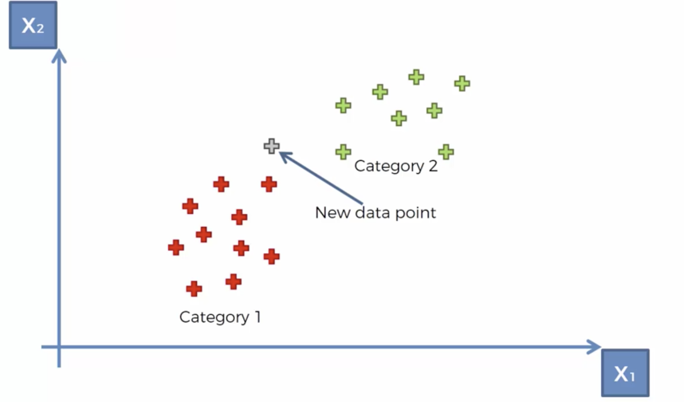

2. Take the **K** nearest neighbors of the new data point according to their Euclidean distance.

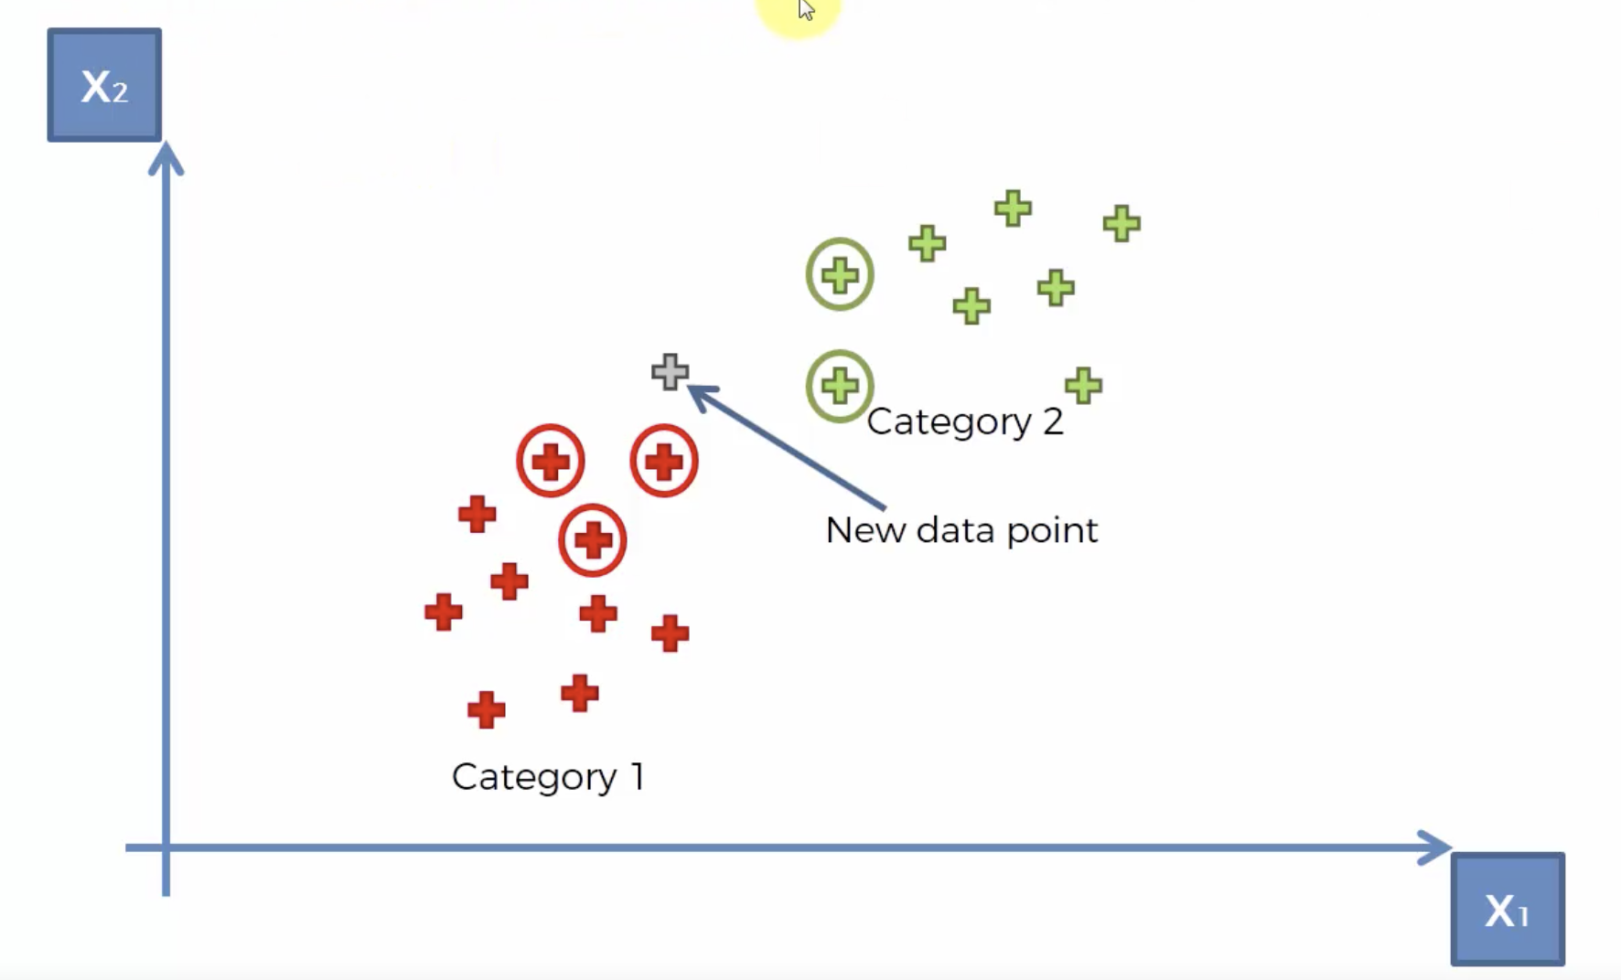

3. Among these neighbors, count the number of data points in each category and assign the new data point to the category where you counted the most neighbors.

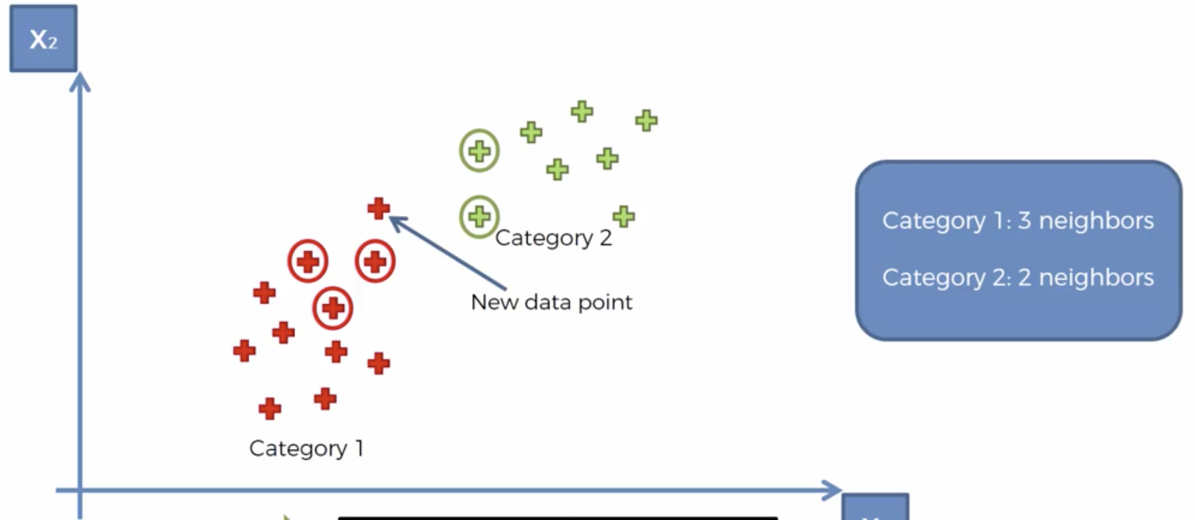

https://miro.medium.com/max/60/1*OMHr6KZl7nHnKgLb8pq0Jg.png?q=20

