Experiment 11

K-Means Algorithm for Image Segmentation
Step 1: Save any image inside src/data folder and name it input_image.jpg
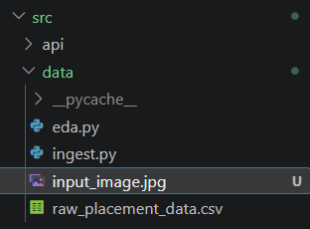
Step 2: Create src/models/ kmeans_image.py
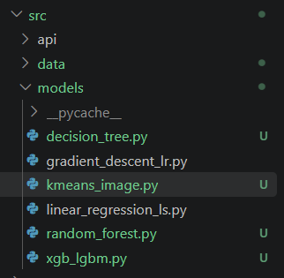
Step 3: Install Pillow, NumPy, Matplotlib and Scikit-learn.
Create python virtual environment and activate it
python -m venv venv
(or)
python -m venv venv --without-pip
source venv/Scripts/activate
.\venv\Scripts\Activate.ps1

pip install pillow numpy matplotlib scikit-learn

Step 4: Paste and save the code.

from pathlib import Path
import numpy as np
import matplotlib.pyplot as plt
from PIL import Image
from sklearn.cluster import KMeans

ROOT = Path(__file__).resolve().parents[2]
IMAGE = ROOT / 'src' / 'data' / 'input_image.jpg'
OUT = ROOT / 'reports' / 'figures'
OUT.mkdir(parents=True, exist_ok=True)

def run():
# Load and preprocess image
img = Image.open(IMAGE).convert('RGB').resize((300, 300))
arr = np.array(img)
X = arr.reshape(-1, 3).astype(float)

ks = [2, 4, 6, 8]
inertias = []
segs = []

# Run K-Means for each K
for k in ks:
m = KMeans(n_clusters=k, n_init=10, random_state=42)
lab = m.fit_predict(X)

# Reconstruct segmented image from cluster centroids
seg = m.cluster_centers_[lab].reshape(arr.shape).astype('uint8')
inertias.append(m.inertia_)
segs.append(seg)

# Save individual segmented output
Image.fromarray(seg).save(OUT / f'segmented_k{k}.png')

# Side-by-side segmentation comparison plot
fig, ax = plt.subplots(1, 5, figsize=(18, 4))
ax[0].imshow(arr)
ax[0].set_title('Original')
ax[0].axis('off')

for a, k, s in zip(ax[1:], ks, segs):
a.imshow(s)
a.set_title(f'K={k}')
a.axis('off')

plt.tight_layout()
plt.savefig(OUT / 'image_segmentation_comparison.png', dpi=150)
plt.close()

# Inertia / Elbow plot
plt.figure(figsize=(8, 5))
plt.plot(ks, inertias, marker='o', color='#2b5c8f', linewidth=2)
plt.xlabel('K')
plt.ylabel('Inertia')
plt.title('Elbow Curve - Image Segmentation')
plt.grid(True, linestyle='--', alpha=0.6)
plt.tight_layout()
plt.savefig(OUT / 'image_segmentation_elbow.png', dpi=150)
plt.close()

print("Segmentation completed. Figures saved to:", OUT)

if __name__ == '__main__':
run()

Step 5: Run from the project root.
New-Item -ItemType Directory -Force -Path data
python src\models\kmeans_image.py

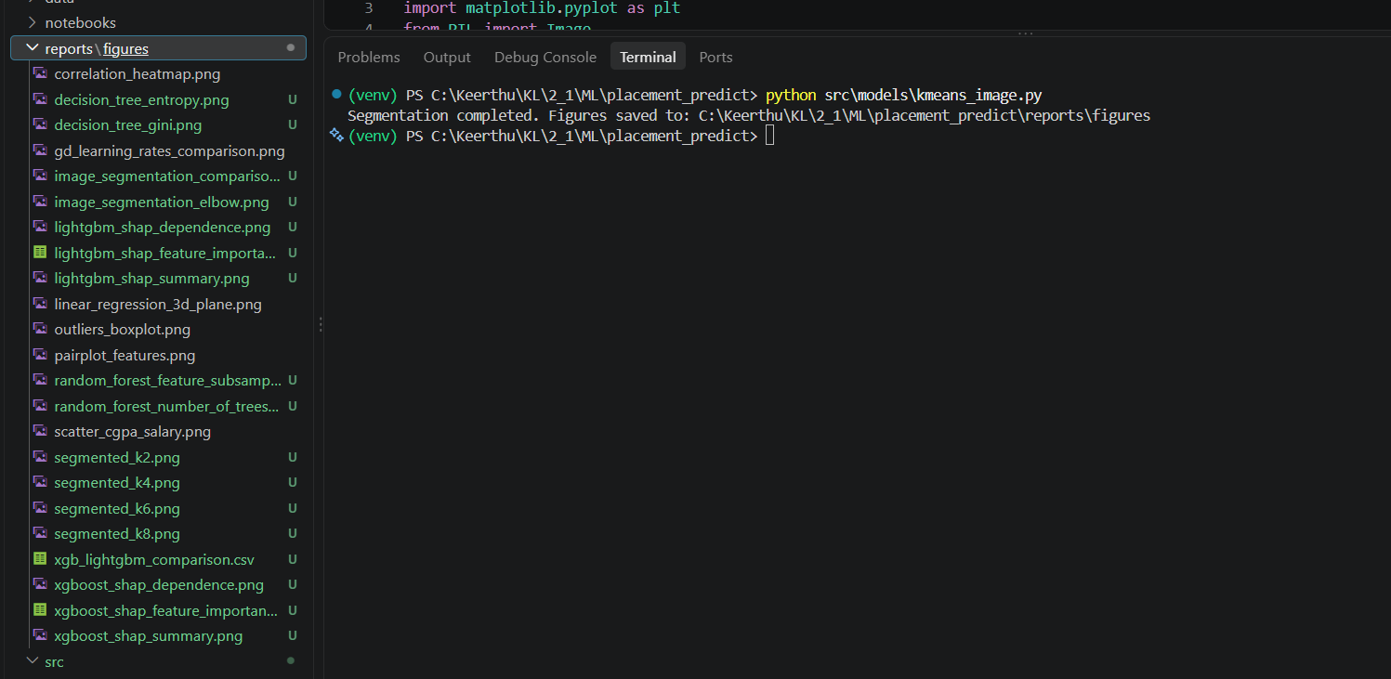

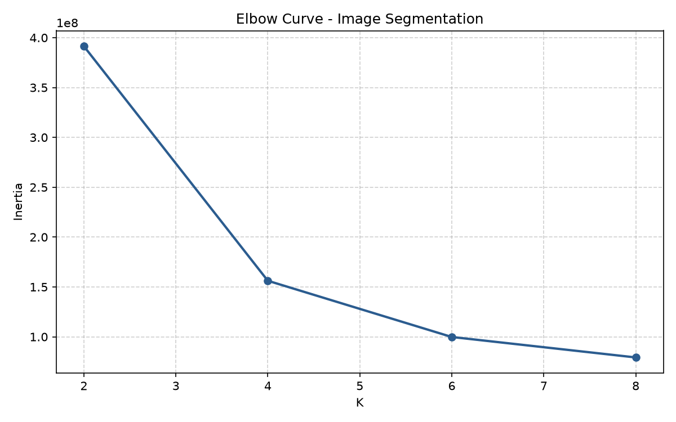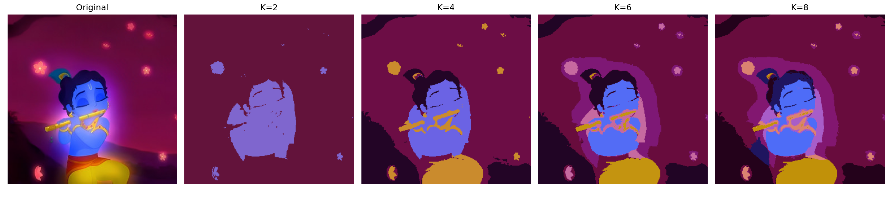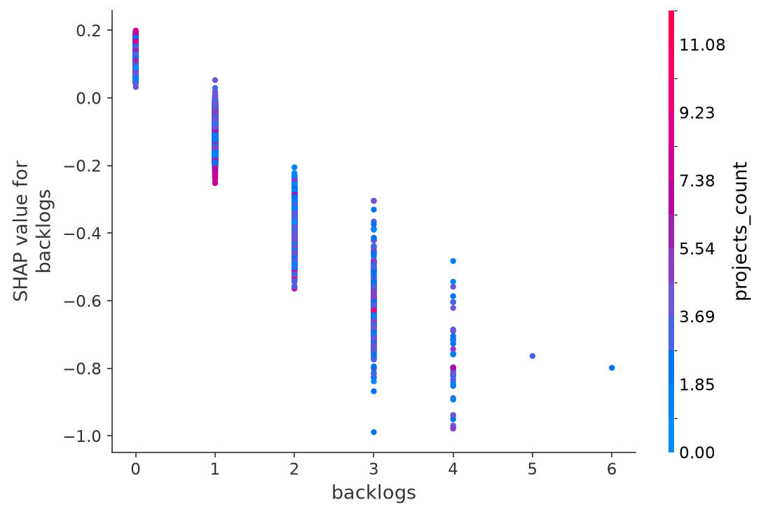
Step 6: Compare K=2,4,6,8 images and the Elbow Curve.

Questions and Answers
1. What is image segmentation?
Dividing an image into groups of pixels with similar characteristics.
2. How is the image represented?
Each pixel is represented by its RGB colour values.
3. How does K-Means segment the image?
It clusters pixels into K colour groups and replaces each pixel with its cluster centroid colour.
4. Effect of increasing K?
More clusters preserve more colour detail but increase segmentation complexity.
5. What is the Elbow Method?
A method that examines inertia for different K values and looks for diminishing improvement.
6. What is a centroid?
The mean point of a cluster; here it represents a representative RGB colour.
7. Why test K=2,4,6,8?
To compare progressively finer colour groupings.
8. Limitation?
K-Means does not directly model spatial context or complex visual structure.

Experiment 12

Apply Clustering Algorithms to Discover Hidden Patterns in the Placement Dataset
Step 1: Create src/models/ clustering.py
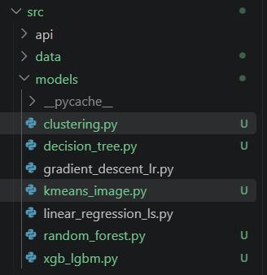
Step 2: Install SciPy in addition to the existing libraries.
Create python virtual environment and activate it
python -m venv venv
(or)
python -m venv venv --without-pip
source venv/Scripts/activate
.\venv\Scripts\Activate.ps1

pip install pandas numpy matplotlib scikit-learn scipy

Step 3: Paste and save the code.

from pathlib import Path
import numpy as np
import pandas as pd
import matplotlib.pyplot as plt
from sklearn.preprocessing import StandardScaler
from sklearn.cluster import KMeans, AgglomerativeClustering, DBSCAN
from sklearn.metrics import silhouette_score, davies_bouldin_score
from scipy.cluster.hierarchy import linkage, dendrogram

ROOT = Path(__file__).resolve().parents[2]
DATA = ROOT / 'src' / 'data' / 'raw_placement_data.csv'
OUT = ROOT / 'reports' / 'figures'
OUT.mkdir(parents=True, exist_ok=True)

# Exact matching columns from raw_placement_data.csv
F = [
'college_tier',
'cgpa',
'backlogs',
'coding_skill_score',
'communication_skill_score',
'internships_count',
'projects_count'
]

def load():
df = pd.read_csv(DATA)
df.columns = df.columns.str.strip()

# Extract digits from 'Tier 1', 'Tier 2', etc. before numeric conversion
if 'college_tier' in df.columns and not pd.api.types.is_numeric_dtype(df['college_tier']):
df['college_tier'] = df['college_tier'].astype(str).str.extract(r'(\d+)')

df_subset = df[F].apply(pd.to_numeric, errors='coerce').dropna()
return StandardScaler().fit_transform(df_subset)

def scores(X, lab):
mask = lab != -1
xx = X[mask]
yy = lab[mask]
n_clusters = len(set(yy))

if n_clusters < 2:
return np.nan, np.nan, n_clusters

sample_sz = min(len(xx), 2000)
return (
round(silhouette_score(xx, yy, sample_size=sample_sz, random_state=42), 4),
round(davies_bouldin_score(xx, yy), 4),
n_clusters
)

def run():
print("Loading data...")
X = load()
n_samples = len(X)
print(f"Dataset loaded with {n_samples} rows. Running K-Means evaluation...")

sample_sz = min(n_samples, 2000)
ks = range(2, 11)
inert = []
sil = []

for k in ks:
m = KMeans(n_clusters=k, n_init=10, random_state=42)
l = m.fit_predict(X)
inert.append(m.inertia_)
# Use sample_size to make silhouette score fast
sil.append(silhouette_score(X, l, sample_size=sample_sz, random_state=42))
print(f" Finished K={k}")

best = list(ks)[int(np.argmax(sil))]
print('\nOptimal K selected by highest silhouette:', best)

# 1. Elbow curve
plt.figure(figsize=(8, 5))
plt.plot(list(ks), inert, marker='o', color='#2b5c8f')
plt.xlabel('K')
plt.ylabel('Inertia')
plt.title('Elbow Curve - Placement Dataset')
plt.grid(True, linestyle='--', alpha=0.5)
plt.tight_layout()
plt.savefig(OUT / 'clustering_kmeans_elbow.png', dpi=150)
plt.close()

# 2. Silhouette analysis curve
plt.figure(figsize=(8, 5))
plt.plot(list(ks), sil, marker='o', color='#d95f02')
plt.xlabel('K')
plt.ylabel('Silhouette Score')
plt.title('Silhouette Analysis - Placement Dataset')
plt.grid(True, linestyle='--', alpha=0.5)
plt.tight_layout()
plt.savefig(OUT / 'clustering_kmeans_silhouette.png', dpi=150)
plt.close()

print("\nRunning model comparisons...")
# K-Means clustering with optimal K
km = KMeans(n_clusters=best, n_init=10, random_state=42).fit_predict(X)
ks1, db1, c1 = scores(X, km)

# Agglomerative clustering with optimal K
ag = AgglomerativeClustering(n_clusters=best, linkage='ward').fit_predict(X)
ks2, db2, c2 = scores(X, ag)

# Hierarchical Dendrogram (subsampled if dataset is large to prevent OOM/freeze)
print("Generating dendrogram...")
dendro_sample = X[np.random.RandomState(42).choice(n_samples, min(n_samples, 1000), replace=False)]
Z = linkage(dendro_sample, method='ward')
plt.figure(figsize=(12, 6))
dendrogram(Z, truncate_mode='lastp', p=30)
plt.title('Hierarchical Dendrogram - Placement Dataset')
plt.xlabel('Cluster / Sample Index')
plt.ylabel('Distance')
plt.tight_layout()
plt.savefig(OUT / 'hierarchical_dendrogram.png', dpi=150)
plt.close()

# DBSCAN clustering
print("Running DBSCAN...")
db = DBSCAN(eps=0.8, min_samples=5).fit_predict(X)
ks3, db3, c3 = scores(X, db)
noise = int(np.sum(db == -1))

# Summary table
res = pd.DataFrame([
['K-Means', c1, ks1, db1, 0],
['Agglomerative', c2, ks2, db2, 0],
['DBSCAN', c3, ks3, db3, noise]
], columns=['Algorithm', 'Clusters', 'Silhouette', 'Davies_Bouldin', 'Noise_Points'])

print('\nClustering Comparison:')
print(res.to_string(index=False))
res.to_csv(OUT / 'clustering_comparison.csv', index=False)
print(f"\nAll outputs and plots saved to: {OUT}")

if __name__ == '__main__':
run()

Step 4: Run it from the project root.
python src\models\clustering.py

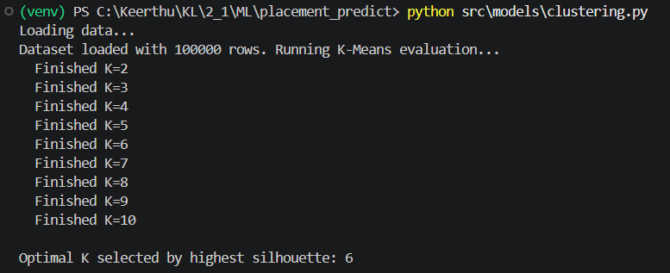
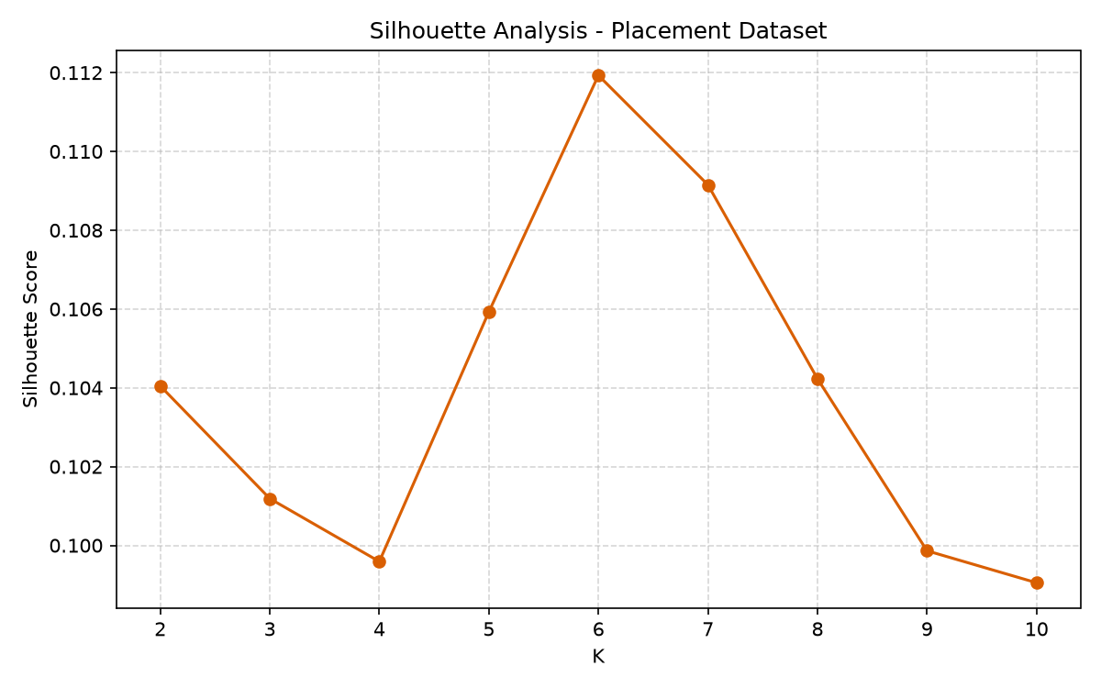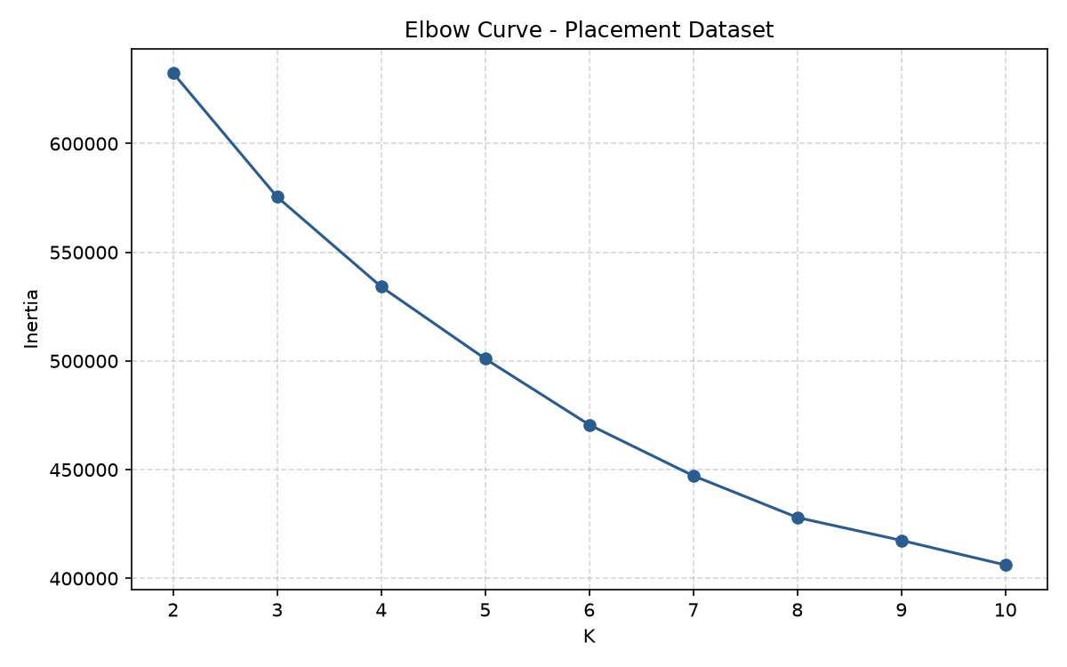

Questions and Answers
1. What is clustering?
An unsupervised technique that groups similar records without using a known target label.
2. How is K-Means used?
It groups placement records using standardized academic and placement-related features.
3. What is the Elbow Method?
It examines inertia for different K values and looks for diminishing improvement.
4. What is Silhouette Score?
It measures how well observations fit their own cluster compared with other clusters; higher is generally better.
5. What is Agglomerative Clustering?
A hierarchical method that starts with individual observations and repeatedly merges clusters.
6. What is a dendrogram?
A tree-like plot showing hierarchical cluster merges and their distances.
7. What is DBSCAN?
A density-based algorithm that finds dense groups and can identify noise.
8. What are noise points?
Records that do not meet DBSCAN density requirements and are labelled -1.
9. What is Davies-Bouldin Index?
A cluster-quality metric where lower values generally indicate compact, well-separated clusters.
10. Why exclude placement_status?
To make clustering genuinely unsupervised and discover groups without directly using the known outcome.
11. What patterns can be studied?
Groups of students with similar CGPA, backlogs, skills, internships and project counts can be investigated.
12. Advantages and limitations?
K-Means is simple but needs K and works best for suitable cluster shapes. Hierarchical clustering gives a hierarchy but can be expensive. DBSCAN can find irregular groups and noise but is sensitive to parameters.

