Option A: Diagram 3 Upright (Horizontal Banner):
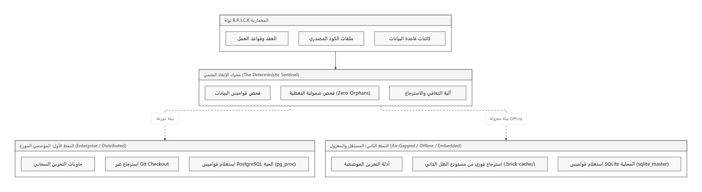
Option B: Diagram 3 Rotated (Sideways):
