

|  |  |  |  |  |
| --- | --- | --- | --- | --- |
| **Student Name:** | | Tulkinova Mukhlisa | | |
| **Student ID:** | | B2100321 | | |
| **Course:** | | BS (Hon) in Computer Information Systems for Business | | |
| **Module Code and Title:** | | ICE1411 – Web Technologies | | |
| **Module Leader:** | | Mr. Jackson Lau Chong Tek | | |
| **Module Tutor:** | | Engr. Eugene Q. Castro | | |
| **Assessment:** | | Assignment 1 | | |
| **Due Date:** | 2 May 2023 | | **Date Submitted:** | **2 May 2023** |
| **Weighting within Module:** | | **50%** | | |
| **ALL MARKS ARE PROVISIONAL AND ARE SUBJECT TO CHANGE UNTIL CONFIRMED BY THE EXTERNAL EXAM BOARD** | | | | |
| **Comments from Internal Examiner (Name):** | | | | |
| **Strengths:** | | | | |
| **Weaknesses:** | | | | |
| **Areas of Improvement:** | | | | |
| **Provisional Mark out of 100:** | | |  | |

Table of Contents

Task 1 - Structure and Content of Webpage 1

Site Map 1

Online Hosting 2

Search-Engine Optimization (SEO) 2

Responsive Web Design (RWD) 4

Internal and External links to and from every page on your site 11

External Links: 11

Task 2 - Style your Webpage 12

Web Font used in Website 12

View of website in different devices 12

Mobile 12

Tablet 12

Desktop 13

Task 3 - Building an 3x3 image gallery from a JSON object 14

Image Gallery 14

JSON File 14

Task 4 - Create an interactive image carousel from a JSON object 16

Framework Used for Carousel 16

JS Code 16

Task 5 - Website Testing and Validation 17

Cross-browser compatibility: 17

HTML/CSS Validation 17

Peer review (via screen share or remote control) 17

# Task 1 - Structure and Content of Webpage

## Site Map

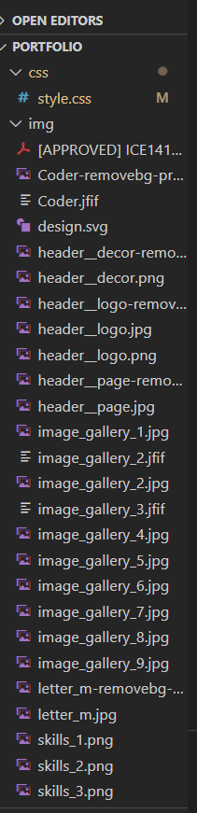

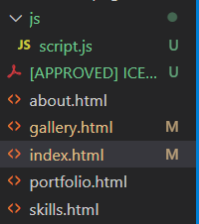

## Online Hosting

The assignment can be accessed on this website <https://www.mywebsite.com>

## Search-Engine Optimization (SEO)

<!DOCTYPE html>

<html lang="en">

<head>

    <meta charset="UTF-8">

    <meta http-equiv="X-UA-Compatible" content="IE=edge">

    <meta name="viewport" content="width=device-width, initial-scale=1.0">

    <title>Portfolio</title>

    <link href="https://fonts.googleapis.com/css2?family=Volkhov:wght@400;700&display=swap" rel="stylesheet">

    <link href="https://fonts.googleapis.com/css2?family=Poppins:wght@300;400;500&display=swap" rel="stylesheet">

    <link rel="stylesheet" href="https://cdnjs.cloudflare.com/ajax/libs/font-awesome/6.3.0/css/all.min.css">

    <link href="https://unpkg.com/aos@2.3.1/dist/aos.css" rel="stylesheet">

    <link rel="stylesheet" href="css/style.css">

</head>

<body>

    <header class="header">

        <div class="container">

            <ul class="header__list" data-aos="zoom-in">

                <li class="header__list-item active "><a href="index.html">Home</a></li>

                <li class="header__list-item"><a href="about.html">About</a></li>

                <li class="header__list-item"><a href="gallery.html">Image Gallery</a></li>

                <li class="header__list-item"><a href="portfolio.html">Portfolio</a></li>

                <li class="header__list-item"><a href="skills.html">Skills</a></li>

            </ul>

                <div class="header__content">~

                    <div class="header__text" data-aos="fade-up-right">

                        <h1>Tulkinova  Mukhlisa</h1>

                        <p>Student of Bangor University, Bachelor degree, <br>

                        the faculty of Computer Information Systems in Business, <br>

                        MDIS, Tashkent.</p>

                        <div class="header__social">

                            <a href="https://t.me/muslima_a9858" target="_blank"><i class="fa-solid fa-paper-plane"></i></a>

                            <a href="https://mail.google.com" target="_blank"><i class="fa-solid fa-envelope"></i></a>

                            <a href="https://duo.app.goo.gl/FwgqoEZ" target="_blank"><i class="fa-solid fa-video"></i></a>

                        </div>

                   </div>

                   <div class="header__image" data-aos="fade-up-left">

                    <img src="img/design.svg" alt="My skills">

                  </div>

                </div>

        </div>

    </header>

    <main>

        <section class="skills">

            <div class="container">

                    <div class="skills__wrapper">

                        <i class="fa-solid fa-gears"></i>  <span>My Skills</span>

                    </div>

                    <div class="skills__content">

                        <div class="skills__content-item">

                            <i class="fa-solid fa-face-smile fa-spin"></i> <br>

                            <span>Communication skills</span>

                        </div>

                        <div class="skills__content-item">

                            <i class="fa-solid fa-code fa-fade"></i> <br>

                            <span>Coding</span>

                        </div>

                        <div class="skills__content-item">

                            <i class="fa-solid fa-list-check fa-spin fa-spin-reverse"></i> <br>

                            <span>Multi Tasking</span>

                        </div>

                        <div class="skills__content-item">

                            <i class="fa-solid fa-people-group fa-fade"></i> <br>

                            <span>Teamworking</span>

                        </div>

                </div>

            </div>

        </section>

    </main>

    <footer class="footer">

        <div class="container">

            <div class="footer__copyright">

                <span>All Rights Are Reserved</span>

                <span>Copyright <i class="fa-regular fa-copyright"></i></span>

            </div>

        </div>

    </footer>

<title> tag: This is the title of the page, which should be descriptive and include relevant keywords.

<meta name="description"> tag: This provides a brief summary of the content of the page, and should also include relevant keywords.

<meta name="keywords"> tag: This provides a list of keywords that are relevant to the content of the page.

<meta name="author"> tag: This indicates the author of the page.

<meta name="viewport"> tag: This sets the viewport size of the page, which is important for mobile optimization.

## Responsive Web Design (RWD)

**Use CSS media queries**:

@media (max-width:1200px) {

    .container {

        max-width: 990px;

    }

    .header {

        padding-bottom: 80px;

    }

    .header__list {

        gap: 50px;

    }

    .header__content {

        padding-top: 80px;

        justify-content: space-around;

        align-items: center;

    }

    .header__text {

        max-width: 50%;

    }

    .header__text h1 {

        font-size: 45px;

        line-height: 82px;

    }

    .header__text p {

        font-size: 18px;

        margin-top: 30px;

    }

    .header__image {

        max-width: 40%;

    }

    .skills__wrapper {

        font-size: 40px;

        display: flex;

        gap: 10px;

        justify-content: center;

        align-items: center;

    }

    .skills__1-content {

        max-width: 100%;

    }

    .about {

        padding: 100px 0 150px 0;

    }

    .about__wrapper {

        font-size: 40px;

        display: flex;

        gap: 10px;

        justify-content: center;

        align-items: center;

    }

    .about__content-item::after {

        content: '';

        position: absolute;

        bottom: -229px;

        right: 85px;

    }

    .gallery__wrapper {

        font-size: 40px;

        display: flex;

        gap: 10px;

        justify-content: center;

        align-items: center;

    }

    .portfolio__content img {

        max-width: 100%;

    }

    .skills__1-wrapper {

        font-size: 40px;

        display: flex;

        gap: 10px;

        justify-content: center;

        align-items: center;

    }

    .portfolio__wrapper {

        font-size: 40px;

        display: flex;

        gap: 10px;

        justify-content: center;

        align-items: center;

    }

}

@media (max-width:991px) {

    .container {

        max-width: 765px;

    }

    .header__content {

        flex-direction: column;

    }

    .header__text {

        max-width: 80%;

        z-index: 1;

    }

    .header__image {

        max-width: 80%;

        position: absolute;

        top: 10%;

    }

    .skills__content {

        max-width: 100%;

    }

    .about {

        padding-bottom: 200px;

    }

    .gallery__content {

        max-width: 100%;

    }

}

@media (max-width:768px) {

    .container {

        max-width: 575px;

    }

    .header__list {

        gap: 20px;

        font-size: 18px;

    }

    .header__text {

        display: flex;

        flex-direction: column;

        align-items: center;

    }

    .about {

        padding-top: 50px;

        padding-bottom: 30px;

    }

    .about__content {

        margin-top: 20px;

        max-width: 80%;

    }

    .about__content-item::after {

        display: none;

    }

    .gallery__wrapper {

        font-size: 30px;

    }

    .gallery__content{

        display: flex;

        flex-direction: column;

        align-items: center;

    }

    .gallery__content-item{

        max-width: 80%;

    }

    .portfolio {

        padding: 50px 0;

    }

    .portfolio__content {

        max-width: 90%;

        height: 400px;

    }

    .skills__1-content {

        display: flex;

        flex-direction: column;

        max-width: 70%;

    }

    .skills__1-content-item{

        padding: 20% 0;

    }

}

@media (max-width:576px) {

    .container {

        max-width: 321px;

    }

    .header__list {

        flex-wrap: wrap;

    }

    .header__list-item {

        font-size: 17px;

    }

    .header__text p {

        font-size: 15px;

    }

    .skills {

        padding: 30px 0;

    }

    .skills__content {

        flex-direction: column;

        align-items: center;

    }

    .skills__content-item {

        min-width: 60%;

    }

    .footer__copyright {

        flex-direction: column;

        gap: 20px;

    }

    .about {

        padding: 20px 0;

    }

    .about__wrapper {

        font-size: 30px;

        padding: 10px 0;

    }

    .about__text {

        font-size: 16px;

    }

    .gallery {

        padding: 30px 0;

    }

    .gallery__wrapper {

        font-size: 30px;

    }

    .gallery__text {

        font-size: 16px;

    }

    .gallery__content {

        max-width: 80%;

    }

    .gallery__content-item {

        max-height: 300px;

    }

    .portfolio {

        padding: 20px 0;

    }

    .portfolio__wrapper {

        font-size: 30px;

    }

    .portfolio__text {

        font: 16px;

        padding-bottom: 20px;

    }

    .portfolio__content {

        max-width: 80%;

        padding: 10px;

    }

    .portfolio__content-item {

        height: 300px;

    }

    .portfolio__content-item img {

        min-width: 100%;

        height: 100%;

    }

    .skills {

        padding: 30px 0;

    }

    .skills__1-wrapper{

        font-size: 30px;

    }

    .skills__1-content-item span{

        font-size: 20px;

    }

}

**Fluid layouts**:

.container {

    max-width: 148m4px;

    margin: 0 auto;

}

**Flexible Typography:**

.header__text h1 {

    font-family: 'Volkhov';

    font-style: normal;

    font-weight: 300;

    font-size: 52px;

    line-height: 82px;

    color: #E4E4E4;

    transition: all .3s ease-in-out;

    cursor: pointer;

}

.header__text p {

    font-family: 'Poppins';

    font-style: normal;

    font-weight: 300;

    font-size: 20px;

    line-height: 26px;

    color: #E4E4E4;

    margin-top: 50px;

}

## Internal and External links to and from every page on your site

Internal Links:

<ul class="header__list" data-aos="zoom-in">

                <li class="header__list-item active "><a href="index.html">Home</a></li>

                <li class="header__list-item"><a href="about.html">About</a></li>

                <li class="header__list-item"><a href="gallery.html">Image Gallery</a></li>

                <li class="header__list-item"><a href="portfolio.html">Portfolio</a></li>

                <li class="header__list-item"><a href="skills.html">Skills</a></li>

            </ul>

# External Links:

<div class="header__social">

                            <a href="https://t.me/muslima_a9858" target="_blank"><i class="fa-solid fa-paper-plane"></i></a>

                            <a href="https://mail.google.com" target="_blank"><i class="fa-solid fa-envelope"></i></a>

                            <a href="https://duo.app.goo.gl/FwgqoEZ" target="_blank"><i class="fa-solid fa-video"></i></a>

                        </div>

# Task 2 - Style your Webpage

## Web Font used in Website

<link href="https://fonts.googleapis.com/css2?family=Volkhov:wght@400;700&display=swap" rel="stylesheet">

    <link href="https://fonts.googleapis.com/css2?family=Poppins:wght@300;400;500&display=swap" rel="stylesheet">

Font-family: Volkhov and Poppins

## View of website in different devices

### Mobile



### Tablet

### Desktop

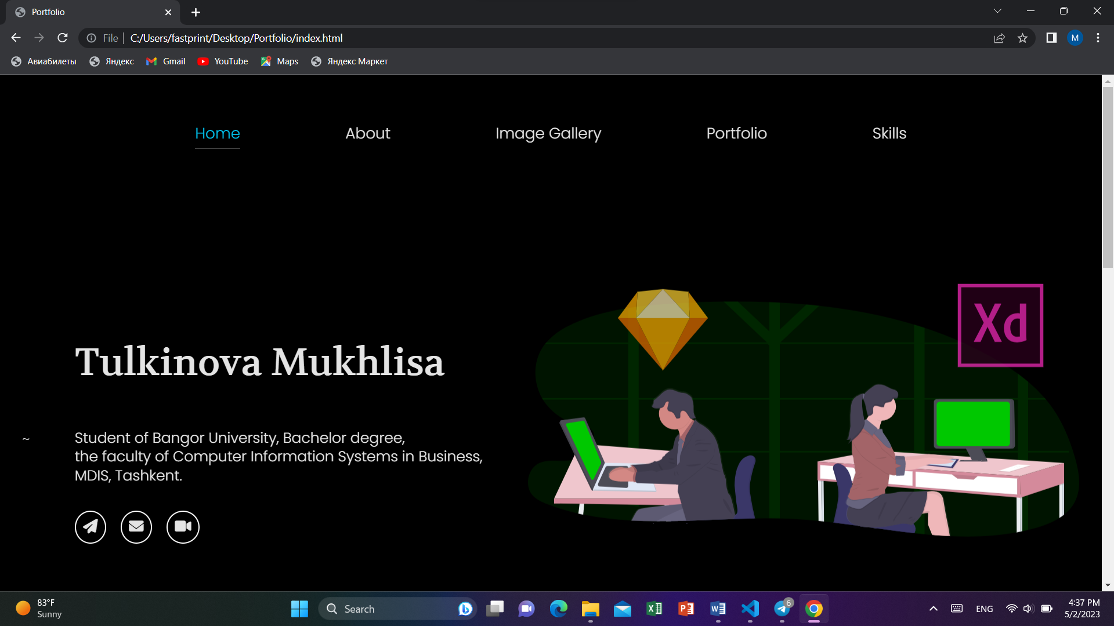

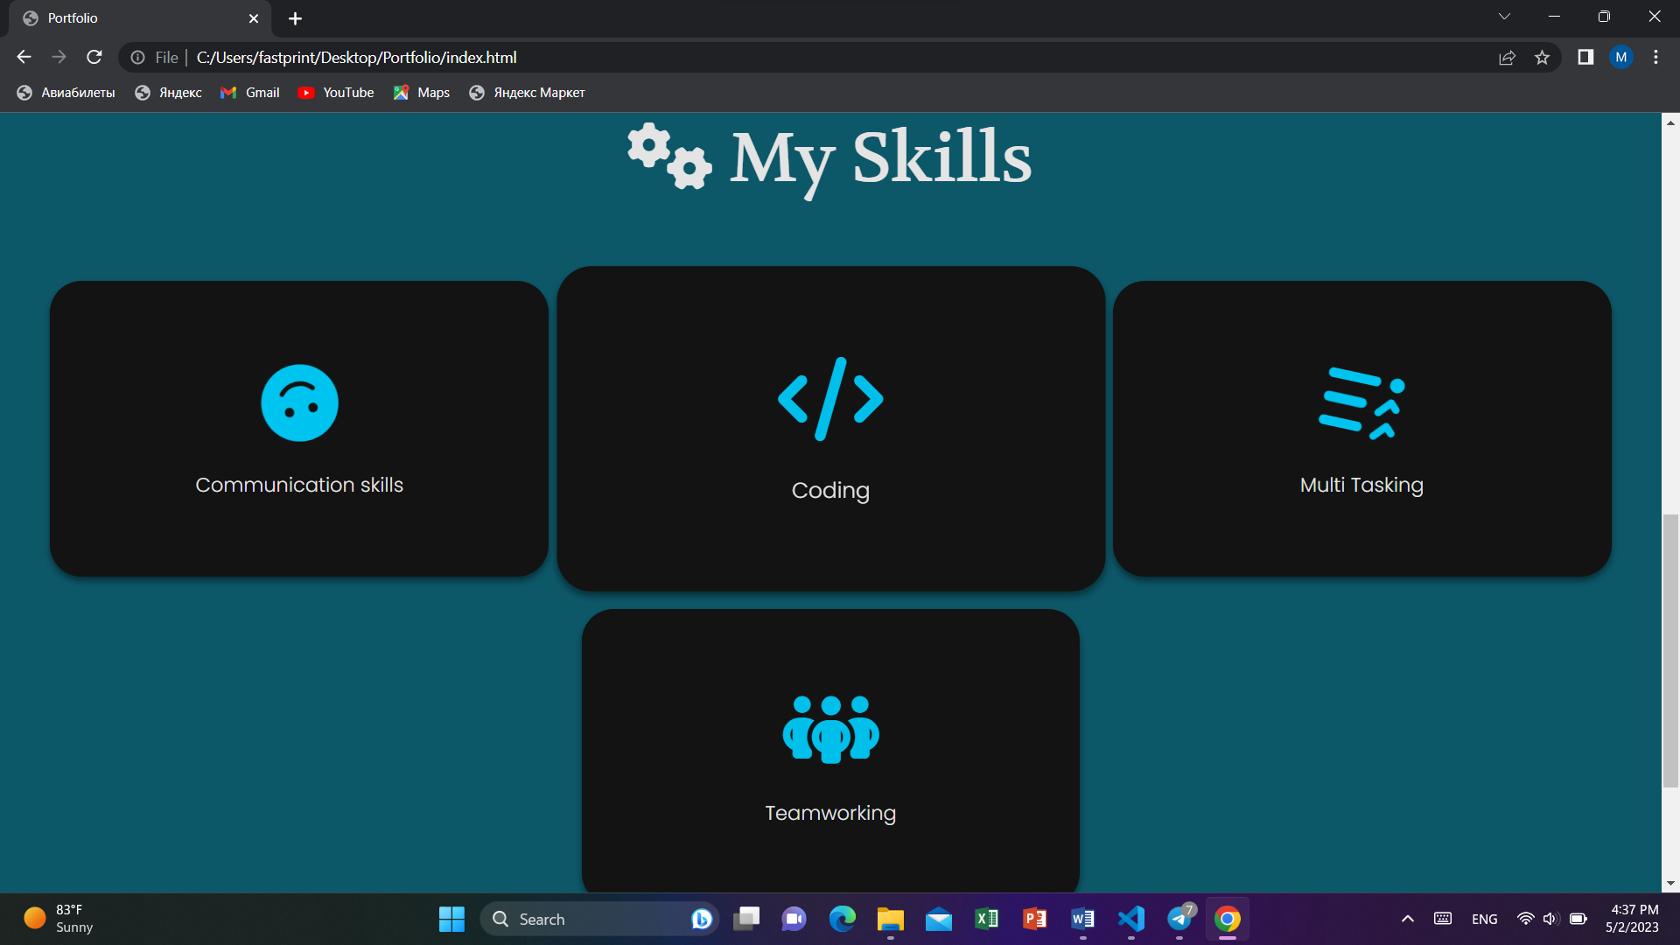



# Task 3 - Building an 3x3 image gallery from a JSON object

## Image Gallery



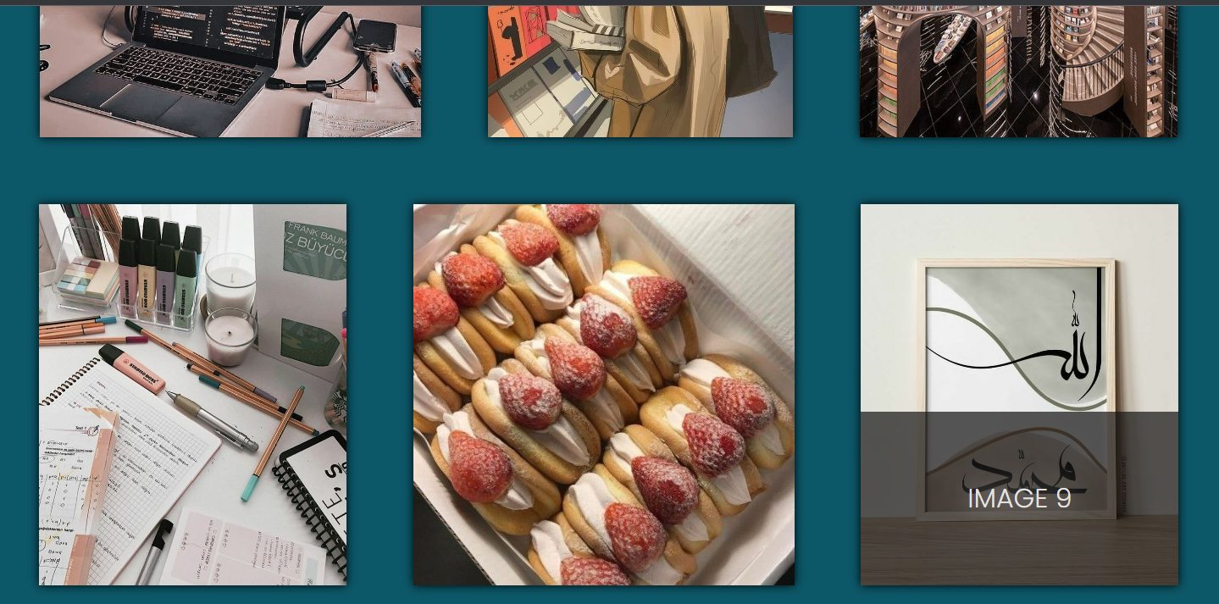

## JSON File

 <script src="https://unpkg.com/aos@2.3.1/dist/aos.js"></script>

    <script>

        var data = [{

                "img": "img/image_gallery_1.jpg",

                "id": "balloon"

            },

            {

                "img": "img/image_gallery_2.jpg",

                "id": "cate"

            },

            {

                "img": "img/image_gallery_3.jfif",

                "id": "dragon"

            },

            {

                "img": "img/image_gallery_4.jpg",

                "id": "groot"

            },

            {

                "img": "img/image_gallery_5.jpg",

                "id": "flareon"

            },

            {

                "img": "img/image_gallery_6.jpg",

                "id": "forest"

            },

            {

                "img": "img/image_gallery_7.jpg",

                "id": "fox"

            },

            {

                "img": "img/image_gallery_8.jpg",

                "id": "glaceon"

            },

            {

                "img": "img/image_gallery_9.jpg",

                "id": "majora"

            },

        ];

        //looping through each

        var _gallery = document.getElementsByClassName("gallery__content")[0],

            _html = '',

            i = 1;

        data.forEach(function(item) {

            _html += '<div class="gallery__content-item">'

                            + '<img src="' + item.img + '" alt="Image 1"> <br>'

                            + '<span class="gallery__content-text">Image ' + i + '</span>'

                        + '</div>';

            i++;

        });

        _gallery.innerHTML = _html

        AOS.init();

      </script>

# Task 4 - Create an interactive image carousel from a JSON object

## Framework Used for Carousel

<link rel="stylesheet" href="https://cdnjs.cloudflare.com/ajax/libs/slick-carousel/1.8.1/slick.min.css">

    <link rel="stylesheet" href="https://cdnjs.cloudflare.com/ajax/libs/slick-carousel/1.8.1/slick-theme.min.css">

## JS Code

<script src="https://unpkg.com/aos@2.3.1/dist/aos.js"></script>

    <script src="https://ajax.googleapis.com/ajax/libs/jquery/3.6.4/jquery.min.js"></script>

    <script src="https://cdnjs.cloudflare.com/ajax/libs/slick-carousel/1.8.1/slick.min.js"></script>

    <script src="https://cdnjs.cloudflare.com/ajax/libs/slick-carousel/1.8.1/slick.js"></script>

    <script>

        AOS.init();

        $('.slide').slick() ;

    </script>

# Task 5 - Website Testing and Validation

## Cross-browser compatibility:

Tested, no differences.

## HTML/CSS Validation

No Error occurred.

## Peer review (via screen share or remote control)

