December 30, 2025

AWS Tables n8n automation

1. Introduction 2
2. Objective 2
3. Architecture Overview 2
3.1 AWS Services Used 3
4. Data Generation Layer 3
4.1 Dataset Description 3
4.2 Data Generation Logic 3
5. Data Ingestion Pipeline 3
5.1 Upload to Amazon S3 3
5.2 Glue Database Creation 4
5.3 Data Transformation 4
5.3.1 Key Transformations 4
5.3.2 Benefits of Using CTAS 4
6. Integration with n8n 4
7. Conclusion 5

1. Introduction
In modern data-driven organizations, the ability to ingest, store, transform, and analyze large volumes of data in a scalable and automated manner is critical. This project demonstrates the design and implementation of a cloud-native data analytics pipeline using AWS services, enabling efficient data ingestion, transformation, storage, and querying.
The system processes transactional cooking oil sales data and transforms it into a structured, query-optimized analytical dataset using Amazon S3, AWS Glue, Athena, and S3 Tables, with integration into n8n for orchestration and automation.

2. Objective
The main objectives of this project are:
- Generate structured synthetic sales data programmatically.
- Store raw data securely in Amazon S3.
- Create a metadata-driven schema using AWS Glue.
- Convert raw CSV data into optimized analytical formats (Parquet).
- Leverage Amazon Athena for serverless querying.
- Enable scalable querying via S3 Tables (Iceberg-based architecture).
- Integrate the final analytical dataset with n8n workflows for automation and downstream use cases.

3. Architecture Overview
The data pipeline begins with a local CSV generator, which creates structured sales data that is uploaded to Amazon S3 as the raw data layer. This data is then cataloged using the AWS Glue Data Catalog, making it discoverable and queryable. Using Amazon Athena, the raw data is transformed through CTAS queries into optimized analytical formats. The processed data is stored in S3 Tables (Iceberg format), enabling efficient querying, schema evolution, and transaction support. Finally, the curated data is consumed by n8n and BI tools for automation, analytics, and reporting workflows.

3.1 AWS Services Used
- Amazon S3 – Raw and curated data storage
- AWS Glue – Metadata catalog and schema management
- Amazon Athena – Serverless SQL analytics
- S3 Tables (Apache Iceberg) – ACID-compliant analytical tables
- IAM – Secure access control
- n8n – Workflow automation and downstream data usage

4. Data Generation Layer

4.1 Dataset Description
The dataset represents retail cooking oil sales and captures detailed transactional information for analytical purposes. Each record includes the brand name of the cooking oil, the store where it was sold, and the seller or distributor responsible for the sale. It also records the quantity sold along with the package weight (such as 1L or 3L), allowing accurate calculation of volume-based sales. Pricing details are captured through the price per unit and the total sale value, enabling revenue analysis. Additionally, each transaction includes the city in which the sale occurred and a unique transaction ID to ensure traceability and data integrity across the dataset.

4.2 Data Generation Logic
- Randomized but realistic values
- Price calculated using brand base price × quantity × weight
- Controlled randomness for realistic variance
- Generated using Python (Pandas)
This approach ensures:
- Consistent schema
- Realistic analytics results
- Reproducible datasets

5. Data Ingestion Pipeline

5.1 Upload to Amazon S3
The generated CSV file is uploaded to Amazon S3 with:
- Server-side encryption enabled
- Versioning enabled
- Public access blocked
- Metadata tagging for traceability
This S3 bucket serves as the raw data landing zone.

5.2 Glue Database Creation
A Glue Database is created to logically organize tables and schemas.
A Glue table is created pointing to the raw CSV data in S3:
- Format: CSV
- SerDe: OpenCSVSerde
- Schema inferred explicitly

5.3 Data Transformation
The raw CSV data is transformed into a columnar Parquet format using Athena’s CREATE TABLE AS SELECT (CTAS) capability.

5.3.1 Key Transformations
- Type casting
- Cleaning and normalization
- Removal of invalid or null records

5.3.2 Benefits of Using CTAS
- High-performance querying
- Reduced storage footprint
- Column pruning & predicate pushdown
- Optimized for analytics workloads

6. Integration with n8n
- The workflow begins with a Chat Trigger node, which activates when a user sends a message or request.
- The request is passed to a Code node, where the input is parsed and analyzed to understand the user’s intent.
- The processed output is sent to a Switch node, which evaluates the request type and determines the appropriate execution path.
- Based on the identified action, the workflow branches into one of the following operations: Read, Create, Update, or Delete.
- Each branch is connected to its respective HTTP Request node, which communicates with backend services such as Athena or an API endpoint.
- After the request is executed, all branches converge into a Wait node to ensure the operation completes successfully.
- Once processing is complete, a Query Result Fetcher node retrieves the response or result set.
- Finally, the output is passed to a Code node, which formats and prepares the response before returning it to the user.
- This structured flow enables a fully automated, scalable, and dynamic interaction between users and the data layer through natural language commands.
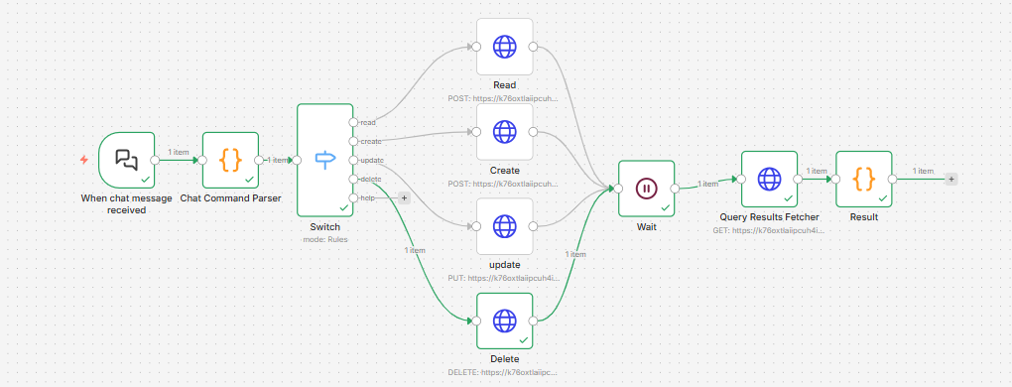

7. Conclusion
In conclusion, this project demonstrates a complete and scalable data engineering solution that seamlessly integrates data generation, storage, transformation, and analytics using modern cloud technologies. By combining Amazon S3, AWS Glue, Athena, and S3 Tables with an intelligent n8n workflow, the system enables efficient data processing, automated querying, and real-time analytics. The modular design ensures flexibility, scalability, and ease of maintenance, while the use of structured workflows and automation reduces manual effort and operational complexity. Overall, this solution provides a robust, enterprise-ready framework for managing and analyzing large-scale datasets, making it well-suited for real-world analytical and decision-making applications.

