

**DEFENCE FORCES TECHNICAL COLLEGE**

DIPLOMA IN ELECTRICAL AND ELECTRONICS ENGINEERING

(POWER OPTION)

**TRADE PROJECT**

**PROJECT TITLE:** DESIGN AND FABRICATION OF SECURITY DOOR USING FACE RECOGNITION

**PROJECT NUMBER:** 2601/306A

**PRESENTED BY :** ELIJAH STEPHEN NGUGI MUNGAI

**COLLEGE NO:**  408101

**INDEX NO:** 408101244

**PRESENTED TO:** THE KENYA NATIONAL EXAMINATION COUNCIL IN PARTIAL FULFILMENT FOR THE AWARD OF A

DIPLOMA IN ELECTRICAL AND ELECTRONICS

ENGINEERING **(POWER OPTION)**

**SUPERVISOR:** CAPT MATOLO

**SERIES:**  NOVEMBER 2023

# **DECLARATION**

I hereby declare that all the elements of this project are original.

No part of this has been stereotyped, photocopied or retrieved from any other.

**STUDENTS NAME:** ELIJAH STEPHEN NGUGI MUNGAI

SIGNATURE: …………………………. Date: ………………………………

This trade project has been submitted for examination with my approval as the supervisor.

**SUPERVISORS NAME:** CAPT MATOLO

SIGNATURE: …………………………. Date: ……………………………….

# **DEDICATION**

I would like to dedicate this project to my family my lecturers and my fellow students who supported and encouraged me throughout the period of my studies .Thanks to all teachers who have given me knowledge throughout my coarse,I am very greatful and may God bless them all.

# **ACKNOWLEDGEMENT**

This work would not have been possible without God’s grace, guidance and wisdom throughout my research period.

I sincerely appreciate everyone who contributed in one way or another to the development of this project. To my colleagues and instructors who help me refine this project from an idea to actualization; thank you.

I appreciate my family, my wife and children for giving me cordial time and moral support during my time working on this project.

I thank my project supervisor whose critic and guidance has been invaluable to my research work.

**TABLE OF CONTENTS**

[**DECLARATION** ii](#_Toc143428247)

[**DEDICATION** iii](#_Toc143428248)

[**ACKNOWLEDGEMENT** iv](#_Toc143428249)

[**ABSTRACT** ix](#_Toc143428250)

[**CHAPTER ONE** 1](#_Toc143428251)

[**1.0 INTRODUCTION** 1](#_Toc143428252)

[1.3 OBJECTIVE 2](#_Toc143428253)

[1.4 HYPOTHESIS 3](#_Toc143428254)

[1.5 JUSTIFICATION OF STUDY 3](#_Toc143428255)

[1.6 LIMITATIONS OF STUDY 3](#_Toc143428256)

[**1.7 CONCEPTUAL AND THEORETICAL FRAMEWORK** 4](#_Toc143428257)

[1.8 SPECIFICATIONS 5](#_Toc143428258)

[1.9 Scope of the project 5](#_Toc143428259)

[**CHAPTER TWO** 6](#_Toc143428260)

[2.0 LITERATURE REVIEW 6](#_Toc143428261)

[2.1 EXISTING SYSTEMS 6](#_Toc143428262)

[2.2 CRITIQUES OF EXISTING DESIGN. 9](#_Toc143428263)

[2.3 EVALUATION OF PROPOSED DESIGN 9](#_Toc143428264)

[2.4 SUMMARRY OF GAPS IDENTIFIED 21](#_Toc143428265)

[3.0 PROJECT DESIGN 22](#_Toc143428266)

[3.1 POWER SUPPLY 22](#_Toc143428267)

[3.2 CAMERA 26](#_Toc143428268)

[3.3 CONTROL CIRCUIT 26](#_Toc143428269)

[3.5 SERVO MOTOR 27](#_Toc143428270)

[3.6 AUDIO ALARM 27](#_Toc143428271)

[3.7 CIRCUIT DIAGRAM 29](#_Toc143428272)

[3.8 CIRCUIT OPERATION 30](#_Toc143428273)

[**CHAPTER FOUR** 31](#_Toc143428274)

[4.1 CONSTRUCTION 31](#_Toc143428275)

[4.2 TEST RESULTS 31](#_Toc143428276)

[4.3 CONCLUSION 32](#_Toc143428277)

[4.4 COSTING 33](#_Toc143428278)

[4.5 RECOMMENDATION 34](#_Toc143428279)

[**REFERENCES** 35](#_Toc143428280)

**LIST OF FIGURES**

[Figure 1: Block diagram 4](#_Toc142941756)

[Figure 2: Transformer 10](#_Toc142941757)

[Figure 3: Voltage regulator 11](#_Toc142941758)

[Figure 4: Bridge Rectifier 12](#_Toc142941759)

[Figure 5: Positive half cycle 12](#_Toc142941760)

[Figure 6: Negative Half cycle 13](#_Toc142941761)

[Figure 7: Camera 15](#_Toc142941762)

[Figure 8: Rasp Berry PI 16](#_Toc142941763)

[Figure 9: LCD 18](#_Toc142941764)

[Figure 10: LCD 18](#_Toc142941765)

[Figure 11: Buzzer 21](#_Toc142941766)

[Figure 12:Transformer 22](#_Toc142941767)

[Figure 13:Bridge Rectifier 24](#_Toc142941768)

[Figure 14:Capacitor 25](#_Toc142941769)

[Figure 15:Voltage Regulator 26](#_Toc142941770)

[Figure 16:Camera 26](#_Toc142941771)

[Figure 17:Raspberry Pi 27](#_Toc142941772)

[Figure 18:LCD 27](#_Toc142941773)

[Figure 19:Servo Motor 28](#_Toc142941774)

[Figure 20:Audio Alarm 28](#_Toc142941775)

[Figure 21:Circuit Diagram 30](#_Toc142941776)

**ABBREVIATION**

**DC-Direct current**

**MAG-Magnet**

**PIR-Passive infrared sensor**

**PID-Passive infrared detector**

**Vs-Voltage in secondary winding**

**VP-Voltage in primary winding**

**Ns-The number of turns in secondary**

**Np-The number of turns in primary windings**

**IC-Integrated circuit**

**VMS-Virtual machines**

**DVR-Digital video recorder**

**VCR-Videocassette recorder**

**LCD-Liquid crystal display**

**LED-Light emitting diode**

**AC-Alternating current**

**PMW-Pulse width modulation**

# **ABSTRACT**

Insecurity can encompass various forms, including social, economic, political, and personal safety concerns. Security is the degree of protection against danger, damage, loss, and criminal activity. Insecurity has been the order of the day. The most common source of insecurity is theft. This antisocial activity is more prevalent in the developing countries. Valuables need to be handled with care and securely. To restrict movement to the rooms where valuables are stored, use of the normal padlocks and door locks is normally employed. This is not efficient since it can be broken or the keys duplicated. This project is developed to ensure that the persons allowed to enter into the restricted area are the authorized only. This project scans the face of the person and checks in its data base and opens the door if the right person is identified. This ensures restricted access and help identify intruders.

# **CHAPTER ONE**

# **1.0 INTRODUCTION**

This chapter covers the background information, problem statement, objectives, justifications of the study, hypothesis and limitations. This provides the reason for developing the project and the general approach.

**1.1 BACKGROUND INFORMATION**

Security is defined as the degree of protection against danger, damage, loss, and criminal activity. Security as a form of protection are structures and processes that provide or improve security as a condition. Having a hundred percent secure environment is however not realistic. Insecurity is as old as mankind itself. Since the beginning of human live on earth, insecurity has been the order of the day. The main source of insecurity is theft. This antisocial activity is more prevalent in the third world countries, this crime is more prevalent. This is largely attributed to the poverty. Because of the low economic standard, people can hardly be able to meet their basic needs. This leads to stealing. In many homes, companies or institutions, there are valuables which could be physical goods or information that are important to the company and that need protection. The most common method used to keep these safe is restricting access to the room or house.

**1.2 PROBLEM STATEMENT**

Security is vital in any area of life. It helps people to live comfortably and peacefully, improves people’s health. Security also leads to a healthy economy. This is because businesses are run without fear. Theft usually takes where valuables are stored. One of the common forms of theft is employee theft. Employee theft in the workplace is a larger concern than many people realize, and it can affect any type of workspace. Billions of dollars are lost across the economy every year due to employee theft. There are various types of things stolen by employees. These includes money directly stolen. There is also employee theft of supplies range from small items like paper to larger items such as computers. Disgruntled employees also steal proprietary information and secrets that could harm a business or an institution. Employee theft costs businesses around $50 billion each year. 57% of these is committed by company insiders or a combination of insiders and outsiders. Working toward employee theft prevention should tackle all types of theft, including stealing from the company and between employees.

The valuables need to be handled with care and securely. To restrict movement to the rooms where valuables are stored, use of the normal padlocks and door locks is normally employed. This though common, is not efficient since it can be broken or the keys duplicated. Better method of restricting access to such places is important and therefore recommended. This project is developed to ensure that the persons allowed to enter into the restricted area are the authorized only. This is done using face recognition. The project scans the face of the person and checks in its data base and opens the door if the right person is identified. This will minimize unauthorized bypassing of the system.

## 1.3 OBJECTIVE

**1.3.1 Main Objective**

To design, construct and test security door using face recognition.

**1.3.2 SPECIFIC OBJECTIVES**

1. To create a database for facial records.
2. To incorporate raspberry pi for data processing and execution.
3. To incorporate servo motor for opening and closing of the door.
4. To incorporate an alarm system for alerting in case of intrusion.
5. To incorporate a display system to show the face of person entering.

## 1.4 HYPOTHESIS

1. Will there be creation of database for facial records?
2. Will servo motor open and close the door?
3. Will the alarm alert in case of intrusion?
4. Will the display show the identified person?
5. Will there be data processing and execution by the raspberry pi?

## 1.5 JUSTIFICATION OF STUDY

Having considered the challenges facing organizations in countering theft through restricting access, search for a local solution is carried out since the system are ineffective. This system will enable opening of the door once the facial recognition has been verified on contrary an alarm system will sound.

## 1.6 LIMITATIONS OF STUDY

1. The project can only use one face at time and not more than one face concurrently.
2. Unavailability of high quality components in the market.
3. Unavailability of some of the key components locally.

**1.7 CONCEPTUAL AND THEORETICAL FRAMEWORK**

POWER SUPPLY

CONTROL CIRCUIT

RASPBERRY PI

Motor Drive

Camera

Door mechanism

DISPLAY

Audio alarm

Servo motor

Figure 1: Block diagram

**POWER SUPPLY**

This converts voltage from 240v ac to stable 5V dc to power the electronic circuit. This ensures stable operation of the circuit.

**CAMERA**

This takes the picture of the face for identification.

**RASPBERRY PI**

This is the brain of the system. It interprets the details of the face captured and runs the servo motor to open or close the door.

**DISPLAY**

This displays the face of the person entering.

**SERVO MOTOR**

This when powered opens or closes the door.

**AUDIO ALARM**

Alerts in case of intrusion.

## 1.8 SPECIFICATIONS

Operating voltage 5 V dc

Operating current 500 mA

Door opening time 5 seconds

Distance of detection 1 meter

## 1.9 Scope of the project

This project is focused on developing a security system that detects motion and to respond speedily by capturing an image and relaying it to an administrator device through the internet platform. The system will require Raspberry Pi module, camera and internet connection. It will come up with an implementation of a surveillance system which presents the idea of monitoring a particular place in remote areas. The system can be monitored by the user form anywhere in the world.

However, this project will not attempt to design the motion detection device, camera or the Raspberry PI. It will therefore use these systems together with a suitable program script to accomplish a real time surveillance system as desired.

# **CHAPTER TWO**

## 2.0 LITERATURE REVIEW

## 2.1 EXISTING SYSTEMS

**2.1.1 Mechanical**

Drawing power from the mains to open a driveway door. Generally there are four types of electromechanical door operator: Worm driven (or screw type) swing gates, barrier arm operators and sliding operators Electric and automatic door openers are designed for both sliding and swinging door. They can be programmed to open with a manual device or a wireless transmitter. Automatic door operators can also be fitted with solar panels to operate without high voltage power. Many manufacturers offer battery backup either integrated or as an add on to systems that ensure function during loss of electricity.

**2.1.2 Hydraulic**

These are used to automatically open an electric driveway door. As the name implies they use hydraulic fluids to operate their motion. Typically hydraulic operators have less moving parts than mechanical operators. The hydraulic motors have a number of advantages when operating door; they are capable of producing more power than mechanical motors and do not have to work at full power when operating large gates, they can be made non locking to avoid damage when hit by vehicles relying on other forms of locking. Hydraulic operators are prone to damage to internal seals caused by high pressure from vehicular collision.

**2.1.3 Barrier**

An automatic door consisting of a breakaway gate arm, motor assembly and housing installed at the departure end of a toll island or a car park. A traffic barrier is used to reduce violations and speed through a toll lane. Barrier door installed in both attended and unattended lanes commonly includes a remote control capability to raise the gate for patrons with insufficient funds.

**2.1.4 Boon Edam Revolving Doors**

One of the primary reasons for considering a revolving door is that it virtually eliminates draughts and more importantly, prevents wild fluctuations in temperature. As well as delivering immediate savings on energy costs, this creates a much more pleasant and healthy environment for staff and visitors to the building.  
There’s also the strong aesthetic appeal of a revolving door - especially with the extensive use of glass - to provide an entrance which is, in effect, always open and always closed.  
As well as saving energy, a revolving door will exclude pollution from dirt and noise, and if you’re looking for security, you’ll find that even a non-security revolving door will help to deter un authorized or undesired access.

**2.1.4 WIRELESS SWITCH**

A wireless switch is a switch that commands a home appliance to turn itself off or on, instead of interrupting the power line going to the fixture. There are different ways to communicate between the switch and the fixture:

1. Using radio transmission: A radio receiver is typically wired or screwed into a fixture or device, wired or otherwise connected to the electrical system of the building or plugged into an outlet. The radio receiver's memory is programmed by any number of means to respond to certain selected "switches" or remote control transmitters.
2. Using the existing power lines: A receiver is plugged into an outlet and a device is then plugged into the receiver. The plug-in receiver is then programmed to the switches.

**2.1.5 MAG LOCK**

The most basic type of electronic lock is a magnetic lock (commonly called a mag lock). A large electro-magnet is mounted on the door frame and a corresponding armature is mounted on the door. When the magnet is powered and the door is closed, the armature is held fast to the magnet. Mag locks are simple to install and are very attack resistant. One drawback is that improperly installed or maintained mag locks can fall on people and also that one must unlock the mag lock to both enter and leave.

**2.1.6 Numerical codes, passwords and passphrases**

The most prevalent form of electronic lock is that using a numerical code for authentication; the correct code must be entered in order for the lock to deactivate. Such locks typically provide a keypad, and some feature an audible response to each press. Combination lengths are usually between 4 and 6 digits long.

A variation on this design involves the user entering the correct password or passphrase.

**2.1.7 Card Readers**

Card readers are normally seen in hotel rooms, and utilize a small credit card shaped key used to unlock the door. This type of electronic digital door lock allows you to refrain from using a traditional key, but also have the benefit of not having to remember a pin number. They are also convenient because they can easily be carried around in a purse or wallet. These locks make for an impenetrable barrier that automatically locks itself upon entry or exit.

**2.1.8 Biometrics**

As biometrics become more and more prominent as a recognized means of positive identification, their use in security systems increases. Some new electronic locks take advantage of technologies such as fingerprint scanning, retinal scanning and iris scanning, and voiceprint identification to authenticate users.

**2.1.9 Use of Passive Infrared Sensor**

A passive infrared sensor (PIR sensor) is an electronic sensor that measures infrared light radiating from objects in its field of view. They are most often used in PIR-based motion detectors. PIR sensors are commonly used in security alarms and automatic lighting applications. PIR sensors detect general movement, but do not give information on who or what moved. For that purpose, an imaging IR sensor is required. PIR sensors are commonly called simply "PIR", or sometimes "PID", for "passive infrared detector". The term passive refers to the fact that PIR devices do not radiate energy for detection purposes. They work entirely by detecting infrared radiation emitted by or reflected from objects.

## **2.2 CRITIQUES OF EXISTING DESIGN**.

The existing systems use as identified are manually operated. Most cannot identify the person so as to restrict access. The password systems used can be outdone by leaking the password to unauthorized personals. This project therefore is important since it avails means automatic identifying the face of a person which cannot be bypassed.

## 2.3 EVALUATION OF PROPOSED DESIGN

**2.3.1 POWER SUPPLY**

**TRANSFORMER**

A transformer is an electrical device that takes electricity of one voltage and changes it into another voltage. Basically, a transformer changes electricity from high to low voltage using two properties of electricity. In an electric circuit, there is magnetism around it. Second, whenever a magnetic field changes (by moving or by changing strength) a voltage is made. Voltage is the measure of the strength or amount of electrons flowing through a wire.

If a load is connected to the secondary, an electric current will flow in the secondary winding and electrical energy will be transferred from the primary circuit through the transformer to the load. In an ideal transformer, the induced voltage in the secondary winding (Vs) is in proportion to the primary voltage (Vp), and is given by the ratio of the number of turns in the secondary (Ns) to the number of turns in the primary (Np) as follows:

\frac{V_\text{s}}{V_{\text{p}}} = \frac{N_\text{s}}{N_\text{p}}

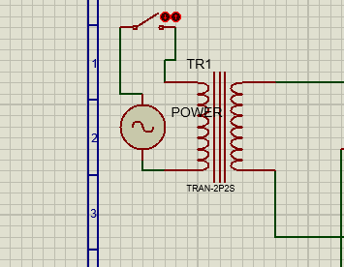

Figure 2: Transformer

**VOLTAGE REGULATOR IC**

|  |  |
| --- | --- |
|  |  |
|  |  |

Voltage regulator ICs are available with fixed (typically 5, 12 and 15V) or variable output voltages. They are also rated by the maximum current they can pass. Negative voltage regulators are available, mainly for use in dual supplies. Most regulators include some automatic protection from excessive current ('overload protection') and overheating ('thermal protection')

. 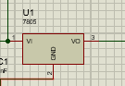

Figure 3: Voltage regulator

**THE STANDARD 7800 SERIES REGULATORS**

|  |  |
| --- | --- |
| Type number | output |
| 7805 | +5v |
| 7806 | +6v |
| 7808 | +8v |
| 7809 | +9v |
| 7812 | +12v |
| 7815 | +15v |
| 7818 | +18v |
| 7824 | +24v |

**RECTIFICATION**

**The Bridge Rectifier**

This type of single phase rectifier uses 4 individual rectifying diodes connected in a "bridged" configuration to produce the desired output but does not require a special centre tapped transformer, thereby reducing its size and cost. The single secondary winding is connected to one side of the diode bridge network and the load to the other side as shown below.

**The Diode Bridge Rectifier**

|  |
| --- |
|  |

Figure 4: Bridge Rectifier

The 4 diodes labelled D1 to D4 are arranged in "series pairs" with only two diodes conducting current during each half cycle. During the positive half cycle of the supply, diodes D1 and D2 conduct in series while diodes D3 and D4 are reverse biased and the current flows through the load as shown below.

**The Positive Half-cycle**

|  |
| --- |
| Positive Half-cycle Bridge |

Figure 5: Positive half cycle

During the negative half cycle of the supply, diodes D3 and D4 conduct in series, but diodes D1 and D2 switch of as they are now reverse biased. The current flowing through the load is the same direction as before.

**The Negative Half-cycle**

|  |
| --- |
| Negative Half-cycle Bridge |

Figure 6: Negative Half cycle

As the current flowing through the load is unidirectional, so the voltage developed across the load is also unidirectional the same as for the previous two diode full-wave rectifier, therefore the average DC voltage across the load is 0.637Vmax and the ripple frequency is now twice the supply frequency (e.g. 100Hz for a 50Hz supply).

**2.3.2 CAMERA**

**digital video recorder**

The digital video recorder includes a host application, video conversion software, storage and disc management application, and a VMS interface to manage the integrated video. The embedded video surveillance application and OS provide an appliance rather than a computer, streamlining the process of integration, maintenance, and support. The DVR was the digital appliance that replaced the analog videocassette recorder (VCR).

**VIDEO CAMERA**

A video camera is a camera used for electronic motion picture acquisition, initially developed for the television industry but now common in other applications as well.

Video cameras are used in two modes. The first, characteristic of much early broadcasting, is live television, where the camera feeds real time images directly to a screen for immediate observation. A few cameras still serve live television production, but most live connections are for security, military, and industrial operations where surreptitious or remote viewing is required. In the second mode the images are recorded to a storage device for archiving; for many years, videotape was the primary format used for this purpose, but was gradually supplanted by optical disc, hard disk, and then flash memory. Recorded video is used in television production, and more often surveillance and monitoring tasks in which unattended recording of a situation is required for later analysis.

**AMG8833 IR THERMAL CAMERA**

AMG8833 is Panasonic’s 8×8 IR Grid-Eye detector that contains eight rows of eight pixels each housing infrared thermopiles, capable of measuring blackbody radiation, around the thermal range of 8-15 microns.

Commonly used in the infrared thermal temperature sensor array, in which the AMG8833 would provide high precision for temperature detection.

**Features of AMG8833**

1. Temperature detection of the two-dimensional area: 8 × 8 (64 pixels)
2. I2C output (capability of temperature value output)
3. Temperature range of measuring object: 0 °C to 80 °C +32 °F to +176 °F
4. Long detection distance
5. Compact SMD package (adaptively to reflow mounting)
6. RoHS compliant
7. Supports both Arduino and Raspberry Pi

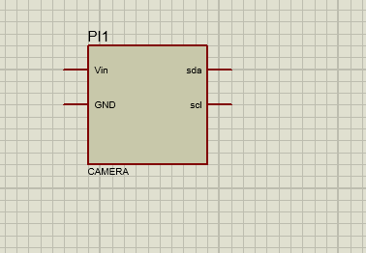

Figure 7: Camera

**2.3.3 CONTROL CIRCUIT**

**RASPBERRY PI**

Raspberry Pi is the name of a series of single-board computers made by the Raspberry Pi Foundation, a UK charity that aims to educate people in computing and create easier access to computing education. The original Pi had a single-core 700MHz CPU and just 256MB RAM, km,kmmmmand the latest model has a quad-core CPU clocking in at over 1.5GHz, and 4GB RAM. The Raspberry Pi runs Linux, but it also provides a set of GPIO (general purpose input/output) pins, allowing you to control electronic components for physical computing and explore the Internet of Things (IoT).

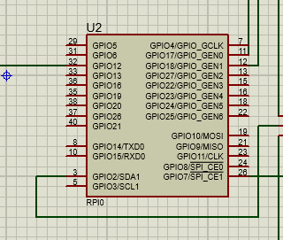

Figure 8: Rasp Berry PI

**RASPBERRY PI**

The Raspberry Pi 4 offers ground-breaking increases in processor speed, multimedia performance, memory, and connectivity compared to the prior-generation boards, while retaining backwards compatibility and similar power consumption. The Raspberry Pi 4 provides desktop performance comparable to entry-level x86 PC systems. The Raspberry Pi 4 comes in three on-board RAM options for even further performance benefits: 2GB, 4GB and 8GB.   
This product's key features include a high-performance 64-bit quad-core processor, dual-display output via two Micro HDMI ports, up to 4K resolution, hardware video decoding at up to 4Kp60, up to 4GB of RAM, dual-band 2.4/5.0 GHz wireless LAN, Bluetooth 5.0, Gigabit Ethernet, USB 3.0, and PoE capability.   
Due to the higher power requirements, the Raspberry Pi 4 requires a 3.0A USB-C power supply (sold separately). If you have an existing power supply that is rated at 3.0A, you may utilize a microUSB to USB-C adapter to utilize your existing MicroUSB power supply to power the Raspberry Pi 4.

**2.3.4 Display**

A liquid-crystal display (LCD) is a flat panel display, electronic visual display, or video display that uses the light modulating properties of liquid crystals. Liquid crystals do not emit light directly.

**16 X 2 LCD**

LCD (Liquid Crystal Display) screen is an electronic display module and find a wide range of applications. A 16x2 LCD display is very basic module and is very commonly used in various devices and circuits. These modules are preferred over seven segments and other multi segment LEDs. The reasons being: LCDs are economical; easily programmable; have no limitation of displaying special & even custom characters (unlike in seven segments), animations and so on.

Standard HD44780 LCDs are useful for creating standalone projects.

1. 16 characters wide, 2 rows
2. White text on blue background
3. Connection port is 0.1" pitch, single row for easy breadboarding and wiring
4. Pins are documented on the back of the LCD to assist in wiring it up
5. Single LED backlight included can be dimmed easily with a resistor or PWM and uses much less power than LCD with EL (electroluminescent) backlights
6. Can be fully controlled with only 6 digital lines! (Any analog/digital pins can be used)
7. Built in character set supports English/Japanese text, see the HD44780 datasheet for the full character set
8. Up to 8 extra characters can be created for custom glyphs or 'foreign' language support
9. Comes with necessary contrast potentiometer and strip of header

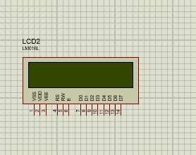

Figure 9: LCD

**20 X 4 LCD**

20x4 alphanumeric LCD. 20x4 means that 20 characters can be displayed in each of the 4 rows of the 20x4 LCD, thus a total of 80 characters can be displayed at any instance of time.

**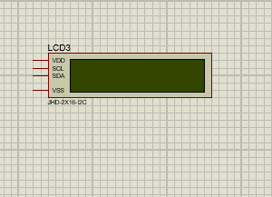**

Figure 10: LCD

A 16 X 2 character LCD is used here due to its reliability and availability. The pin out is illustrated below. A 16x2 LCD means it can display 16 characters per line and there are 2 such lines. In this LCD each character is displayed in 5x7 pixel matrix. This LCD has two registers, namely, Command and Data.

**2.3.5 Servo Motor**

**Servo Motor**

A **servo motor** is an electrical device which can push or rotate an object with great precision. It is just made up of simple motor which run through **servo mechanism**. If motor is used is DC powered then it is called DC servo motor, and if it is AC powered motor then it is called AC servo motor. There is a very high torque servo motor in a small and light weight packages.

A servo consists of a Motor (DC or AC), a potentiometer, gear assembly and a controlling circuit. First of all we use gear assembly to reduce RPM and to increase torque of motor.

All motors have three wires coming out of them. Out of which two will be used for Supply (positive and negative) and one will be used for the signal that is to be sent from the MCU.

Servo motor is controlled by PWM (Pulse with Modulation) which is provided by the control wires. There is a minimum pulse, a maximum pulse and a repetition rate. Servo motor can turn 90 degree from either direction form its neutral position. The servo motor expects to see a pulse every 20 milliseconds (ms) and the length of the pulse will determine how far the motor turns. For example, a 1.5ms pulse will make the motor turn to the 90° position, such as if pulse is shorter than 1.5ms shaft moves to 0° and if it is longer than 1.5ms than it will turn the servo to 180°.

 Servo motor works on PWM (Pulse width modulation) principle, means its angle of rotation is controlled by the duration of applied pulse to its Control PIN. Basically servo motor is made up of DC motor which is controlled by a variable resistor (potentiometer) and some gears. High speed force of DC motor is converted into torque by Gears.

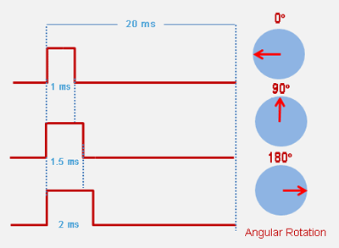

Servo motor can be rotated from 0 to 180 degree, but it can go up to 210 degree, depending on the manufacturing. This degree of rotation can be controlled by applying the Electrical Pulse of proper width, to its Control pin. Servo checks the pulse in every 20 milliseconds. Pulse of 1 ms (1 millisecond) width can rotate servo to 0 degree, 1.5ms can rotate to 90 degree (neutral position) and 2 ms pulse can rotate it to 180 degree.

All servo motors work directly with your +5V supply rails but we have to be careful on the amount of current the motor would consume, if you are planning to use more than two servo motors a proper servo shield should be designed.

**2.3.6 AUDIO ALARM**

**BUZZER**

A buzzer or beeper is an audio signaling device, which may be mechanical, electromechanical, or Piezoelectric. A piezoelectric element may be driven by an oscillating electronic circuit or other audio signal source, driven with a piezoelectric audio amplifier. Sounds commonly used to indicate that a button has been pressed are a click, a ring or a beep. Below is the piezzo buzzer internal structure.

|  |
| --- |
| C:\Users\hp\OneDrive\Desktop\Capture 10.PNG |

Figure 11: Buzzer

## 2.4 SUMMARRY OF GAPS IDENTIFIED

The design and fabrication of a security door utilizing face recognition technology represents a significant advancement in access control systems. By integrating face recognition, this system offers a streamlined and efficient means of allowing authorized personnel access while preventing unauthorized entry. However, a notable gap compared to existing systems lies in the robustness and adaptability of the face recognition algorithm. Current systems often struggle with accuracy in varying lighting conditions, pose changes, and with individuals wearing accessories such as glasses or hats. This gap underscores the need for a more sophisticated and adaptable face recognition algorithm that can handle diverse scenarios and provide reliable identification. Additionally, user privacy concerns are another aspect that requires attention. Striking the right balance between security and individual privacy is crucial to ensure the wider acceptance and ethical implementation of such technology. In summary, while the integration of face recognition in security doors represents a promising advancement, addressing the challenges of algorithm robustness and privacy concerns is vital for achieving a more effective and widely accepted solution compared to existing systems.

**CHAPTER THREE**

## 3.0 PROJECT DESIGN

## 3.1 POWER SUPPLY

A power supply can by broken down into a series of blocks, each of which performs a particular function.

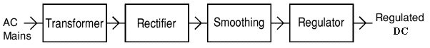

**TRANSFORMER**

The aim of the transformer in this project is to step down voltage from 240 volts ac to 12 volts ac. Therefore, step down laminated core transformer is the one used because it is designed to work at a low frequency. The laminated core transformer is the one used here. This is because of the low frequency operation.

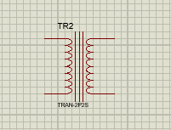

Figure 12:Transformer

Since the circuit is rated a current of about 300mA, the transformer should handle slightly more than this. Therefore the transformer rating is 12 volts, 500mA.

To bet the input current, the transformer equation can be used.

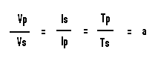

From here we can get

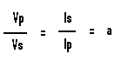

Vp=240V

Vs= 12V

Is= 0.5A

Therefore,

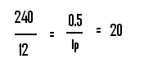

Ip which is the input current to the transformer can be calculated as follows



The power rating of the transformer can be calculated as follow.

**P= VOLTAGE X CURRENT**

**P= 240 X 0.025**

**P= 6 VA**

RECTIFICATION

Bridge rectification is the one selected because it is economical and more effective than the other methods. The circuit is described below.

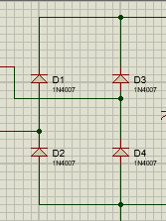

Figure 13:Bridge Rectifier

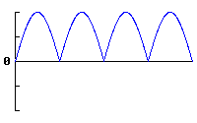

The choice of the diode depends on the intended application. In our case, the diodes are required to convert ac to dc. Therefore, rectifier diodes are the ones ideal for this work. Each of the four diodes is required to carry the required current of 300mA and withstand a voltage of at least 12 volts. Therefore, the best diode for this is the one rated just above 300mA and above 12 volts. Therefore, the ideal diode for this is IN4007. It has a current capacity of 1 ampere and peak inverse voltage capacity of 1000 volts. Four of them will be used to form a four-diode bridge rectifier.

**Smoothing Circuit**

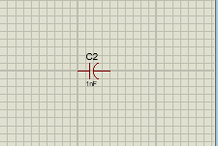

Figure 14:Capacitor

**C = ( 5 \* Io) / (Vs \* F)**

C = smoothing capacitance in farads (F)  
Io  = output current from the supply in amps (A)  
Vs = supply voltage in volts (V), this is the peak value of the unsmoothed DC  
f    = frequency of the AC supply in hertz (Hz), 50Hz in our case   
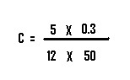

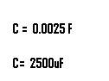

VOLTAGE REGULATOR

Since our required output is 5 volts to power the microcontroller, we use 7805 voltage regulator IC.

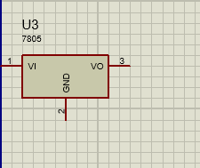

Figure 15:Voltage Regulator

## 3.2 CAMERA

AMG8833 camera is used due to its compatibility with external controllers.



Figure 16:Camera

## 3.3 CONTROL CIRCUIT

Raspberry Pi4 is used here due to high memory and compatibility with external modules.

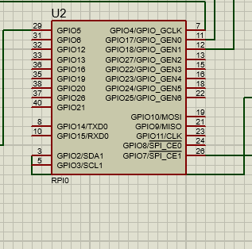

Figure 17:Raspberry Pi

1602 LCD is used here due to its availability and affordability. It can display up to 32 characters.

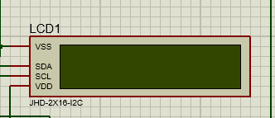

Figure 18:LCD

## 3.5 SERVO MOTOR

Servo motor MG90S was used due to its ease of operation and minimal power consumption.

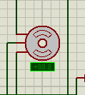

Figure 19:Servo Motor

## 3.6 AUDIO ALARM

Since the buzzer is rated 12 volts, and a current of 10mA, the switching transistor should be rated at least higher than 12 volts and 10mA. Therefore, BC337 n-p-n transistor is used here because it is rated 40 volts Vceo and a collector current of 500mA. It is described below.

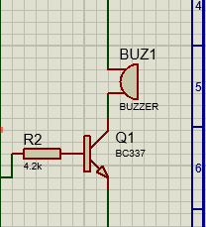

Figure 20:Audio Alarm

The base current of BC337 should not exceed 0.5 mA. The output of the microcontroller is a maximum of 5 volts. To offer this protection, Rb is used. Therefore,

**Rb= 5V / 0.005A**

**Rb= 10 KΩ**

A piezzo buzzer is selected since it small in size and therefore minimizes space therefore reduce bulkiness.

## 3.7 CIRCUIT DIAGRAM

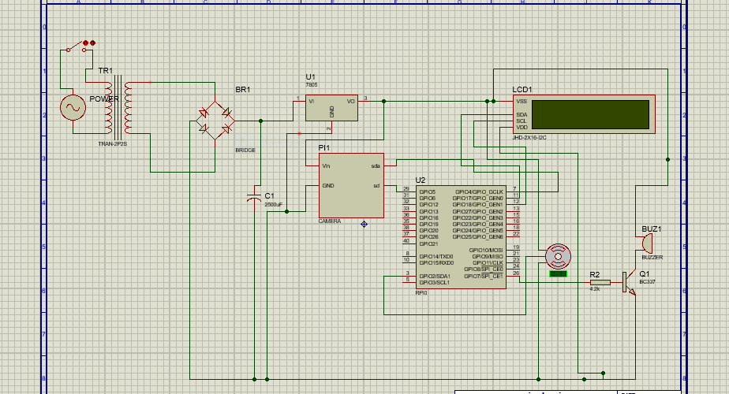

Figure 21:Circuit Diagram

## 3.8 CIRCUIT OPERATION

When the switch is closed, the transformer steps down 240V ac to 12 V ac. This is then rectified by the four diode bridge rectifier after which it is smoothened by the 2500uF capacitor. The 7805 IC is a voltage stabilizer IC. This is meant to ensure that the circuit is constantly supplied with 5 volts regardless of variation in the source voltage this ensures stable operation of the circuit.

When a visitor comes close to the camera, the raspberry controller prompts the camera to read the image of the visitor and compare it with its database. If the image is authorized to enter, the LCD displays the name of the person. The controller then outputs through output pin GPIO2 when sends PWM signals to the servo motor to open run it in one direction for some time and then stops. It then is run in the opposite direction for some time closing the door. When unauthorized person or card is detected, the controller’s GPIO7 goes high. This output through a transistor wired as a switch powers the buzzer that generates audible sound.

# **CHAPTER FOUR**

## 4.1 CONSTRUCTION

The appropriate components were purchased from the local electronic shops. The project was then constructed on a strip board by the use of a solder wire and soldering iron. The circuit designed in this document was used for this. The project was then tested for a long time for endurance before presentation. And problem seen was rectified early in advance.

## 4.2 TEST RESULTS

|  |  |  |
| --- | --- | --- |
| **TEST POINT** | **EXPECTED VALUE (VOLTS)** | **ACUAL VALUE (VOLTS)** |
| 1 (bridge output) | 13V DC | 14.4V DC |
| 2 (5V regulator) | 5V DC | 4.9 V DC |
| 3 (microcontroller output) | 5V DC | 4.8V DC |
| 4 (transistor collector) | 0V DC | 0.4V DC |

## 4.3 CONCLUSION

The one image was programmed to be monitored in the raspberry pi. When the face was scanned by the camera, the servo motor ran in one direction for some time and then went off than after some few seconds it ran on the opposite direction and went off. When other face was scanned, the motor did not open and the alarm went on for some time. This showed that the project was successful.

**4**

## 4.4 COSTING

|  |  |  |  |  |
| --- | --- | --- | --- | --- |
| **ITEM** | **DESCRIPTION** | **QUANTITY** | **PRICE PER UNIT** | **TOTAL PRICE** |
| Diodes | 1N5408 | 4 | 60 | 240 |
| Step-down transformer | 12V, 2A | 1 | 1100 | 1100 |
| Capacitors | 6600uF | 1 | 80 | 80 |
| Regulator | 7805 | 1 | 55 | 55 |
| Resistors | 1K  10K  330R | 2  2  1 | 20 | 100 |
| Strip board | 300 \* 140 MM | 1 | 200 | 200 |
| Buzzer | 5V Piezzo | 1 | 350 | 350 |
| Transistor | BC547 | 1 | 60 | 60 |
| Servo motor | MG90 | 1 | 450 | 450 |
| Solder wire |  | 3 METRES | 70 | 210 |
| Connector wires | 0.8 sq mm | 6 meters | 80 | 460 |
| Casing | 20 \* 10 \* 7 CM | 1 | 450 | 450 |
| Raspberry PI 4 |  | 1 | 6500 | 6500 |
| LCD | I2C | 1 | 1200 | 1200 |
| PI camera |  | 1 | 4500 | 4500 |
| **TOTAL** |  |  |  | 15955 |

## 4.5 RECOMMENDATION

The project can be improved by incorporating data storage for keeping records of all the people who have been scanned over a period of time.

# **REFERENCES**

1.Z. Sundas, “Motion Detecting Camera Security System with Email Notifications and Live StreamingUsing Raspberry Pi.” .

2.M. Peter and H. David, “Learn Raspberry Pi with Linux,” *Apress*, 2012

3.Jain & jain (2013): ABC of Electrical Engineering.

4.Dr. Miltiadis A. Boboulos (2000). Automation and Robotics