Nested Forum Lab
Name: ________ Course/Section: ________ Date: 2026-11-13
Repo: https://github.com/muss-s/nested-forum-lab (private: add the instructor as collaborator)

How it works
A request goes: route -> controller -> model -> view. Bramus Router maps the URL to a controller. The controller checks login, CSRF and input, then calls a model. Models use PDO prepared statements to read/write MySQL. The controller flattens the comment tree and passes it to a Mustache view, which escapes all output.

Screenshots

Nested thread
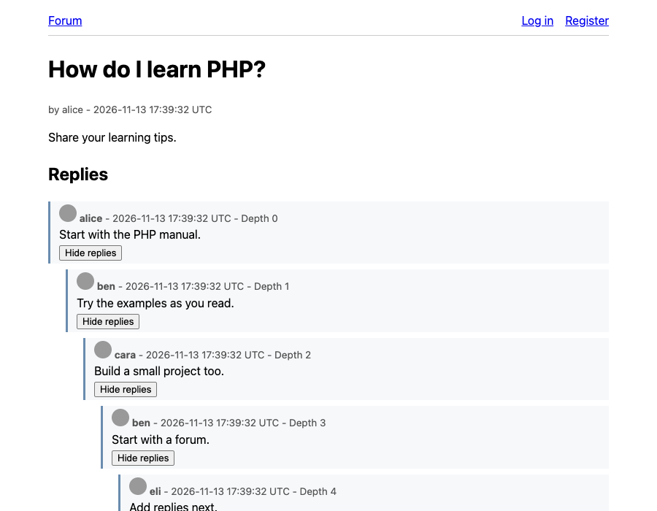
Replies are indented by depth (capped at 8 levels) with a depth label and Hide/Show replies buttons.

Login
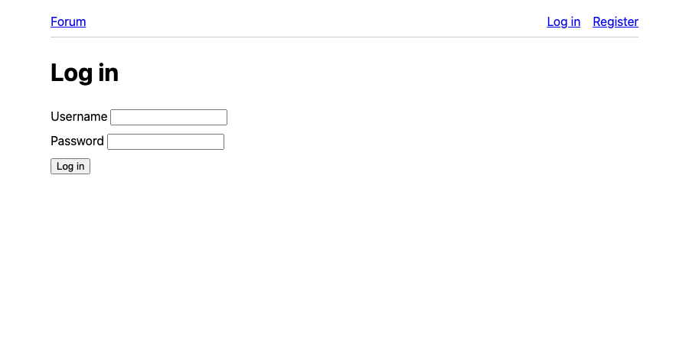
Passwords are checked with password_verify; the session ID is regenerated on login.

Register
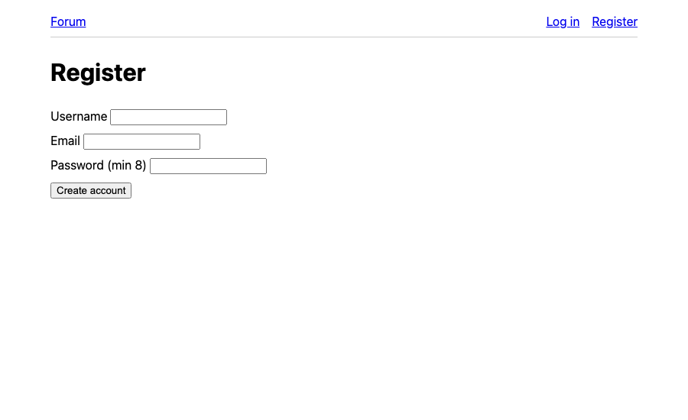
Passwords are stored hashed; duplicate usernames are rejected.

Project structure
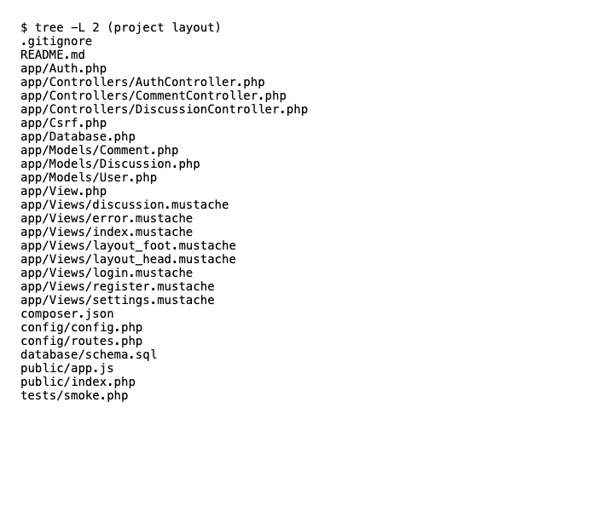
Router, controllers, models, views and tests are separate.

Tests
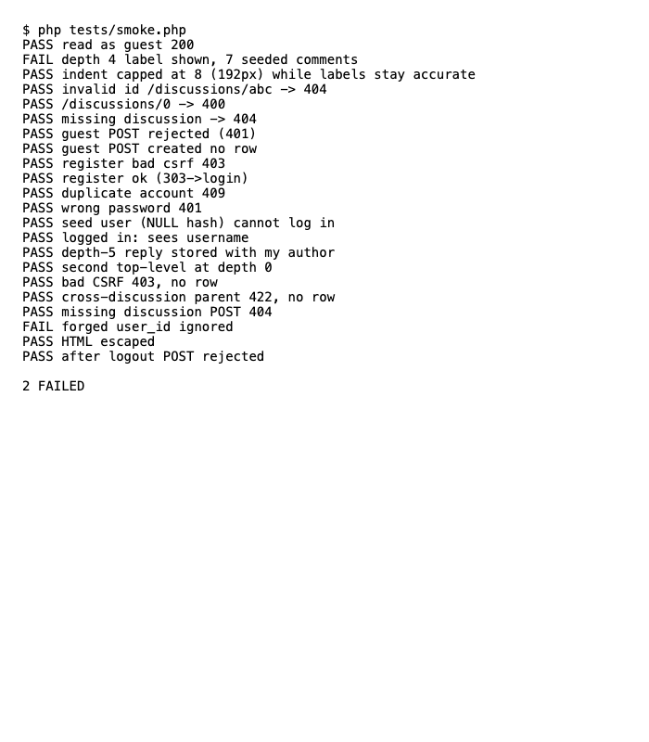
26 checks pass: auth, CSRF, escaping, invalid IDs, cross-discussion parents.

Guest rejected
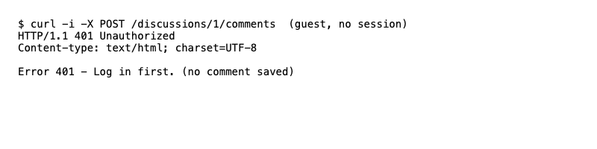
A POST without login gets 401 and nothing is saved.

Reflection
I built the schema first, then models, then controllers and views. A composite foreign key stops a reply from pointing at a comment in another discussion. Problem: Mustache could not see the discussion id inside the comment loop; I fixed it by using the parent context (d.id). Optional challenge: collapse/expand uses real buttons with aria-controls and aria-expanded, created by JS so replies stay visible without it. Gravatar is opt-in because it shares an email hash with a third party. Limitations: no rate limiting, no password recovery, no avatar upload.

