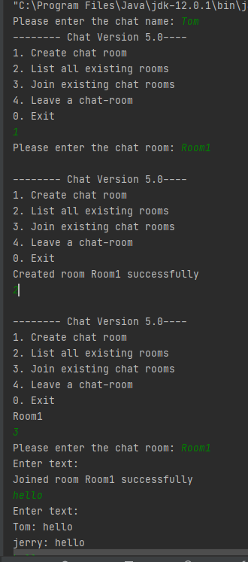

For the first client I created a room by entering number 1, and listed all the rooms created by entering two, and Room1 was displayed after the confirmation message. You can join the chat by entering number 3 and chatroom. You can see the chats between Tom and Jerry.

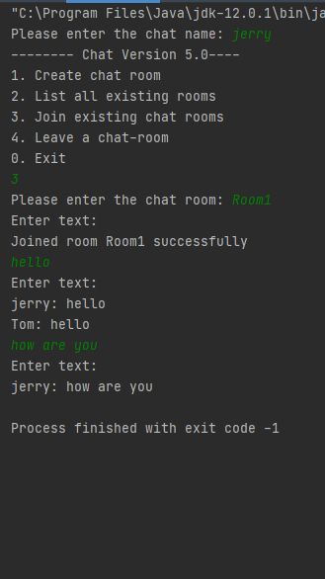

This is the second client, you can join the chatroom the other client created by entering number 3 and chatroom name, which you can see above. You can also see the chat between Tom and Jerry above.