Medical Consumables UAT

3rd Mar 2020

1. **Problem Statement**

The problem statement is that the inventory is not showing accurate information for the Consumables. For Drugs, the said issue is not existing.

1. **Reason for the problem.**

Once the non-drugs items are transferred from the Main Store to sub stores, it gets reduced in main store inventory, but does not reflect in the Sub store count, as the sub store is not usually receiving them in system and there is no In-transit Report to show that it is pending for receipt. Also, the consumption of consumables can’t be tracked as they are not appearing in HIS front end. Once again, none of these issues are existing in Drug as drug is maintained in the front end of HIS and Drug Sub stores are accepting the items in the system.

1. **Proposed Solution**

Consumables to be treated the same way (configuration) how drugs are treated. This can be done by a configuration change in DMS. All consumables to be mapped under **SU** category to bring them in front end.

1. **User roles**

|  |  |  |
| --- | --- | --- |
| **#** | **User** | **Role** |
| 4.1 | Main warehouse store Keeper | Receive the goods from the suppliers and issue to the sub store upon request |
| 4.2 | Sub store keeper | Request and Receive the good from the main store |
| 4.3 | Nurse | Responsible of charging consumables to the patient |
| 4.4 | Billing Officer | Check the consumable to be billed according to the protocol |
| 4.5 | Medical supply buyer | Create new codes, identify the supplier, |

1. **Assumption**
   1. Mode of charge happen by nursing. Hence software training is required.
2. **Pre-test** 
   1. System configuration
      1. creating a new charge item in HMIS
      2. creating a new item code under **SU**
      3. create a new supplier in HMIS in order
      4. link sub store with FMIS department
3. **Test scenario** 
   1. ICU sub store (ICU2) will request for item (10-125) from the main store using the HMIS-pharmacy management -department requisition function . main store will acknowledge the request in the store. Main warehouse will transfer the goods to (ICU2) using FMIS-inventory -inventory router- transfer to department after check on pharmacy checkbox. The ICU2 will receive the goods by using the HMIS-pharmacy- inventory management- addition . Nursing will charge the medical supplies to the patient by using HMIS-Pharmacy- inventory management-direct dispense. Sub store keeper check his inventory item to
   2. The billing team will check the bill after charging under package and outside package.
4. **Use case diagram.**

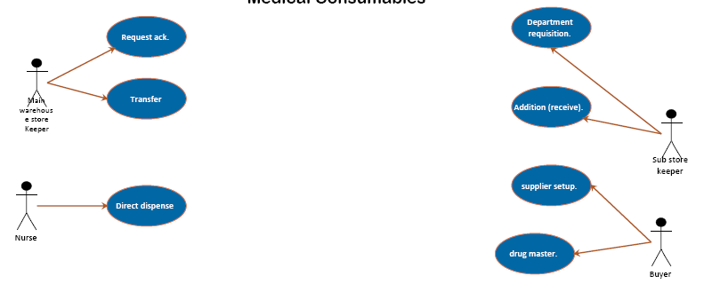

1. **functional**

|  |  |  |  |
| --- | --- | --- | --- |
| S/N | Module | Sub-Model | Sub-functional |
| 1 | FMIS – Inventory | Inventory router | 1-Request ack.  2- Transfer |
| 2 | HMIS – Pharmacy | Inventory management | 1-Addition (receive).  2-Department requisition.  3-Pharmacy setup  4-supplier setup.  4- drug master.  5-direct dispense |

1. **UAT table**

|  |  |  |  |  |  |  |
| --- | --- | --- | --- | --- | --- | --- |
| Step | Scenario | User role | Expected result | Actual result | Pass/fail | comment |
| 1 | CU sub store (ICU2) will request for item (10-125) from the main store using the HMIS-pharmacy management -department requisition function | Sub store keeper | Raise a request with a unique number linked with sub store department | Request has been raised and link to a unique number |  |  |
| 2 | main store will acknowledge the request in the store | Main warehouse store Keeper | Acknowledge the request and the requester department | Request has been acknowledge with the department and request number. |  |  |
| 3 | Main warehouse will transfer the goods to (ICU2) using FMIS-inventory -inventory router- transfer to department after check on pharmacy checkbox | Main warehouse store Keeper | Transaction to be completed in the main store by reducing the item quantity and generating a transfer document with a serial number | System has generated a unique document number showing the item and the quantity has been transfer to the ICU department as per the request |  |  |
| 4 | The ICU2 will receive the goods by using the HMIS-pharmacy- inventory management- addition | Sub store keeper | ICU to be able to receive the quantity has been transferred from the main warehouse | ICU successfully receive the goods in the store with a batch number |  |  |
| 5 | Nursing will charge the medical supplies to the patient by using HMIS-Pharmacy- inventory management-direct dispense. | Nurse | Nursing will be able to charge the goods to specific patient and deduct the quantity from the sub store | Nurse are able to dispense the goods to a patient |  |  |
| 6 | The billing team will check the bill after charging under package and outside package | Billing Officer | System to bill the item with selling price and concede the item with zero if its under a package | System has applied the approach and affect the packages . |  |  |

|  |  |  |  |
| --- | --- | --- | --- |
| Stakeholder | Designation | Date | Signature |
| Vishnu Raj |  |  |  |
| Shyeeb Khazi |  |  |  |
| Ahmed Safi |  |  |  |

Project Manager: Bilal Al Soweissi