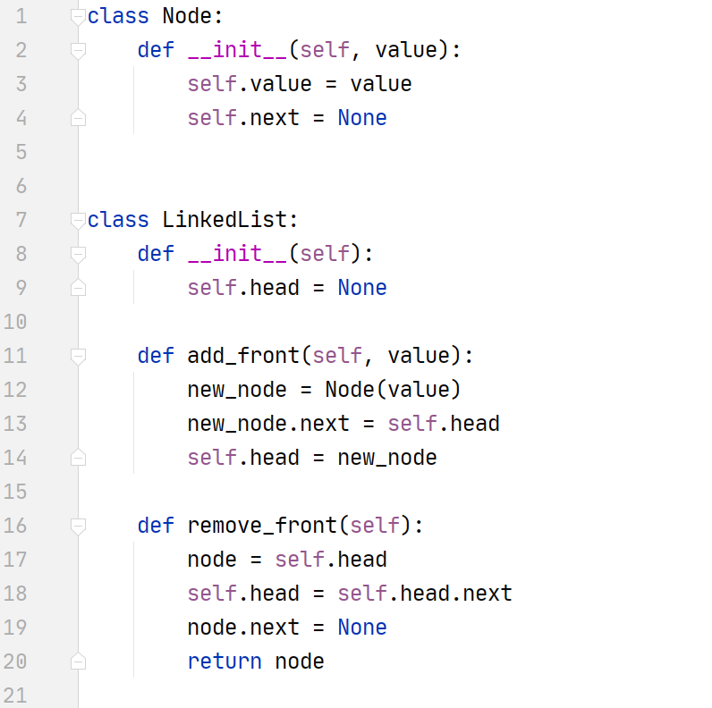

**Traverse A LL:**

current = self.head

while current is not None:

print (current.value)

current = current.next